Goodluck India is into 4 divisions- CR Sheets, Pipes & Tubes; Precision Tubes; Forging; and Engineering Structures.

Their products in each division are:

Engineering Structures – Transmission & Telecom towers, Fabricated steel structures (including structure for solar panels), Railway & Road Bridges

Forging – Forged flanges, gear rings, gear shanks, forged shafts, railway products, Defence, Aerospace (defence is currently 2% of forgings revenue)

Precision Tubes – Auto Tubes, CDW/ERW Tubes, Boiler Tubes, Transformer Tubes, Air Heater Tubes

CR Sheets, Pipes & Tubes – C.R Sheet/Coil, G.P.G.C Sheet/Coil, C.R.C.A Sheet/Coil, Pipes, etc.

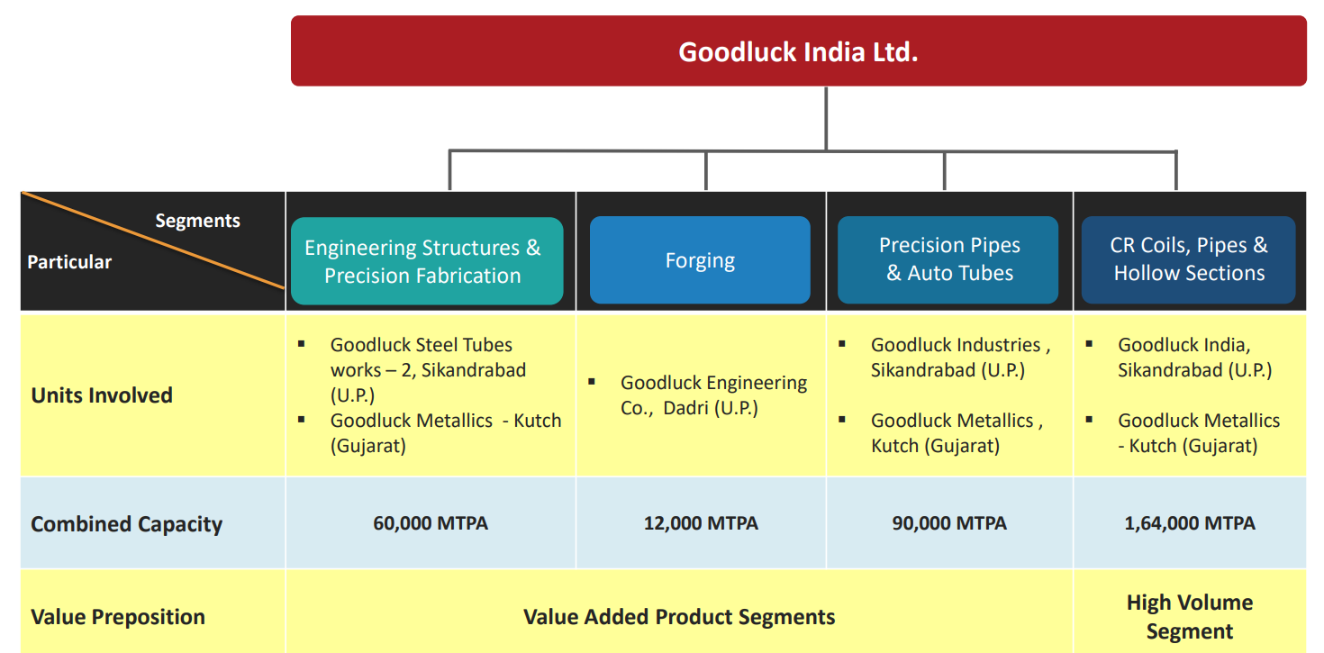

Some of their clients are:

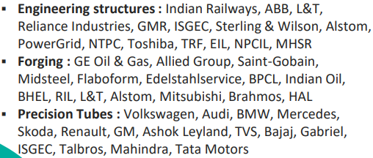

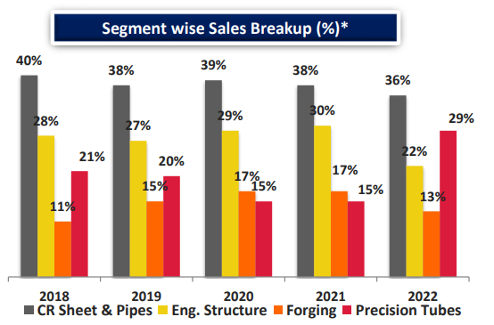

Forging and precision tubes segments are higher EBITDA margin segments

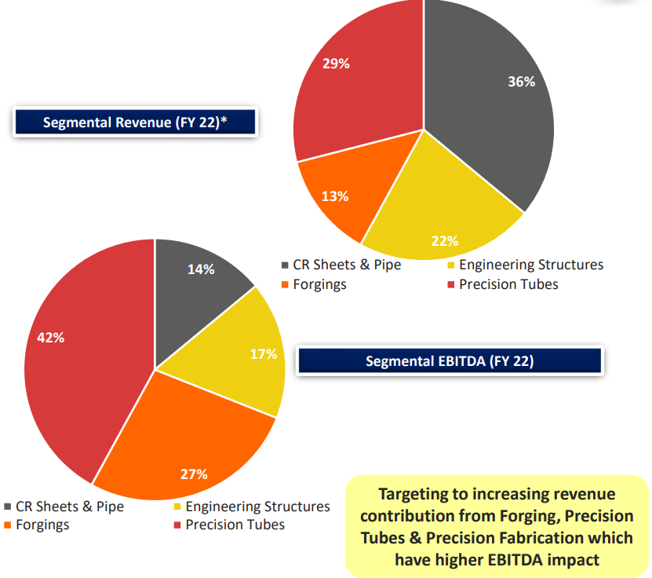

The company aims to be debt-free in the next 3 years.

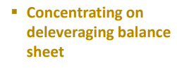



Historically, interest cost has been more than net profit.

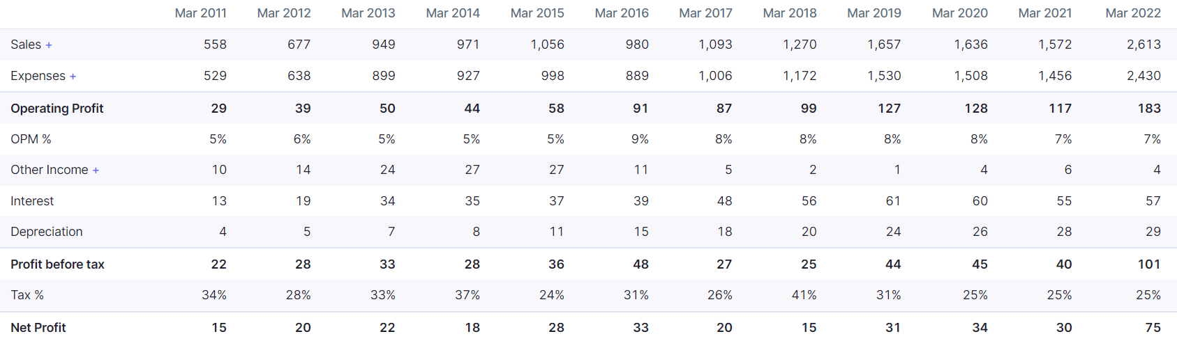



So, if interest goes down to zero within 3 years, PAT will double in 3 years even if there is no increase in revenue.

They are focusing on increasing the share of value-added products

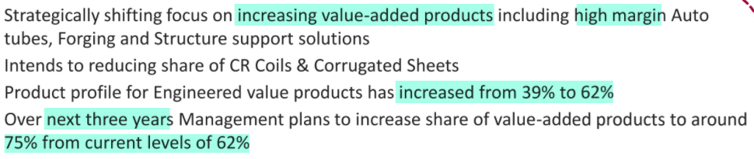

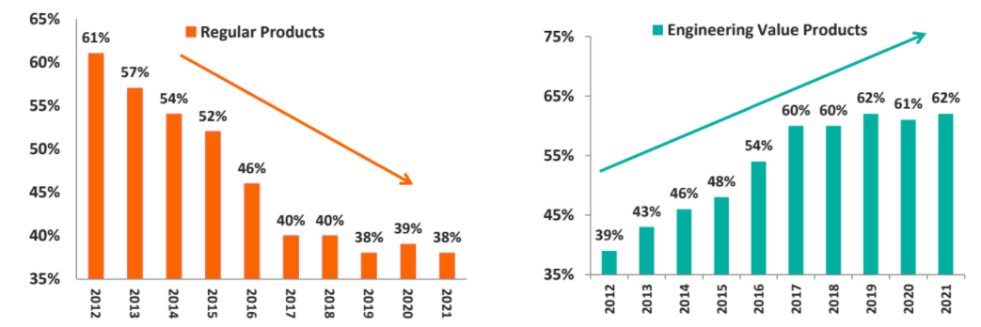





In line with this plan, they have recently expanded capacity of forgings division from 12000 MTPA to 30000 MTPA (addition of 18000 MTPA).

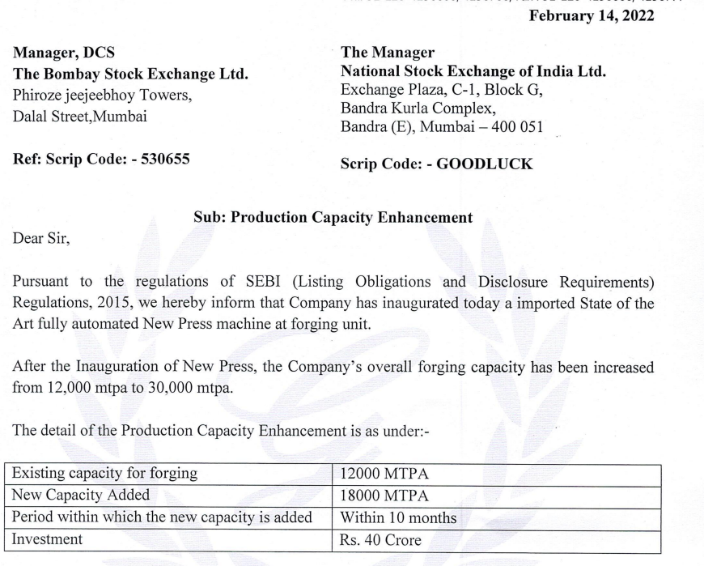

FY21 EBITDA was Rs 117 Cr. Forgings division was 36% of FY21 EBITDA so forgings division did an EBITDA of Rs 42 Cr in FY21 (when capacity was 12000 MTPA). So, in 18000 MTPA capacity, assuming same utilization and realization as FY21, they would earn Rs 63 Cr EBITDA. So, it is interesting to note that they were able to add 18000 MTPA capacity with an investment of only Rs 40 Cr (i.e., they will earn more EBITDA in a single year than the entire investment amount). This plant will also enable them to make larger forgings (single largest piece will increase from 7000 kg to 14000 kg), thus opening multiple opportunities.



They are expecting to reach peak utilization on the new plant in a quick time period

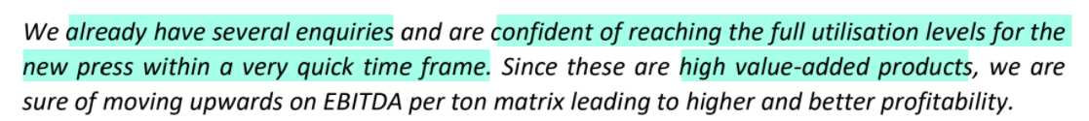

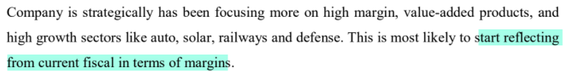

Q3FY22 EBITDA/ton was Rs 6557 (EBITDA of Rs 47.39 Cr and volume of 72273 tons). They are targeting to reach Rs 8000 EBITDA/ton

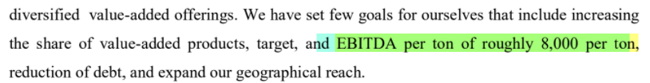

In Q3 FY22 they did the then-highest-ever quarterly volumes, sales and profits

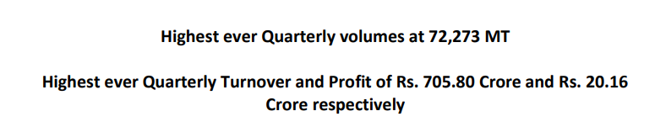

There was further growth in Q4 too

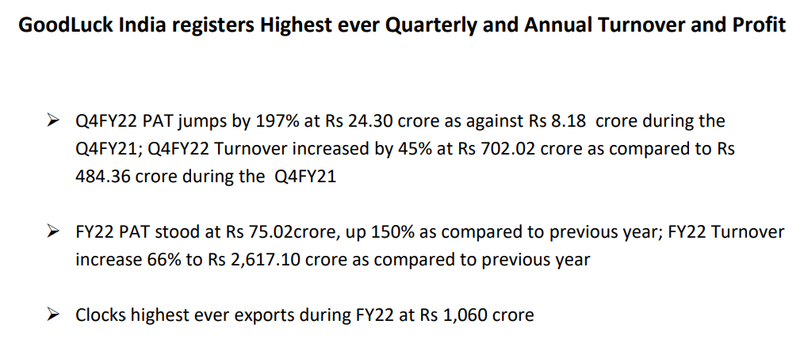

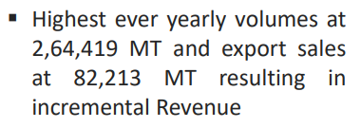

They also recently got letter of intent for Rs 198 Cr from L&T for Mumbai-Ahmedabad bullet train

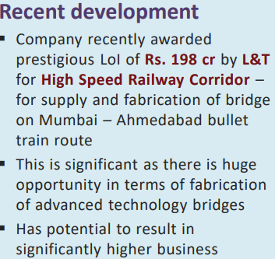

This will start contributing to revenue from Q1 FY23



EBITDA margins are quite stable between 6 to 8%

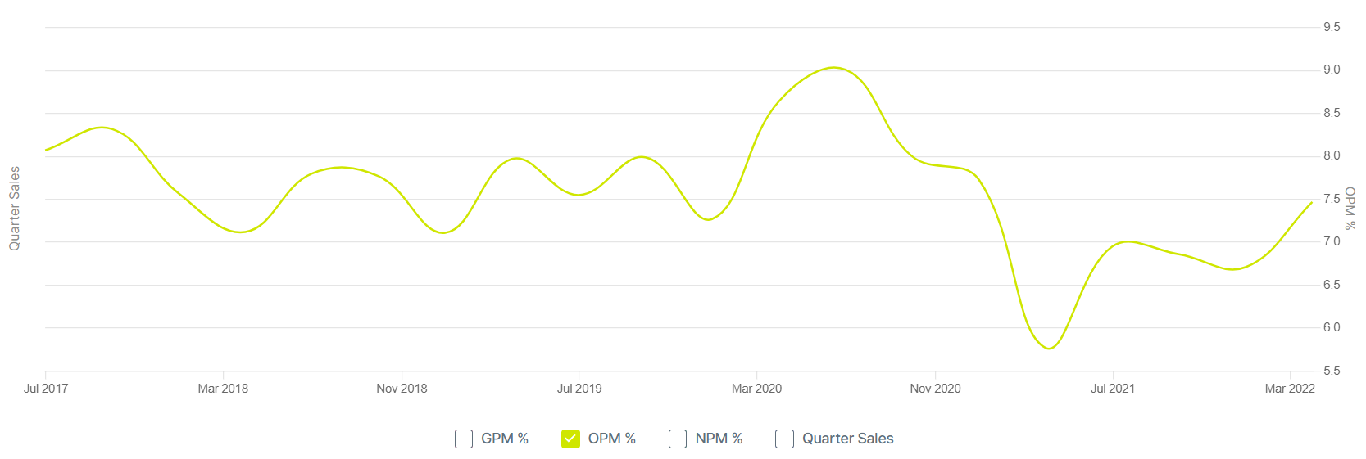

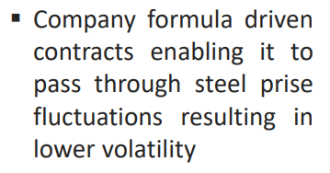

Realisations have improved in FY22

|  |  |  |  |  |
| --- | --- | --- | --- | --- |
|  | 19 | 20 | 21 | 22 |
| Volume (MT) | 2,26,439 | 2,40,259 | 2,19,903 | 2,64,419 |
| Revenue (Rs Cr) | 1,657 | 1,636 | 1,572 | 2,613 |
| Realisation (Rs/MT) | 73176.44 | 68093.18 | 71486.06 | 98820.43 |

There is a renewed management focus with intent on moving towards being a solution provider





They have a vision of Rs 5000 Cr revenue in next 5 years

