Apollo Micro Systems

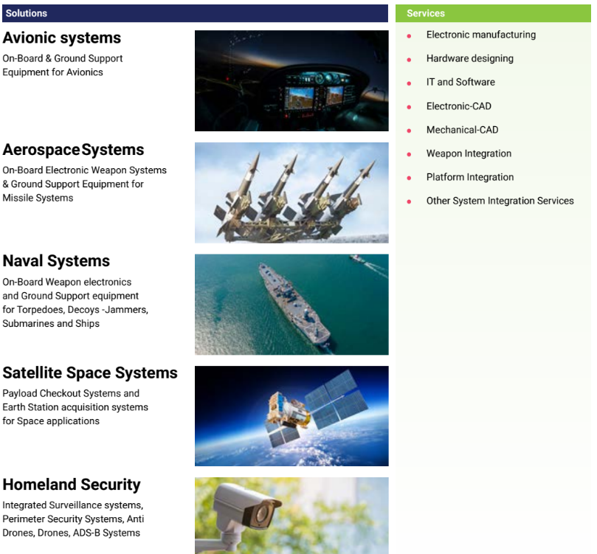

Their clients include ministry of defence, DRDO, HAL, BEL, BDL etc.

They have an order book of Rs 280 Cr

