Roto Pumps

The pumps industry has two types- centrifugal pumps and positive displacement pumps. Roto is operating in the latter segment.

The company manufactures & sells broadly three categories of Pumps-

Progressive Cavity Pumps

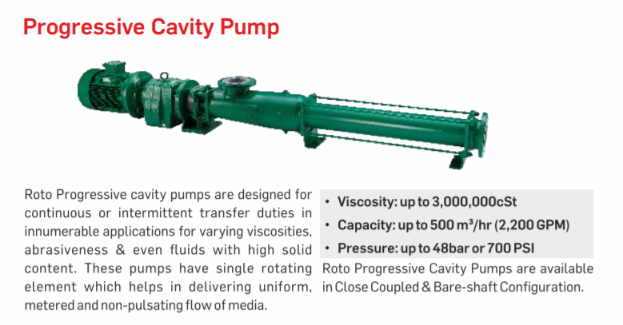Twin Screw Pumps

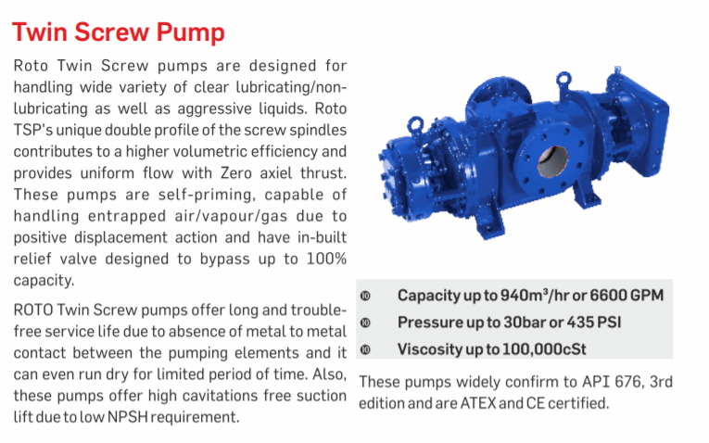

Roto manufactures pumps that are specialized and custom made and used in industries where fluid viscosity is high. The end users are diverse range of industries including Wastewater, Sugar, Paper, Paint, Oil & Gas, Chemicals & Process, Ceramics, Food & Beverages, Renewable Energy & Power, Mining & Explosives, Marine & Defense.

Roto Pumps Ltd was incorporated in 1968. Roto Pumps is the pioneer manufacturer of Progressive Cavity Pumps in India. The company is exporting to more than 50 countries. In the overseas market, it sells its products in countries like Australia & New Zealand, Africa, UK & Europe, USA, Middle East & Southeast Asia. Their manufacturing facility is also equipped with a solar power plant that meets 50% of energy needs.

Exports is 67.5% of sales:

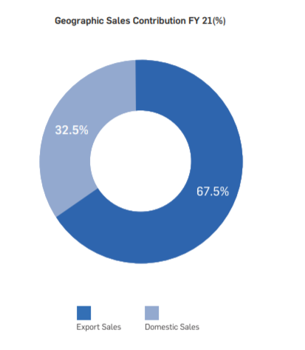

The pumps sales are one-time when a company does capex (and when the old pumps need to be replaced), hence Roto can be an indirect beneficiary and proxy play of capex cycle. However, there is also a segment of spare parts for pumps in Roto’s revenue which has recurring sales irrespective of capex.

They are working on new product launches of downhole pumps and solar pumping systems:

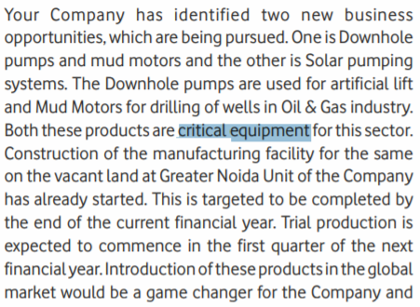

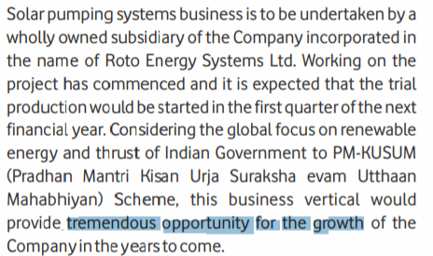

Some more detail on the same:

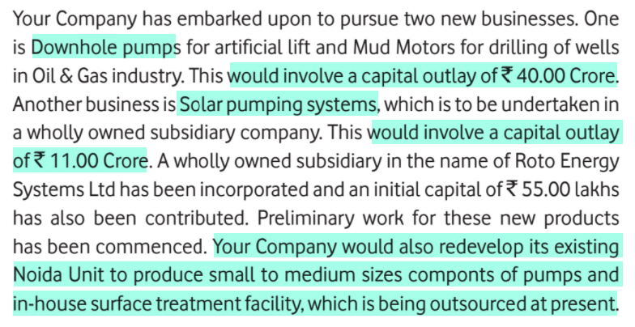

From what I understand, downhole pumps are a high margin product and this could boost margins. Also, downhole pumps are currently being imported; hence, this could also be an import substitution play.

They are expecting to complete setup of downhole pump business around Q4 FY22:

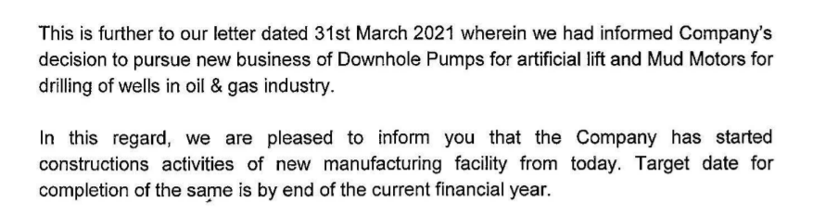

Once this begins there could be additional revenue coming onstream. Historically the company’s fixed asset turnover has been 2 to 3x and if we assume same asset turns on these two new projects then potentially additional sales could be 100 to 150 Cr (2 to 3x 51 Cr). Current TTM sales is 136 Cr so revenue could possibly double within 3 to 5 years.

They are also planning to begin in-house manufacturing for work currently being outsourced and this can boost margins:



From a recent credit rating report:

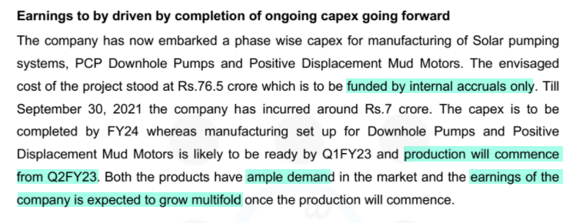

This implies that capex on positive displacement mud motors will be Rs 25.5 Cr (76.5-40-11)

They are also listing on NSE (currently they are BSE-only):

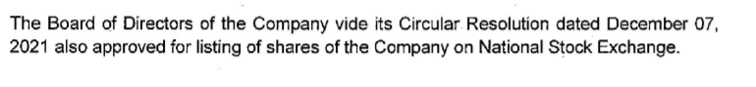

This can give a liquidity boost for the stock