BCL Industries has three divisions:

**Edible Oil & Vanaspati:** 66% of revenue in FY21 vs 53% in FY20  
**Distillery:** 32% of revenue in FY21 vs 44% in FY20  
**Real Estate:** 2% of revenue in FY21 vs 3% in FY20

The revenue mix has further changed and edible oil business is becoming a bigger portion:

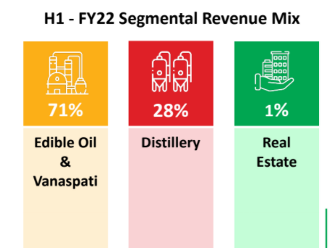

Distillery/liquor business: Whisky, Gin, Rum, Vodka, etc under the brand **Asli Santra, Ranjha Saunfi, Punjab Special, Cozi Dry, Red Royal, Summer Chef.** In the distillery segment, the company has a long-standing relationship with key clients, like Pernod Ricard, Radico Khaitan, Punjab Chemicals and Crop protection limited, Wonder healthcare.

They are expanding capacity in liquor business from present 200 KLPD (kilolitres per day) to 700 KLPD.

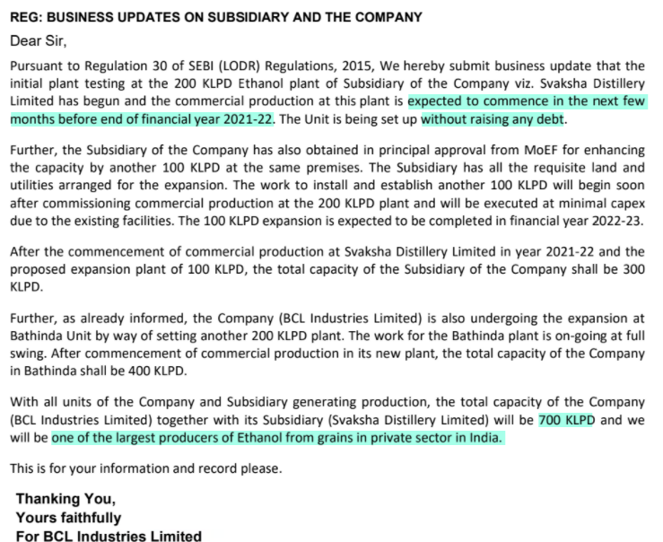

Initial plant testing for Svaksha has begun and the additional 200 KLPD at Bathinda is expected to be complete by November 2022:



FY21 sales from liquor business were 470 Cr. If we assume capacity utilization levels and realizations on the new capacity to be same as earlier, then sales from liquor business alone can be 1645 Cr within 2 to 4 years (700/200*470). TTM sales of entire company is 1740 Cr.

Realizations in ethanol is around Rs 51.975 per litre:

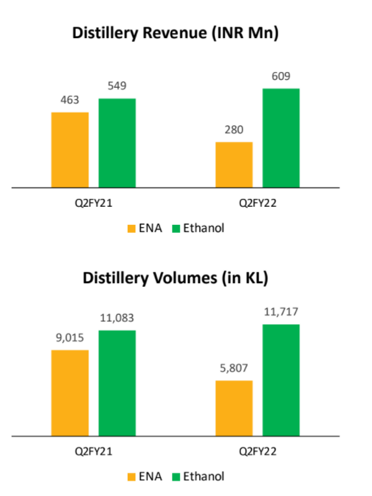

Presently, they seem to be operating at full capacity utilization since present capacity is 200 KLPD. There are around 65 weekdays per quarter so 200*65=13000 KL in a quarter. Q2 FY22 was 11717+5807=17524 which means they are probably working some weekends also (e.g. alternate Saturdays).

**Edible Oil:** Soyabean refined oil, cottonseed refined oil, palm refined oil, mustard oil under the brands **HomeCook and Murli.**  
**Basmati Rice:** Under the brands HomeCook, White Gold and Permal.  
**Vanaspati Ghee:** Under the brands HomeCook and DO Khajoor. The manufacturing plant is located in Bathinda, Punjab, with a capacity of processing 1,020 metric tonnes per day. Segment-wise, manufacturing capacity of 300 TPD for oilseed crushing and solvent extraction each, and a total refining capacity of 420 TPD.

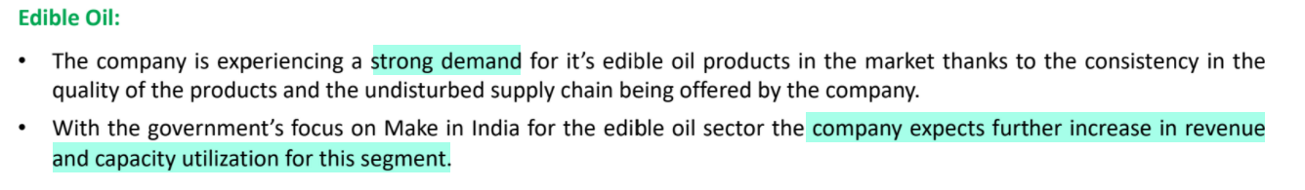

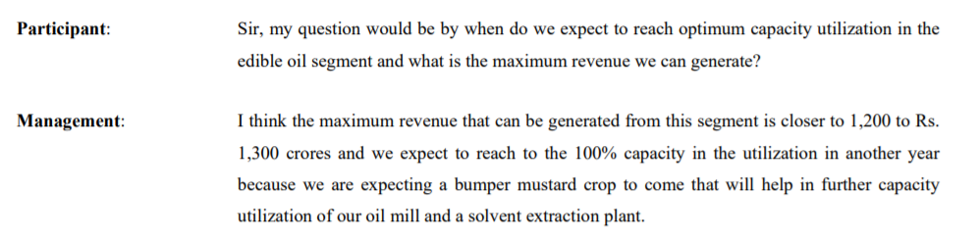

Deleveraging is another trigger for the company:

