Precision Wires

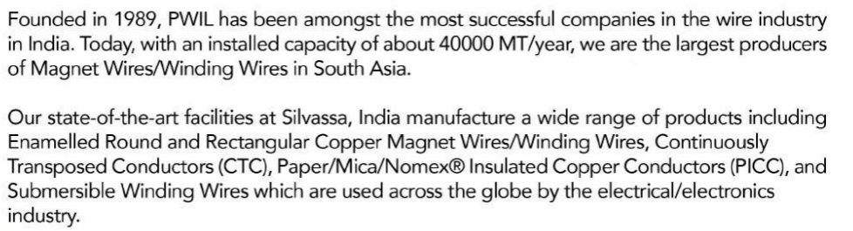



They are planning capex to increase capacity from 40000 MTPA to 45000 MTPA

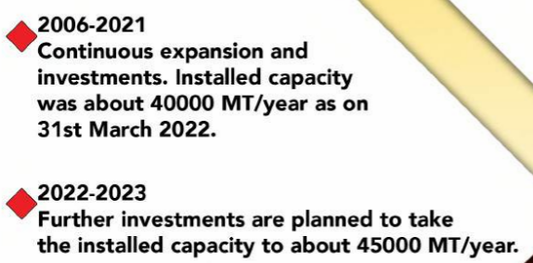

<http://precisionwires.com/wp-content/uploads/2022/05/PWIL-2022-brochure.pdf>

