Cash & Leverage Aversion

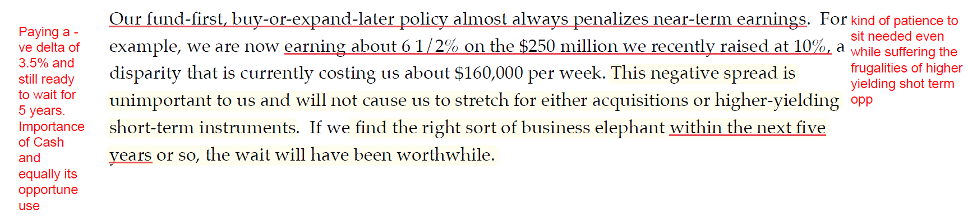

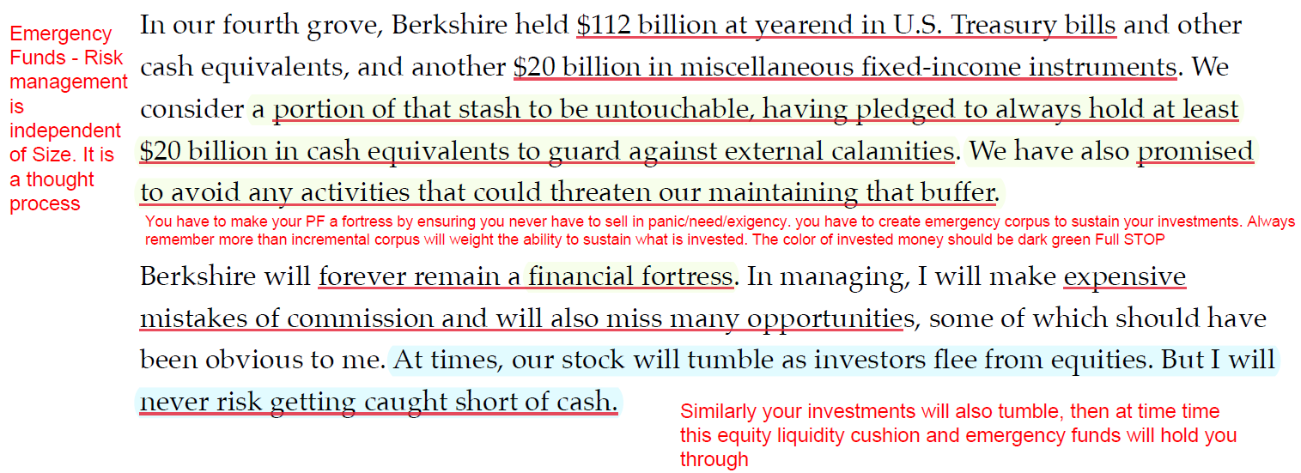

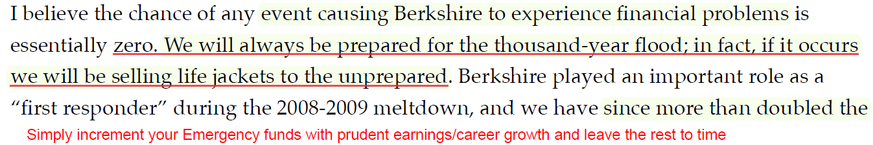

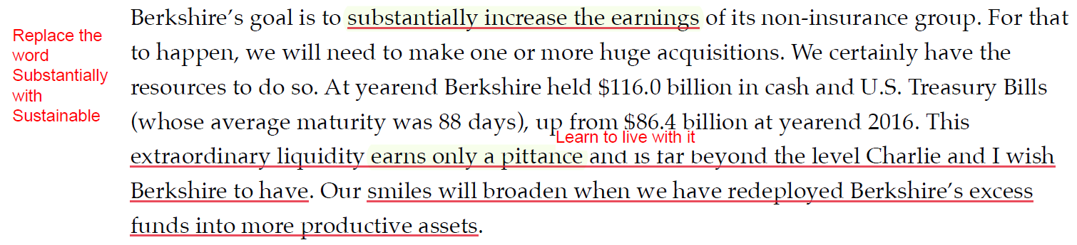

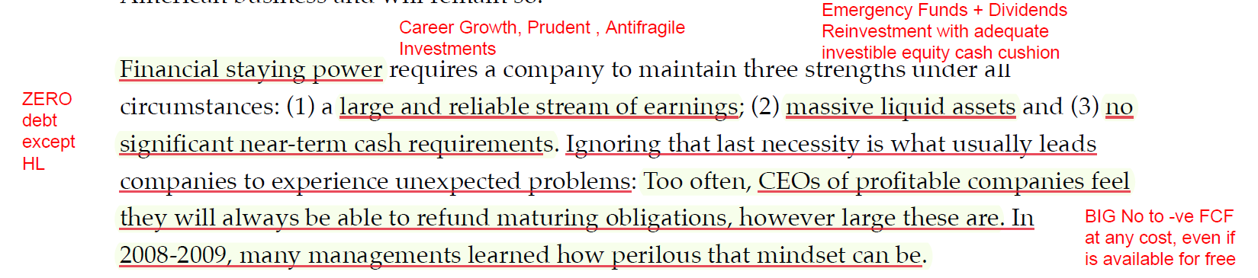

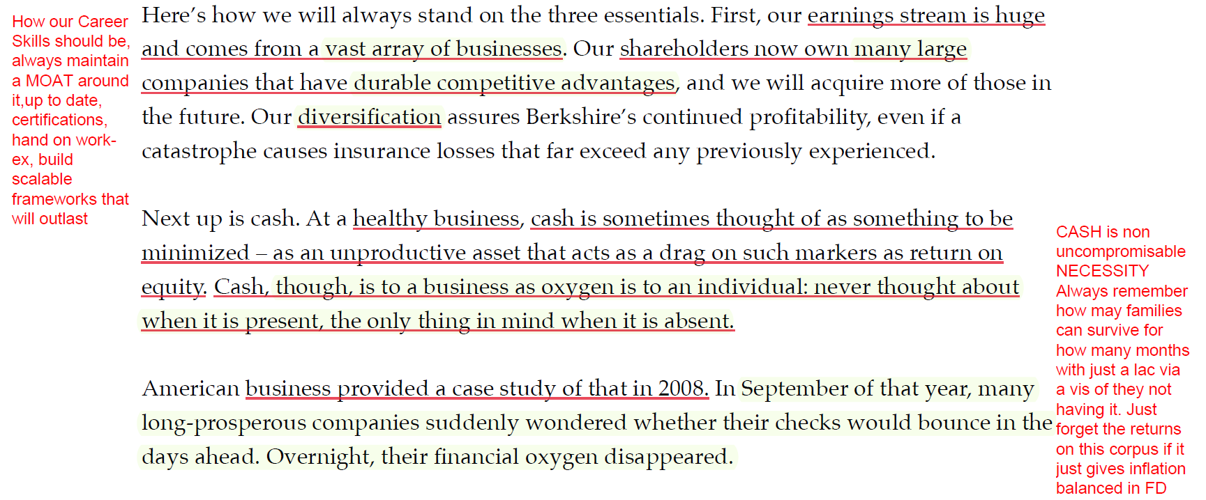
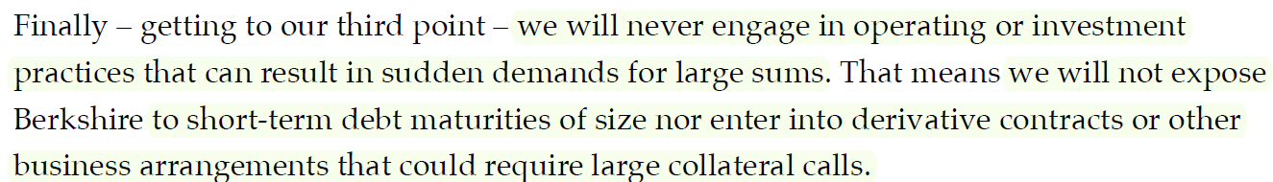
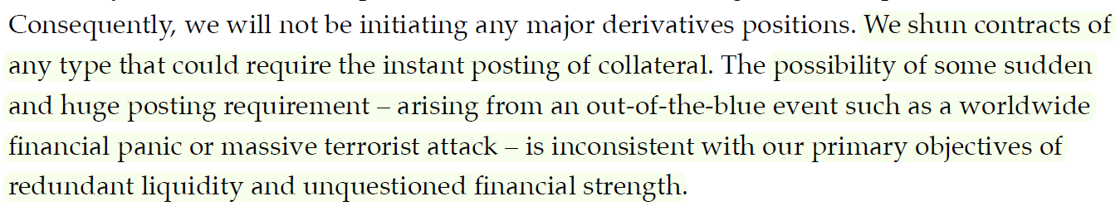

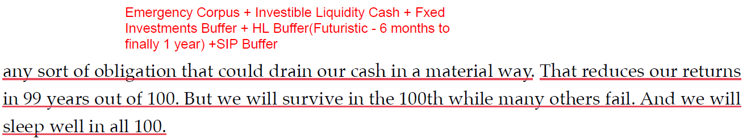
Letter by Warren's grandfather to his uncle

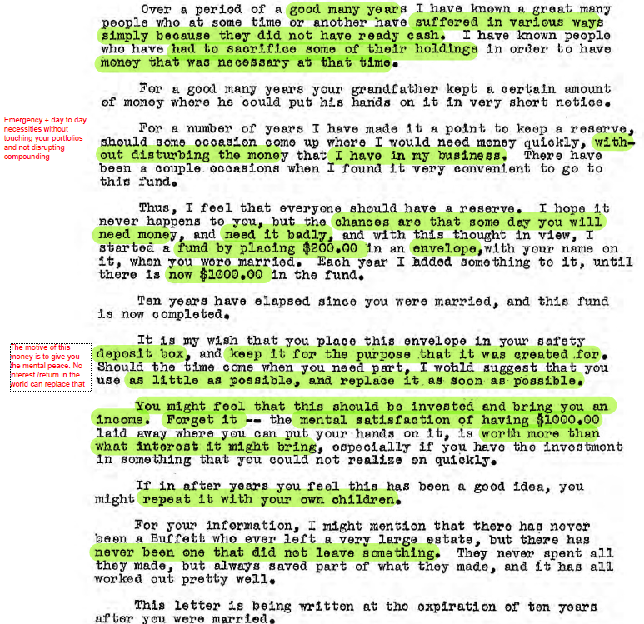

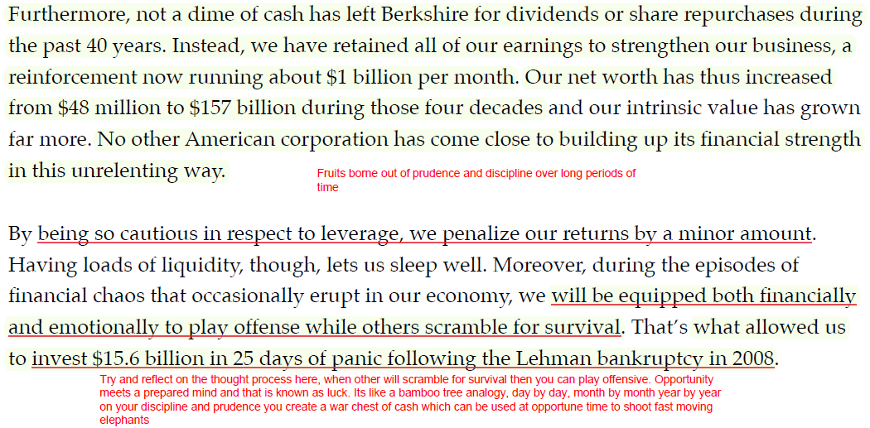

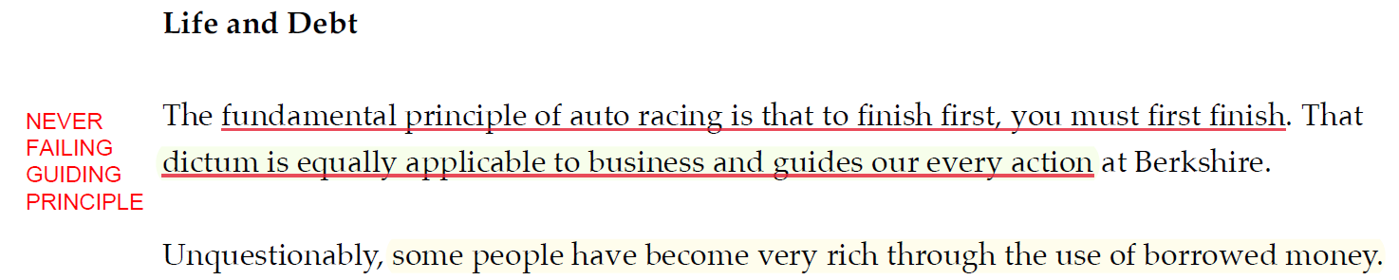
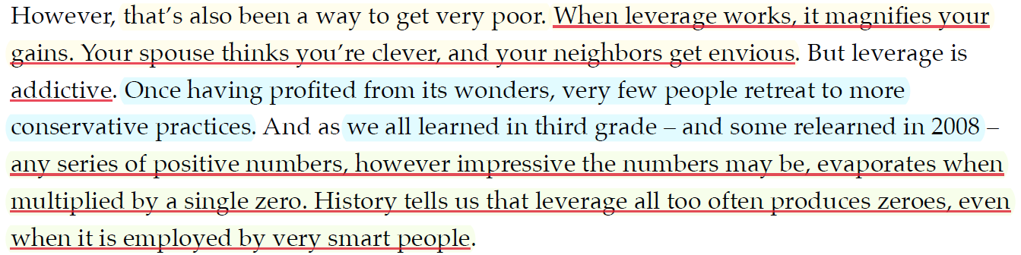

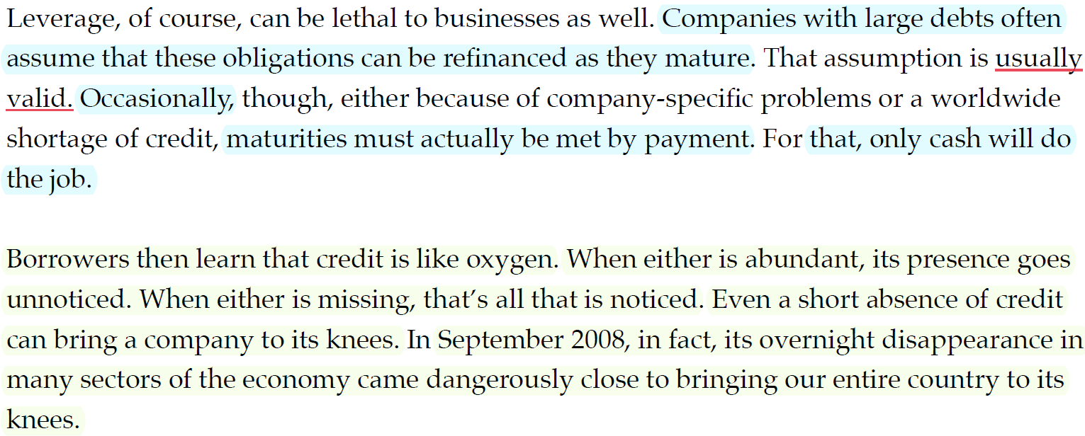

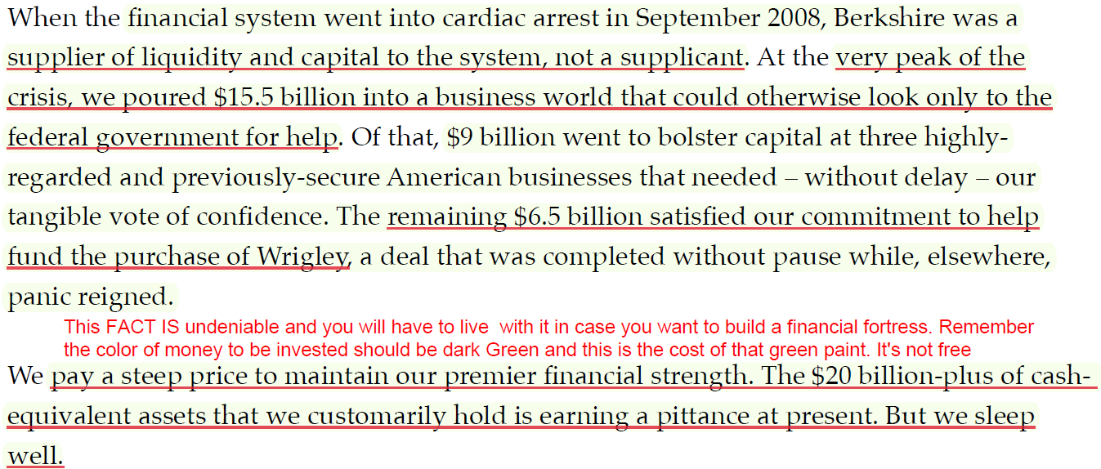

What happened with DHFL

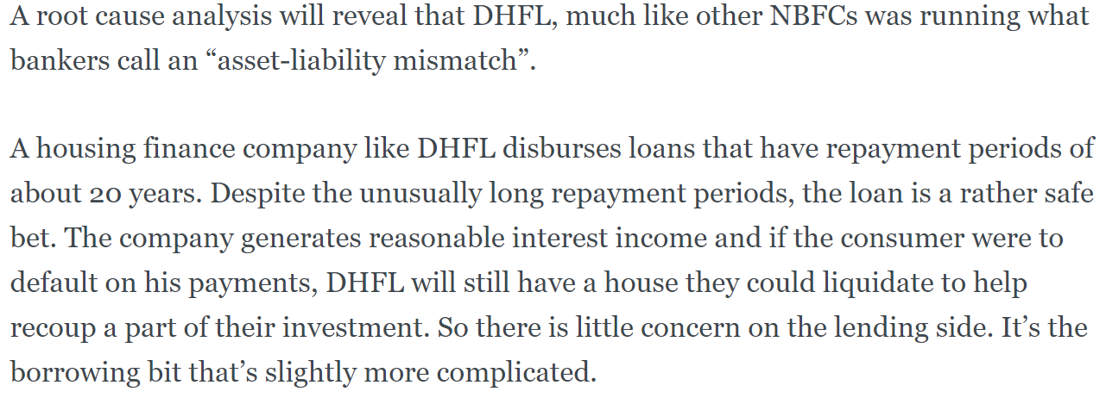
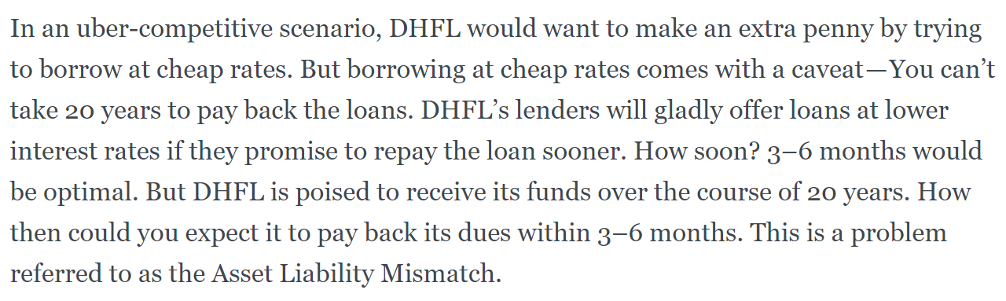

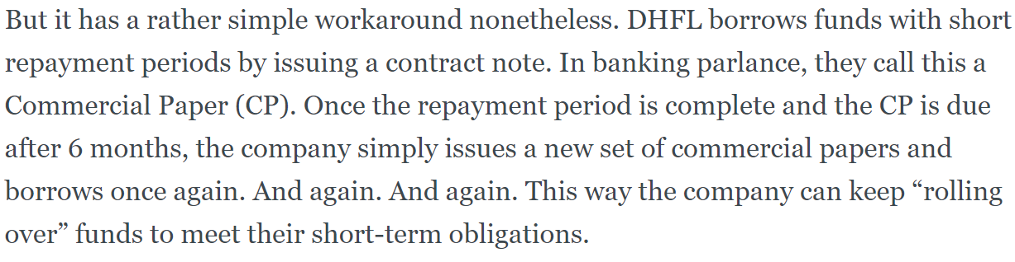
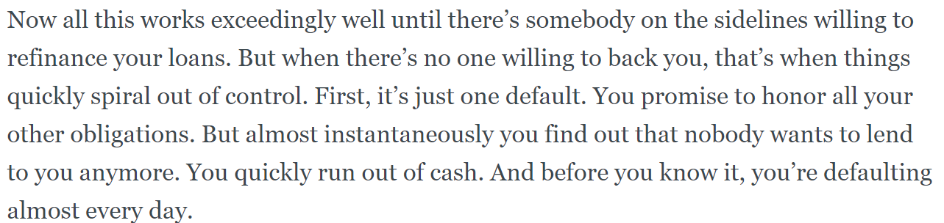

That is exactly why MFL (Manappuram Finance limited) want to diversify their funds/liability base even at a 200 bps higher cost than CP coz they want to have adequate liquidity over a longer period of time.

