Cineline India is into four businesses- hospitality (hotel), windmill (power generation), rental assets (rent + parking + advertisement) and theatres.

In FY21, revenue split was:

Hotel- 11.3 Cr

Windmill- 1.53 Cr: They have two windmills with power generation capacity of 1.6 MWA and 0.6 MWA individually. This is sold to the respective state governments.

Rental assets- 16 Cr

The Company was present in the film exhibition business through its ‘Cinemax’ Brand since 1997. However, in 2012, they had discontinued the theatre business by selling it along with Cinemax Brand to PVR Limited under a non-compete clause which has already ended. Further, the Company had leased out 9 properties with 23 screens to PVR on which Multiplex operations were run by PVR. But they have re-entered the cinema business recently.



The Company has recently acquired 52 screens on a lease basis of which 7 are in Hyderabad, 11 are in Noida, 3 in Gurgaon, 4 in Nagpur, 5 in Punjab, 9 in Uttar Pradesh, 6 in Rajasthan, 5 in Gujarat and 2 in Maharashtra. All the screens are leased properties. These theatres will have an aggregate seating capacity of more than 10,500 seats. The lease agreement with PVR will end on 31st March 2022, and after this, the Company will also have access to its own 9 properties with 23 screens across Mumbai, Thane, Nashik, and Nagpur having an aggregate seating capacity of more than 6,000 seats which is expected to commence operations in Q1 FY23. Overall, they will have capacity of 75 screens with 16,500+ seats.

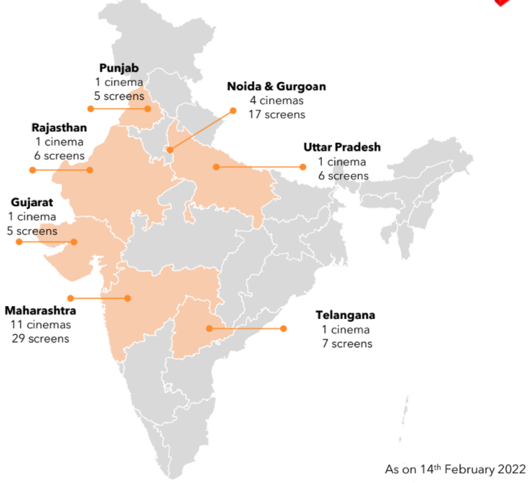

They plan on aggressively growing the film exhibition business by acquiring theatre properties pan-India. Going forward, they are intending to focus purely on the film exhibition business.



The plan is to reach 300 screens and 70000 seats by 2025.

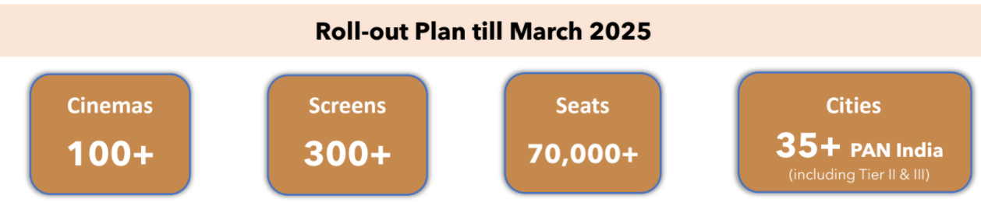

Their cinema exhibition business was earlier operating under ‘Cinemax’ brand but they have changed this to MovieMax

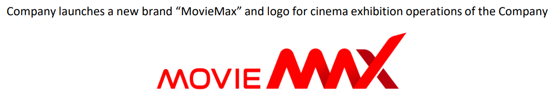

The capex per screen is expected at Rs 2.2 Cr to Rs 2.5 Cr

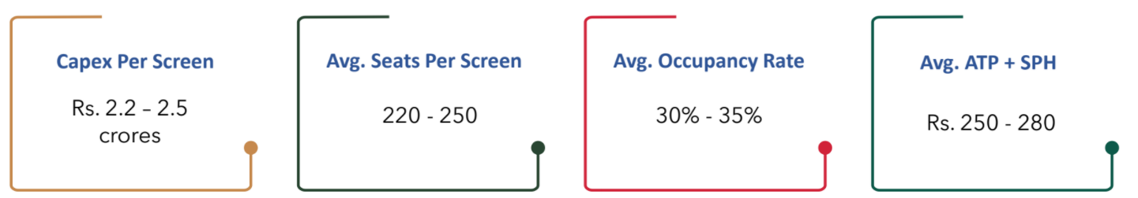

There is a change in management with Mr Ashish Kanakia (son of Mr Rasesh Kanakia, next generation of promoter family) coming in as CEO



They are monetizing non-core assets to reduce debt and re-invest in the core cinema business.

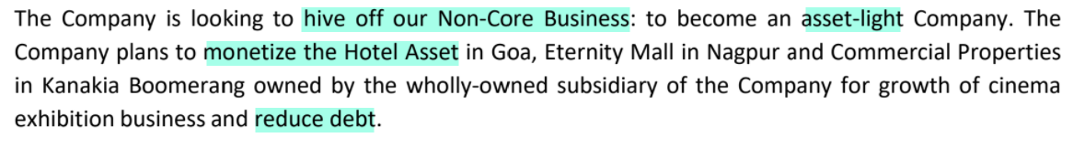

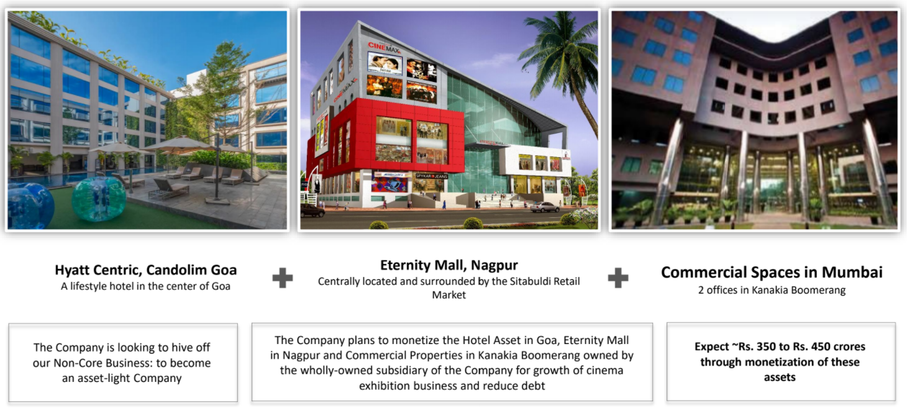

They are selling one windmill.



They are expecting to receive Rs 350 Cr to Rs 450 Cr through these sales.

