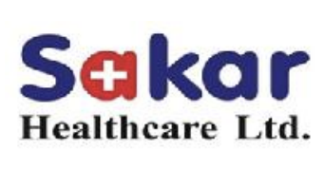

26/08/2024

Established by first generation entrepreneur Mr. Sanjay Shah in 2004 in Changodar, Gujarat, India. Started with manufacturing Oral Liquid as a Contract Manufacturer for pharma multinationals (CMO).

Sakar Healthcare has walked the path of brisk success because of its uncompromised values and impregnable entrepreneurial acumen. The Liquid & Lyophilised Injection unit (small volume parenterals in ampoules and vials) at Sakar Healthcare has been EU GMP approved and all four state of the art manufacturing units are certified by ISO 9001:2015 BVQI , WHO-GMP, cGMP, in addition to the approvals by ‘National Drug Authority’ of Uganda, Kenya, Yemen, Ethiopia, Congo, Ghana, Zimbabwe(MCAZ), Cambodia, Vietnam, Malawi, Namibia, Nigeria, Cote d’ivoire, Philippines, Peru.

Operating in over 50 countries globally, Sakar has 292 registered products and further 210 products under registration. Sakar has +70 overseas partners, who helps in promotion and distribution of Sakar brands in multiple nations.

**In FY21, Sakar forayed into Oncology by setting-up a greenfield integrated unit at Bavla, Gujarat, which will contribute to the next phase of growth at Sakar Healthcare.**

The Research-driven, API-integrated, ONCOLOGY, finished dosage-OSD (tablet, capsule, granule) & Injection (liquid, lyophilised) manufacturing unit has become fully operational with domestic supplies and international regulatory compliant. The manufacturing block for OSD and injection have received EU GMP approval to export oncology products to regulated markets; certification will remain valid for three years.

**Oncology corporate Video: (Must Watch):**

<https://youtu.be/pdMIvAzfVkw?si=piQPZX0CsPj2c8ak>

**Formulation Segmentation:**



**Oral Liquid:** The liquid form is the most acceptable dosage form across age groups. It is normally available in sealed glass or pet bottles in different volumes.

**Key Molecules:**

-Metronidazole

-Nystatin (Anti fungal)

-Ambroxil,Terbutaline, Guaphenisin (Cough expectorant)

**Liquid Injections (Vials & Ampoules):** They are meant for administration inside veins or muscles in human body and are manufactured aseptically.

**Key Molecules:**

-Tramadol (Analgesic)

-Diclofenac (Anti inflammatory)

-Heparin (Anti coagulant)

**Lyophilized Injection (Vials):** Lyophilization is the process commonly known as Freeze Drying which helps enhance the product stability. It is manufactured in a Lyophilizer.

**Key Molecules:**

-Pantoprazole (Proton Pump Inhibitor)

-Omeprazole (Proton Pump Inhibitor)

-Vancomycin (Antibiotic)

**Oral Solid (Tablet/Capsule/Dry Syrup):**  Cephalosporins are antibiotics used to treat a wide variety of bacterial infections, such as respiratory tract infections, skin infections and urinary tract infections. This is the most widely used formulation type.

**Key Molecules:**

-Cefuroxime (Antibiotic)

-Cefpodoxime (Antibiotic)

-Cefalexin (Antibiotic)

**Oral Solid (Dry Powder Syrup):** Dry Powder need to be reconstituted prior administration and is intended for paediatric use.

**Key Molecules:**

-Cephalexin (Antibiotic)

-Cefixime (Antibiotic)

-Cefpodoxime (Antibiotic)

**Dry Powder Injections:** Cephalosporin Dry powder injections are stable and need to be reconstituted with WFI prior administration inside veins or muscles in human body.

**Key Molecules:**

-Cefotaxime (Antibiotic)

-Ceftriaxone (Antibiotic)

-Ceftazidime(Antibiotic)

**Business Vertical Contribution:**

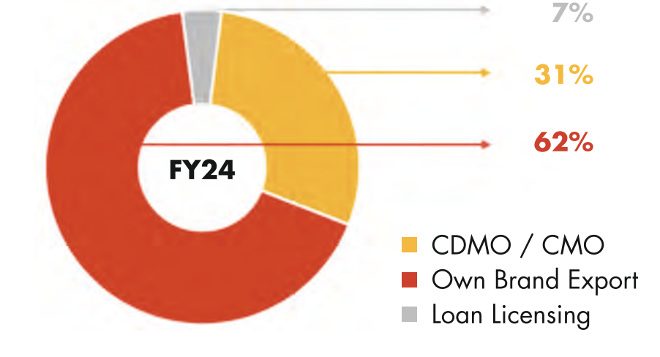

**Next Phase of Growth- Oncology**

**Rationale for Diversifying into Oncology:**

**Presence of limited players in India for both API & finished formulations in Oncology due to high entry barriers thereby ensuring healthy competition.**

♣ Majority of the players have presence in regulated market with less players having presence in semi-regulated markets where Sakar has firm presence since over a decade.

♣ Exhaustive range of off-patent products in the pipeline; thereby enhancing growth opportunities

**New cancer cases in 2020 were 13,24,413 of which Breast cancer 13.5%, Oral cavity 10.3% , Cervix Uteri 9.4%, Lung 5.5%. The Indian Cancer market shows a healthy double-digit growth.**

**Oncology being margin accretive supported by strong growth drivers across geographies.**

♣ Sakar’s objective was to enter R&D with hi-tech equipment to cater to the global requirements.

▪ Sakar has set-up a fully equipped state of the Art facility in Oncology and a fully integrated plant catering to R&D, OSDs, Injectables.

▪ Oncology products are cytotoxic in nature and requires containment set-up and implementation of safety handling procedures which are in place.

<https://youtu.be/pdMIvAzfVkw?si=piQPZX0CsPj2c8ak>

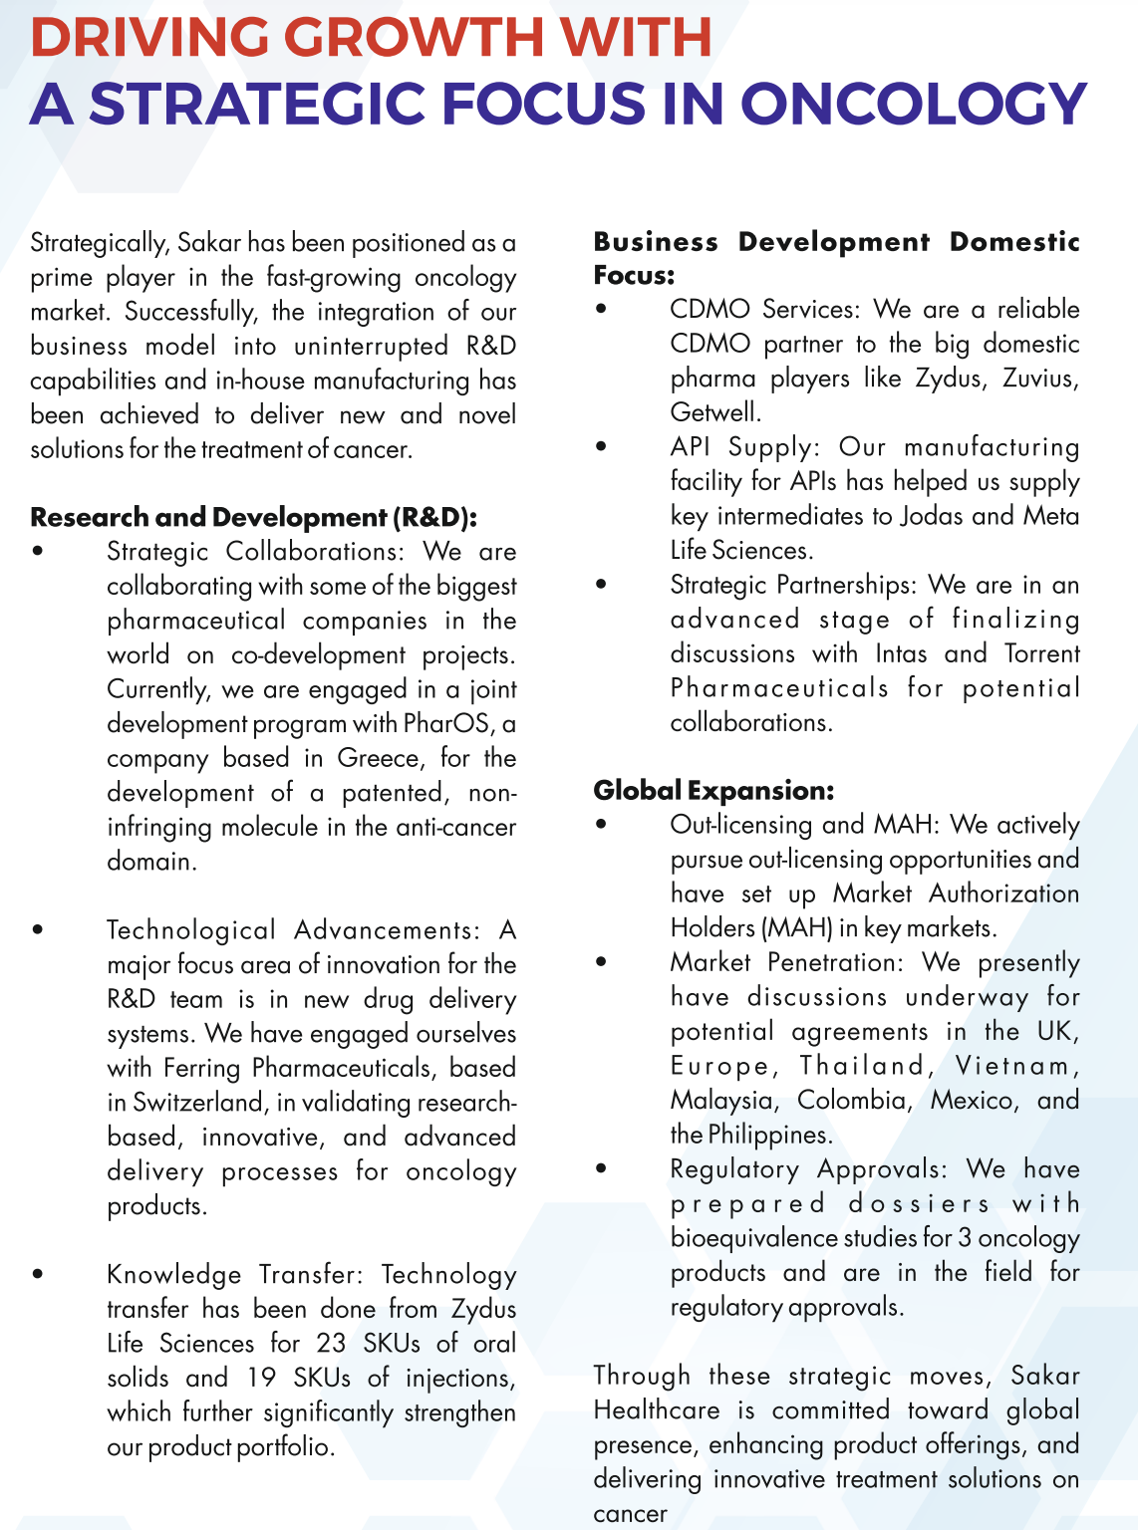

**Strategic Partners:**

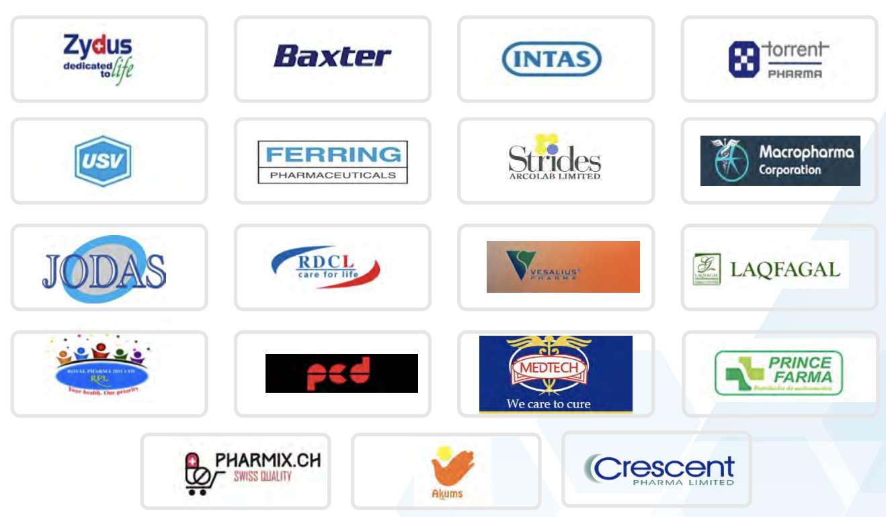

**Key Achievements:**

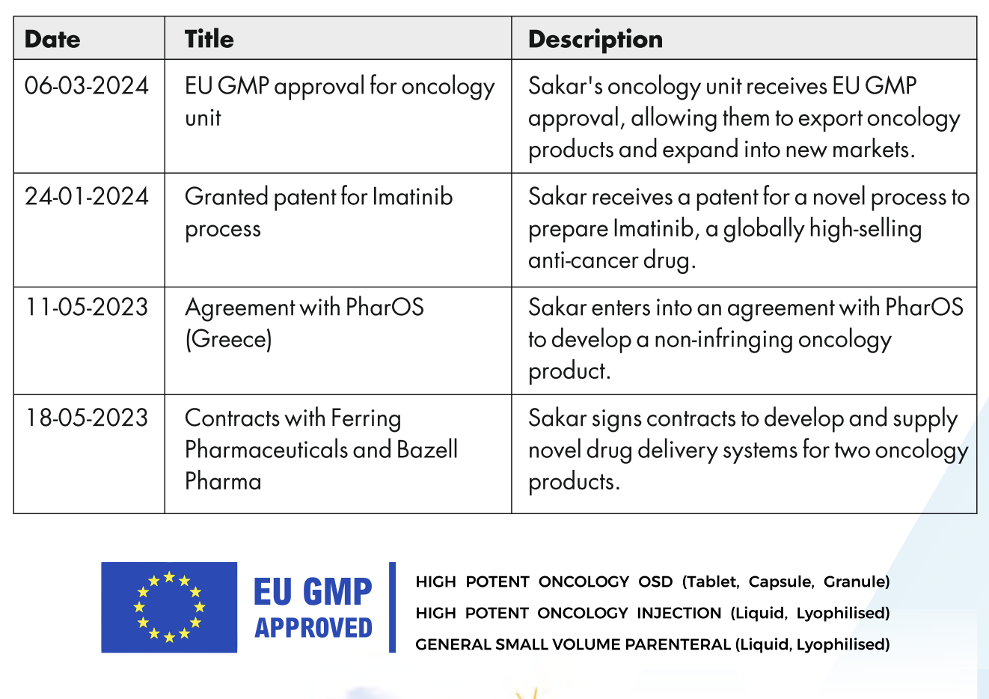

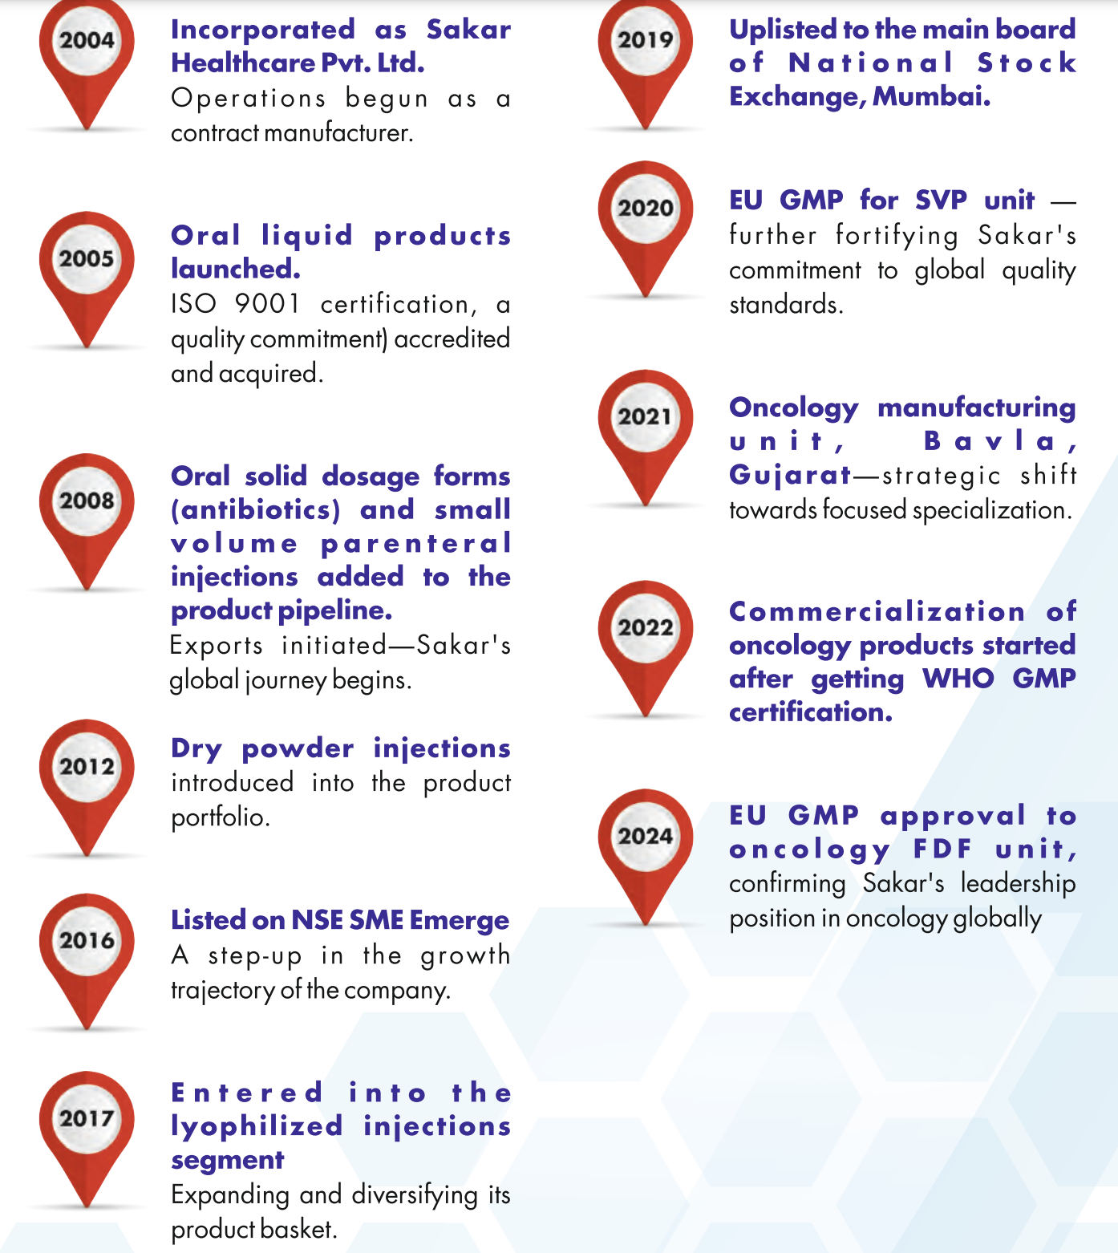

**Various Updates:**

05/03/2024

**Sakar's oncology (anti-cancer) unit receives EU GMP approval**

Sakar Healthcare Ltd., ONCOLOGY (anti-cancer) unit has received EU GMP approval dated **5th March 2024** with a validity of three years from audited date.

The research-driven API-integrated oncology formulation (liquid injections, Iyophilised injections, tablets, capsules, granules) manufacturing unit located at Bavla, near Ahmedabad, Gujarat has been a state-of-the-art manufacturing unit with equipment hand-picked from across the globe. The European Agency audit team inspected the manufacturing blocks of Oral Solid Dosage (Tablet, Capsule, Granules) and Injection (Liquid, Lyophilised) with packaging and storage compliances in last quarter of calendar year 2023 and has granted the approval.

The WHO GMP approved vertically integrated ONCOLOGY unit of SAKAR has been selling products nationally since few quarters. Meanwhile the dedicated technical team has made slow and steady advancements. 30 generic anti-cancer molecules have been developed at in-house labs and the technology transferred successfully to manufacturing units for commercial scale up. In regulatory part:

• Oral Solid Dosage: 9 product CTD dossiers have been developed for submission, with Bioequivalence studies (completed for 3, ongoing for 6), Process validation and Stability data • Injections: 8 product CTD dossiers have been made ready for submission supported by Process Validation batches and Stability studies

•Of the l2 oncology APIs developed in this segment, 11 has been granted Written Confirmation that allows export of the API to the European Union

**Now with EU GMP certification and in-house preparedness Sakar will have distinctive advantages:**

-Register & Export oncology products to EU as Marketing Authorisation Holder or as a CDMO

-Expand export opportunity to high-regulated markets of Canada, Mexico, Colombia, Brazil, South Africa, PICs, GCC, MENA, AP AC region- apart from continent of Africa

-Sign business contracts under discussion, submit dossiers and supply against Marketing Authorisations (MAs) hold by partners or in Sakar name

-The target market size increases manifolds that ensures healthy business growth opportunity Fully integrated unit will offer competitive advantage with regards to offers and continuity

09/05/2024

**Sakar enters into agreement with 7-partners from Europe, South & Central America, Asia Pacific, Africa for 24-oncology (anti-cancer) products in various business models**

Sakar Healthcare Ltd., ONCOLOGY (anti-cancer) unit has entered into definite agreement with overseas partners covering Europe, South& Central America, Asia Pacific, Africa.

Now with EU GMP certification of oncology site, Sakar business development and regulatory team have coordinated for global association:

• One Licensing, Manufacturing and oncology Product supply agreement signed, each in

-Europe with 8 products

-Central America with 7 products

-APAC with 9 products

• A dynamic agreement on profit-sharing model has been signed in Europe with a set of anti-cancer products

• Another three addendums have been signed with 2-European and African existing partners

The partner selection-oncology product mapping-dossier submissions for product registrations are ongoing and is soon to evolve a powerful business-oriented matrix with Sakar's registered oncology products covering four continents.

08/07/2024

**Sakar submitted 20 dossiers of oncology product registration across regions covering Switzerland, Bulgaria, Slovenia, Vietnam, Myanmar & Ethiopia**

Sakar has started with product dossier submission in anti-cancer segment to overseas countries. It is worth mentioning that Sakar has developed oncology products in its research-driven, API-integrated EU GMP approved finished dosage manufacturing units (oral solids and injections), off-which 19 product dossiers in this category has been prepared for submission in key identified countries worldwide. The molecules in the category have been suitably mapped against high-potential countries.

Meanwhile the in-house technical and regulatory team worked towards firming up of dossiers:

• oral solid dosages undergoing bioequivalence studies from EU approved CROs

• injection products tested for bacterial endotoxin (BET) and sterility, post completion of process validations with stability studies

• reference standards utilized for product development have been procured from Europe

• APIs are with CEP making the formulation dossiers complying to regulations of EU and other regulated markets

The registration clock has started and registration or Marketing Authorisation (MA) once received will open the window for export business opportunity with this value products across Europe, the UK, South & Central America, Africa, MENA & APAC regions.

18/08/2024

**Sakar entered into Confidentiality agreement for oncology API (intermediates)& FDF development with Dr. Reddy's Laboratories, Biocon Pharma, Emcure Pharmaceuticals**

Sakar has entered into three definite confidential agreements with Indian multinationals for their API intermediates & finished dosage formulation development viz. Dr. Reddy's Laboratory, Biocon Pharma & Emcure Pharmaceuticals, who are fully integrated, innovation-led bio/pharmaceutical company engaged in manufacturing, marketing and exporting of pharmaceutical products. They have entered into active discussion for their intermediates and pilot batch manufacturing to scale-up of developed products at Sakar's research-driven, API-integrated, EU GMP approved oncology finished dosage (oral solids, injections) manufacturing unit.

These strategic confidential agreements in oncology domain:

• Will allow Sakar team to interact with diverse scientific and technical teams of MNCs

• Allow opportunity to value-add / develop API & FDF in confidence

• Sharpen the robust manufacturing process of intermediates to meet expectations

• Get the technology-transfer process aligned for niche finished dosage forms

• Organise skill-sets to integrate functions to deliver varied solutions with cytotoxic range

With increasing credibility through confidentiality to the process of development, technology-transfer, scaling up of niche anti-cancer products for multinationals, Sakar is emerging as one-stop reliable solution for pharmaceutical companies into oncology.

**Sakar has done Equity dilution (Preferential Basis) multiple times to fund its Oncology aspirations. Here are the details:**

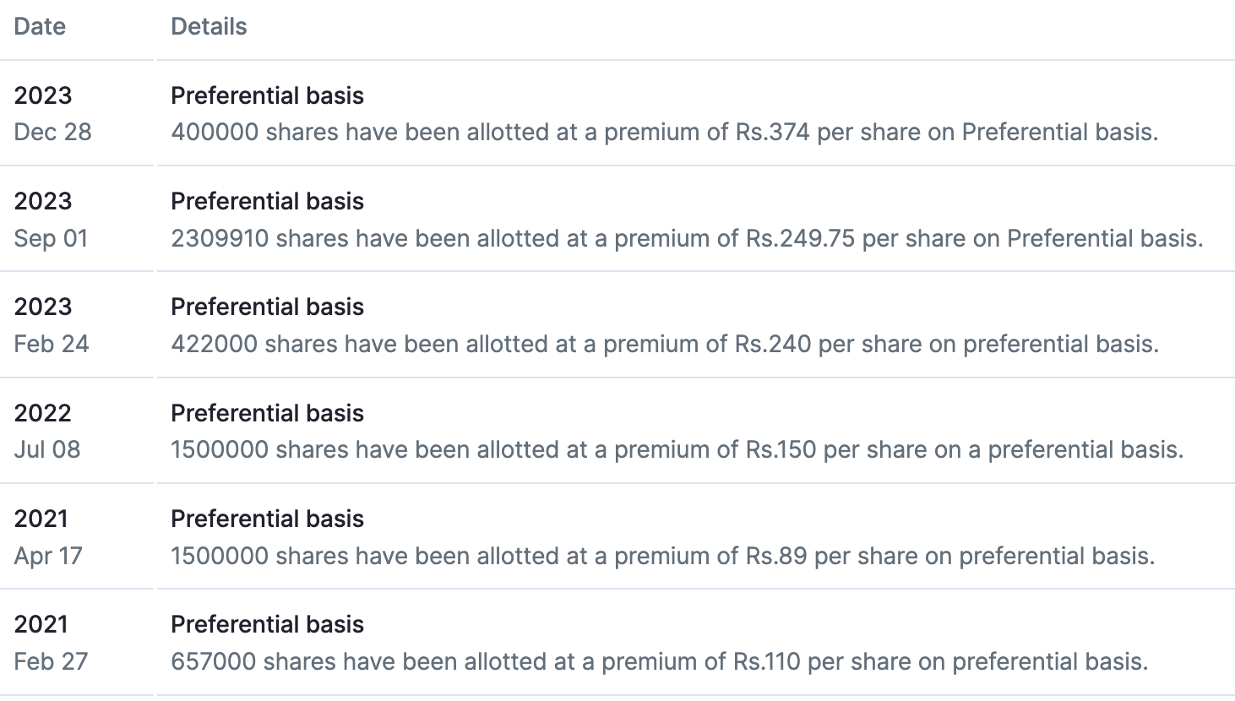

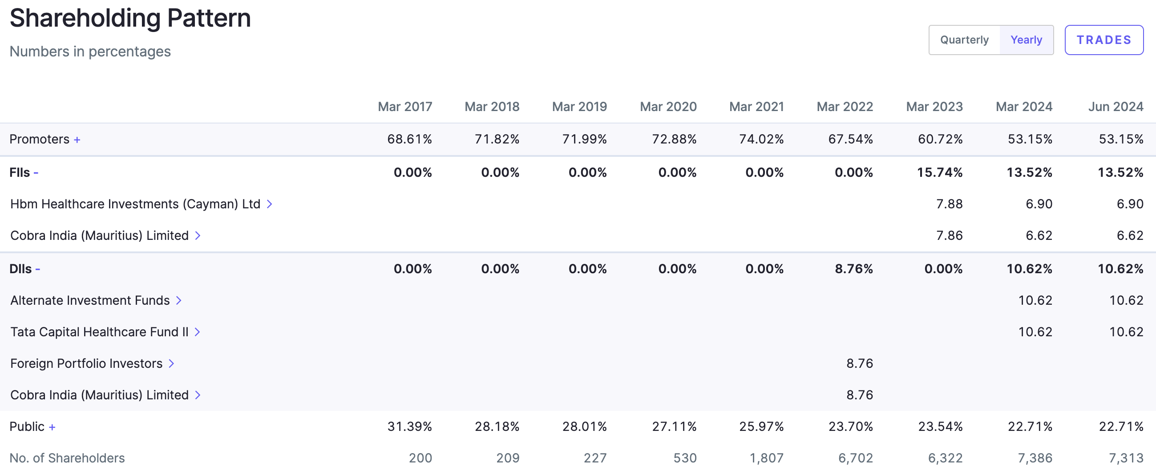

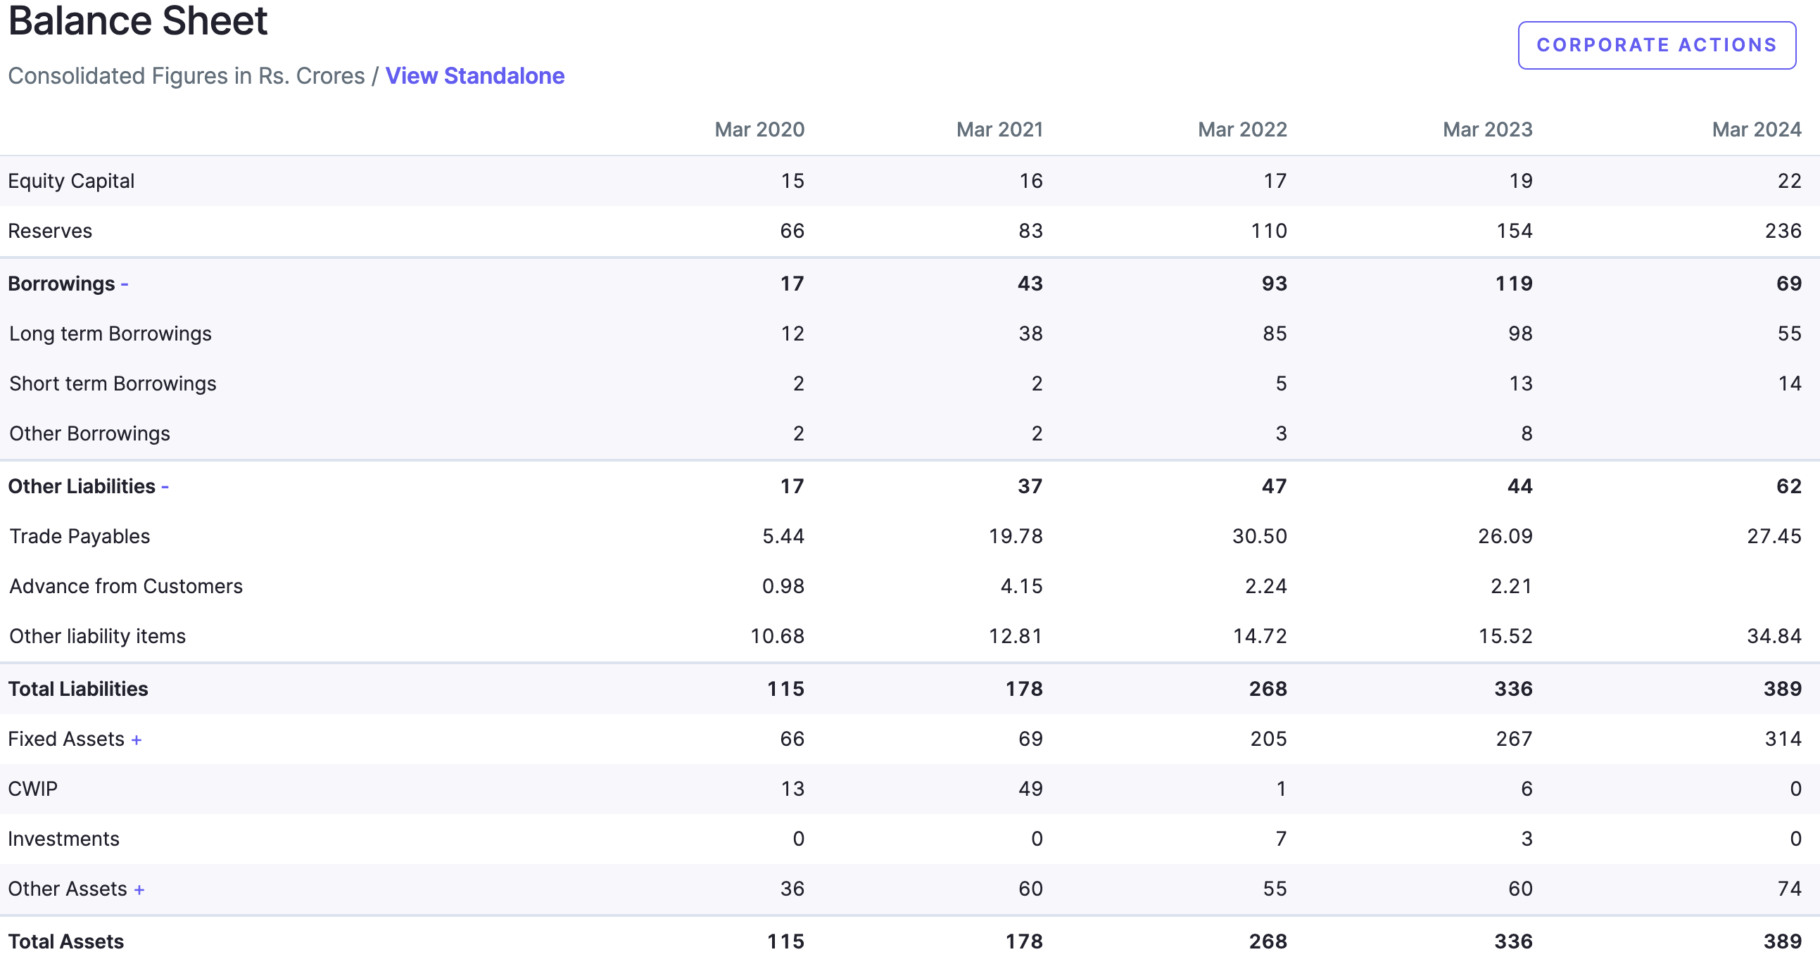

**The Capex is almost complete, Gross Block has more than tripled in 3 years.**

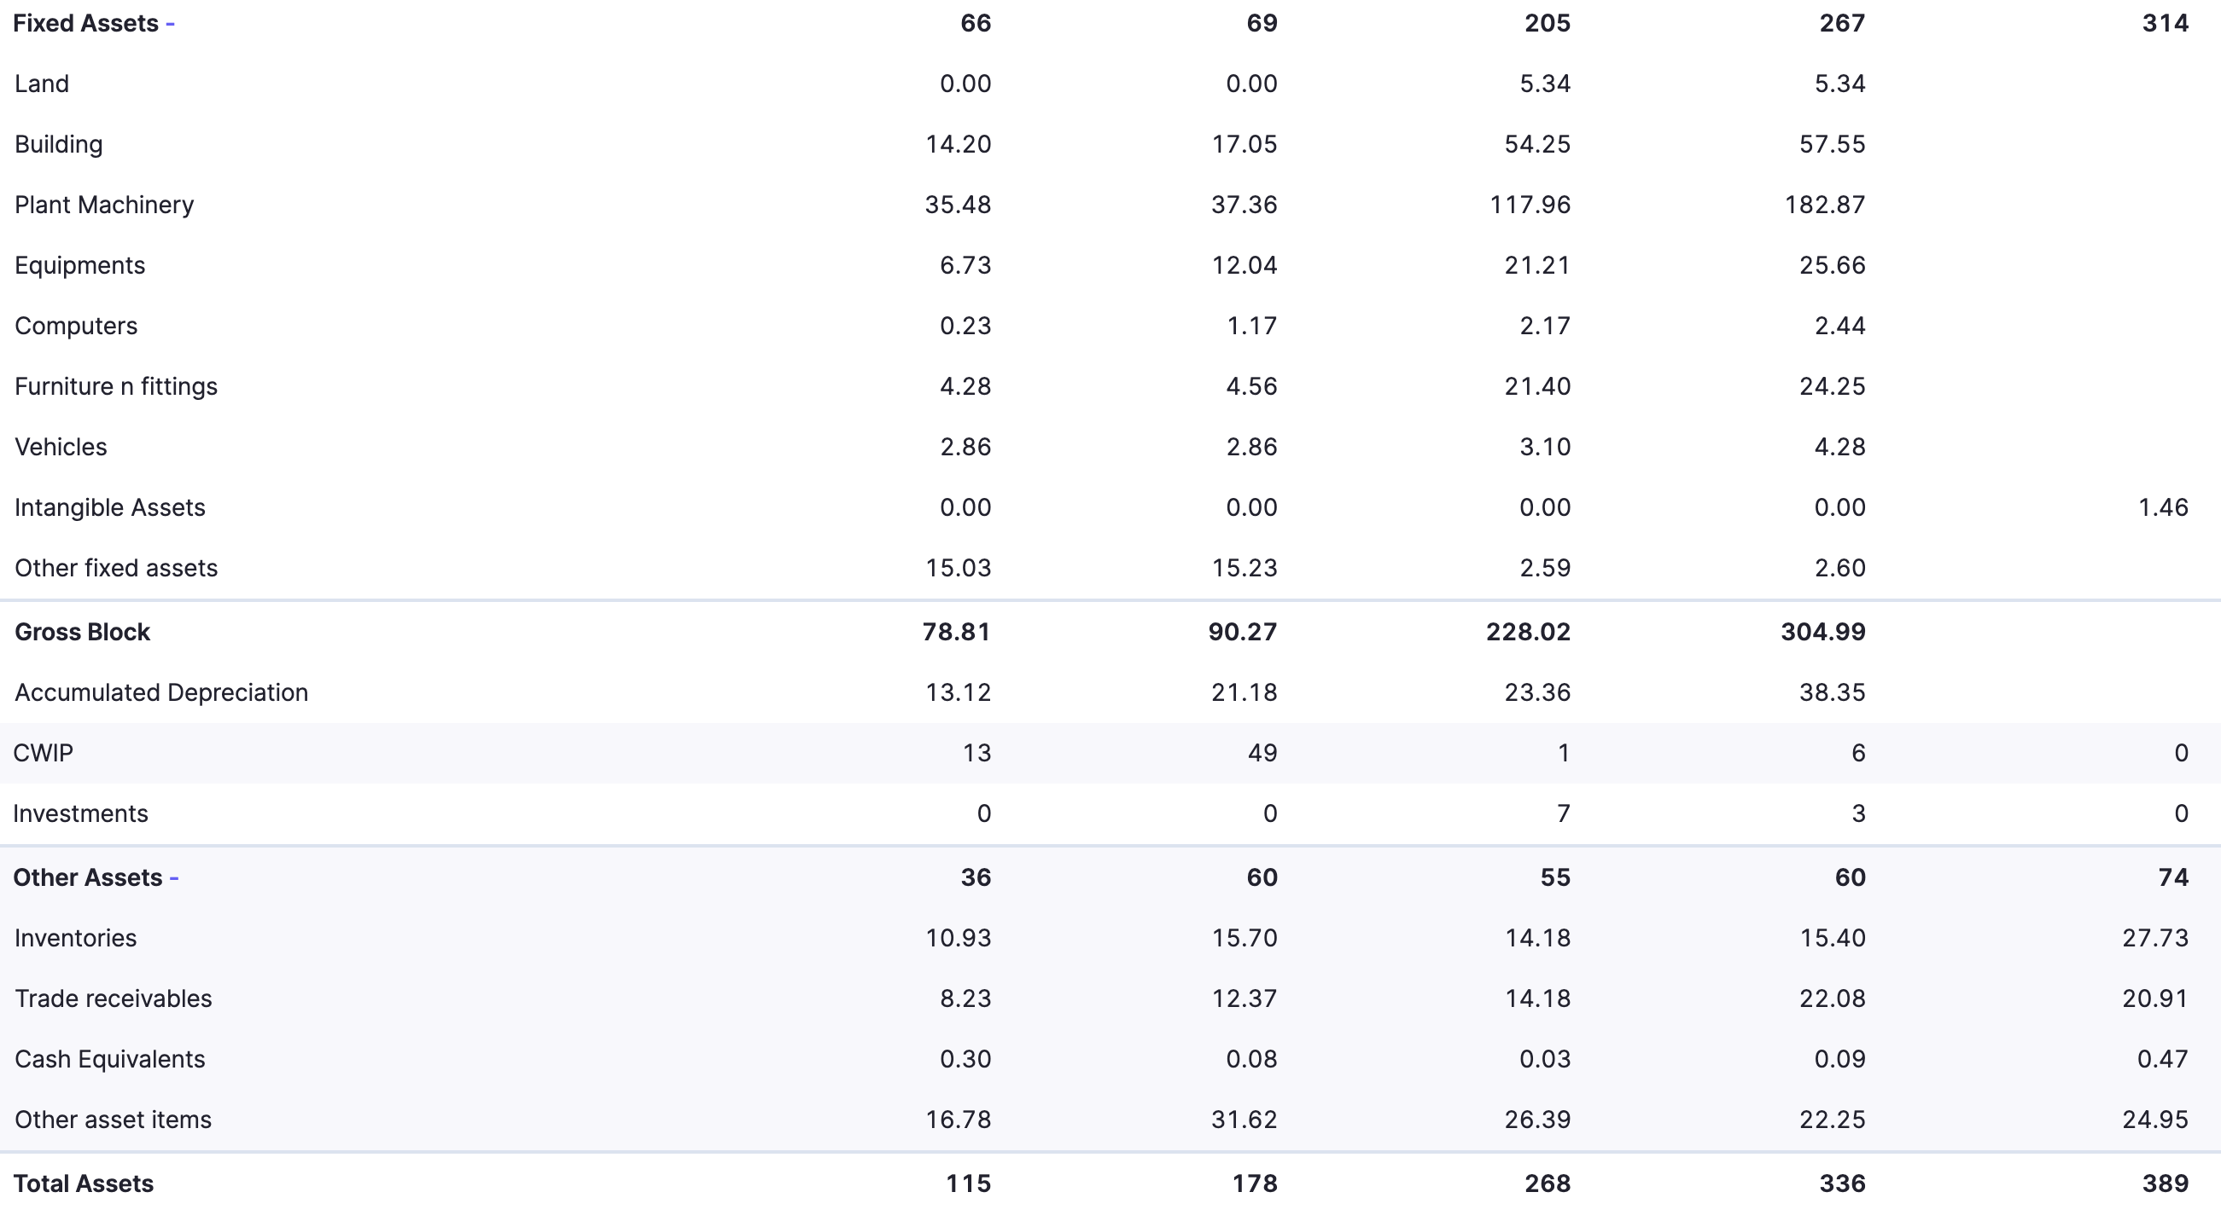

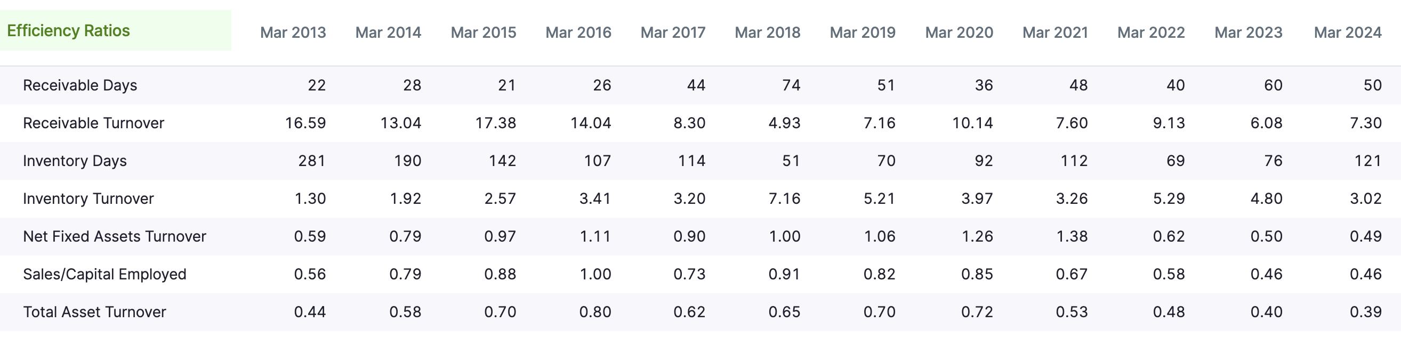

**Depreciation is eating into the Bottom Line:**

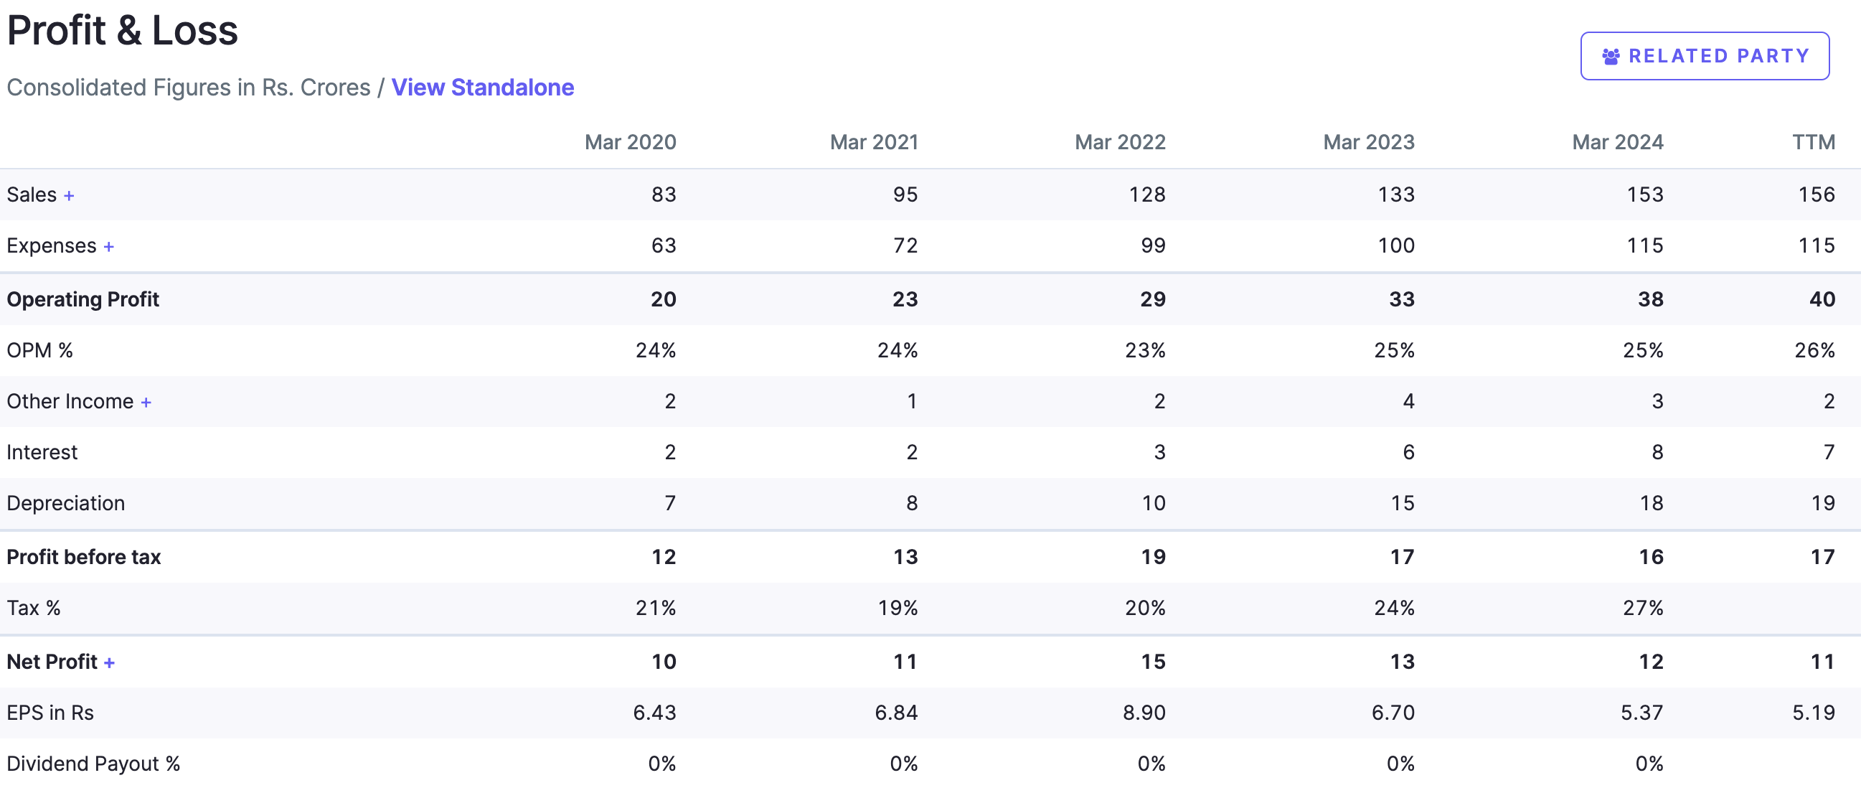

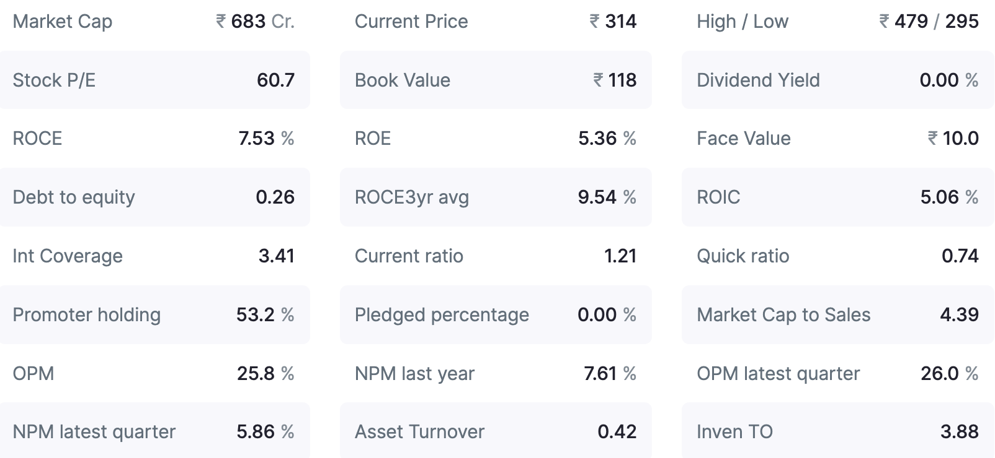

**EU GMP certified companies have no competition from China as Chinese plants are not up for inspection and not certified because of that.**

**As Sajal Kapoor says, “Once company sends an Invite, One should be ready with Suit & Tie to attend”. And the invitation is expected soon.**

**=================================================================Compiled notes from here & there ☺**

**=================================================================**