Ecoboard Industries has two divisons- EcoBuild (around 68% of FY22 revenue) and EcoEnergy (around 32% of FY22 revenue)

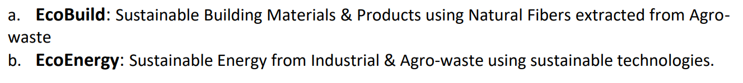



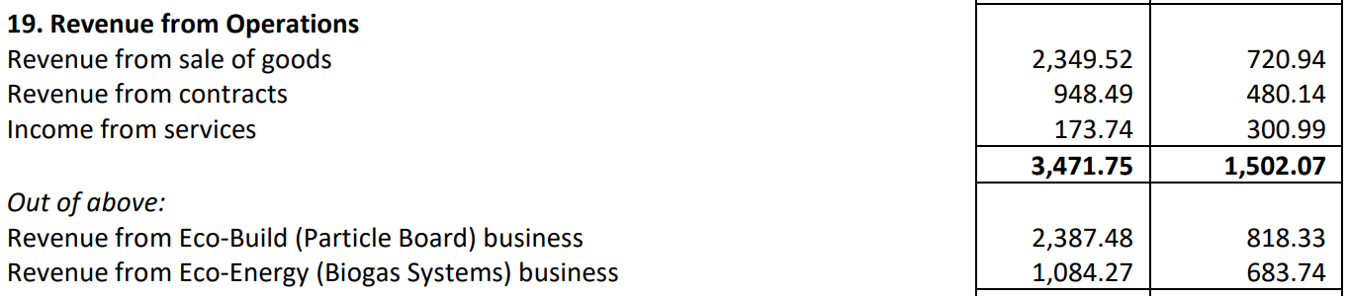

EcoBuild division makes laminated particle boards made from agri-residues, mainly sugarcane bagasse. They are 100% wood free and all-purpose boards. They are meant to be an alternative to conventional wood-based particle boards, plywood and other panel products.

Bagasse (around 39%) and chemicals (around 22%) constitute majority of RM cost

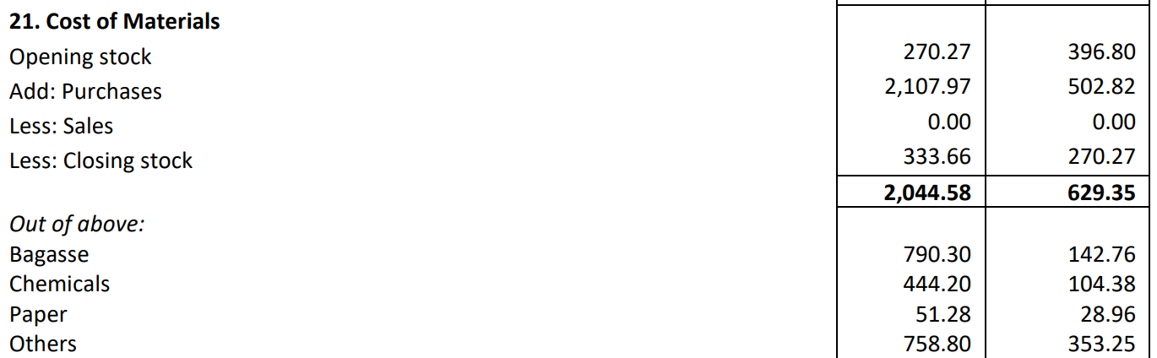

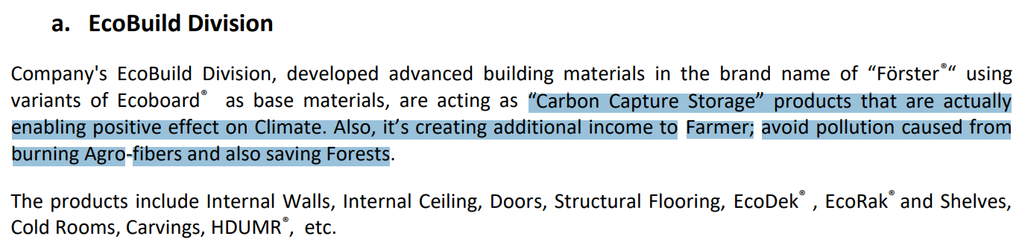

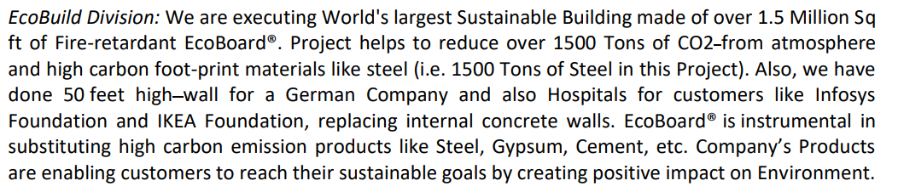

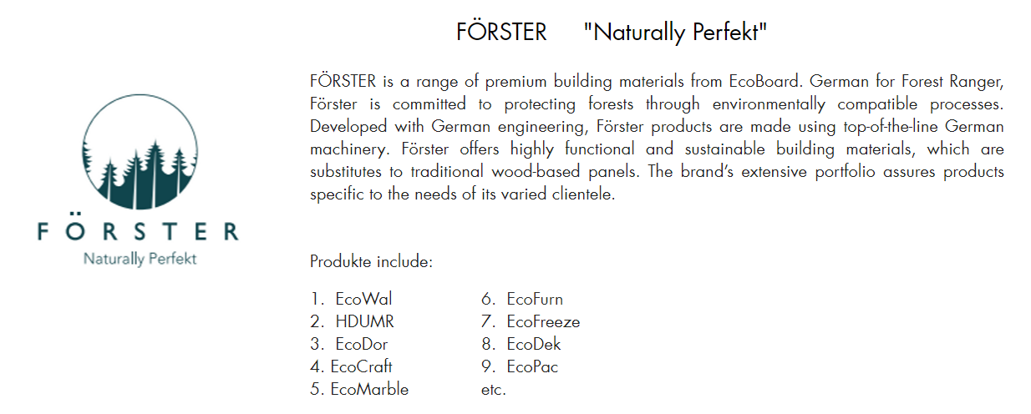

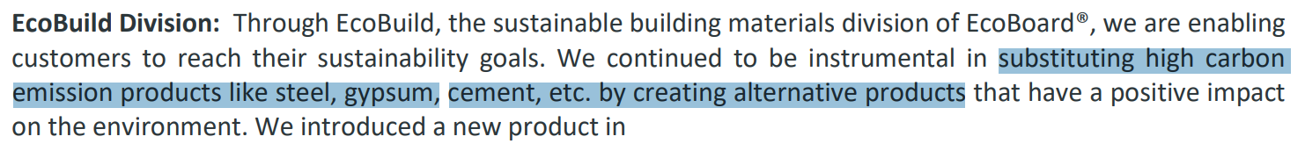

They procure agro fibres and process them to make these boards

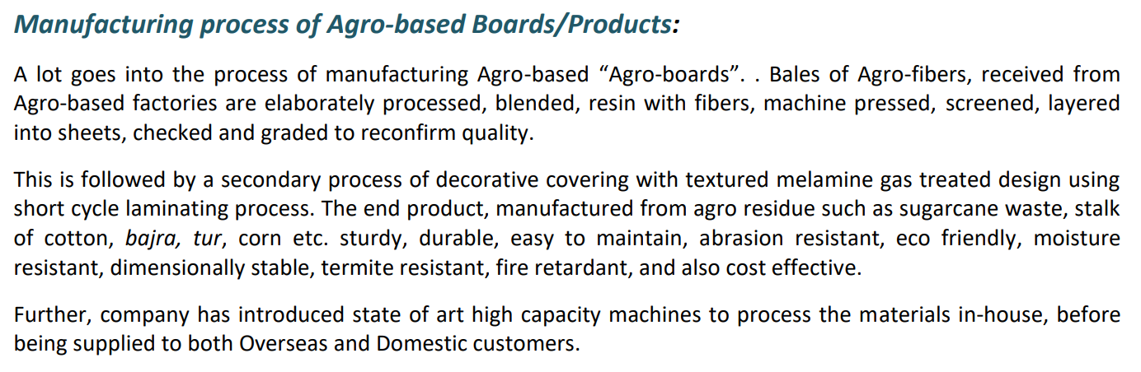

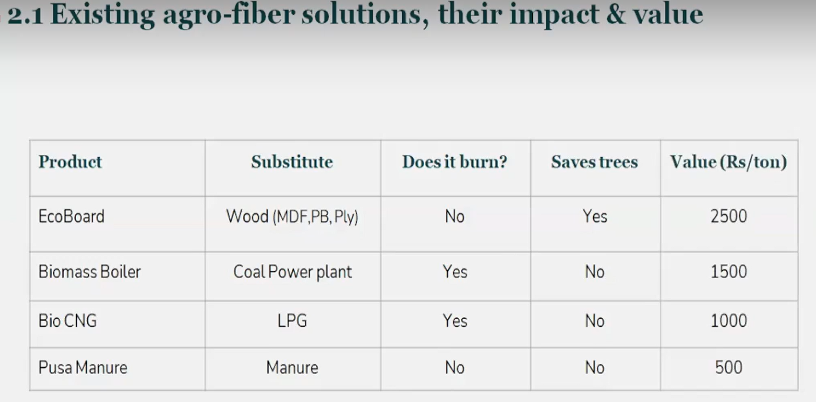

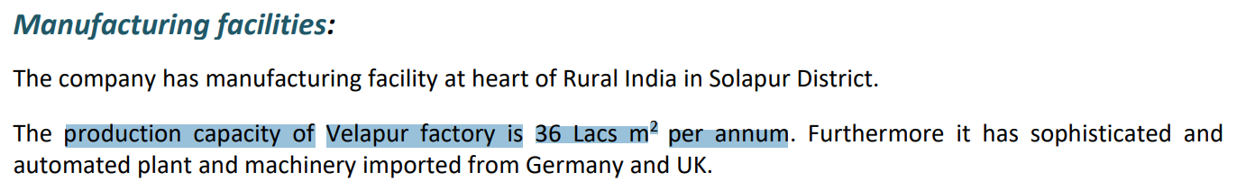

Their products were used for making the set of KGF 2

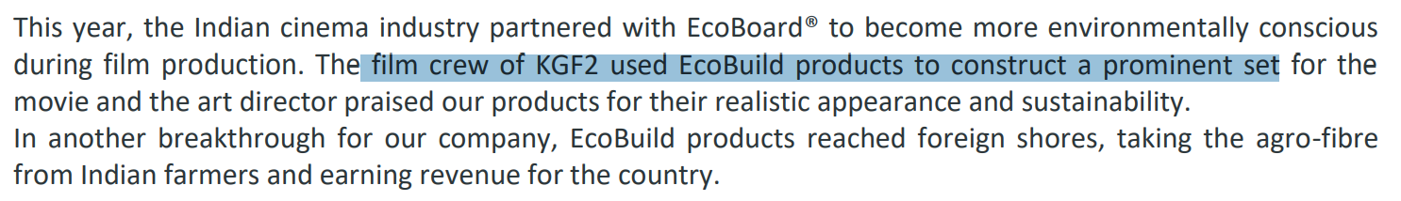



It is also used by Formula Manipal



Seems like Ecoboard products are also used in IKEA furnitures



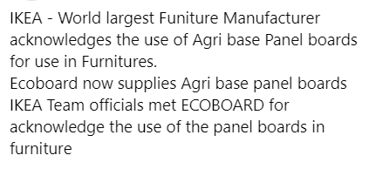

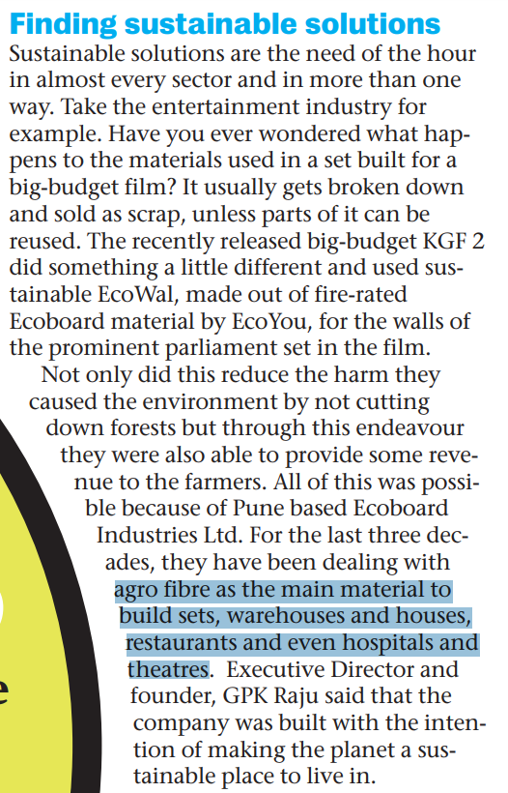

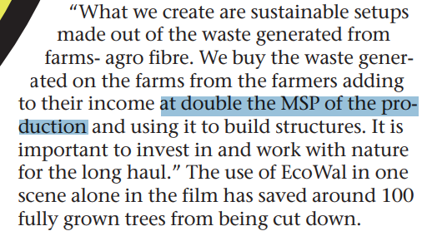

They also export these products

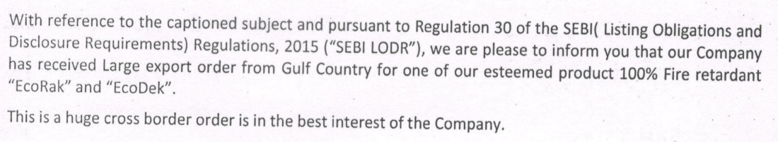

EcoEnergy is into waste water treatment, to convert it into energy (fuel)

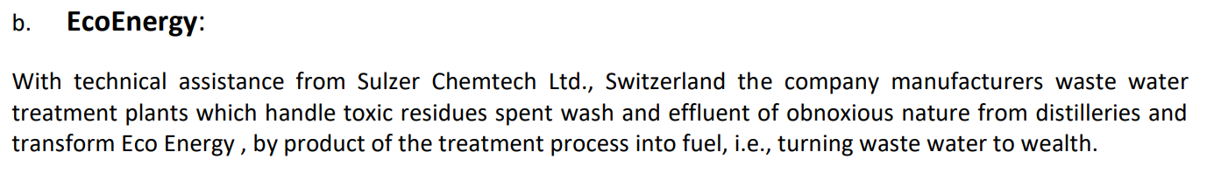



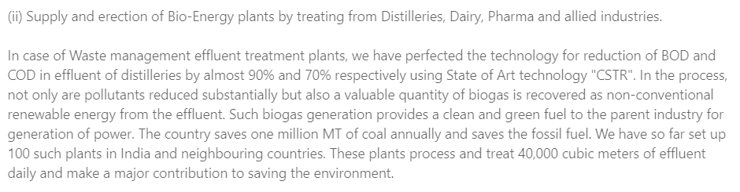

They have done restructuring, including sale of unused land and debt reduction

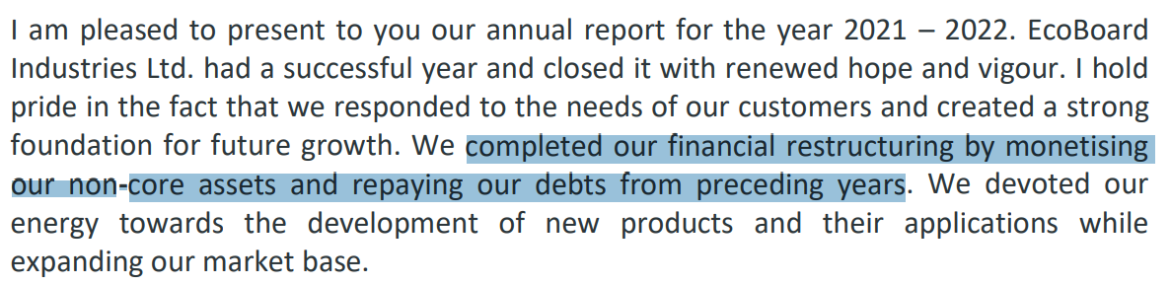

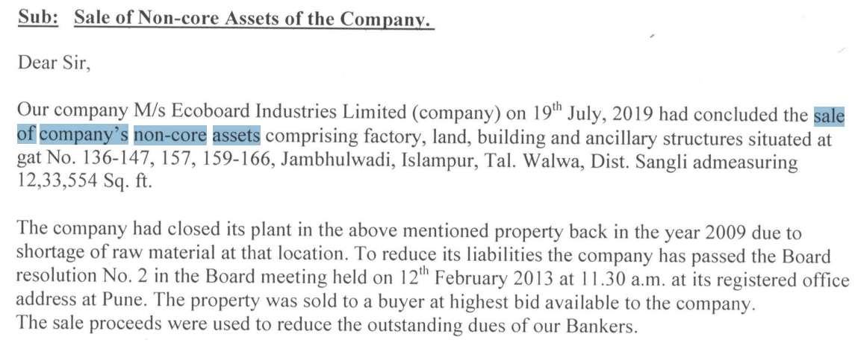

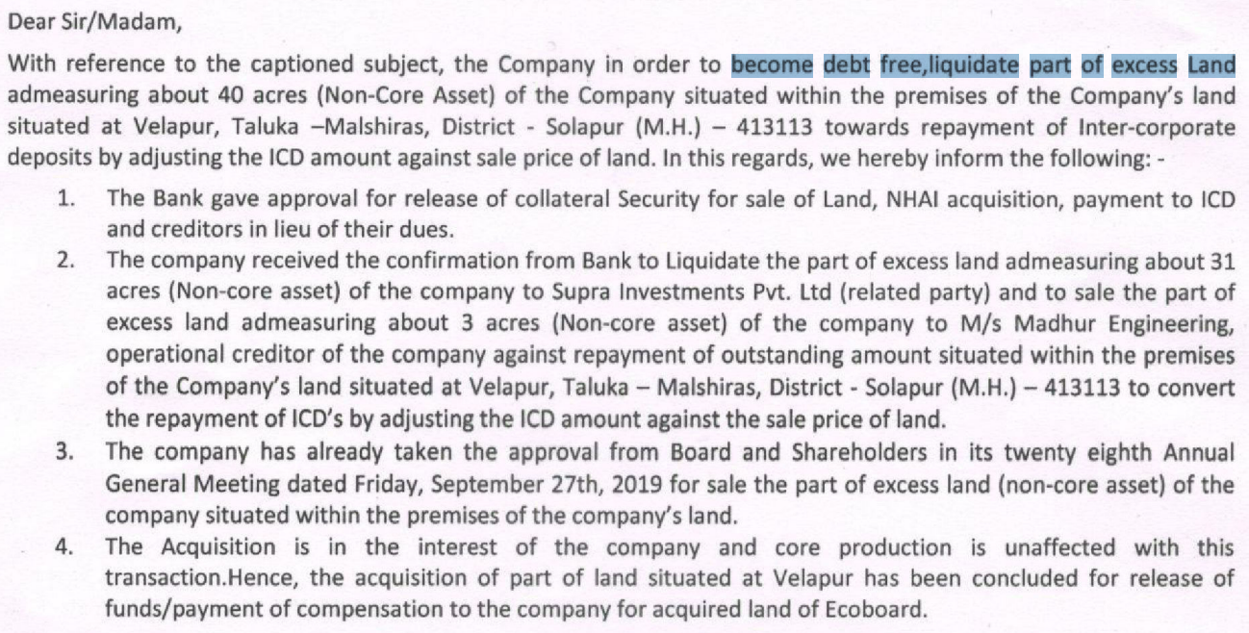

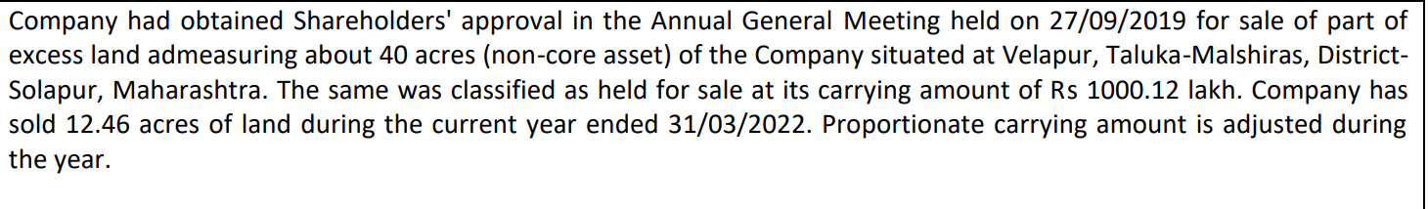



One can see Rs 2.63 Cr CWIP ‘stuck’ on balance sheet since several years. This relates to 8x4 lamination line which was paused due to Covid, but is expected to resume soon

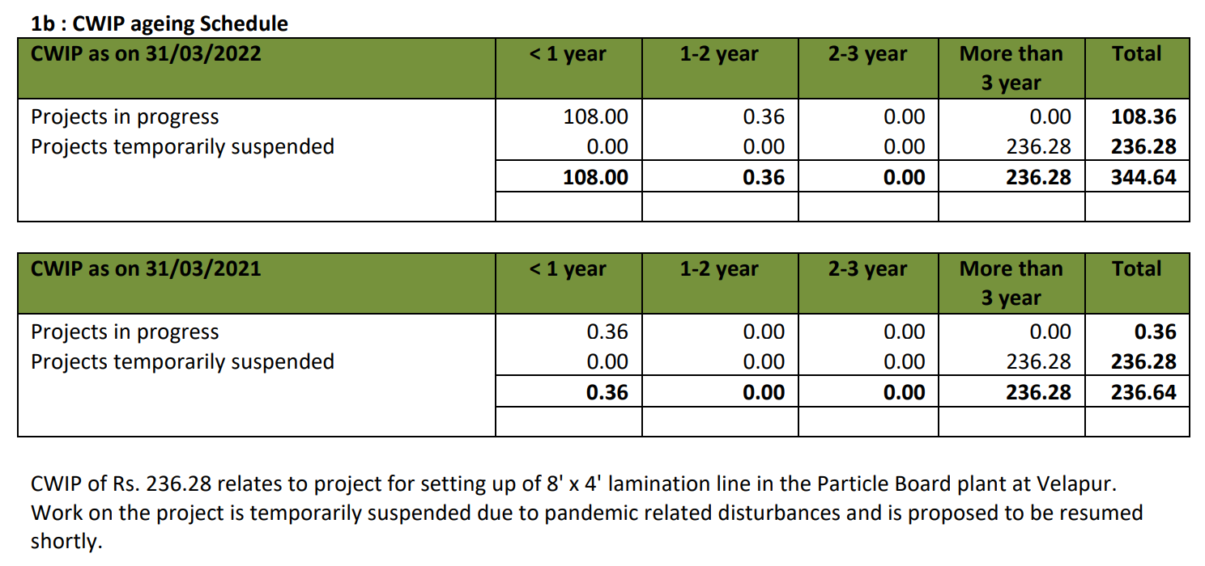

Directors had also extended interest-free loans in the past when company was loss-making

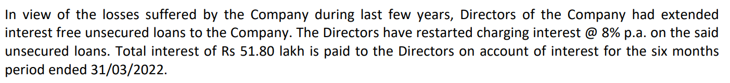

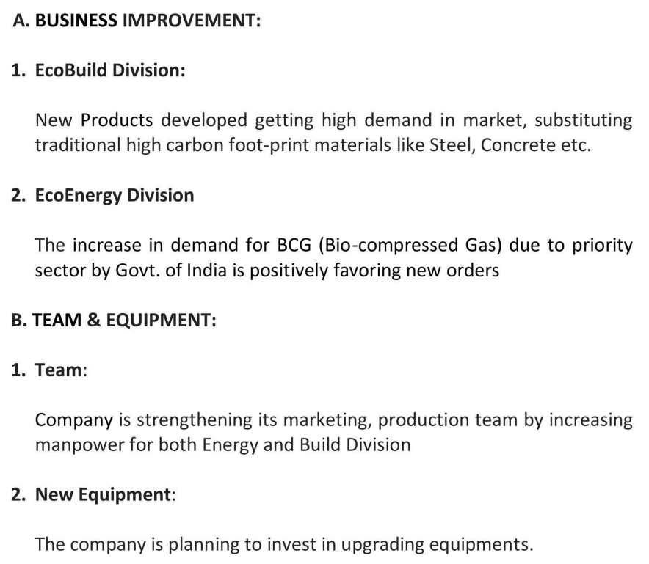

AGM 2022 recording: <https://www.youtube.com/watch?v=bkxjeyFF804>

AGM 2021 recording (which has a very informative presentation as well as good Q&A): <https://www.ecoboard.in/investor-relations>

<https://ecoyou.in/>

<https://www.youtube.com/watch?v=fI8UpeQs76o>

<https://www.youtube.com/watch?v=x4rfhUfzl4Q>

Disclaimer: Any content shared should not be construed as investment advice. Any content is not a buy/sell/hold recommendation. The writer is not a SEBI registered investment advisor. Please consult your financial advisor before taking any decision. The author shall not be liable for any losses incurred by readers while acting on any analysis. The author may or may not have holdings in any companies mentioned and the content might be biased. The content shared is for educational purposes only.

The writer can be reached at malhar.manek@gmail.com