Tilaknagar Industries is into manufacturing and selling of Indian-made foreign liquor (IMFL).

The company has a strong and diverse portfolio of 15 brands in various liquor categories including **brandy (Mansion House Brandy, Courrier Napoleon Brandy- Red and Courrier Napoleon Brandy- Green), whiskey (Mansion House Whisky and Senate Royale Whisky)**, **white spirits (Blue Lagoon Gin) and rum (Madira Rum).**

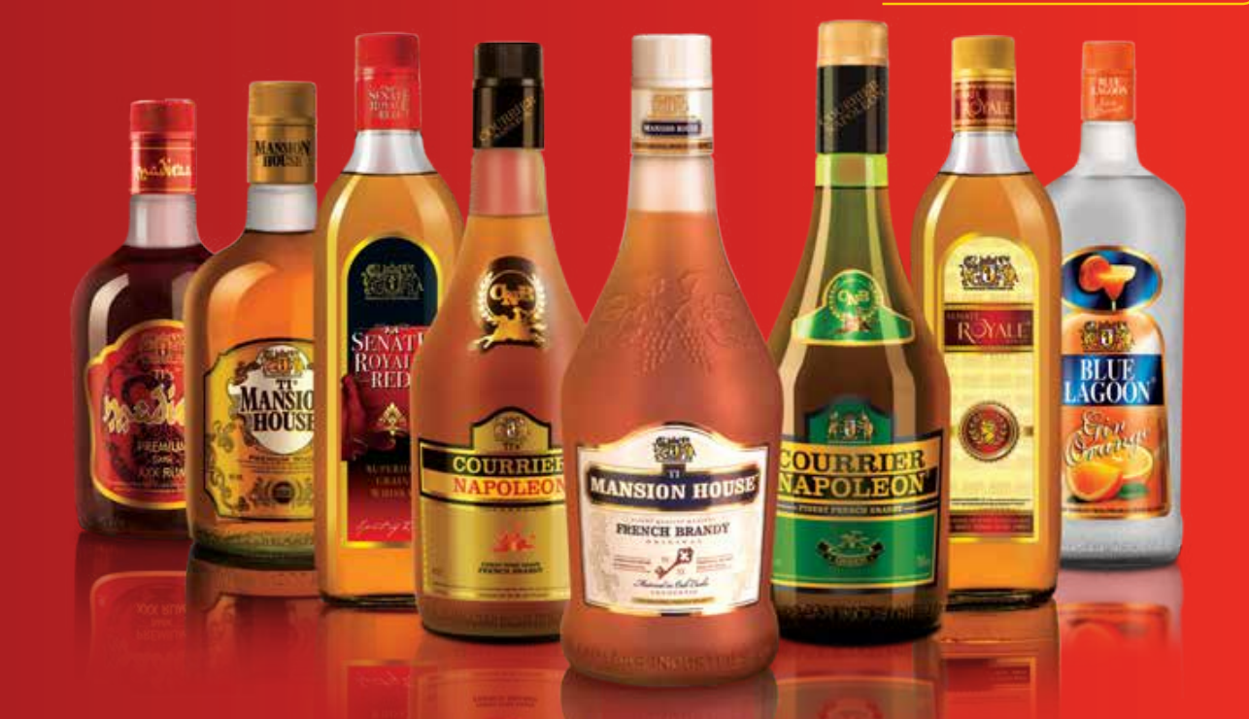

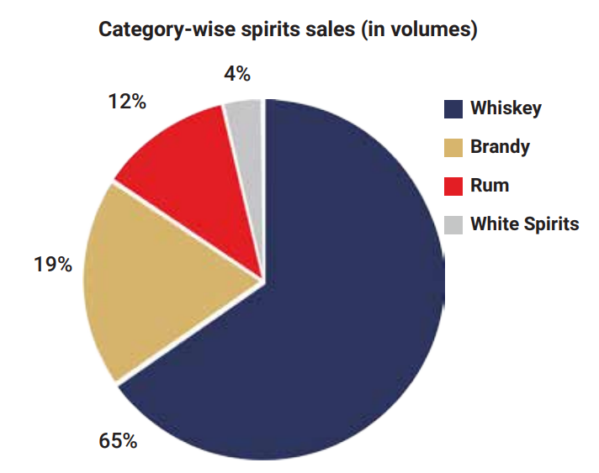

**Their** premium brandy brand, Mansion House is the market leader in the premium brandy segment and sold 4.4 million cases in FY21. They also have another brand, Courrier Napoleon, which sold 0.6 million cases in FY21.

They have 16 manufacturing units spread across 11 states- 4 are company-owned (1 directly and 3 through subsidiaries) and 12 are contract manufacturing (3 leased and 9 tie-ups).

Key thesis here is turnaround story.

They have done large-scale debt reduction

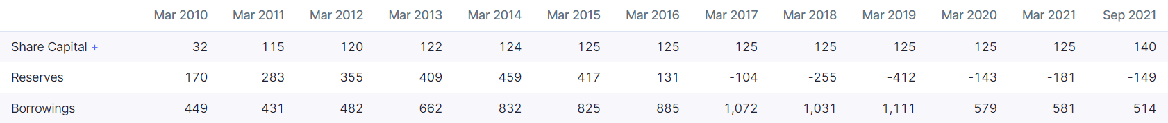



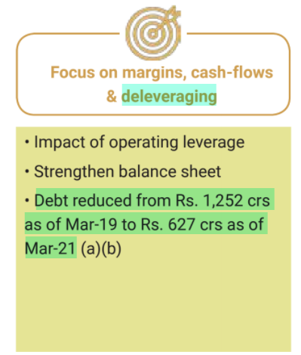

This has further decreased to Rs 488 Cr as of Dec 2021 (net debt as of Dec 2021 is even lower at Rs 383 Cr)



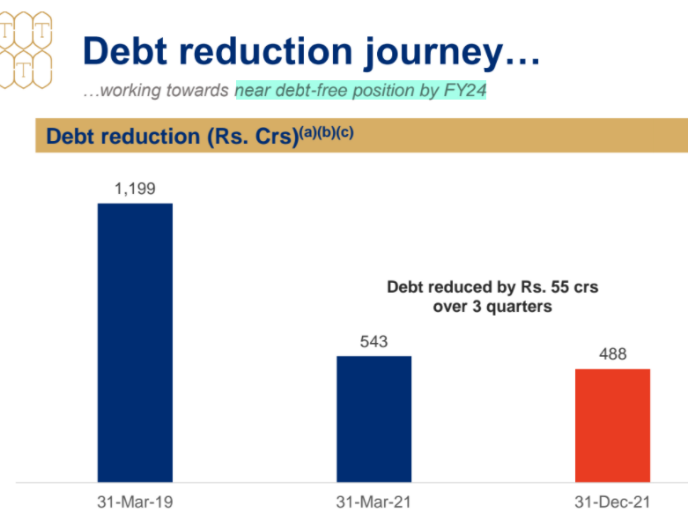

Initially, this was done through restructuring, one-time settlement with lenders and conversion of debt into equity shares.





But now, further debt repayment is being done through cash flows



This has led to sharp decrease in finance costs:

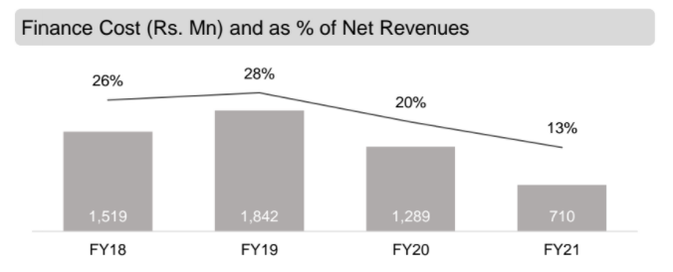

They are aiming to be almost debt-free by FY24

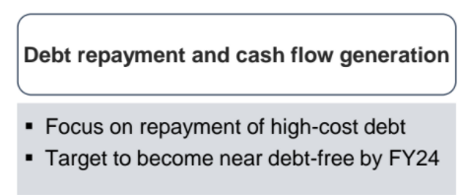

They made their first profit after many quarters in Q1 FY22

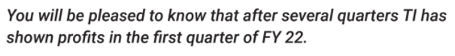

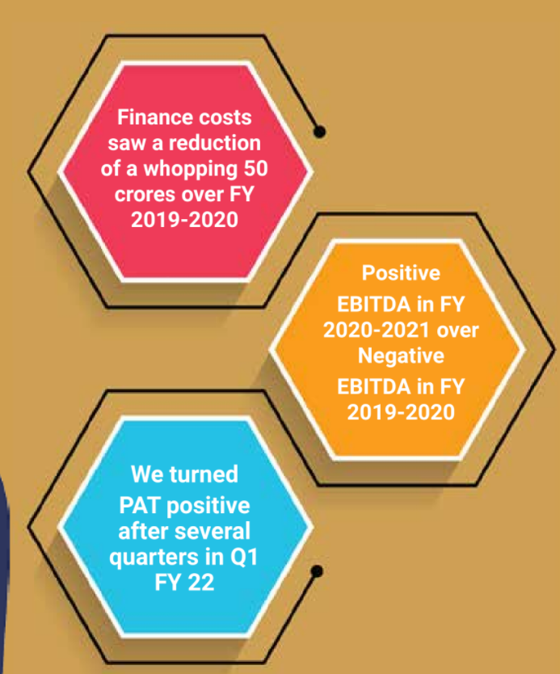

Importantly, this was without significant other income and has been sustained through Q2 and Q3 as well

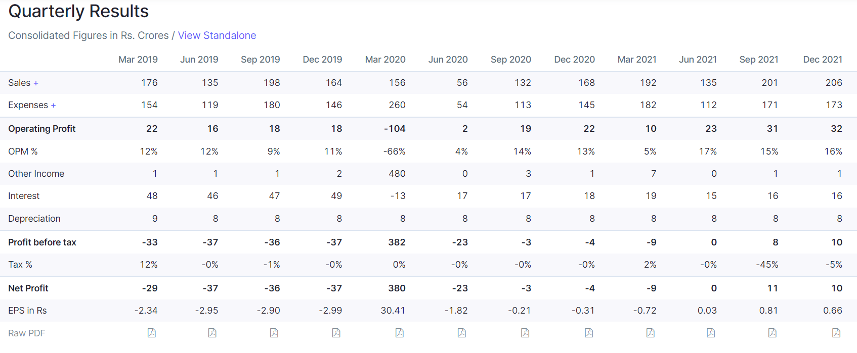



Management commentary regarding intent to turnaround is very positive

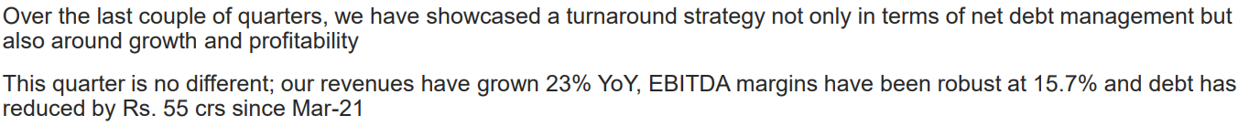

They have signed 10-year agreement for bottling of Pernod Ricard India’s products in their facility

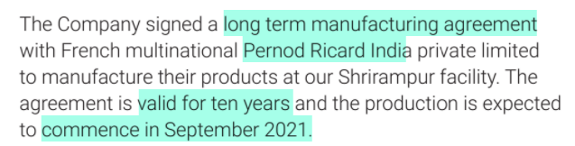

Interestingly, Pernod Ricard is the maker of famous brands like Imperial Blue, Royal Stag and Blenders Pride.

Importantly, this helps their plant operate at a good utilisation level



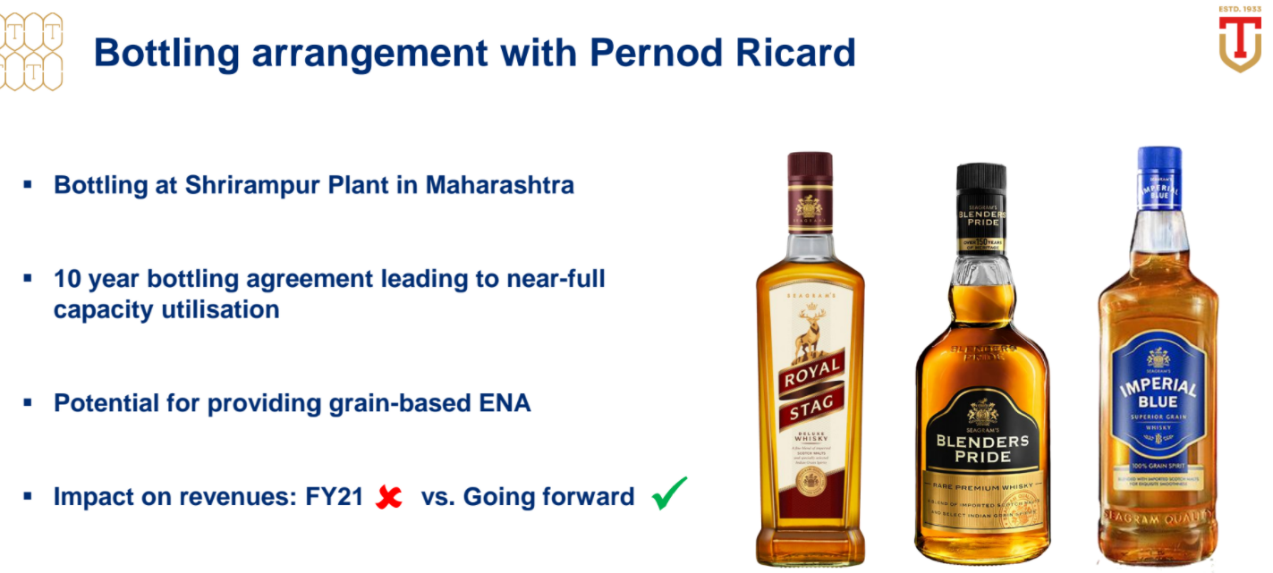

They have announced commencement of production of the Pernod Ricard brands

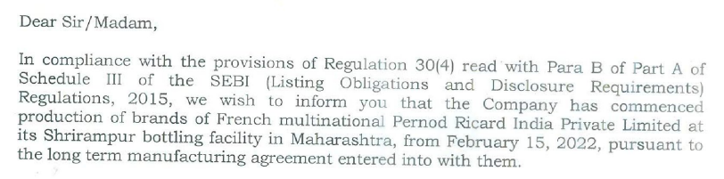

They are also doing new product launches







They launched cherry, peach and orange flavoured premium brandy

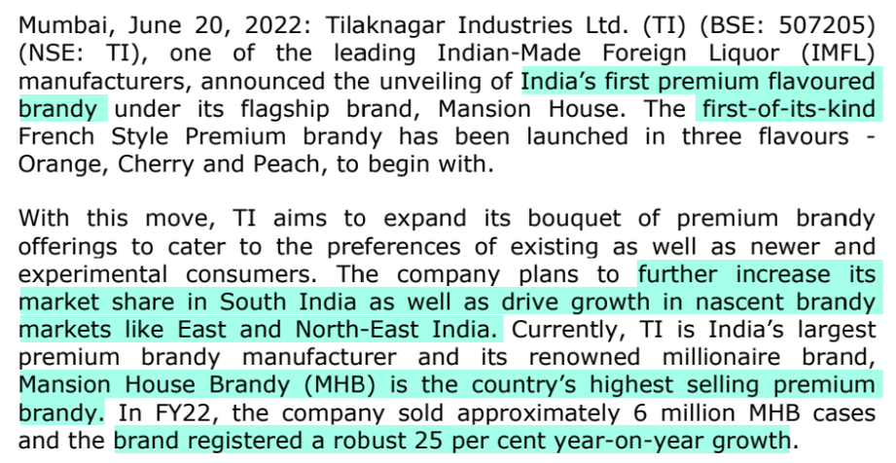

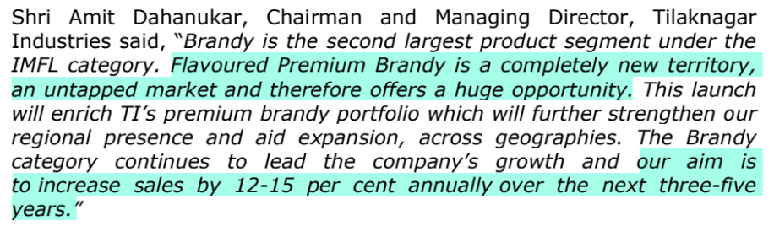

They are upgrading their plant

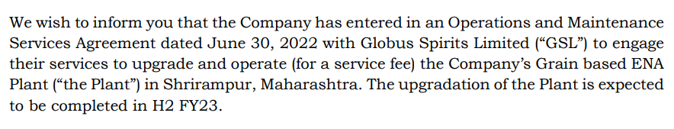

Globus Spirits will be paid on a % of EBITDA basis

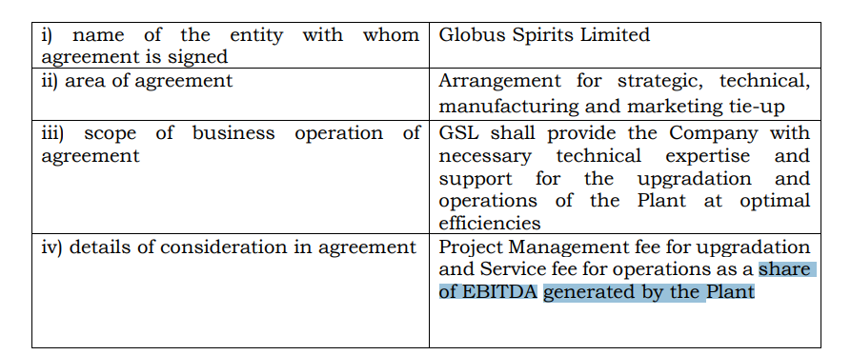

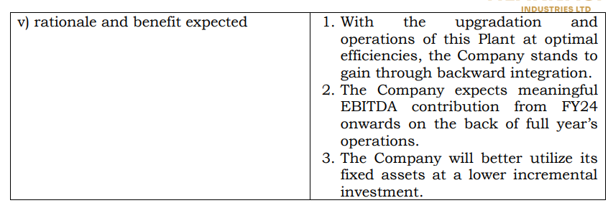

There is also a premiumisation trend with improving realisations

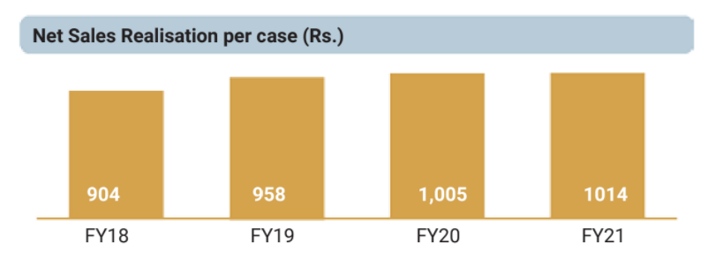

Recent decrease in promoter holding is not because of share sales by promoters, but because of dilution due to preferential allotment done to Lotus Family Trust (Madhu Kela).

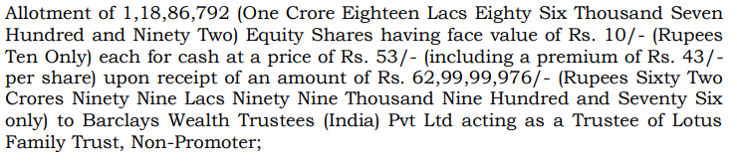

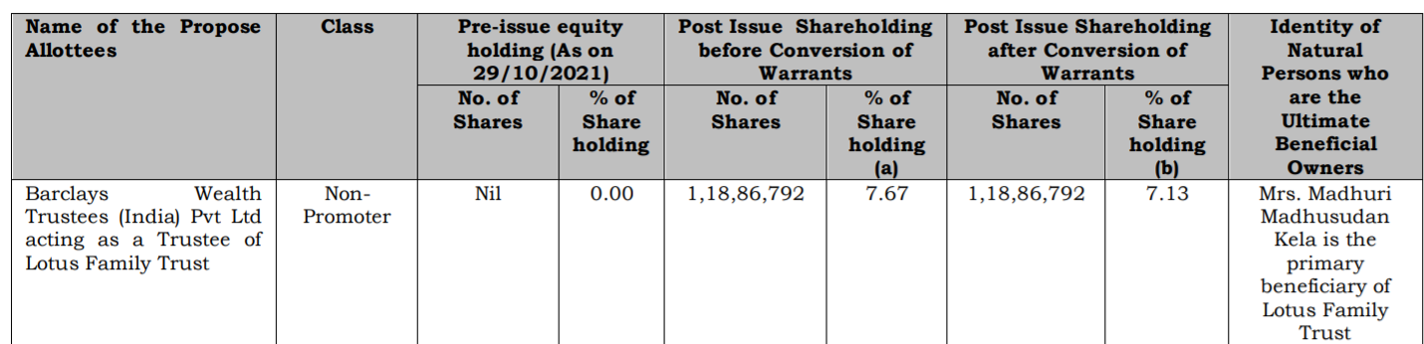

There is also a hint towards improving corporate governance, since they want to actively resolve the multiple auditor qualifications.

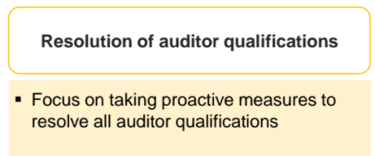

Disclaimer: All analysis shared is for private circulation only. Any analysis shared should not be construed as investment advice. Any analysis is not a buy/sell/hold recommendation. I am not a SEBI registered investment advisor. Please consult your financial advisor before acting on any analysis. The author shall not be liable for any losses incurred by readers while acting on any analysis. The author may have holdings (and hence a vested interest) in any companies mentioned and the analysis may be biased. The content and analysis shared are for educational purposes only.

The writer can be reached at malhar.manek@gmail.com