***Rishabh Instruments Limited***

***Company Overview:***

* Rishabh Instruments Limited, incorporated in 1982, is a leading manufacturer and developer of testing and measuring instruments and industrial control products.
* Its wide array of products includes Shunts, CAM Switches, Digital Panel Meters, Multifunction Meters, Digital Multimeter, Clamp Meters, and more, serving a versatile target market. The company operates in a highly competitive industry. It also provides complete aluminum high-pressure die-casting solutions for customers requiring close tolerance fabrication (such as automotive compressor manufacturers and automation high precision flow meters manufacturers), machining, and finishing of precision components. he company also provides certain manufacturing services which include mold design and manufacturing, EMI/EMC testing services, Electronic Manufacturing Services, and software solutions (e.g., MARC).
* The company has 5 manufacturing units (2 in Nashik, 2 in Poland and China), 270+ dealers across the globe reaching 70+ countries and 187 dealers across India. Products are manufactured in house from scratches I,e, vertically integrated. subsidiary, ESL, focuses on developing software solutions such as MARC, and their capabilities allow to integrate software capabilities in the products.
* B2B business model except for Portable T&M which is sold also on a merchant basis.
* seven foreign Subsidiaries – three in Poland, one in the United Kingdom, one in the United States of America, one in China and one in Cyprus, In 2011, Rishabh Instruments acquired Lumel Alucast, a non-ferrous pressure casting company in Poland, which helped the company establish a strong foot in manufacturing and supply of low-voltage current transformers. List of all subsidiaries is given below:

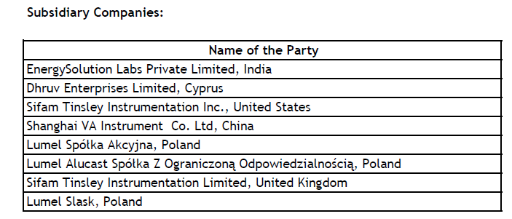

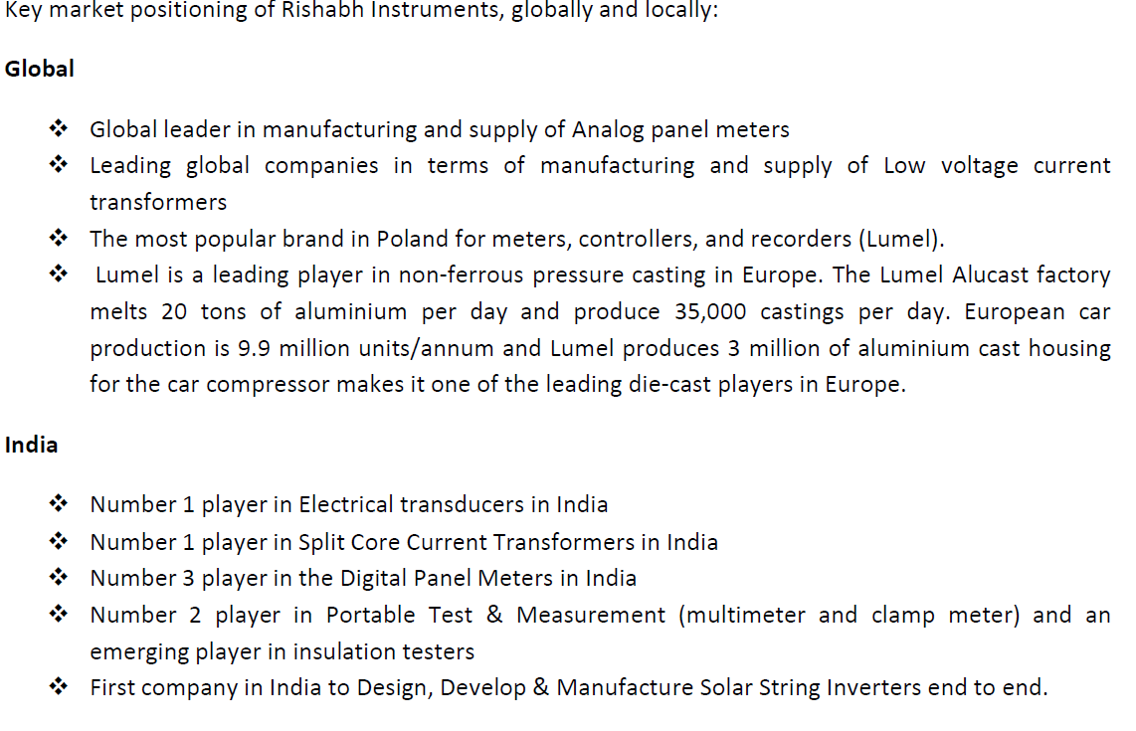

* Revenue distribution geography wise: for FY 23: India: 34%, RoW: 66%. Product wise: for FY 23: Electrical Automation: 9.92%, metering, control, and protection devices: 42.62%, portable test and measuring instruments: 7.18%, solar string inverters: .67%, Aluminium high pressure die-casting:39.62%

***Product Segmentation****:*

* 4 segments: (a) Industrial Panel devices: i. electrical automation devices; & ii. metering, control, and protection devices

(b) portable test and measuring instruments; and

(c) solar string inverters.

(d) Aluminium high pressure die-casting

For further information, please refer to Industry Report.pdf

***Industry and product Analysis:***

1. **Electrical automation devices:**

* The global electrical automation market was valued at USD 147.5 billion in 2022 and is expected to grow at CAGR of 7.8% to reach USD 215.1billion by 2027. The Indian Electrical Automation market was valued at USD 6367.8 million in 2022 and is forecasted to grow at **a CAGR of 9% to reach USD 9802.6 million by 2027**

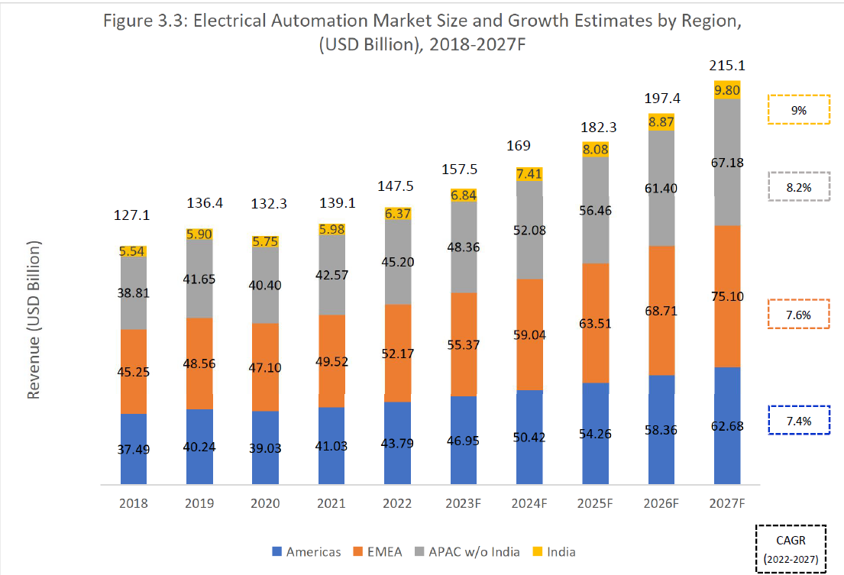

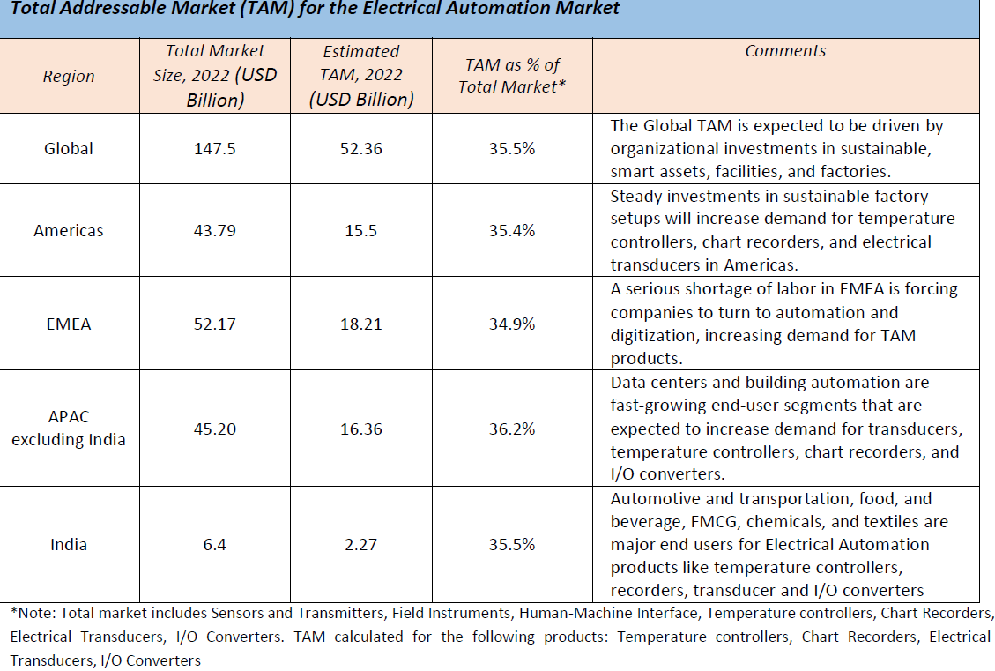

* largest end user of electrical automation is Automotive and Transportation, followed by FMCG. Steel, Consumer electronics, and Pharmaceuticals also have considerable demand Hybrid industry revenue (IoT, Machine interface etc) is expected to increase, driven by the adoption of remote monitoring solutions, directly driving the demand for electrical automation products. In India, **Automotive and transportation, food and beverage, FMCG, chemicals, and textiles are major end user. The push for localized manufacturing, development of IT infrastructure, and home automation systems can be seen as driving factors for electrical automation components**.
* Company currently manufacture and provide I/O converters, transducer and transmitters, EMS, paperless recorder, dataloggers, and temperature and humidity recorder among others. These find application in power generation, transmission and distribution, renewable energy, FMCG, pharmaceutical, cement, steel, oil & gas and railways sectors. They are in the process of expanding our electrical automation product portfolio to add communication protocol converters, high end recorders, multifunction transducer, pollution transducer, and humidity with temperature transmitter with wireless communication and planning to introduce certain new products in the electrical automation segment which include neutron detectors and temperature monitors.
* significant customers for their automation products category include ABB India Limited, Elko Vertriebs GmbH Seit 1988, Sang Chai Meter Co. Ltd, Gama Electrical Trading Co (LLC,) Pt.Amptron Instrumindo and Siemens Limited.
* Key industry players: Yokogawa, Chino, Omron, Phoenix, Masibus, Honeywell, Allen Bradley, Gefran, Waree, Baumer, Radix, Siemens, ABB, Schneider Electric, Selec, Delta, Emerson, Multispan & Rishabh. **Globally**, the electrical automation component market has been dominated by international players. The top 5 players occupy 27.5% of the global market share. The top companies have retained their market positioning by developing a strong product portfolio based on digitization. They also have a global presence and strong brand equity in this product segment that makes competition difficult.

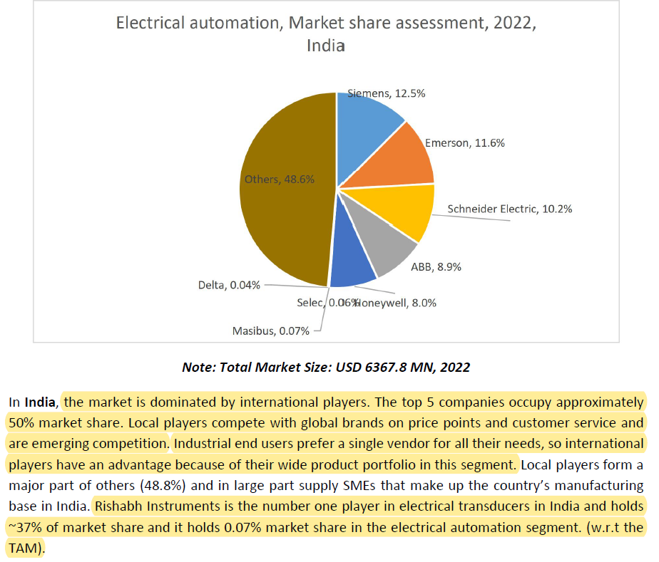

* **Global drivers:** Rising adoption of Industrial Internet of Things solutions, Rising integration of OT-IT shop floor data to business and enterprise systems because of COVID-19. **Restraints:** *Lack of a clear digitization roadmap, Unclear ROI from digital technologies*
* **Indian Drivers:** Make in India campaign, initiative to lower factory cost leading to increase demand in automation equipments. **Restraints:** Higher initial investment. **Companies like Rishabh Instruments have already incurred the CAPEX and hence are ahead of the curve*.***

1. **Metering, Control & Protection Device:**

* The Metering, Control and Protection Devices, such as Analog/Digital Panel Meters, Multi-Function Meters, Current Transformers, APFC relays, Protection relays etc. are used in centralized system to measure, control, record, analyze and protect the electrical system
* The components are used in applications such as electrical distribution, industrial panels, and process control, and their end users include residential buildings, commercial buildings, industrial buildings, and other industries such as Railways, Defense, Steel & Cement, Oil & Gas, and Utilities. The global Metering, Control and Protection Devices market is estimated at USD 34.08 billion in 2022 is expected to witness a 4.8% CAGR to reach USD 43.04 billion by 2027. The Indian Metering, Control and Protection Devices market was valued at USD 660.8 million in 2022 and is forecasted to grow at a CAGR of 5.5% to reach USD 864.5 million by 2027. Expansion of power generation and distribution facilities, and construction of new factories would contribute to major revenues in the future. The main end users of the Metering, Control and Protection Devices are broadly categorized as residential, commercial, industrial, and utilities. The industrial segment accounted for about 60% of market in 2022.

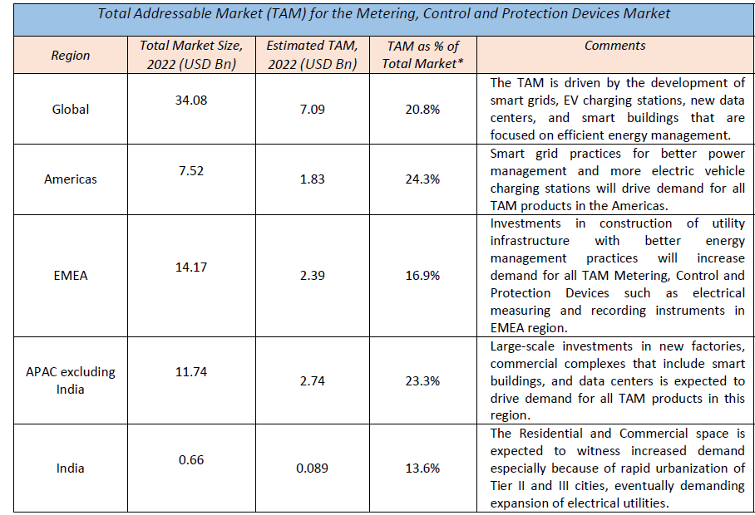

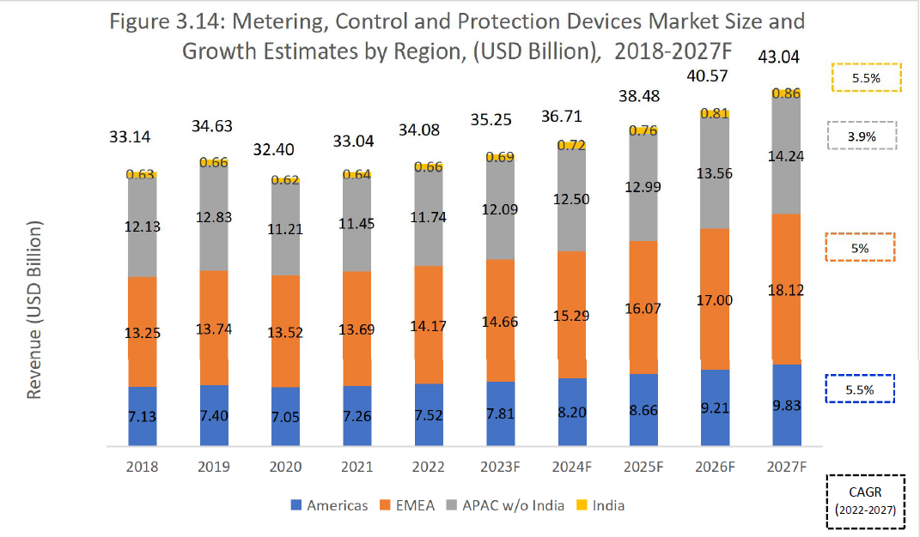

* **Key players**: Global companies Schneider, Satec, and Janizta, and homegrown companies Rishabh instruments, Elmeasure, and Selec are among the leading players in this segment. **Globally**, the Metering, Control and Protection Devices market is highly fragmented. The players can be classified as Tier 1, Tier 2 and Tier 3 companies. Rishabh instruments is a global leader in Analog Panel meters and is among the leading global companies in low voltage current transformers. Lumel is the most popular brand for meters, controllers, and recorders in Poland.

In India, the market is consolidating at the top and is dominated by a handful of players. Schneider

Electric, with its inorganic growth strategy, is dominating the Indian Metering, Control and Protection Devices market following the completion of its acquisition of L&T‘s electrical business unit. Schneider Electric has the largest market share in India, with its wide product portfolio. Siemens is another leading company with ~15% market share. Rishabh Instruments is one of the top three players in digital panel meters in India and it holds 8.01% market share within digital panel meters

* **Drivers : Global:** Building energy management systems (BEMS) and home energy management systems (HEMS) creates opportunities for new devices with monitoring and analytics capabilities.

**India:** Government’s focus on infrastructure and rural electrification, Renewable Energy & metro projects.

* **Restrains: Global**: **Price volatility due to constrained availability of raw materials and limited skilled labor**- Prices of copper, steel, and aluminium—key raw materials for the production of Metering, Control and Protection Devices —have been on the rise since 2020, with copper and steel reaching their highest prices to date in 2021. This trend may put cost pressures on market participants and affect the construction industry, which also requires these materials.
* **India: Increasing pricing pressures due to high competition:** The market is very competitive, especially for volume-driven products, making it difficult for large MNCs to sustain their market share. Factors inhibiting the market from realizing its true potential are fluctuating raw material prices, imports from other Asian nations, and the pressure on companies to reduce prices and sustain their business.

1. **Portable Test & Measurement Instruments:**

* They used to test and measure the various electrical parameters, e.g., voltage, current, power, etc. onsite. Portable Test & Measurement (T&M) equipment play a central role in enabling digital transformation, IoT, Industry 4.0.
* The demand for Portable Test and Measurement equipment in India stems from the automotive industrial (process and discrete), defense, lab (research and educational), telecommunications, and consumer electronics industries. In this segment, where both Indian and Chinese players limit themselves to low-end maintenance and repair solutions, Rishabh has extended its offerings to professional, industrial TMI products capable of serving needs in modern laboratories and even aerospace.

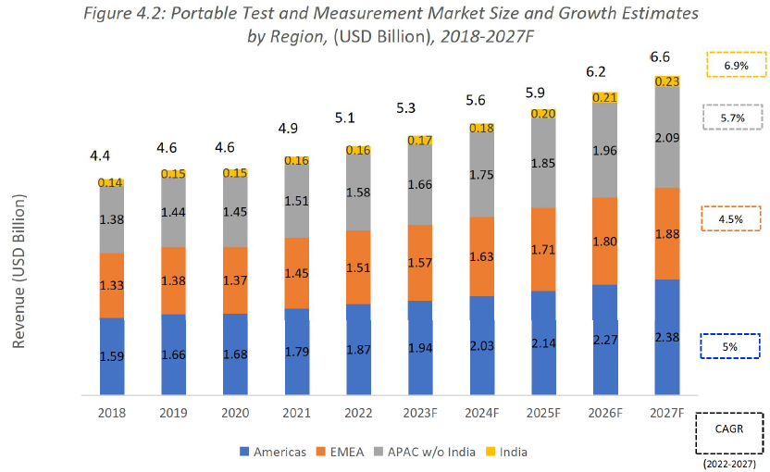

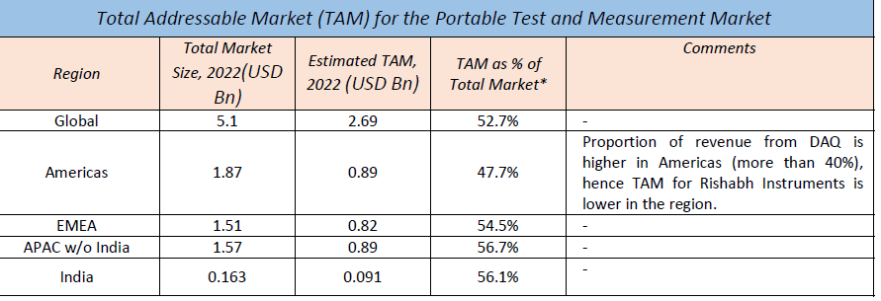

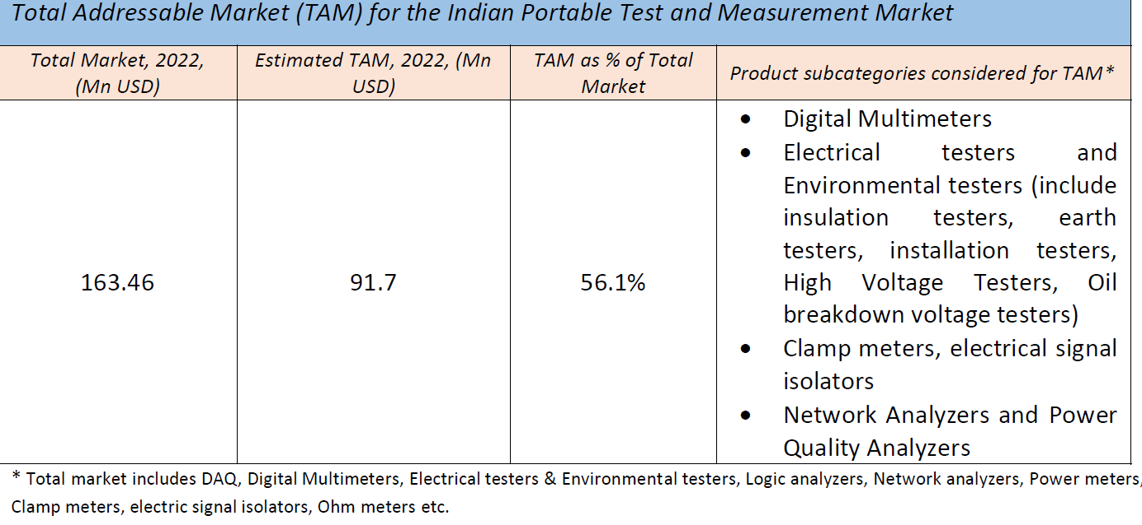

* **Key Players:** Fluke, Kyoritsu,Megger, Hioki, Agilent, Yokogawa, Sonel,Metrel, Meco Instruments,Motwane,Waco, Ideal Industries & Rishabh.

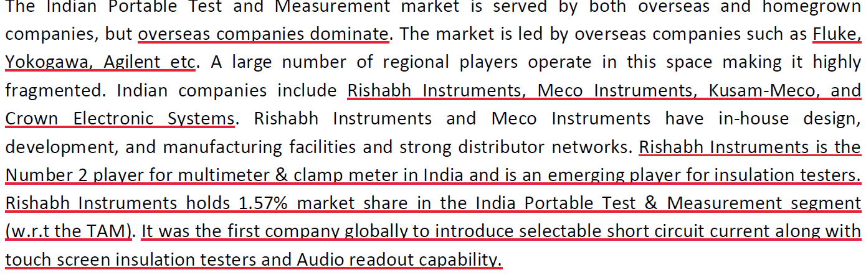

* **Drivers:**

**Global: i.Power management applications**: The new technologies consume more power, increasing the importance of power management. For the portable T&M market, this will translate into higher demand for power analyzers, RF test equipment for power amplifiers, electrical testers, and DMMs—especially for the automotive, A&D, communication, power, consumer electronics, and semiconductor industries and data centers

**ii**. **Growth in Electronics Content in Automotive:** Growth in vehicle diagnostics, infotainment, and the development of autonomous vehicles, electric vehicles (EVs) and connected cars spur the adoption of electronics in the automotive industry. The increase in electronics content will directly drive the need for more portable test and measurement instruments for product development and manufacturing. RF test instruments such as network analyzers, power clamp meters, DMMs, electrical testers, and DAQ will be in demand

**India: Make in India initiative**

* **Restraints: Global:** *Semiconductor supply constraints, High Fragmentation and market maturity hampers growth (*especially in the DAQ, DMM, and electrical and environmental tester segments. The current scope of innovation and product optimization lies in feature enhancements and design ruggedness rather than technology advancements)

**India: i.** The Indian government has several policies to attract investments in manufacturing of electronics, but there are not enough policies and financial incentives to support the growth of the Portable Test and Measurement market. Companies often face higher GST on certain components required. **ii**. Cheaper imports from China.

1. **Solar String Inverters:**

* String inverters can be used for residential and medium-sized commercial solar PV installations. Solar string inverter segment growth is directly proportional to the increase in solar PV installations. String inverters are used in medium-sized

installation across residential, commercial, utility, and industrial segments. String inverters dominate residential, commercial, and industrial installations, which are medium-size and mostly rooftop. The fastest-growing segments are commercial and industrial installations in educational institutions, automotive and transportation, and power generation and distribution. Customers prefer string inverters to central inverters because of their reliability, modular design, ease of installation, and low maintenance

* Risabh’s solar string inverters include power classes from 10 kW to 50 kW and are designed for use in photovoltaic installations connected to the grid. These solar string inverters have integrated data storage, USB connectivity and widescreen LED display. They even have inbuilt GSM modules or remote monitoring with IoT module. These find application in power generation, transmission and distribution and renewable energy sectors
* Market is expected to increase from USD 4.3 billion in 2022 to USD 6.6 billion in 2027 at a CAGR of 9.1%.

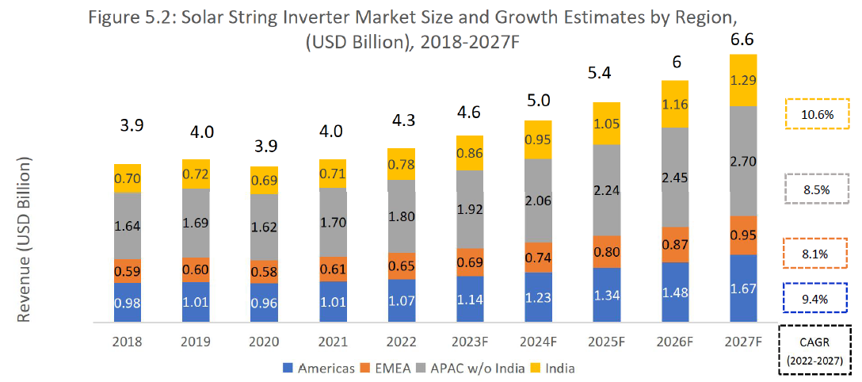

* The Indian solar string inverter market was valued at USD 778.14 million in 2022 and is forecasted to grow at a CAGR of 10.6% to reach USD 1290.6 million in 2027. India is the second-largest market in Asia Pacific occupying more than 25-30% of the Asia pacific market for solar string inverters.
* **Key players:** Huawei, Growatt, SolarEdge, Delta, SMA, Sungrow, Fimer, kSolare, PowerOne, GoodWe, ABB, TMEIC & Rishabh**.** Dominated by Chinese manufacturer both globally and in India also.**A close-up of a text

  Description automatically generated**
* **Drivers: For both India & Global:** *renewable energy targets, Falling renewable energy installation costs*

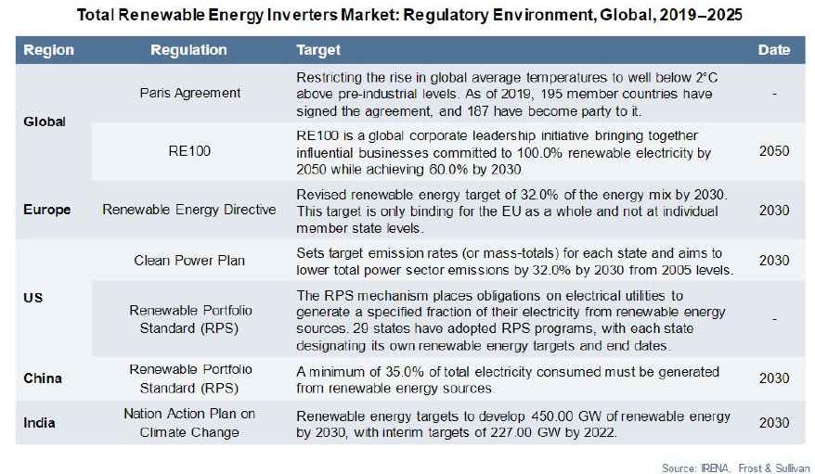

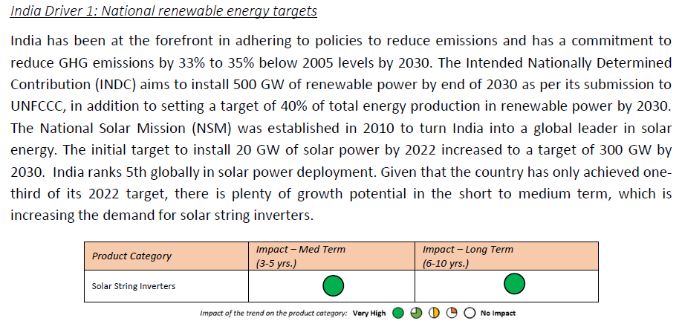



* **Restraints: Global:** *Grid saturation , Restructuring and reduction of renewable energy incentive programs***, Indian:** *Risks associated with RE projects, Restructuring of open access fees*

1. **ALUMINIUM HIGH PRESSURE DIE CASTING (HPDC):**

* Aluminium Die Casting is the process of creating aluminium alloy-based products by forcing the molten metal into a die casted mold cavity. for high-volume manufacturing for automotive components. The High-Pressure Aluminium Die Casting market in India is mature and has continuously grown in production capability to meet both domestic and global requirements. Companies manufacture components including engine blocks, bed plates, and several other thin wall castings. The automotive industry is the largest revenue contributor for the high-pressure aluminium die casting market. India has a well-developed ecosystem of material suppliers, support services, skilled labor, and equipment suppliers for both global and domestic players to support the growing demands for high-pressure aluminium die cast parts.
* In this segment, there is risk of client concentrations as significant revenue comes from Endress+Hauser Flowtec AG

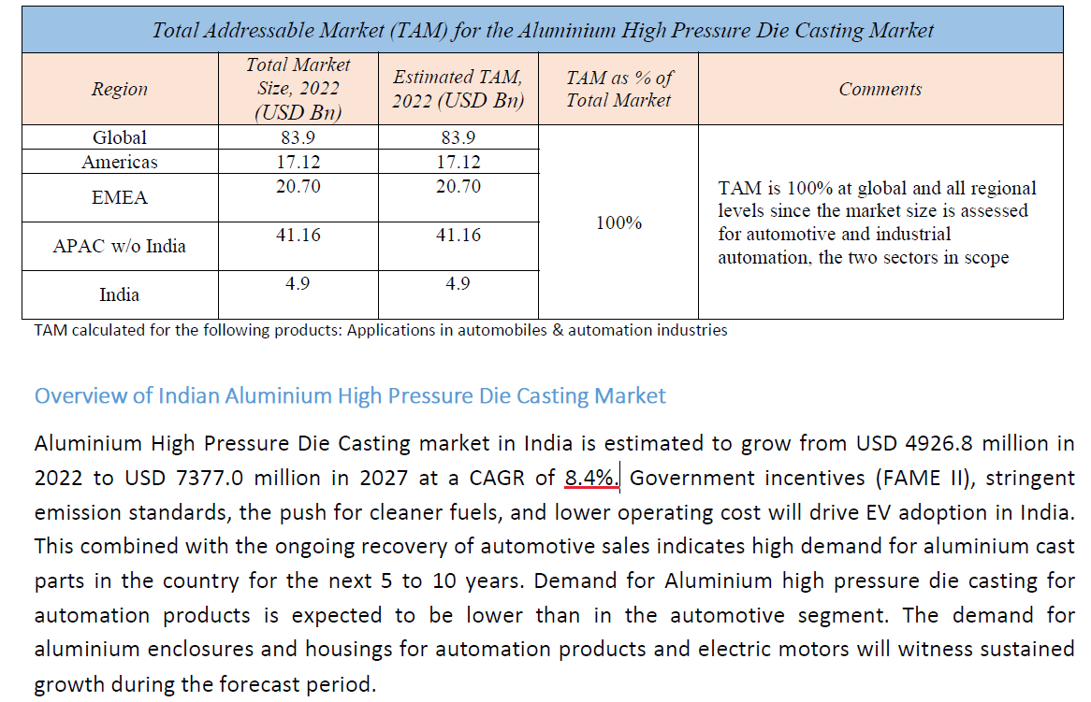

* **Key Players**:

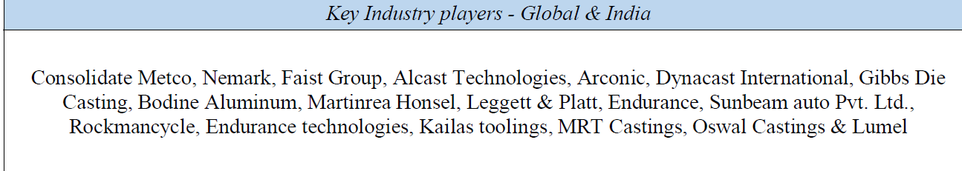

Lumel holds 0.09% market share in the overall EMEA Aluminium High Pressure Die Casting Market.

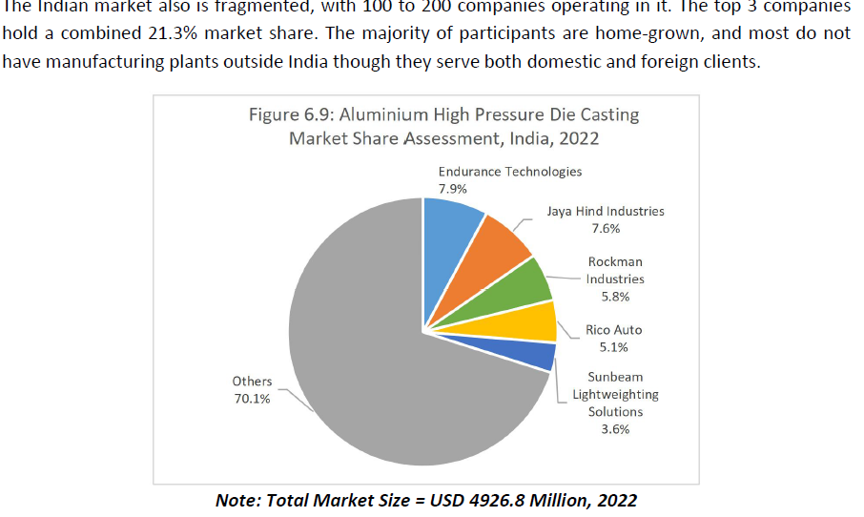

* **Drivers:** Vehicle light weighting, favorable policy change
* **Restraints:** High initial & operating cost (for India)

***Financial Analysis****:*

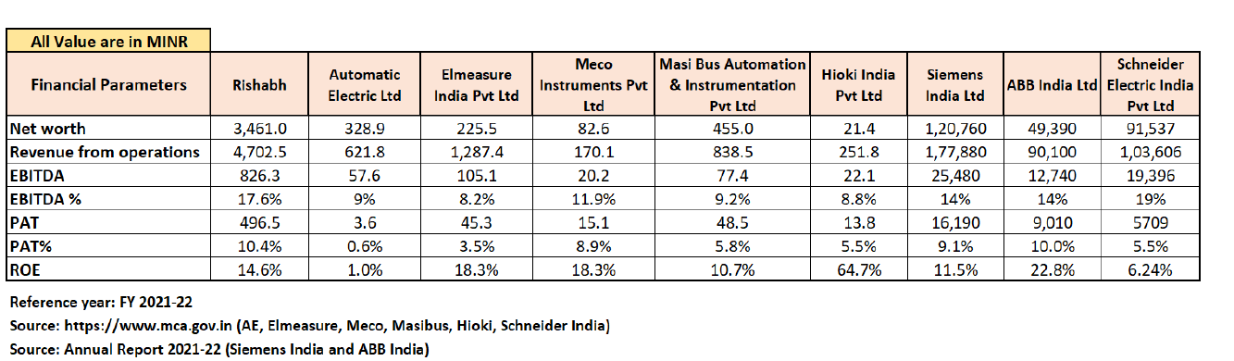

* ***SWOT Analysis for Indian Market:***

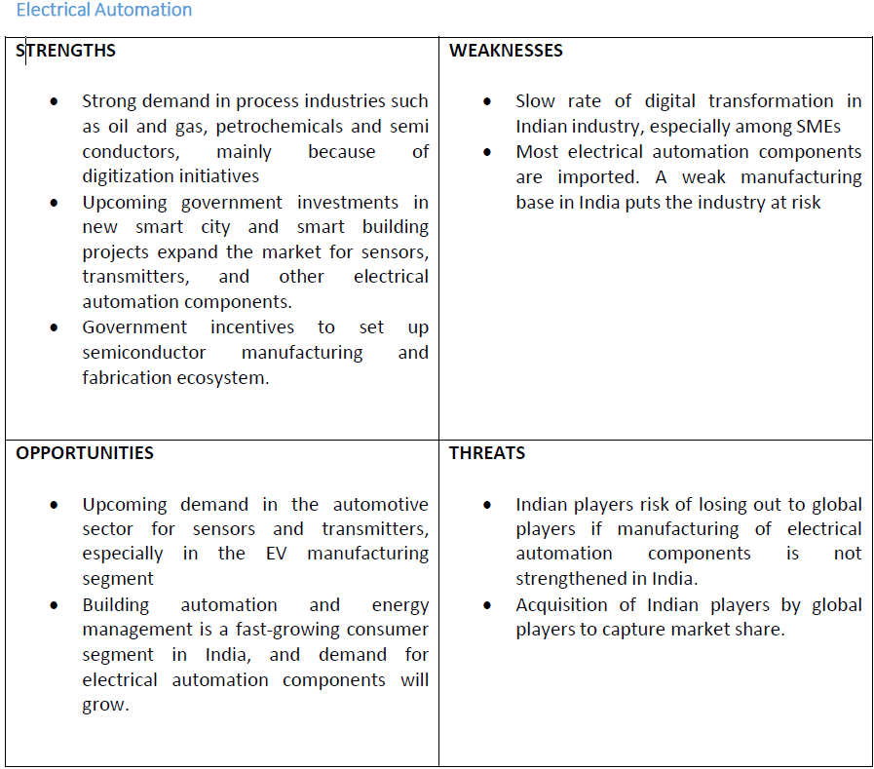

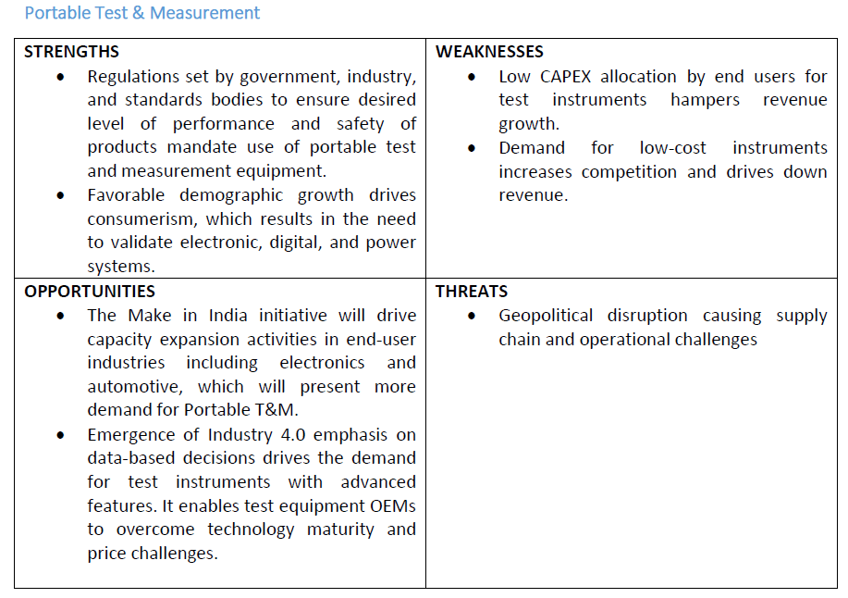

***Risks and Challenges***:

* Dependent on the Poland Manufacturing Facilities for a significant portion of production. Poland Manufacturing Facility II requires natural gas for the aluminium high-pressure die casting business. Due to the conflict between Russia and Ukraine and sanctions imposed on Russia by the Government of Poland, Russia may shut down the supply of natural gas to Poland

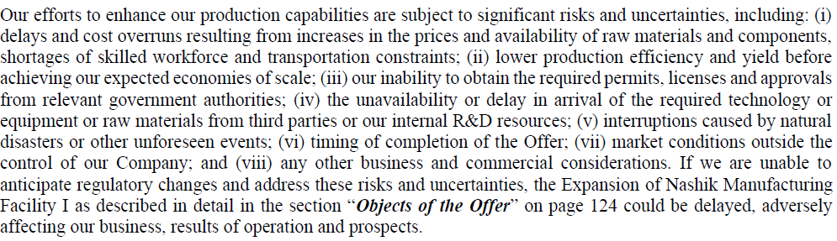

* **High dependence on subsidiaries for revenue generation**

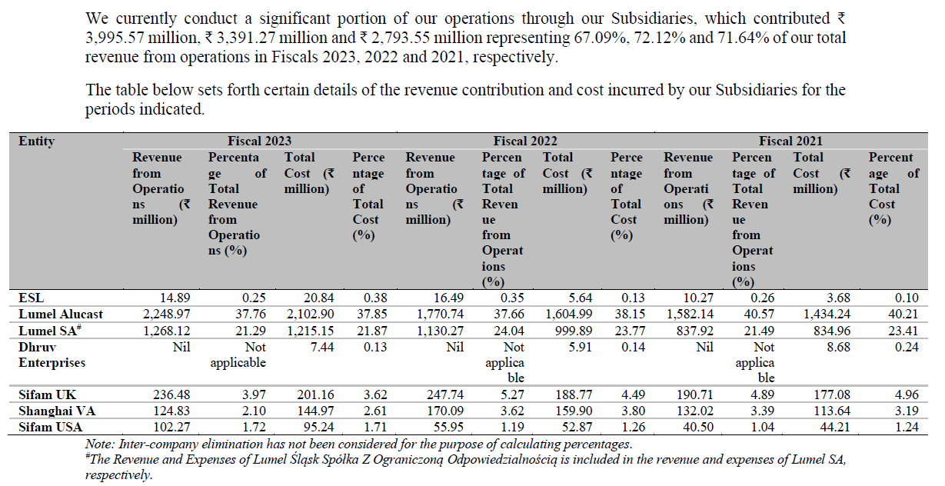

* Failure to manage component and material purchasing and shortages in the supply of major production inputs could adversely affect ability to deliver products.
* **Shortages in the supply of semiconductors may have adverse impact on the business:** Some of the components required for operation is available from one manufacturer only
* ***Under-utilization of manufacturing capacities:*** Average utilization of 50% capacity only (Lumel SA Poland manufacturing unit 1 capacity utilization only 20%)

***Business Moat/Investment Thesis:***

1. Rishabh is a global leader in manufacturing and supply of analog panel meters and is among the leading global companies in terms of manufacturing and supply low voltage current transformers. Lumel is one of the leading non-ferrous pressure casting players in Europe. With over 145 product lines and catering to over 3000 customers globally, Rishabh Instruments has undisputedly positioned itself as a leading player within the space.
2. Key strengths of Rishabh Instruments are:
3. **Vertically integrated State-of-the-art operation facilities, backed by strong manufacturing capabilities:** Rishabh Instruments is currently operating 5 manufacturing facilities (of which 2 are inNasik, India) spread across 3 countries: India, Poland and China. All facilities are vertically integrated with end-to-end product development capabilities from concept design to bulk manufacturing, withdedicated R&D units. At Rishabh Instruments, under all product segments, 99% of manufacturing operations are done in-house (in India) and only 1% of the total turnover is spent on outsourcing processes. This flexibility between manufacturing facilities has allowed Rishabh to plug gaps in product offerings across price and performance parameters
4. **Comprehensive Product Test Facility**
5. **Strong and diversified Product Portfolio and Services:** The High-pressure Aluminium die casting business from Lumel also helps the company to bring new customers for the electronic and electrical products. As the Aluminium die castings are mainly used by big automotive, automation and other industrial customers, it eventually opens business doors for products from the other segments thus building synergy between the two business units. The diversified product portfolio helps Rishabh to retain its customers and strengthen cross-selling efforts across product portfolios. Rishabh also provides strong software platform solutions (MARC) under ESL (Energy Solution Lab), which supports total integration of intelligent products supplied by all types of manufacturers.
6. Key services that Rishabh provides are:
   1. **Electronic Manufacturing Services (EMS) -** Rishabh is an emerging player in one of the fastest growing EMS business segments which is currently lead by player like Syrma SGS Technology Pvt Ltd, Dixon Technologies India Ltd, Amber Enterprises India Ltd etc. providing huge future growth opportunity for the company. (The total addressable EMS market in India was valued at USD 36 in FY21, and is expected to grow to USD 135 Billion in FY26 with a CAGR of 30.3%)
   2. **Mould Designing and Manufacturing**
   3. **EMI/EMC Testing**
7. **Global Customer Base:** Serving over 3000 customers globally, Rishabh has an extremely wide customer base spread across the globe ensuring the avoidance of business risk due to concentration and dependency on a few big customers. At the same time, the product developed for these customers has wide applicability which avoids risk of ceasing any product line due to the loss of a particular customer.

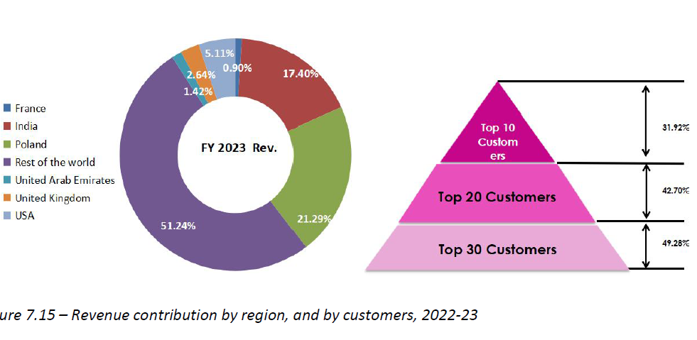

1. **Extensive network of sales partners in India and across the globe**
2. **Strong R&D Focus:**

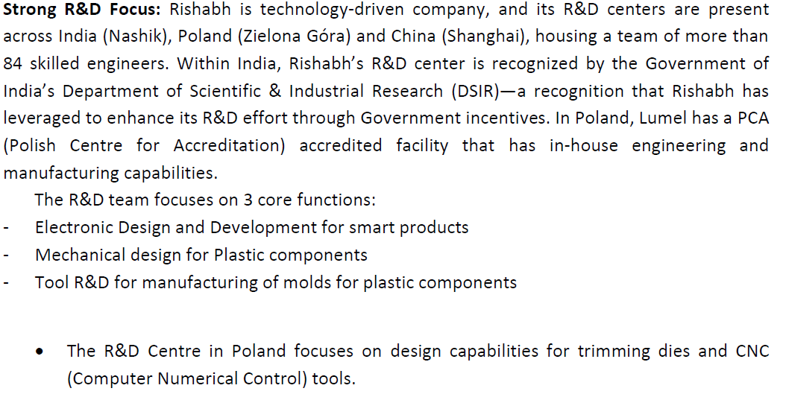

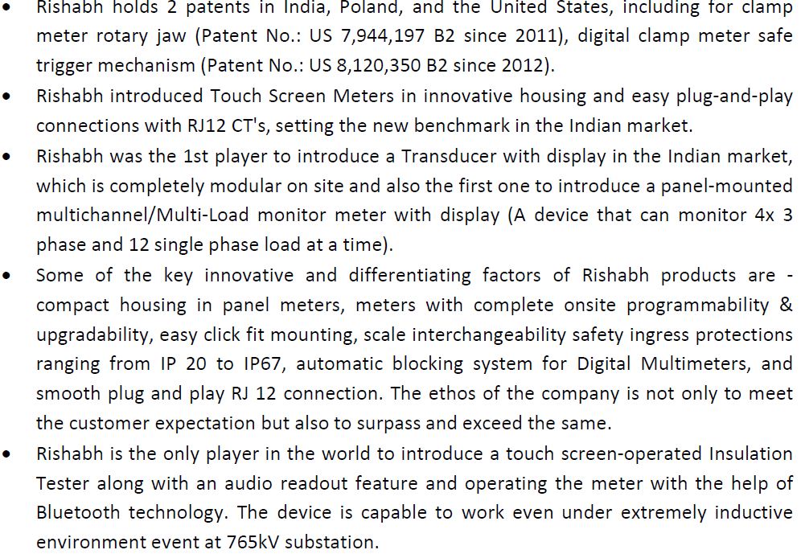

1. **Enhance product quality, design & comptence while focusing on higher value addition**: we seek to focus on developing products with advanced technology such as IIoT, bluetooth capabilities and advanced technical specifications along with miniaturization of product size.

**Conclusion:**

Rishabh Instruments, with its experienced leadership and diversified product offerings, presents a valuable opportunity. However, careful consideration of its financial health, industry trends, and associated risks is vital.