D-Link India Ltd

Proxy to Data Center Play?

04/06/2024

D-Link (India) Limited is a part of D-Link Corporation of Taiwan and is one of the largest networking companies in India. The Company is engaged in the marketing and distribution of networking products in India and SAARC region.

D-Link (India) Limited is a key market player with nationwide reach, robust product portfolio and superior services in India. The Company is firmly committed to delivering high quality, efficient and reliable networking products, solutions and services. D-Link India has 13 branch offices with a pan India state of-the-art service support infrastructure.

D-Link is a name to reckon with, in the Home and SMB/ SME networking space on account of its strong brand recall, heritage, extensive product portfolio, wide spread nationwide distribution network and unparalleled support infrastructure.

D-Link is an end-to-end solution provider, offering products that extend across all areas of network infrastructure. D-Link’s rich and robust product portfolio adds value to businesses at each level of their network infrastructure.

Today, D-Link is laying the foundation for a world that’s more connected, smarter, and more convenient. Our Wi-Fi routers, IP cameras, smart home devices and other products let consumers enjoy richer online experiences and greater peace of mind in the comfort of their homes. Meanwhile our unified network solutions continue to integrate capabilities in switching, wireless, broadband, IP surveillance, and cloud-based network management.

Our Subsidiary:
TeamF1 Networks Adding Intelligence to Hardware

TeamF1 is a provider of networking and security software for embedded devices with experience spanning close to two decades. Established in the year 2000, TeamF1 was acquired by D-Link in June 2014 as a wholly owned, but independently operated subsidiary. TeamF1 provides network security, Wi-Fi management, CPE turn-key and component software using our core platform TFOS® – ‘TeamF1 Operating System’.

TeamF1 focuses on high-performance Networking, Security, Wi-Fi management, VPN software and all its products/solutions are developed on in-house developed proprietary (TFOS)/Open Source (Debian/ Open WRT) platforms. It supports customization, virtualization, solution hardening, and its software platforms are Silicon & ODM agnostic. Its customers can mix and match components, extensions/ enhancements and build custom firmware based on their specific deployment needs and use-case scenarios.

TeamF1 provides highly specialized connectivity and security software products for embedded systems. This includes an advanced security platform with well-integrated modular technologies tailored to the embedded OEM market.

The completely customized solutions of TeamF1 Networks encompass the breadth of requirements for securely connecting devices: from high-performance routing stacks, hardware-accelerated security protocols to intuitive device management, bridging the gap between demand and supply in the network security space. TeamF1 has vast experience in embedded systems and related technologies. It is well equipped to provide firmware for modern networking devices with cutting-edge feature sets including Ethernet, GPON, ADSl/VDSL and CPE Gateways.

TeamF1’s field-proven firmware is running on millions of devices across India. Around the world, there are thousands of Secure Gateway routers, Cloud/onsite managed Wi-Fi Access point controller solutions, ONT/ONUs running on TeamF1 firmware.

Products:

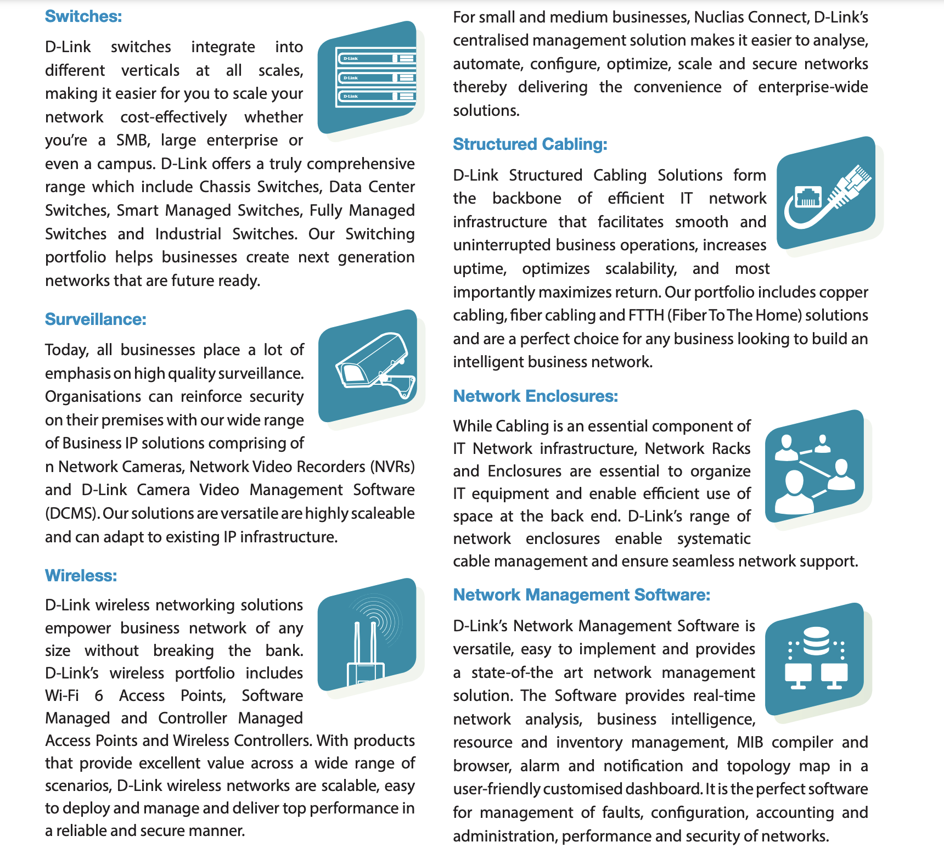

From Annual Report:

OPERATIONAL REVIEW:
The “Make in India” initiative is a government program that aims to make India a global manufacturing hub. One way to achieve this goal is through outsourced manufacturing.

D-Link (India) Limited is strongly focusing on local products as part of its ‘Make in India’ initiative. “Make in India,” and localization of products are two important initiatives of the Indian government that are closely linked. D-Link (India) has been granted exclusive rights/ license by the parent company to use the D-Link trademark for such locally manufactured products. The Company had made strategic decisions on manufacturing certain products locally through third-party or contract manufacturing with its own brand names, under its own proprietary designs, quality control and supervision. The Company has made noteworthy progress in this direction and has entered into arrangements with local manufacturers.
The future of the structured cabling market in India is bright. The market is expected to continue to grow at a rapid pace in the coming years, driven by the increasing demand for higher bandwidths, the rapid digitization of the economy, and the government’s focus on infrastructure development.
D-Link offers a wide range of structured cabling products, components, and services and is one of the major players in the Indian structured cabling market.
The Company maintains a substantial market share in the consumer wireless and switching sectors. Its unmanaged and smart managed switches are among the most popular products among small and medium-sized businesses (SMBs).
D-Link is focused on providing world-class customer services and keeps working towards enhancing its existing countrywide distribution and support infrastructure. It has a strong network of National Distributors, Business Distributors, and over 15000+ resellers reaching out to its customers across the length and breadth of the country and ensuring that its products are available in the remotest parts of the country.
To serve its customers in a holistic way, D-Link India has invested in state-of-the-art support infrastructure for both consumers and enterprises, which includes 10 D-Link-owned Service Centres with 50+ experts in Tier 1 cities, 23+ Partner Service Centres with 40+ experts in Tier 2 / Tier 3 cities, Partner Collection Points in 105+ cities and logistic support in 190+ cities.

Product & Solutions:

The Company launches new upgraded, improved, or innovative products. The Company remains a leading global brand in wireless, broadband, SMEs and home network product markets. The main products recently launched include cloud switches, 2.5Gbps smart switches, enhanced enterprise integrated wireless solutions; EAGLE PRO AI Wi-Fi Mesh routers, bridges, and access points; multifunctional wireless broadband 4G/5G routers and developed AIoT applications in various industries; high-resolution two-way IP cameras for real-time voice chat, peripheral devices related to smart homes, and cloud network management platforms.

Network Switching Solutions:
The switch market, which is the backbone of the network, has always been the biggest beneficiary of traffic growth. Nuclias Connect is a cloud management platform that provides centralized control and management for D-Link wireless access points (APs). It can be used to manage APs in a single location or across multiple locations. Nuclias Connect offers a variety of features.
The Company also developed and launched the DSS network surveillance switch series with a 250m distance specially used to connect Power over Ethernet (PoE) devices such as wireless access points (APs), IP cameras, and IP phones to the network. The switches can provide power to IP cameras and other PoE devices over the same network cable that carries data.
The switch market will continue to grow as network traffic continues to rise. D-Link (India) offers a series of relevant 10G/100GbE Ethernet switches to effectively alleviate the server congestion and congestion backbone network. In addition, Data Center switches, PoE switches (surveillance switches) for camera deployment, and enterprise wireless cloud switches are also under continuous development.
There is increased demand for gigabit switches from large enterprises and service providers. For this, D-Link has a comprehensive range of switching solutions including Chassis, L3/L2 Managed, Smart and Un-Managed switches which can be used in the Core, Distribution, and Access levels in the networking infrastructure. Verticals like government, retail, manufacturing, services, financial, education and healthcare contributed to the revenues of this segment. Built on the strength of these D-Link Network Switches, specific network solutions can help small and medium-size businesses, hospitals, schools, universities, and government agencies meet the challenge of growing demands.
D-Link offers a wide variety of data solutions to meet the specific requirements of a smart city communication network, playing a pivotal role in designing the network and providing the essential building blocks.

Industrial Switching Solutions:
Industrial switching solutions are a type of networking technology specifically designed for use in industrial settings. They provide reliable, high-speed data transmission for industrial networks, including 10G industrial switches for faster speeds. D-Link has extended its portfolio by introducing an extensive line-up of Industrial grade Ethernet switches. D-Link has multiple series of Industrial grade switches with options like rail mount and rack mount that shall provide users with best-fit solutions.
D-Link Industrial switches are designed to operate in extreme weather, resist shock/vibration, and surge ratings, thereby offering high reliability. D-Link Industrial switches can withstand harsh environmental conditions and are suited for controlled and challenging needs of Oil & Gas industry, Shipping, Manufacturing etc. With their strong build, the whole family of Industrial switches is certified against vibration, shock and free-fall. The industrial product range was created to withstand extreme heat and below-freezing temperatures.

Wireless Solutions:
D-Link is developing an upgraded AQUILA PRO AI series of EAGLE PRO AI during the year and introducing Matter technology, coupled with a series of IoT devices, to build a smart home solution that provides services in the hope of increasing sustainable revenue and stabilizing profitability.
In the future, the Company will expand its product series and enhance the added value of its customized software and hardware while strengthening its bids for more projects. The pandemic has increased the demand for broadband access, which is expected to grow considerably this year.
In the Business Class of products, the Company introduced Wi-Fi 6 access points to provide unbeatable speeds, greatly increased capacity, and interference-free coverage throughout businesses. A new wall-mounted Wi-Fi access point was introduced for Small to Medium size businesses (SMB) and this works with D-Link’s free software-based management solution, Nuclias Connect.
D-Link continues to play a pioneering and driving role in the cost-effective convergence of wired and wireless networking. The Company enjoys a good market share in unit terms in the WLAN category. Its product portfolio includes Wireless Routers, Business Class Access Points & Unified Switching Solutions.

Structured Cabling Solutions:
Structured Cabling is another key segment for D-Link. D-Link’s wide product range, combined with premium quality and excellent brand recall has resulted in confidence amongst partners and customers. D-Link has the entire copper and fiber range which can be positioned in high-end applications like data centers.
Over the years, D-Link has witnessed remarkable growth in the Structured Cabling product category, with strong demand from large enterprises/SMEs/SMBs. The emphasis has always been on delivering complete end-to-end solutions, and with this agenda, we decided to introduce networking enclosures into our product portfolio. Moving ahead, the Company is confident of continuing to deliver technological excellence and complete customer satisfaction.

Surveillance Solutions:
The mydlink service solution is centered on surveillance, and the existing switches, IoT, and software are integrated into one cloud service platform to allow customers to select, purchase, operate, and maintain security control equipment and systems more conveniently and easily, which significantly saves users’ time and cost. Moreover, products of the same brand can avoid the issue of product incompatibility and provide users with a more stable security surveillance environment D-Link surveillance products are in demand with broad acceptance from various industry verticals. The focus is on all three segments separately - be it Consumer, SMB/SME or Enterprise.
D-Link offers a range of IP-based Surveillance Cameras with Wired and Wireless options; these can be integrated with NVR (Network Video Recorder) solutions for archiving. The cameras span the spectrum of possibilities, including Stand-Alone Network Cameras, Pan Tilt Zoom Cameras, Dome Cameras (Day & Night), Box Cameras and Outdoor Cameras. D-Link Surveillance solution boasts the highest degree of scalability and can easily adapt to the existing IP infrastructure. The advanced features such as high security encryption, superb image quality, digital zoom, and remote accessibility surpass the most cutting-edge technologies available today.
While D-Link continues to be one of the key players in the IP Surveillance domain, it also expanded its product portfolio by venturing into the CCTV segment. D-Link CCTV range includes Analog HD Camera, DVR, DVR Enclosure, and CCTV Cable. D-Link with its CCTV Analog HD is set to address the growing demand from Residential, SOHO, SME, Banking, Hospitality and other commercial establishments. With resolution starting from 1 MP which goes up to 5 MP, D-Link Analog HD cameras are well suited for both indoor and outdoor applications and offer amazing clarity, sturdy looks, superlative quality, and are backed by D-Link’s excellent support infrastructure.

===========================================================================

D-Link announced the launch of its Made in India range of Surveillance solution christened ‘Indigenous Series’.
July 2023

As the name suggests D-Link Indigenous series range includes surveillance solution that is designed & manufactured in India. This is in line with D-Link’s commitment to governments ‘Make in India’ vision, that focuses on local manufacturing. D-Link Indigenous series includes a range of IP based Cameras and Network Video recorders that have been crafted to perfection in India and designed keeping in mind the security concerns of every Indian.

D-Link Indigenous series offers an extensive range of IP based surveillance Cameras and Network Video Recorders (NVRs) that are packed with advance features, offers robust built, and most importantly is backed by D-Link’s emphasis on quality. Further D-Link Indigenous series is supported by D-Link VISION App that enables customers to view their cameras and receive instant alerts when motion is detected. D-Link VISION app features a user-friendly interface that makes it easy to set up and use. Plus, with advanced features like two-way audio and night vision, you can communicate with anyone on the other end of the camera and get clear footage even in low-light conditions.

D-Link Indigenous series is a complete surveillance solution that includes a range of DomeIP Cameras, Bullet IP Cameras, Network video recorders and is supported by an exclusive D-Link VISION App for easy monitoring.

===========================================================================

What’s new @ D-Link?
Optionality of Data Center Products:

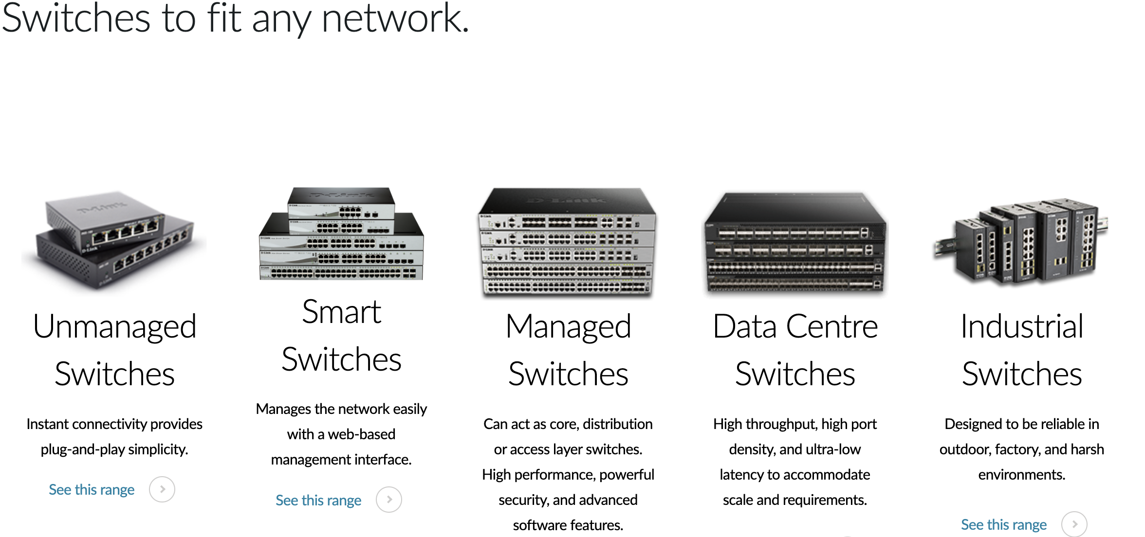
Data Center Switches Range:

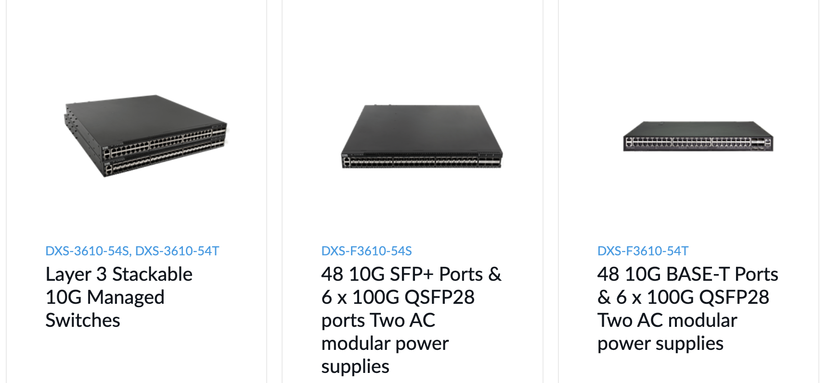

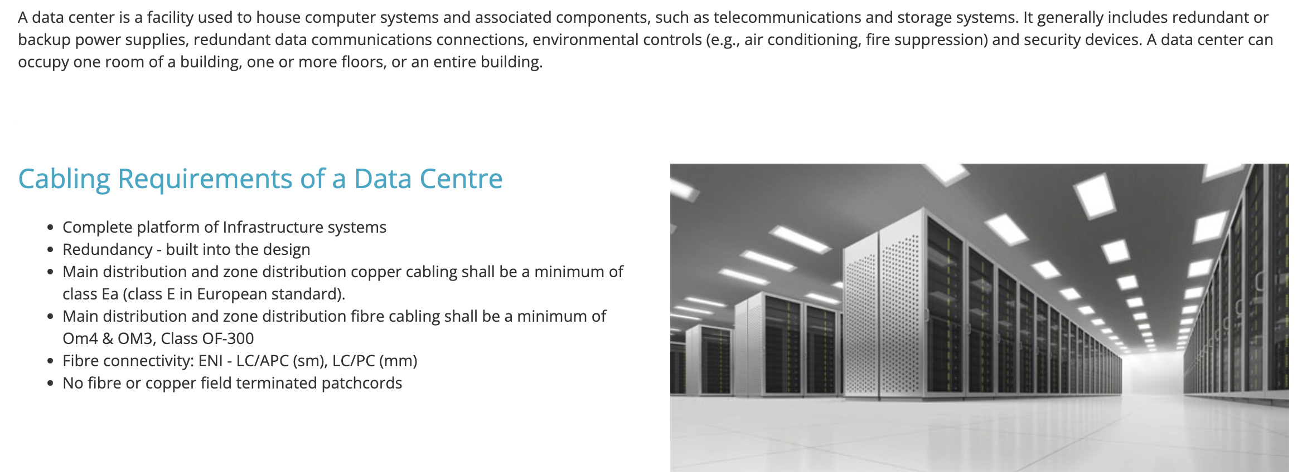

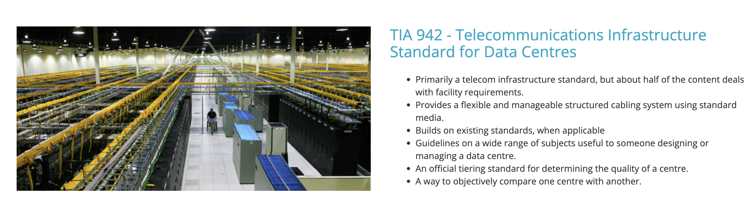

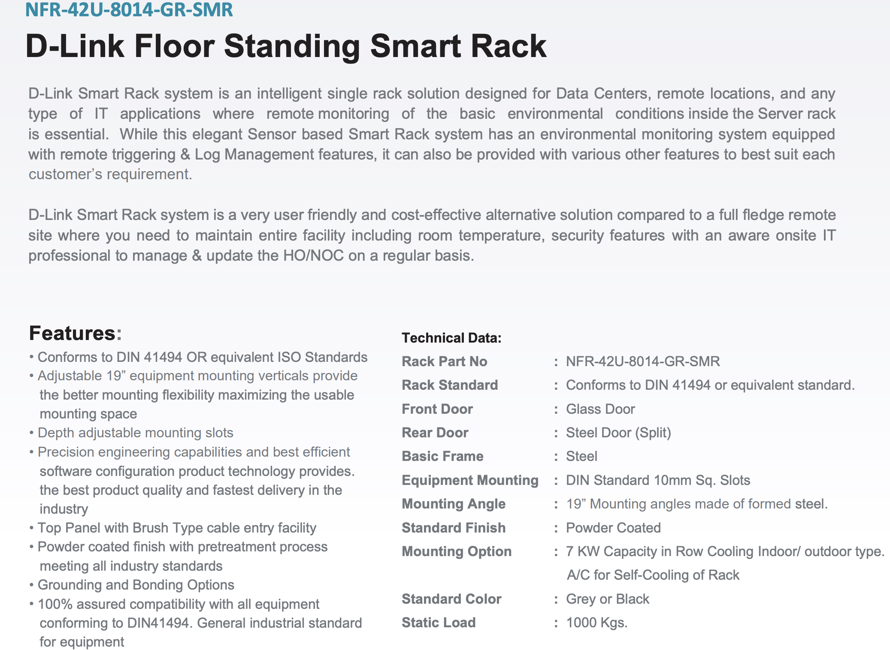
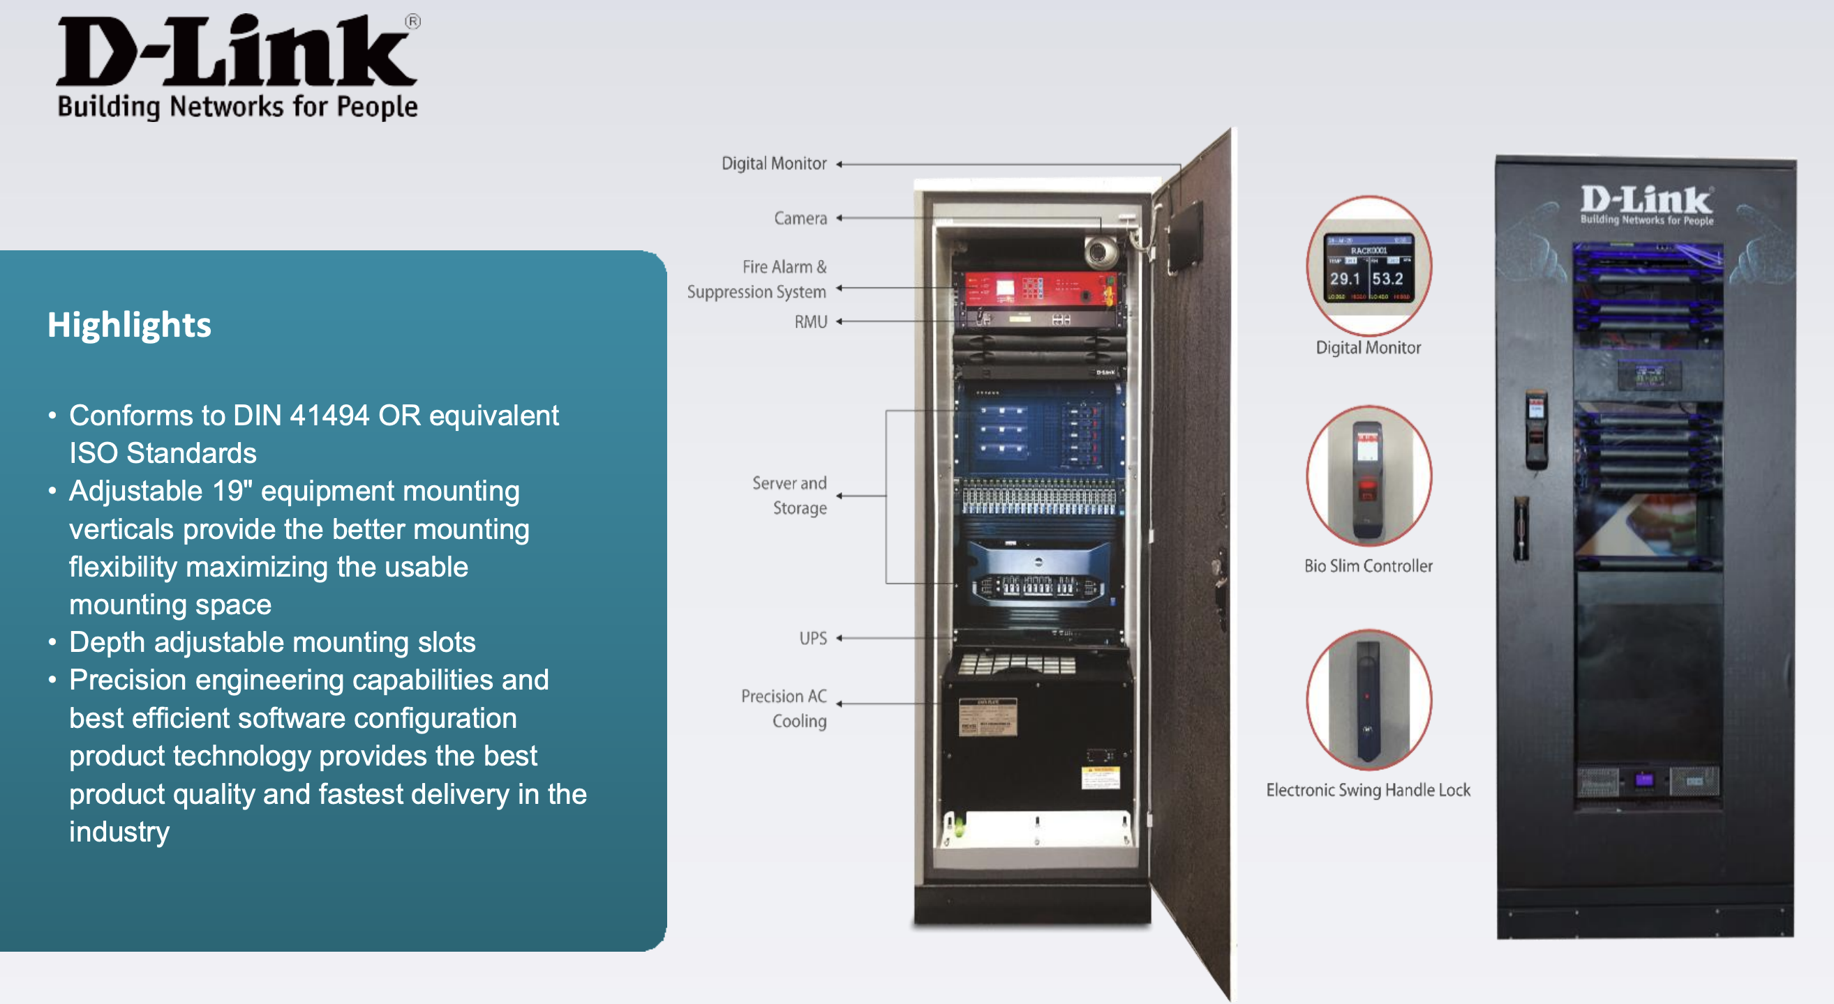

Company blog on Data Center Solutions:
https://businessblog.in.dlink.com/cutting-edge-resilient-data-center-solutions/

Company Video on Data Center Solutions:
https://www.youtube.com/watch?v=xh1dpu6coBI
Company Webinar on Smart Racks:
https://www.youtube.com/watch?v=6ZvKn_SNfyw&t=973s

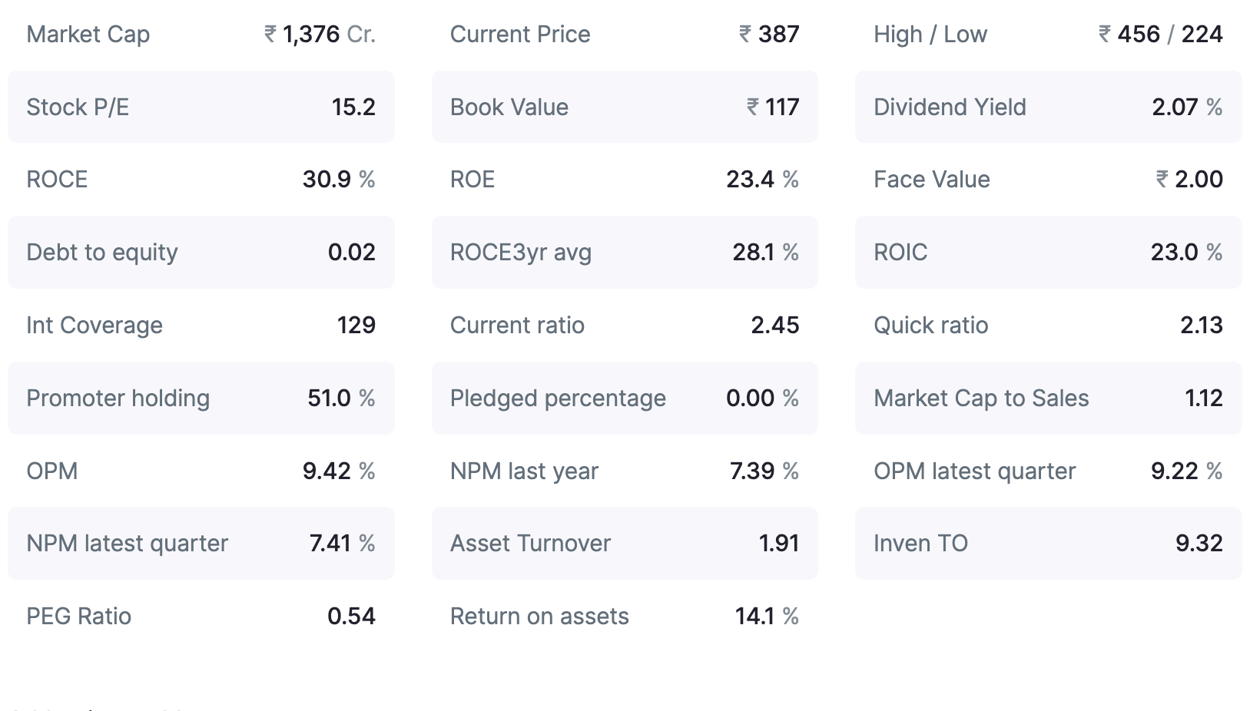
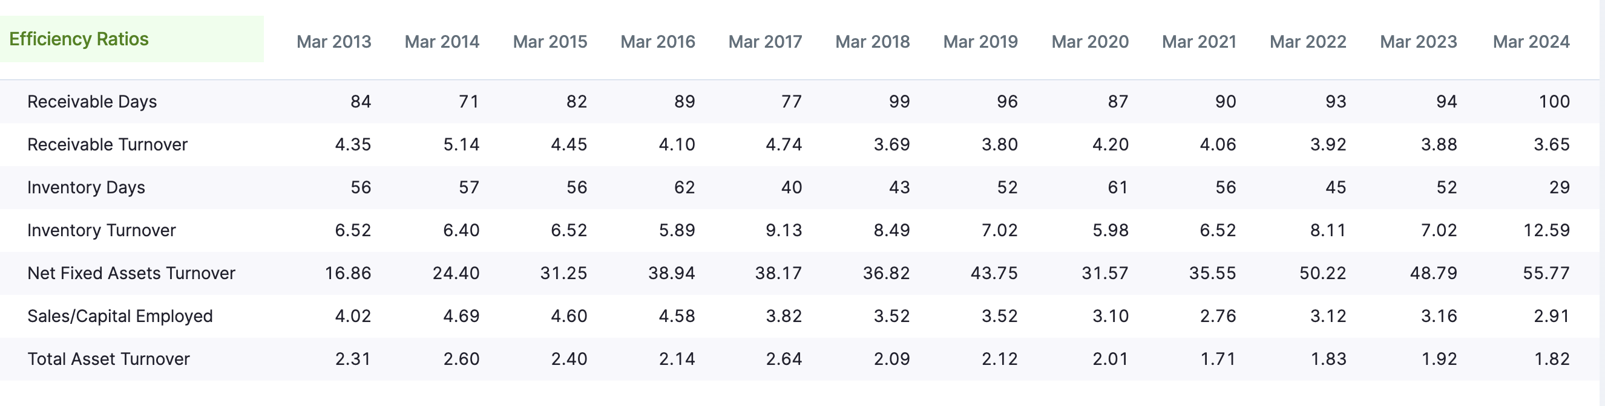

===========================================================================Compiled Notes from here & there
===========================================================================

