Dues from Monitoring Committee- Donimalai complex in Karnataka: The total trade receivables from monitoring Committee as on 31.3.2020 is Rs 2434.79 crore. This includes regular dues of Rs. 290.15 crore and Rs. 2122.46 crore towards 10% of sale proceeds retained by Monitoring Committee for the period from 04.10.2011 to 31.03.2020 pending directions from Hon'ble Supreme Court and Rs. 22.18 crore long pending dues for which company has made a total provision Rs. 2144.64(2122.46+22.18) crore.
Key Audit matter: As at 31st March 2020, current asset in respect of trade receivable includes receivables from monitoring committee amounting to Rs 2144.64 crores which are pending adjudication. Since it is an area of higher assessed risk of material misstatement, this is considered to be a key audit matter. (Ref. Note No.2.34.6 of financial statements)
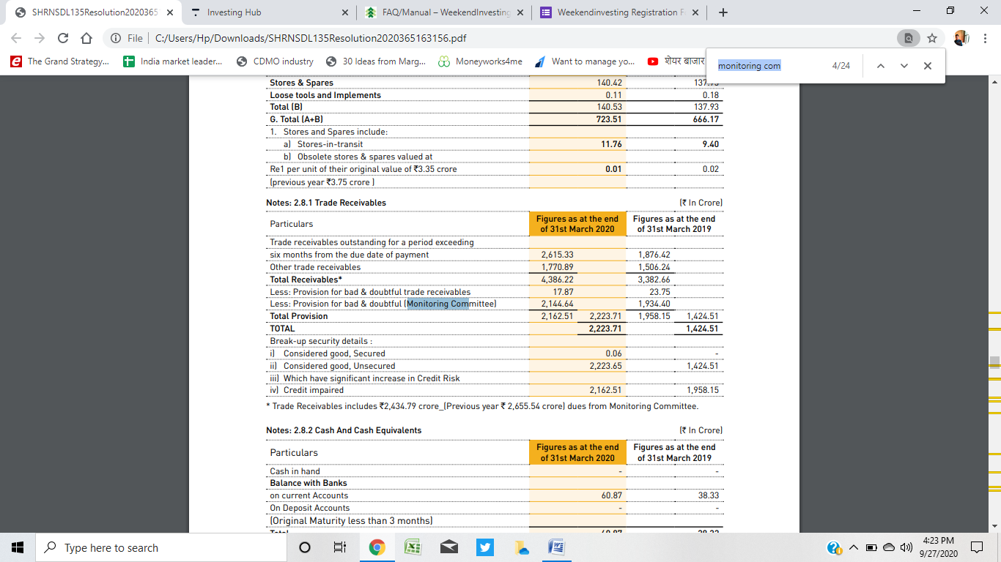
Common Cause Judgement for Bailadila Sector: The Company had received Show Cause Notices dated 31 .07.2018 from Dist. Collector, South Bastar Dantewada as to why NMDC should not be asked to deposit an amount of Rs. 7,241.35 crore as compensation as calculated by Collector based on the Hon’ble Supreme Court Common Cause Judgement related to Orissa Iron ore mines ( Writ Petition Civil No 114 of 2014 dated 2nd August 2017). The Company had been contesting the Show Cause Notices with Dist. Collector, South Bastar Dantewada on the ground that the said judgement is not applicable to NMDC . Meanwhile, revised showcause notices dated 26.09.2019 were received for a revised amount of Rs 1,623.44 Crore from Dist. Collector, South Bastar, Dantewada, to be replied within 21 days of notice. NMDC while reiterating the fact of non-applicability of the Hon’ble Supreme Court Judgement in the state of Chhattisgarh, has sought time for replying to the show cause notices. Further to above, Dist. Collector, South Bastar, Dantewada had issued Demand notices dated 15/11 /2019 for the amount to Rs 1,623.44 Crore towards EC Capacity violation and proposed production violation as per approved Mining Plan / Scheme respectively (Bacheli - Rs 1,131.97 Crore & Kirandul Rs 491.47 Crore) asking to deposit the amount within 15 days.
As the Mining Leases of the company in the State of Chhattisgarh were expiring on 31 .3.2020 and due for renewal, the Company has paid an adhoc amount of Rs 600 Crore under protest and filed writ petitions in the Hon’ble High Court of Bilaspur, Chhattisgarh and a Revision application with Mines Tribunal, Ministry of mines, Government of India , New Delhi praying to set aside the demand notices. Hon’ble High Court of Bilaspur has heard the WPs on 19.02.2020 and sought certain clarifications from the respondent and directed ‘no coercive action till 12.3.2020 and listed the case for 12.3.2020. However due to COVID-19 situation, no further hearings could take place The demand amount of Rs 1,623.44 crores has been shown under ‘Contingent Liabilities’.

- Income Tax Act: An amount of Rs 1,692 Crore has been shown under ‘Contingent Liabilities’ as on 31.3.2019 against Income tax disputes at various forums pertaining to various Assessment years. During the year Govt has enacted ‘Vivad Se Vishwas’ scheme for settlement of pending disputes whereby certain concession on the payable amounts was offered with waiver of interest and Penalty. The Board Directors of the Company has approved settlement of the disputes under the scheme. Accordingly, the Company has opted to settle the disputes under the scheme and as against the total disputed amount of ` 1,869 Crore (as per joint statement of company and tax authority) for Assessment years up to 2017-18, an amount of Rs 981 Crore has been paid in full settlement of the disputes. This has an impact in reduction of current year PAT by ` 795 crores. Accordingly, the amounts shown under the Contingent Liabilities has been withdrawn.

- Disputed claims under ‘ Karnataka Forest Act: Government of Karnataka had introduced Forest Development Tax (FDT), to pay @ 12% on the sale value of iron ore with effect from 27.08.2008. NMDC preferred an appeal before Hon’ble High Court of Karnataka and the court passed an interim order directing the Company to pay 50% of FDT, consisting of 25% in cash and balance 25% in the form of Bank Guarantee. As against the total FDT demand of `487.27 Crore( from August 2008 to Sep-2011), the Company has deposited an amount of Rs 121.84 Crore (25%) in cash which has been shown as amount recoverable and submitted a bank guarantee for similar amount. An amount of ` 365.43 Crore (balance 50% amount of ` 243.69 Crore plus 121.84 Crore paid and accounted as amount recoverable) is included under disputed claims at 1.1.A. The amount of ` 121,84 Crore for which BG was given is included under contingent liability on BGs’ at 1.2. Hon’ble High Court of Karnataka vide order dated 03.12.2015 has quashed the orders of Government of Karnataka levying the FDT and ordered refund of the tax collected within three months and accordingly the Company has lodged refund claims. However, Government of Karnataka has filed a Special Leave Petition with Hon’ble Supreme Court of India, challenging the orders of Hon’ble High Court of Karnataka. Hon’ble Supreme Court of India has accepted the same and imposed stay on refund of the FDT amount. Meanwhile Karnataka State Govt. had enacted Karnataka Forest (Amendment) Act 2016 vide Gazette notification dated 27.07.2016. The amendment substituted the word ‘Tax’ in the principal act to ‘Fee’ w.e.f 16th day of Aug 2008. Based on this the Monitoring Committee had started billing the Forest Development Fee in its invoices. Meanwhile consumers in Karnataka had filed separate Writ Petitions in Hon’ble High Court of Karnataka on the above. Karnataka High Court vide its order dated 20th Sept. 2016, had ordered that State Govt may restrain from collecting FDF during the pendency of the writ petition, subject to the condition of furnishing bank guarantee in respect of 25% of the demand in relation to future transactions. Karnataka State Govt. had approached Hon’ble Supreme Court on this. Hon’ble Supreme Court vide its order dated 13.02.2017 modified the order of High Court of Karnataka and ordered for payment of 50% of the demanded amount and furnish Bond for balance amount. The amount billed by the monitoring committee amounting to `93.85 crore towards FDF has been accounted under sales revenue during the Financial year 2017-18. As, the Karnataka High Court vide its judgement dated 4th October 2017 has declared the Karnataka Forests (Amendment) Act, 2016 which was introduced for collection of Forest Development Fee (FDF) as unconstitutional, No FDF was collected nor paid with effect from 5th October 2017.

