RPG Life Sciences has three segments

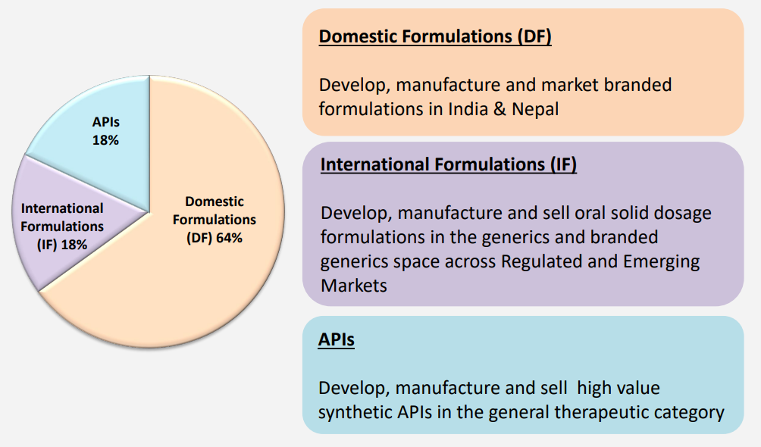

Products

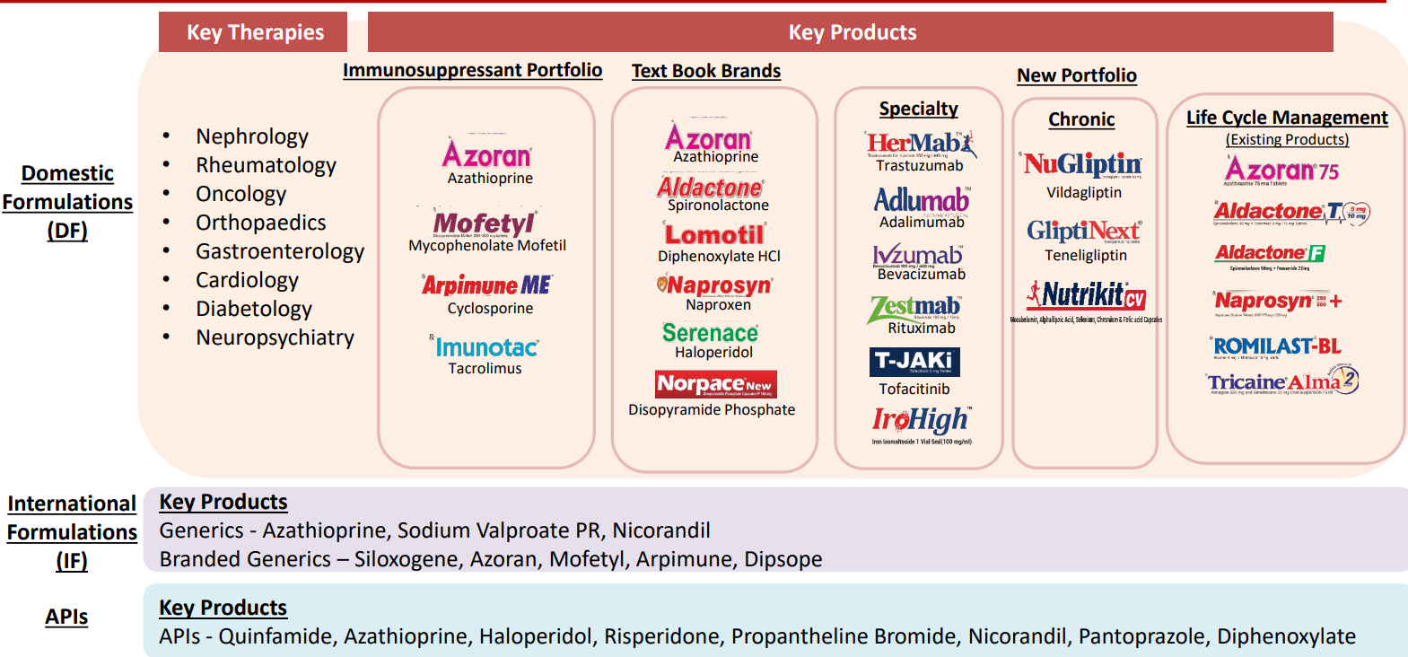

They are the leader in immunosuppressants in the domestic market.

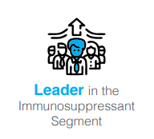

In API segment, they are focusing on high value, low volume, niche APIs. The API business also provides backward integration for IF segment.