Anlon Technology Solutions Limited
06.03.2024
Listed on NSE Emerge, Lot Size 400
Incorporated in 2015, Anlon Technology Solutions Limited is primarily engaged in the business of providing engineering services. The company provides engineering services for engineering systems, built on automotive chassis and allied areas, majorly for airports, high-rise buildings, and refineries.
The company offers services such as:
Airport Rescue and Fire Fighting vehicles,
High rise building rescue, evacuation and firefighting equipment,
Industrial Fire Engines,
Runway Rubber removal and paint removal machines,
Runway sweeping and Bay cleaning,
Disabled Aircraft Recovery Kit (DARK),
Supply of Airport interior components.

There are two primary segments for the bifurcation of the business:
1. Engineering services: Commissions from the Sale of Equipment, Spare Parts Trading, and Maintenance and Service.
2. Designing, Fabrication, and Installation Services: Maintenance and Service for the products sold.
The company provides services to clients spread across the country, namely in cities like Mumbai, Bangalore, Thane, Delhi, Hyderabad, Kurnool, Kannur, Jamnagar, Kolkata, Barmer, Ahmedabad, Lucknow, Guwahati, Mangalore and Chennai.
Competitive Strengths:
- Experienced management team and Strong technical team.
- Strengthening trust developed by and with Anlon in years.
- Fulfilling other service gaps.
- 24*7 Availability for customer service.
- Regular technological upgradation.
- After-sales service and operation.

Anlon specializes in providing end-to-end engineering services tailored for aviation infrastructure including:
Firefighting trucks,
Rubber removal machine,
Spare parts and other equipments.
Anlon performs sourcing, supervising, quality control, transportation, and installation of equipment for airports (~80% of revenues),
Government, municipalities and refineries (~20% of revenues).

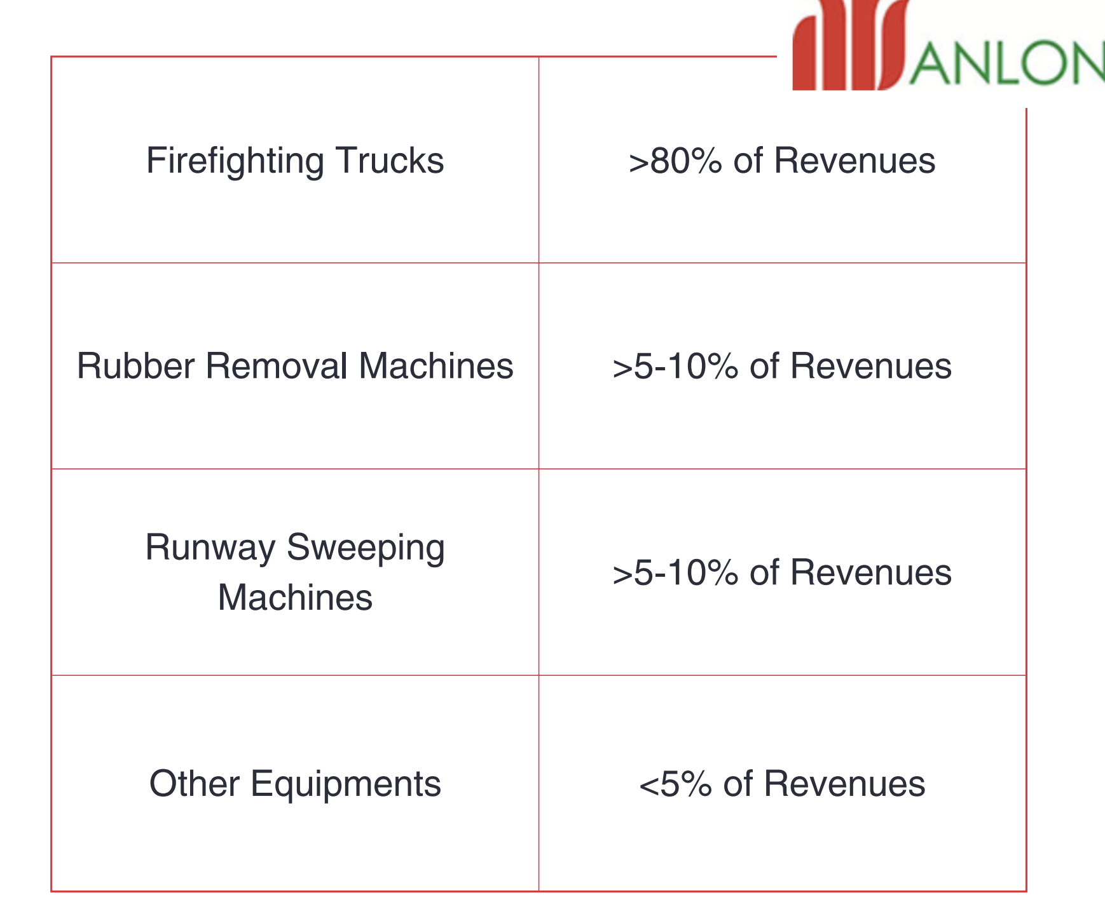

Anlon has collaborations with leading manufacturers worldwide to deliver bespoke solutions that meet the unique needs of their clients.

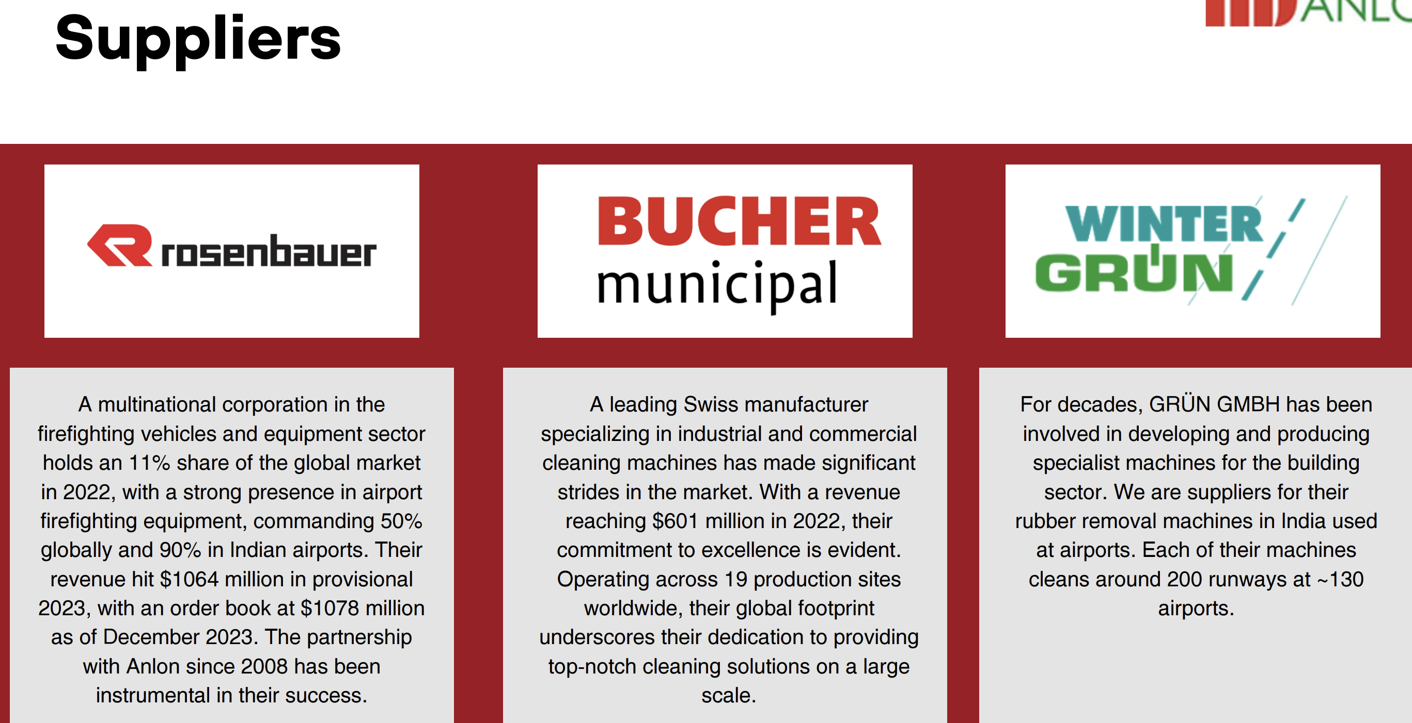

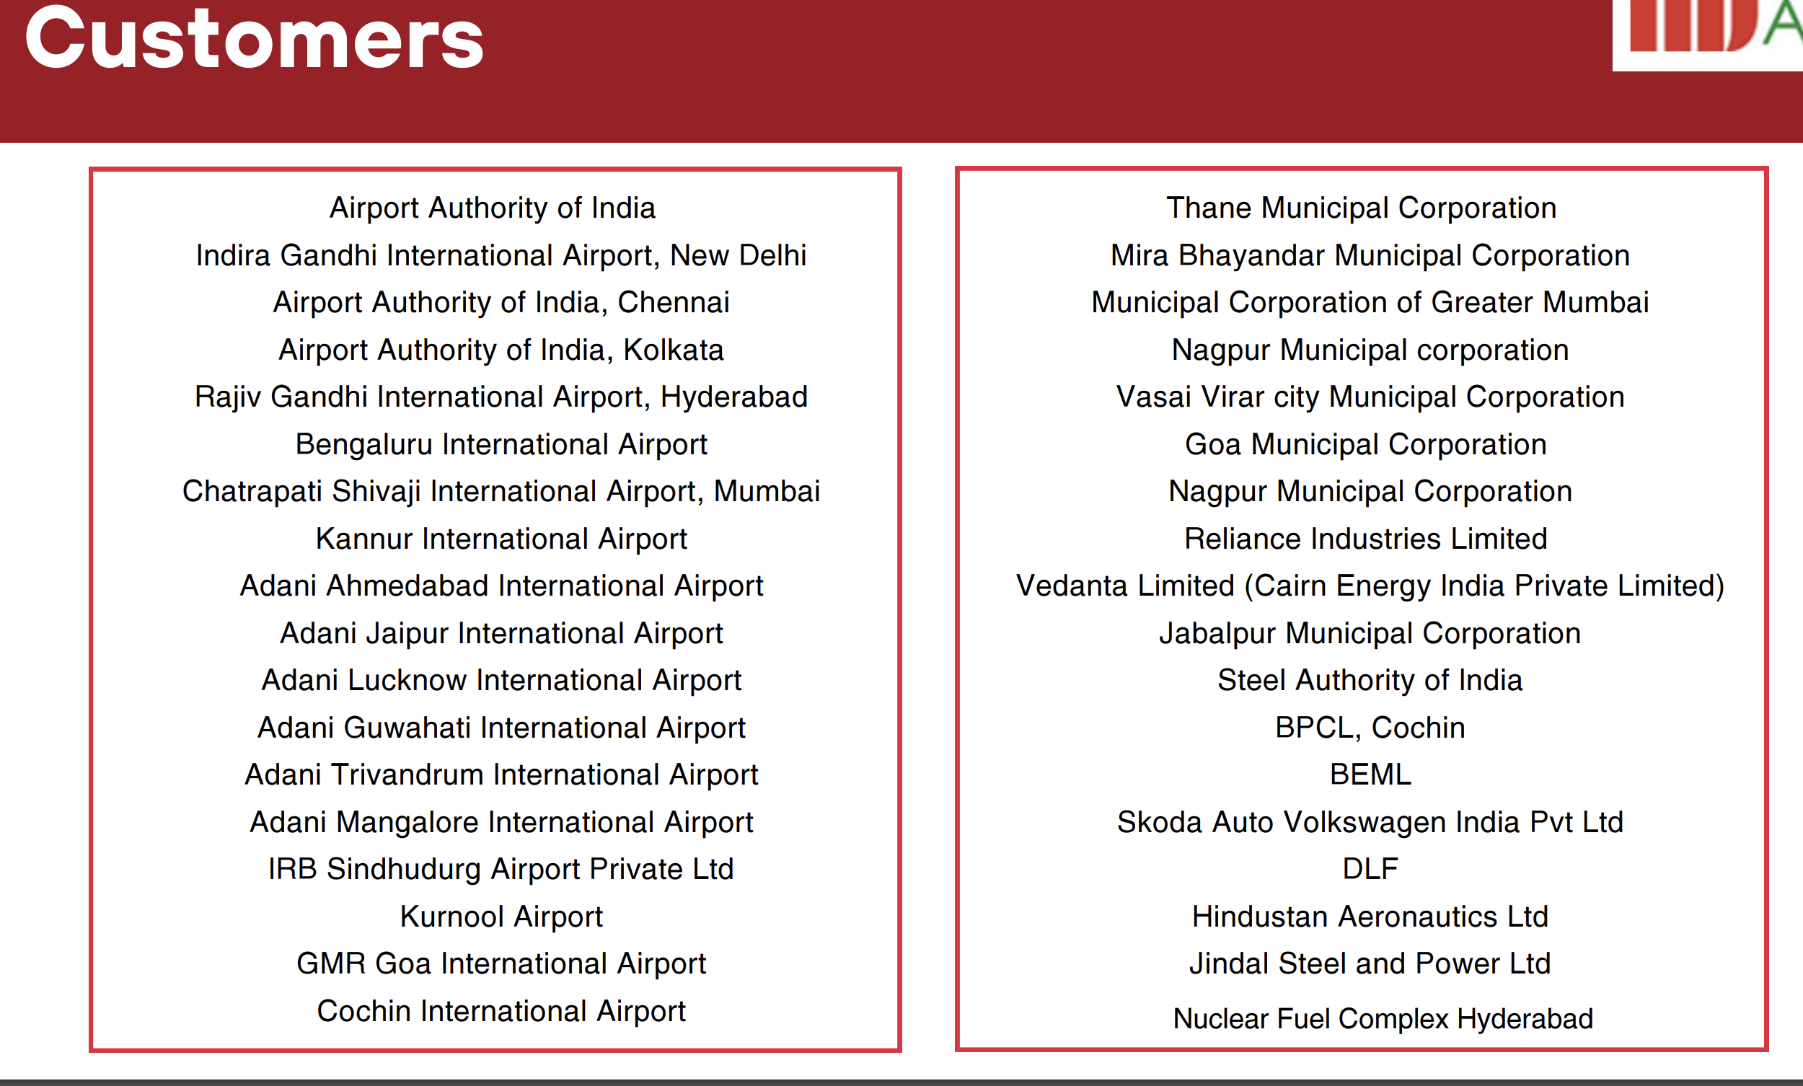

From Annual Report:

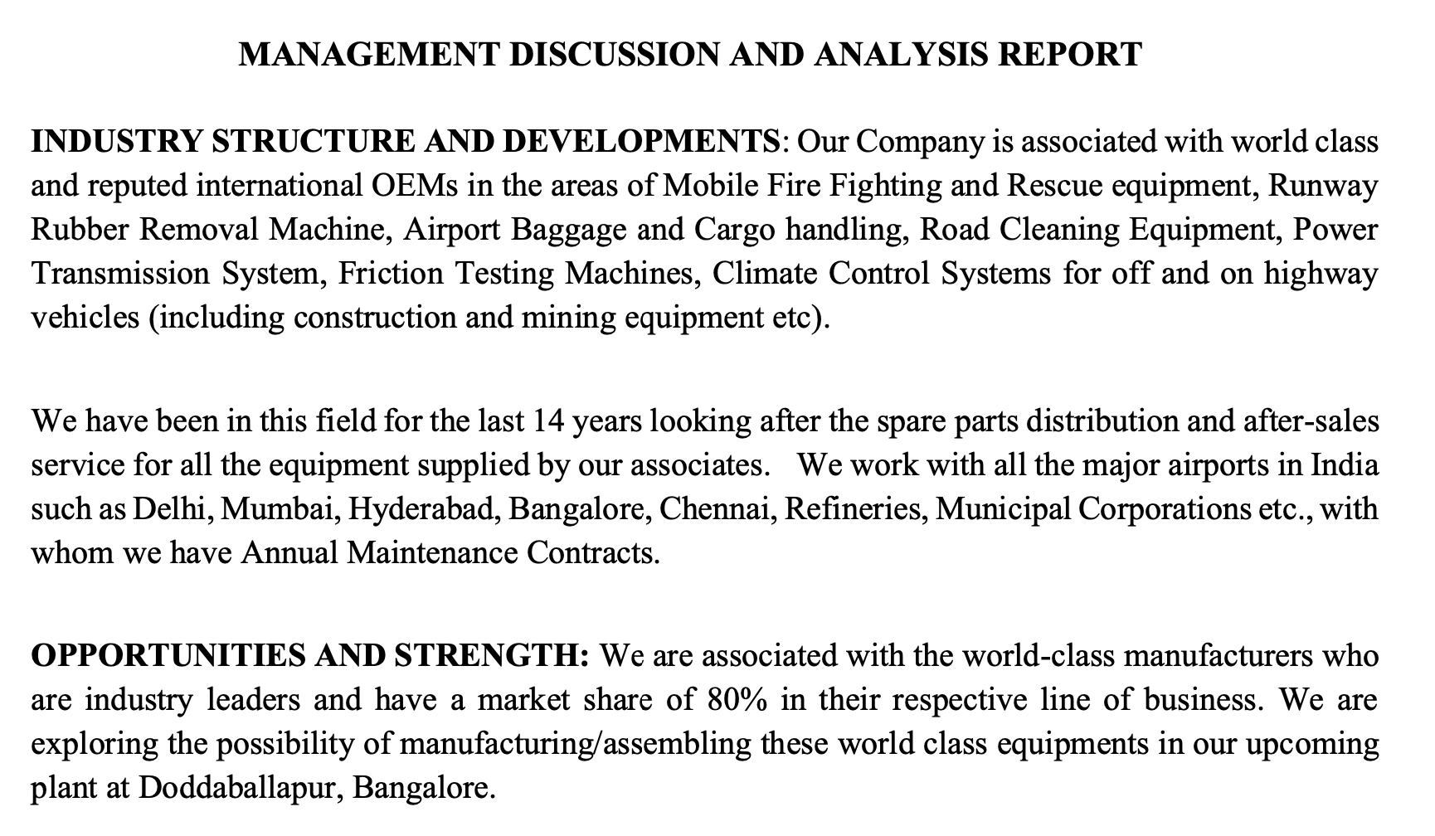

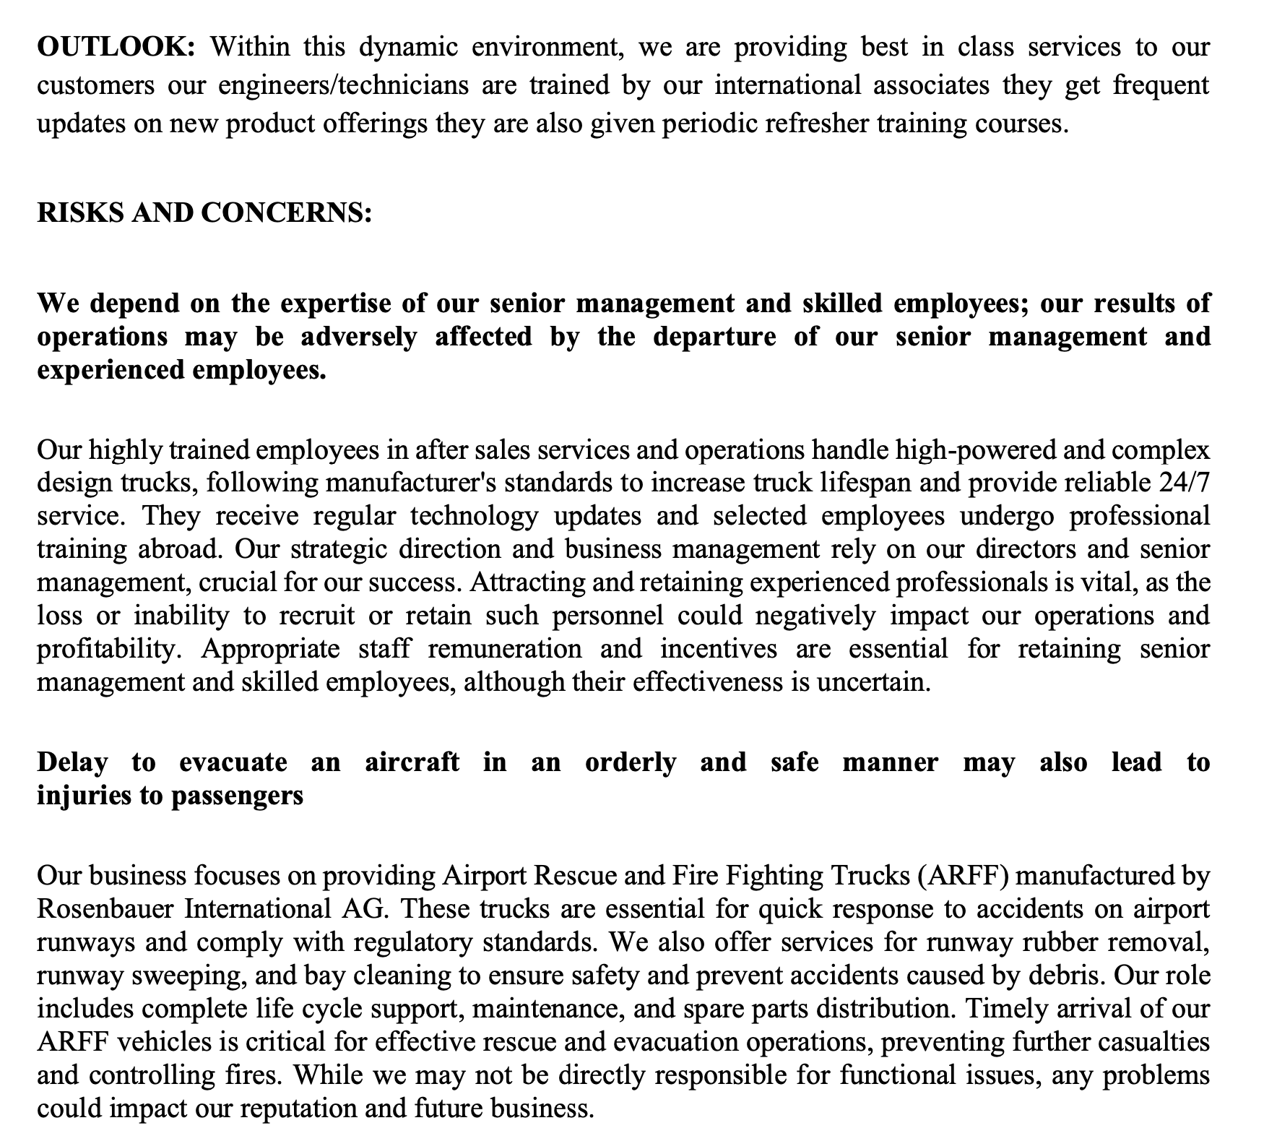
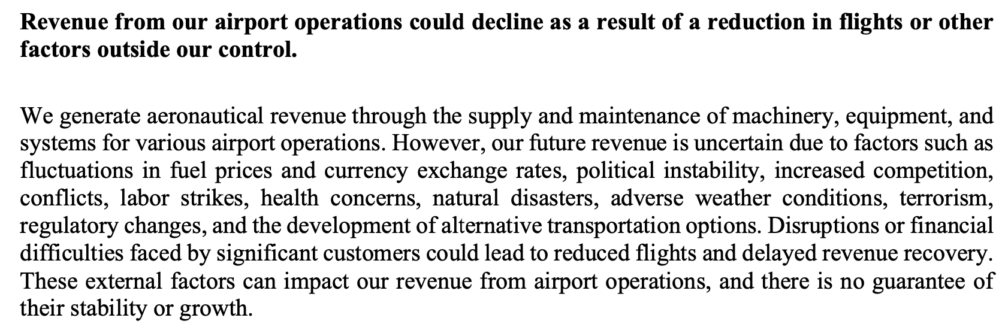
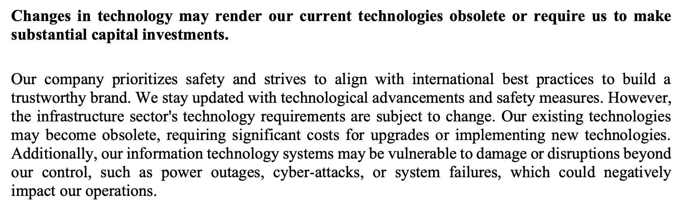
Order Wins:

December 2023 :
Anlon Technology Solutions Limited (ANLON) informed the exchange about receiving orders worth ₹9.07 Crores from Navi Mumbai International Airport Private Limited and Guwahati International Airport Limited. Navi Mumbai order's value is ₹8.73 Crores, while Guwahati's order amounts to ₹34.56 Lakhs, both excluding GST. The orders include Defect Liability Period (DLP) warranty services and annual maintenance services for Crash Fire Tender Vehicles.

13th Feb 2024:
Anlon Technology Solutions Limited informed the exchange about receiving an order amounting to ₹1.16 Cr from Delhi International Airport Limited for the refurbishment of Trackjet make Runway Rubber Removal Machine at IGI Airport, New Delhi

Way Forward:

New Plant Commissioned:
Anlon inaugurated its new plant on 29th Feb’24 dedicated to manufacturing and assembly of FireFighting Vehicles, Rubber Removal Machines and other vehicles and Equipments.
Till now it just used to supply these Vehicles and charge commission from suppliers.

Positive Impacts:
With the manufacturing plant Company will be able to cater to:
More Demand
Better Cost
More penetration
Higher Orders
Sustainable increase in margins
New Launches

Key Partnerships:
For Rosenbauer, the company is an exclusive representative across India except Airport authority of India.
For Bucher, it is the only exclusive supplier in India.
For Winter Grun, Anlon is supplier for their rubber removal machines for airports.

Fundamentals:

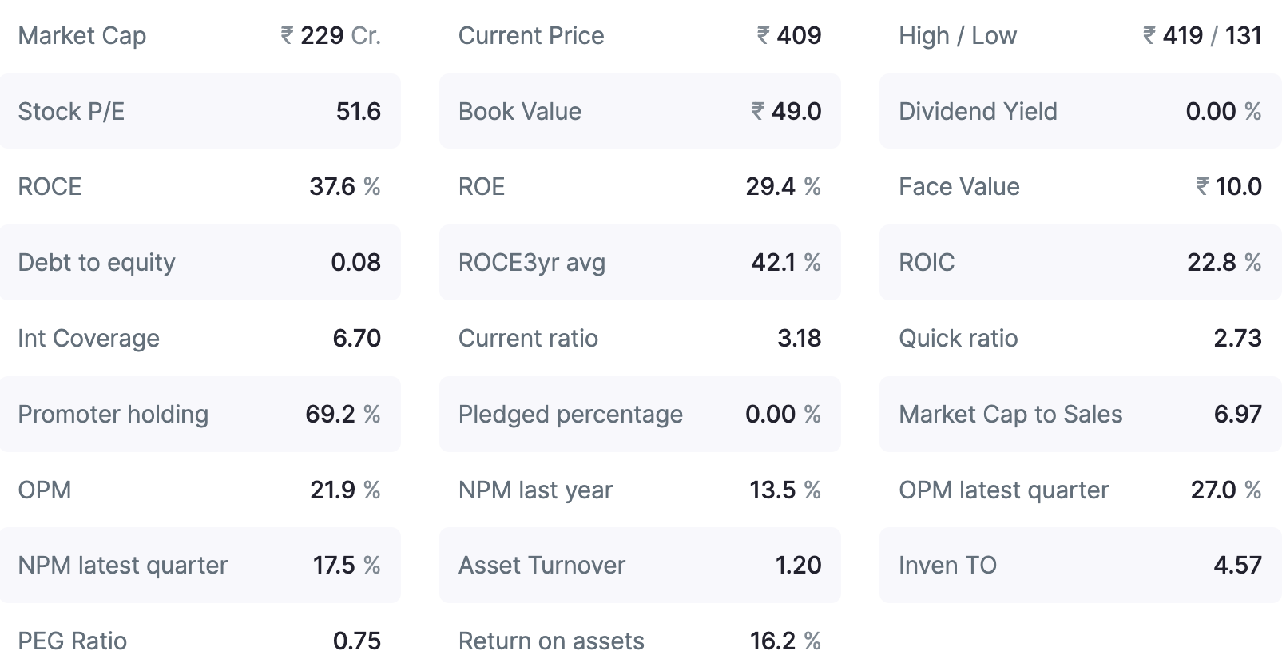

Check Corporate Video here:
https://www.anlon.co/video-gallery

Interview:
https://youtu.be/IEWJ9GVO1kk?si=ZWkR08FmIDSFVCjQ

Presentation:
https://nsearchives.nseindia.com/corporate/ANLON_05032024220612_Regulation30.pdf

Compiled Notes from here and there

