PORTFOLIO CONSTRUCTION

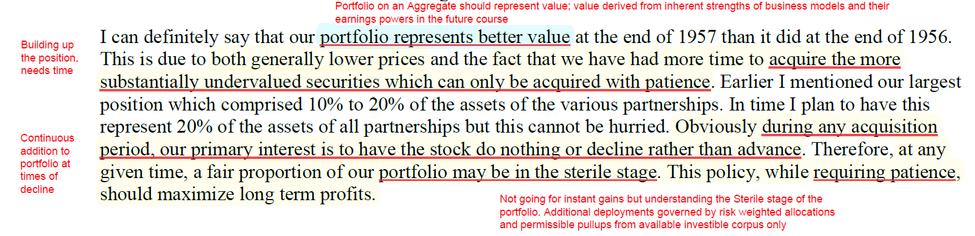

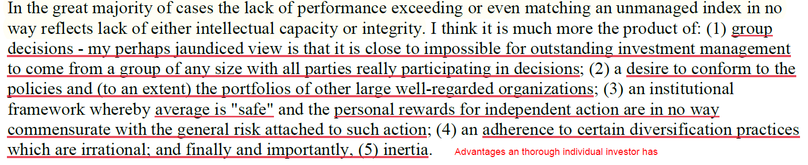

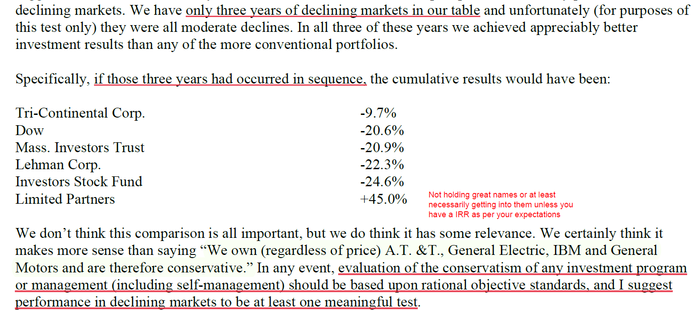

PORTFOLIO DIVERSIFICATION AND ALLOCATION

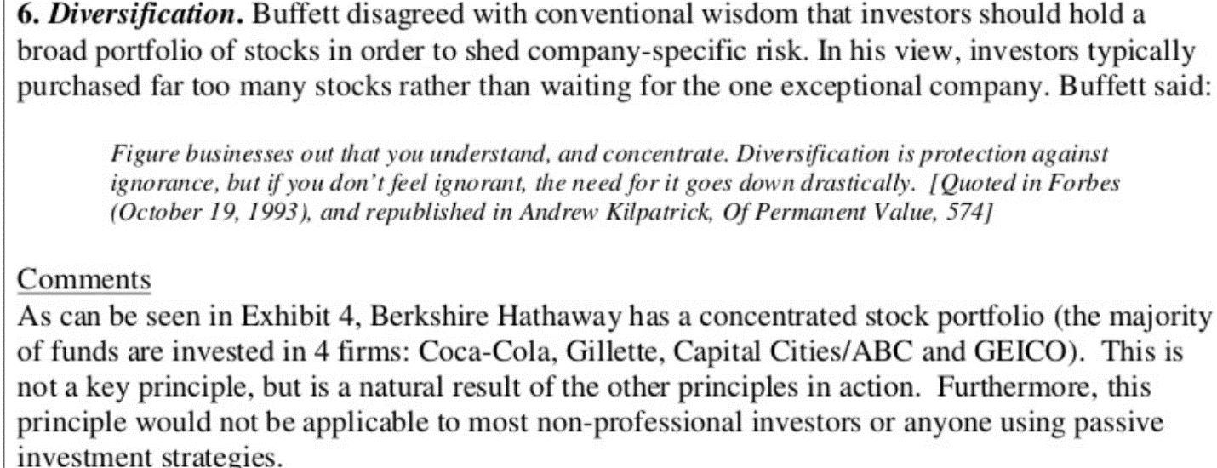

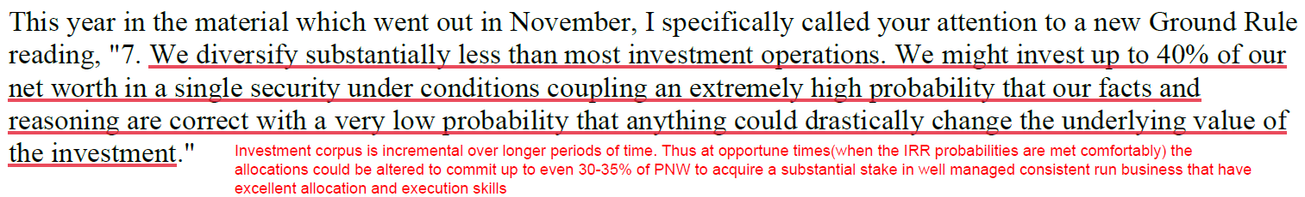

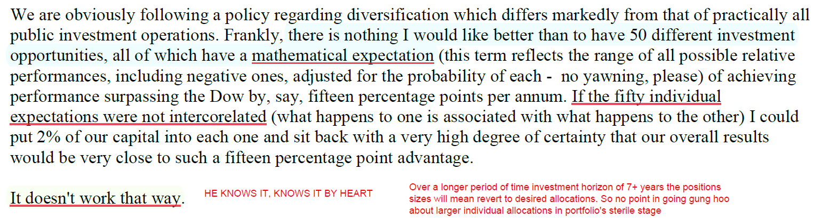

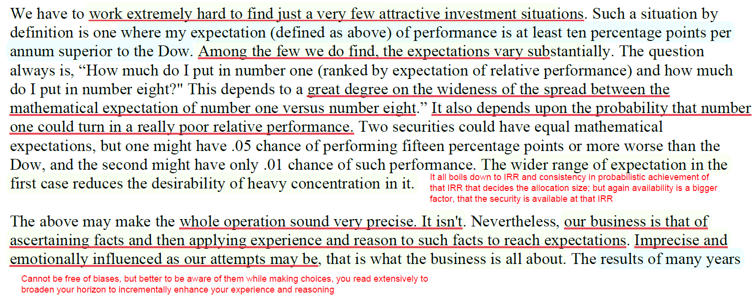

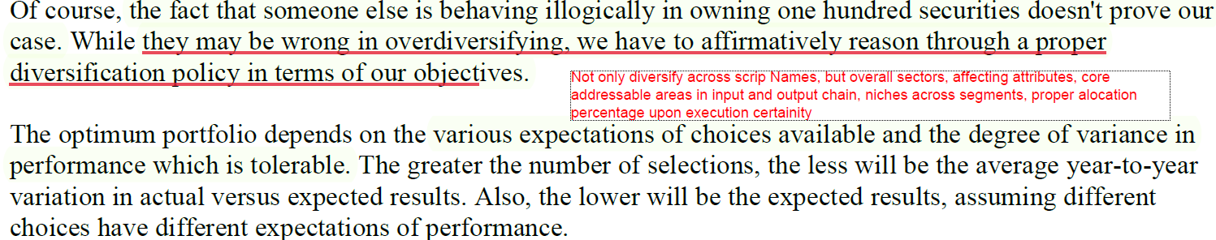

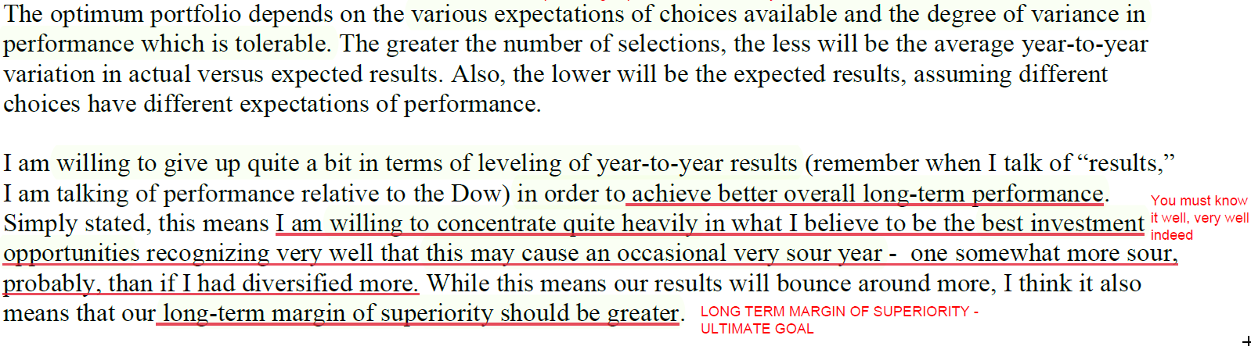

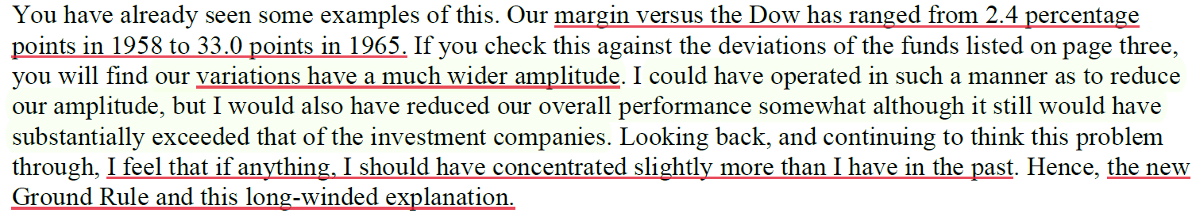

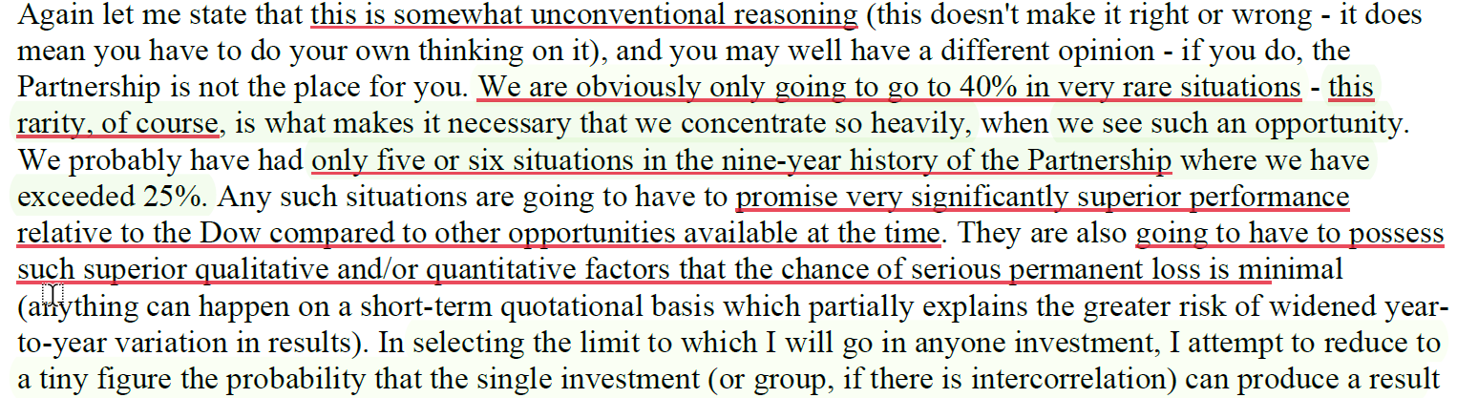

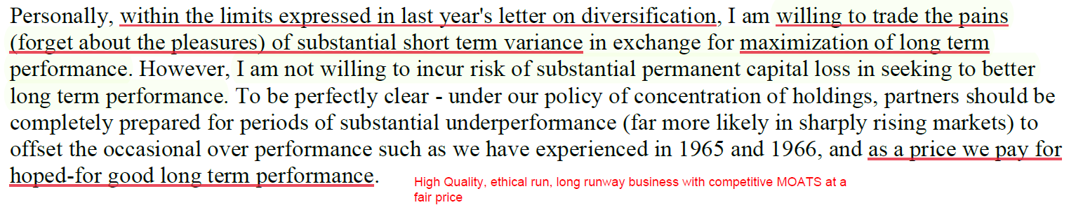

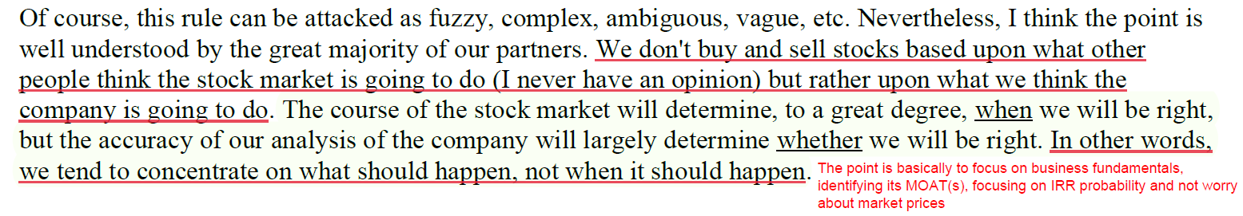

Rarity of IDEAS

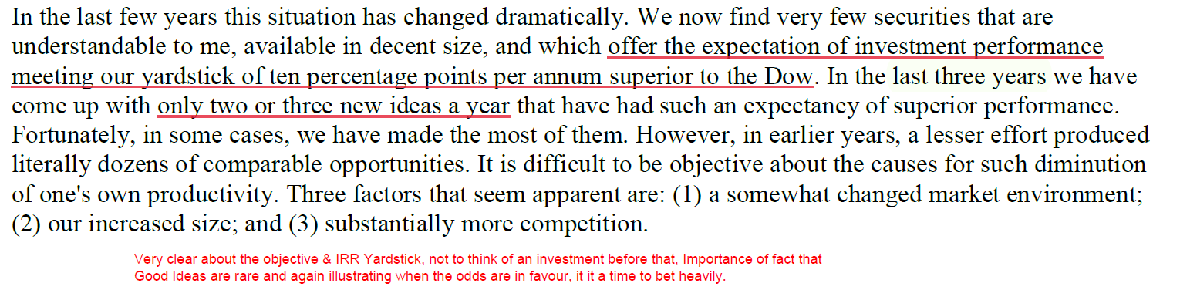
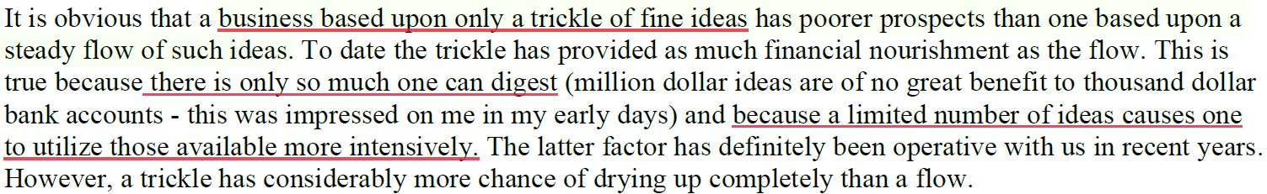

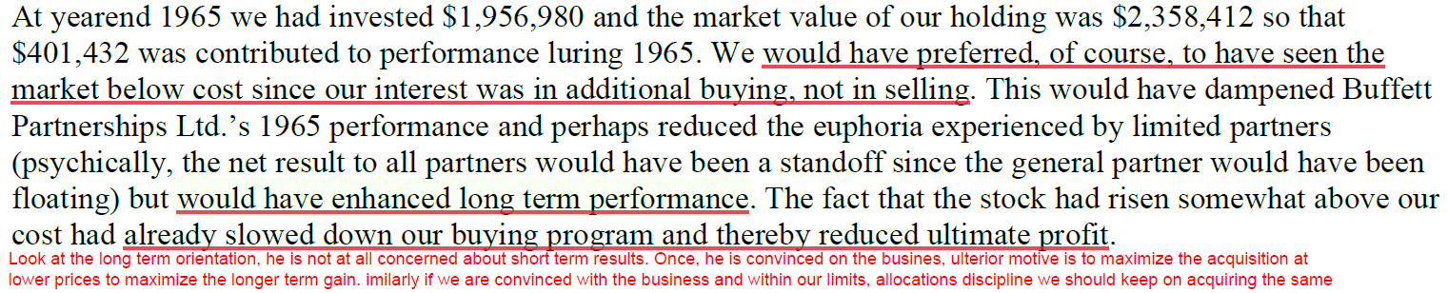

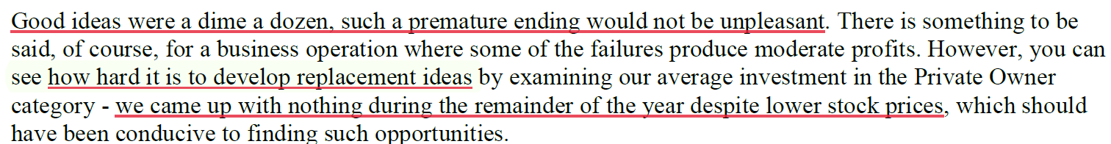

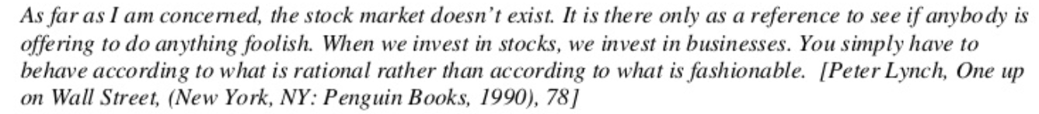

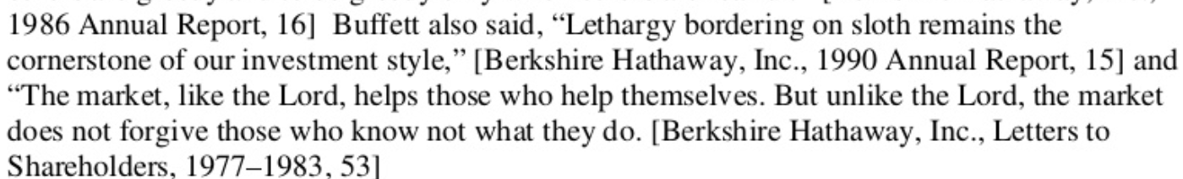

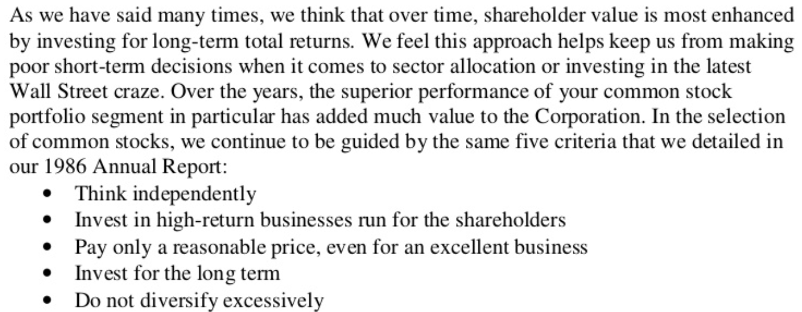

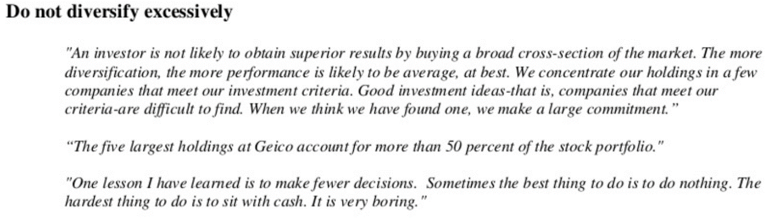

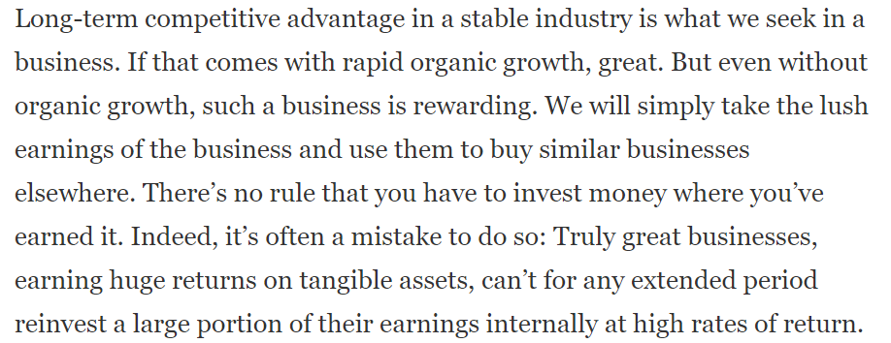

Same thoughts of our applies to financial sector is India which is undergoing value migration from inefficient, not an great customer experience, stuck in bureaucracy PSU banks to robust, tech driven, risk averse Private sector banks and financial institutions.
Financialization of India at a broader level with increasing internet penetration is going to have a huge potential for the next decade for these well managed/stable and highly scalable business models.

