Sealmatic

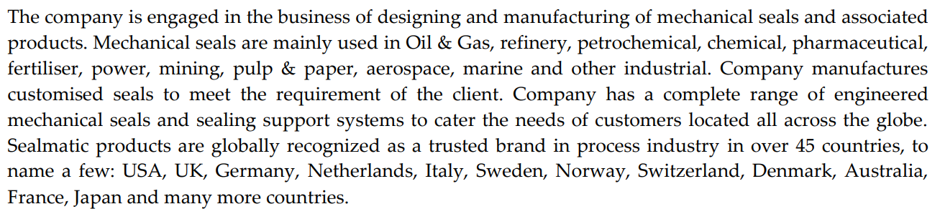

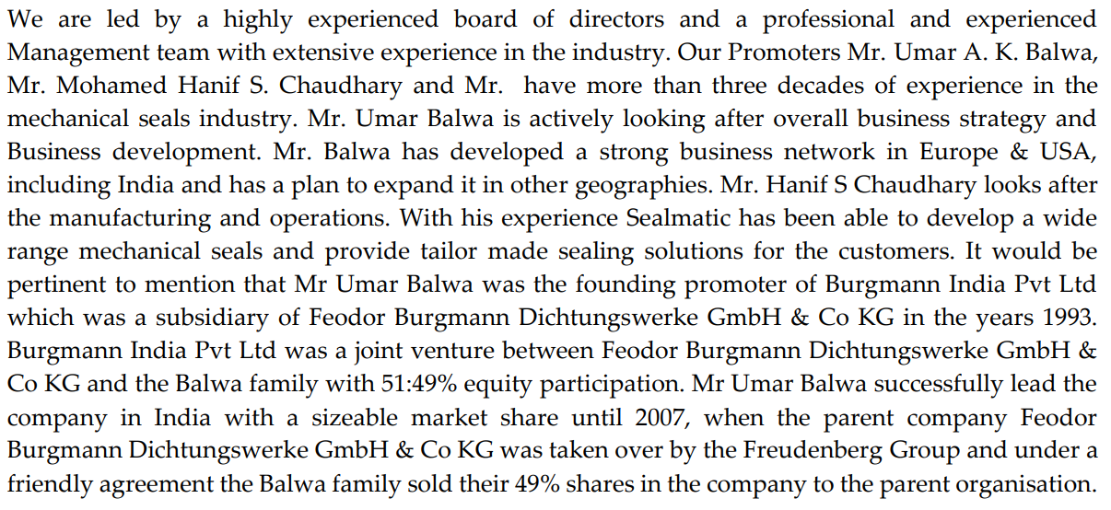

Change in depreciation method has artificially boosted profits

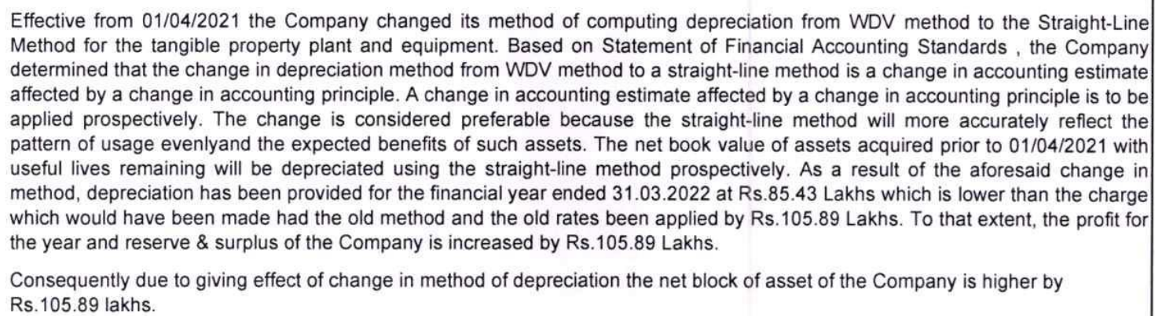

<https://primeinsights.in/sealmatic/>