CHAIRMAN SPEECH
The successful commissioning and vertical start-up of the Indonesia BOPP film line in December 2021 is a major milestone which is expected to positively impact earnings in future, as we continue to ramp up the capacity to optimum
levels. This, along with the US expansion and other ongoing smaller investments are aimed at increasing our competitive edge with increasing share of specialty products and productivity enhancement which would provide further impetus to our operations over the next few years.
As a leading producer of plastic packaging films, Polyplex has a strong commitment towards sustainability and has long been working on innovative and sustainable solutions, as an endeavor to continuously address global concerns around sustainability and circular economy. A major step in this direction was the setting up of our subsidiary in Thailand, Ecoblue in 2012. Over the years, EcoBlue has successfully developed new innovative solutions and recycled resins for use in high end applications. The newly started recycling line at Ecoblue is targeted towards meeting the brand owners’
growing demand for recycled resins for meeting their sustainability commitments.
In 2021, the Company has succeeded in scaling up the post-consumer recycling (PCR) content in our film from 90% to up to 100% and hopes to increase gradually the commercial sales volumes in the future. Our R&D efforts remain directed towards developing solutions which fit in to our commitment to reducing the impact of plastic waste on the environment.
Our low gearing of 0.09 (net of cash& cash equivalents) at the end of the current financial year gives us the right platform to consider positively, any potential growth opportunities.
In line with the improving profitability and financial position, as well as keeping in mind the cash requirement for the growth capital commitments, the Board has proposed a final dividend of 0.34 THB per share subject to approval of the shareholders.
Taken along with the interim dividend of 0.97 THB per share, the total payout of 1.31 THB per share for the year represents 35% of the normalized net profit of the company, as compared to a payout of 30% in the previous year

---------------------------------------------------------------------------------------
Polyplex has always been a first mover and Trend Setter in the Industry. Given below are some of our achievements and our key strengths:
1) First Indian headquartered film producer to set-up overseas operations in 2002
a) This was a unique and bold step for a single location producer with a modest turnover and balance sheet to make a greenfield investment in a PET film line in Thailand
b) This was followed quickly with another PET film line (financial commitment made even before the first line started up in Apr’2003) and resin plants at the same location
c) In 2004, the PTL was listed on the SET in Thailand (among the fastest to list from start-up of
operations) and decided to invest into another greenfield site in Turkey
d) This was followed by regular growth capex in all existing locations besides addition of two new
countries – USA in 2011 and Indonesia in 2017.

2) First in the industry to
a) Invest in forward integration into Metalizing
b) Run 10.6 meter PET film line at speed of 675 mpm with Direct Melt Casting
c) Strategically invest in assets and product development to broad base the portfolio resulting in
Polyplex having an unmatched and most diversified portfolio of products

3) First producer to
a) Have Direct Melt Casting facility for better productivity and lower energy costs
b) Introduce several specialty products in the market including very high barrier metalized films, twist films, etc.

4) Perhaps the only player to have integrated resin and film manufacturing across all locations.

5) Long before industrywide concern and efforts around sustainability and recycling plastic waste, in 2013,
PTL invested in mechanical recycling of post-industrial and post-consumer plastic waste through its subsidiary EcoBlue in Thailand. As a next big step in this direction, a new state-of-the-art mechanical recycling facility which uses post-consumer baled bottles as input has just started in Ecoblue in Q4
2021-22. It would cater to high-end applications in PET Bottles and Polyester Filament Yarn, supporting brand owners to meet their sustainability targets. Complementing this, PTL has also invested in selfdeveloped,
chemical recycling process whereby post-consumer PET bottle waste is converted to food grade Resin which is used with varying concentration in PET films. PTL has products in portfolio which have up to 100% PCR content. With ongoing investment to expand chemical recycling capacities in Turkey and Thailand, PTL leads the way towards achieving circularity in flexible Packaging.
In addition, EcoBlue has also built capacity to recycle post-consumer Olefin based waste to enable Global Brands to meet their sustainability targets around usage of recyclable material and recycled content in their plastic consumption. The machinery has been commissioned in March 22 and trial runs are underway, with commercial production expected to start within Q2 2022-23.

Business Strategy
Over the years, Polyplex has been working towards developing a strategy which would enable it to become one of the Leading One-stop Innovative plastic film suppliers, the preferred Global Packaging Solution providers, offering a wide range of plastic films.
Polyplex seeks sustained and profitable growth i.e. a judicious balance between revenue enhancement and benchmark return on capital employed.

Key elements of our business strategy
1) Investment in versatile state-of-the art film plants and other assets
2) Sustained focus on operational excellence to maintain global cost leadership
3) Upstream and forward integration to broaden product portfolio and enhance competitiveness
4) Focus on increasing the share of speciality films (based on cost- effective R&D, open innovation, backward integration and multi-level customer collaboration) underlying which is a substantial base of standard films to position ourselves as Tier -1 supplier leading to increased margin with reduced
volatility. Standard films are essential as most customers (especially in flexible packaging segment) buy both standard and speciality films. This also helps defray costs optimally through scale. The dynamic nature of what constitutes “speciality” means that this would always be a relatively small (but
essential and profitable) component of the business portfolio.
It is true that the erstwhile “majors” are almost exclusively focused on the higher end of the market – e.g. the electronics segment.
Such an approach requires a very high level of technological competence and investment and at the same time it has resulted in their diminishing market share and presence in the overall PET film industry.
5) Strengthening market leadership by converting and dedicating older lines to speciality film production (with rationalised production for global niche markets) making them highly cost effective
6) A strong and growing volume of standard films in markets where there is a clear competitive advantage and an ability to differentiate from other local producers.
7) A unique value proposition to the customers which combines the benefits of on-shoring, off-shoring and near-shoring (combination of core values of cost competitiveness, customer intimacy, innovation and a safe, reliable and responsive supply chain)
8) Building global leadership position in value-added film segments like silicone coating where backward integration, customer synergies, economies of scale and global market reach provide significant competitive advantage
9) Product diversification across different types of plastic films
10) Maintaining a conservative financial profile
11) Continuously evaluating growth / acquisition opportunities in niche value- added film segments to consolidate our position
12) Post-industrial and Post-consumer waste recycling to support global initiative towards sustainability and circular economy
Working on this strategy, we have over the years, built a business model which is very difficult to replicate and have established ourselves as a Supplier of choice for all the innovative product needs of our customers
globally.

Integration
This ensures supply chain efficiency, cost optimization & lower time to access and market new Products and
Applications.
Backward integration into resin at all our film manufacturing locations is unique to Polyplex among the large
global producers as others either do not have any captive resin facility or even if they do have, it may be at
one location only and may not cover their entire requirement.

Well spread Sales & Distribution network
1) Polyplex sales & distribution network is unmatched in the industry even when compared to other multilocational producers. Except Africa and South America where we do not have any direct local presence and sell either directly or through some commission agents, we have direct presence mostly through
employees of local origin in all the key regional markets.
2) Direct sales presence through employees of local origin in key geographies in Asia, Europe and NorthAmerica
- Local presence in China, Japan, Korea, Malaysia, Vietnam, Philippines, Singapore besides Thailand and Indonesia
- Physical presence of European sales team comprising of more than 8 nationalities in many countries of the EU
- North America sales team physically located in different US cities
- Customers in African and South American markets are catered directly or through commission agents
3) Knowledge of local language, cultural affinity and physical presence play an important role in developing strong customer relationships and is a key differentiator for Polyplex in the competition landscape.
Particulars Other Asia Europe North America
Competitive Advantages from Ongoing strategy
1) Standard products
a) Much better placed than most of our competition which helps get better & more stable prices / margin as well as volumes due to:
i) Multiple locations, near-shore or onshore presence in all key markets resulting in quick deliveries and supply chain dependability
ii) Competitive delivered cost due to logistics / duty differentials
iii) Cost leadership through investment in state-of-the-art contemporary assets with multiple lines / facilities in one location for economies of scale, highest productivity and operational excellence
iv) Benefits of Integration - captive resin as well as downstream assets complement the product range, enable product development and a complete supplier image
v) Consistent and good quality
vi) Customer intimacy with our Sales & distribution teams, technical services and R&D / innovation efforts
b) Higher sales in more sophisticated, quality and service conscious markets with entry barriers like USA and Europe (with some supplies from low-cost manufacturing locations) has helped us increase our EBITDA/kg as well as EBITDA margin
2) Value Added & Speciality products
a) A substantial portfolio of value added and speciality / D-PAC products has been created which acts as a twin-layer moat for preserving the profitability / margins on the entire business
b) An ever-expanding range of products covering metallised films, offline coated films – extrusion coated, silicone coated as well as general purpose coatings, inline coated films and holography have led to expansion of as well as stability in margins

Thin PET
We have internally categorized the end use of thin PET films in different applications as follows:
1) Flexible Packaging
a) Food Packaging
i) Sugar & Chocolate Confectionary
ii) Cheese and Dairy Products
iii) Tea & Coffee
iv) Frozen Foods
v) Crisps, Snacks & Nuts
vi) Dried, Dehydrated Foods & Cereals
vii) Biscuits & wafers
viii) Staples like sugar, rice, flour, spices, cooking oil, etc
ix) Other foods e.g. ketchup, juice, water cup lidding, ice cream cones, etc.
b) Cigarettes & Tobacco e.g. cigars, chewing tobacco, etc.
c) Medical & Pharmaceutical e.g. transdermal patches, gel patches, etc.
d) Personal care & hygiene e.g. wet wipes, shampoo, hand soap, etc.
e) Kitchen & Home care e.g. detergents, fabric softeners, refill packs, kitchen sponge, etc.
f) Pet Foods
g) Garden and Outdoor e.g. insect control, fertilizers, seeds, pesticides, etc.
h) Miscellaneous including balloons, car freshener, bag in box, gift wraps, garment packaging etc.

2) Labels
Barcode, outdoor labels (shipping / retail), QR code, Liquor bottle, shampoo, etc.
3) Carton packaging
Liquor Boxes, Tetra Pak, laminated cartons, susceptor pouches, perfume, chocolate boxes, etc
4) Electrical & Electronics
a) ESD Bags
b) Cable insulation
5) Other Industrial
a) Flexible duct
b) Hot Stamping Foil
c) Adhesive Tape
d) Construction Industry e.g. shingle tape, etc.
e) Release and transfer application e.g. FRP, textile transfer films, printed wood panels, etc.
f) Others - emergency blanket, textile yarn, glitter, reflective insulation, blackout blinds, etc.
6) Digital
Wide format, photo album, signage, tags, Calendar, display / menu cards, etc,
7) Thermal Lamination
Book lamination, ID card lamination, cigarette carton, lamination pouch, etc.

Thick PET
Key applications for thick films are as follows:
1) Media & Decoration Films e.g. Backlit, Banners, Window ads, graphic arts
2) Release Liner Films e.g. liner for electronics, protection films, etc.
3) Window
a) Safety Films
b) Sun-Control Films
4) Specialty Liner e.g. Medical Patch
5) Electronic Segment e.g. Membrane Touch Switches “MTS”, Keypad, mobile protection films, etc.
6) Electrical Segment e.g. motor and transformer insulation, heating films,
7) Photovoltaic (PV) Back-sheet
8) Construction Segment e.g. Fiber Reinforced Plastic

BOPP (or OPP)
Sarafil BOPP films are transparent bi-oriented polypropylene films designed to offer high performance, great appearance and easy converting for flexible packaging and other applications.
Like BOPET film, BOPP is also a biaxially oriented film with good mechanical and physical properties. It is a clear, flexible, transparent or translucent material produced from PP polymer, a linear, thermoplastic polypropylene resin. BOPP film is available commercially in a range of widths, thicknesses and properties
depending upon the end use requirements. The subsidiary in Indonesia has implemented a project for BOPP film which just started commercial operations in December 2021.

Like PET films, we have internally categorized the end use of BOPP films in different applications as follows:
1) Flexible Packaging
a) Food Packaging
i) Confectionery
ii) Ice cream
iii) Crisps, Snacks
iv) Biscuits
b) Personal care & hygiene e.g. shampoo, soap overwrap, etc.
c) Garden and Outdoor e.g. flower overwrap
2) Labels including Wrap around labels, Pressure sensitive labels and In-mould labels
3) Carton packaging including lamination and overwrap
4) Textile Bags
5) Adhesive Tape
6) Graphics Lamination film - Covers, Menu Cards, Photo album, Visiting Cards, Diaries, etc.

CPP
Sarafil CPP films are transparent cast polypropylene films designed to offer high performance, great appearance and easy converting for flexible packaging and other applications.
CPP films are also produced from a combination of various grades of PP polymer. Various constructions of CPP are available (multi-layer options) which are used to cater to several applications in specialty packaging, as a sealant layer in conjunction with other plastic substrates for packaging of food products, twist wrap usage in candies, etc.
1) Flexible Packaging (Plain and Metalized)
a) Traditional applications
i) Sealing
ii) Barrier
iii) Overwrap / bread bags
iv) Lidding films
b) Non-conventional / specialty applications
i) Retort CPP film
ii) Medical
iii) Anti-fog films
2) Industrial
a) Decorative lamination
b) Carrier film for printed circuit board
3) Labels
a) Protection films for labels
4) Others
a) Flower wrap
Blown PP/PE
BLOWN PP and PE film are available in a wide variety of features and properties used in specialty flexible
and other applications
BLOWN PP, another variant of PP based film are used in pressure sensitive applications
Another variant of PP based film; this film would be silicone coated either on one or two sides for usage as a
carrier film for pressure sensitive applications. Available in various colors, this kind of PP film is mainly used
in the peel & stick waterproofing membranes where low release property at very high temperature is required.
The Blown PP film is a niche product requiring specialized assets with unique flatness and low shrinkage
requirements to enable optimum film processing on variety of coating machines.
The end use of Blown (PP/PE) films in different applications as follows:
1) Flexible Packaging (Plain and Metalized)
a) Traditional applications
i) Sealing Layer
b) Non-conventional / specialty applications
i) Retort PP film
ii) Metalized PE films
iii) High Barrier films – meat, seafood, etc.
2) Industrial
a) Release Liner for water proofing underlayment
b) Laser die-cutting for safety airbags
c) Container liners
d) Vapor Corrosion Inhibitor (VCI) films for metal protection
3) Agricultural Application
a) Mulch Film for moisture & insect protection and fumigant retention
b) Silage films

Markets and competitive environment
Our core business is BOPET films, which is a very well established industry with emerging end uses ensuring consistent healthy growth rates and a significant Potential.
It is an attractive, vibrant and growing $10bn industry with > 2.5x of global GDP growth rates since the turn of the millennium and > 3x in the last decade.

Some of the key features of this industry which ensures such a healthy growth rate is as under:
• The products’ versatility ensures a continuous stream of new applications
• Consistent increase in demand de-linked from broader economic cycles as many applications including flexible packaging are non-discretionary in nature
• Low per capita consumption of flexible packaging and end use consumer applications for electrical & electronics and other industrial films in developing countries to assure sustained growth for the foreseeable future
Over the years, the BOPET industry has evolved across the breadth of product usage, cost-efficient manufacturing technology as well as capacities and geographies. Some key structural changes brought about by this evolution is as under:
• An inexorable move to the East with Asia accounting for ~80% of both demand and capacity
- Chinese producers turned to manufacturing at scale to serve a rapidly growing domestic demand with a few of them backward integrated into feedstock
- China accounts for almost half of the world’s demand and supply for both Thin and Thick Films
- India emerges as strong demand center with consumption levels higher than North America, Europe and Central & East Asia (excluding China)
- Indian owned businesses have enhanced capacity and global footprint
• Packaging has become the largest application constituting ~62% of demand. Flexible packaging continues to spur growth, further aided by new applications across electrical (PV) & electronics and other industrial films
• A dispersion of technology with progressive orientation towards higher productivity assets for standard films
• Gradual regionalization with domestic producers meeting requirements in large demand centers

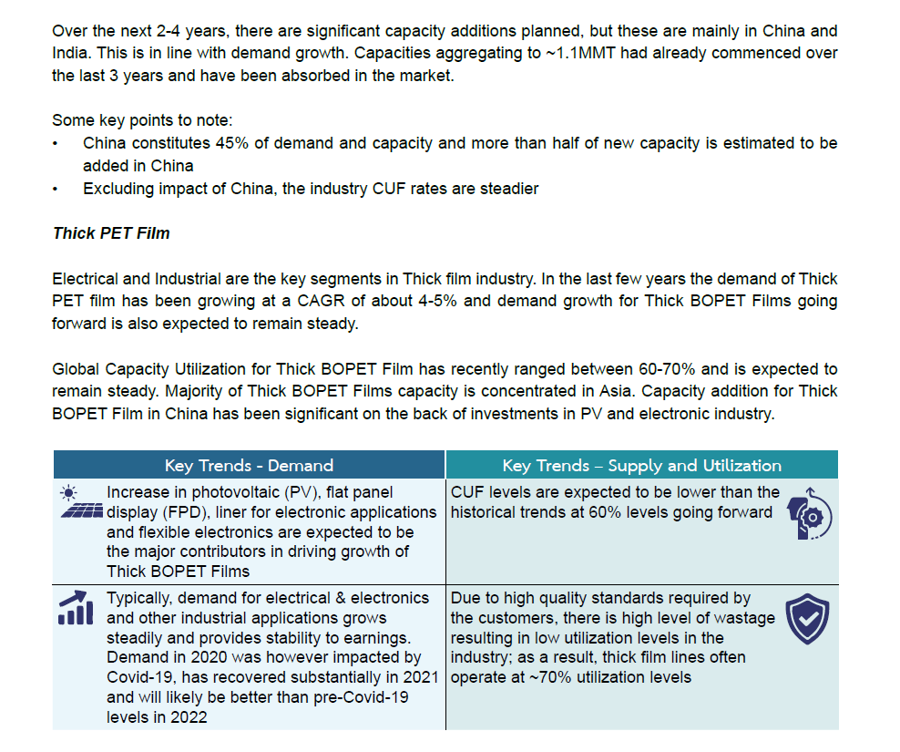
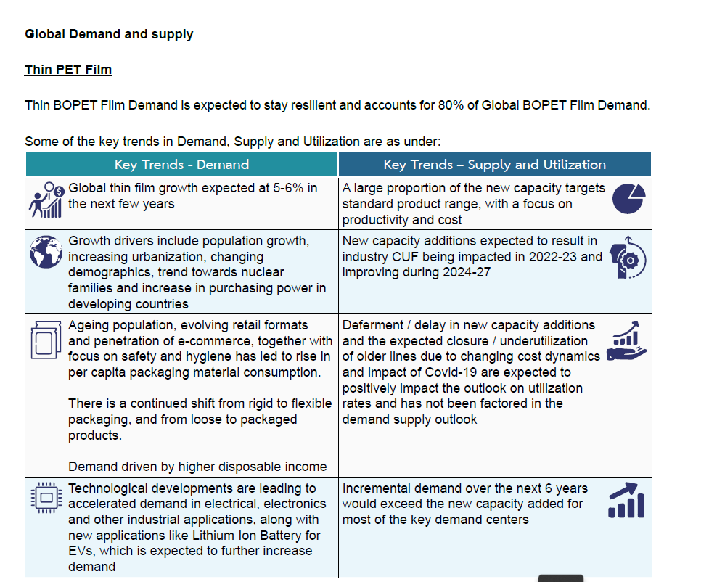

Conclusion on BOPET Thin film Industry
• While there is significant capacity addition expected in next 2-4 years, this is in line with demand growth.
• Most of the new capacity additions are planned in India and China (together accounting for ~80% of total):
• Exports from China beyond East Asia are insignificant, given limited product portfolio, inflexible commercial terms, constrained technical support and high import duties (especially in USA). Within East Asia also, Chinese imports are subject to significant import duties in Indonesia and Korea.
• As far as India in concerned, it is a big market and growing at double digit rates which itself would generate additional demand in future. Exports to USA market are limited due to heavy duties on most of the products. Europe is one of the key markets for Indian players who already have presence in
this region.
• Given the versatility of the product, new applications with significant volume emerge from time to time.

Illustratively, PET film is now being used in the production of Solar modules and Electric Vehicle (EV) Batteries. Demand for these and other such applications would ensure healthy growth of the industry in the coming years.
• The impact of new capacities is also likely to be mitigated somewhat by expected closure of some older and inefficient lines as they would not be able to compete with the new wider and faster high productivity
lines.

BOPP Film Industry
• The global demand for BOPP is ~9,000 KMT and is expected to grow at ~5%
• Food packaging accounted for ~65% and non-food packaging for 18% of the total BOPP demand in 2020
• International trade in BOPP relative to production is much lower in comparison to BOPET, as BOPP is dispersed geographically
