New Delhi Television (NDTV) is one of the leading news broadcasting companies in India. The company operates three channels namely NDTV 24X7, NDTV India and NDTV Prime. The company earns revenue from advertisements sales (63% of FY21 revenue), event sales and subscription revenue (DTH and cable operators). Advertising revenue includes sale of free commercial time (FCT), sponsorship of programs, etc. Subscription income comprises of revenue from Cable and Direct-to-Home (DTH) Providers and from international distribution operations. Event sales are derived from special programmes or campaigns that are sponsored.

NDTV Convergence Limited, a subsidiary of the company, is set up to use the synergies between television, Internet and mobile. NDTV Convergence owns the digital media business of the group and controls all NDTV websites, including NDTV.com



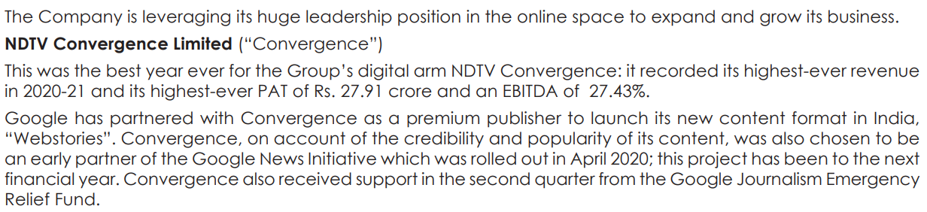

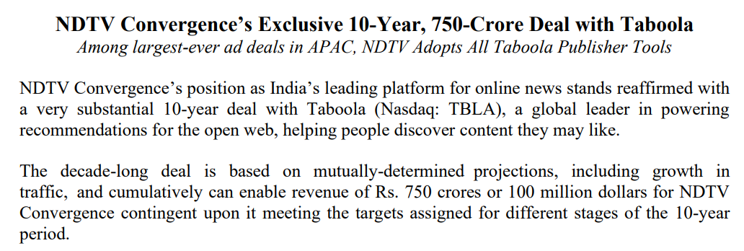

In the last few years, there have been several structural, transformational changes in the company.



There has been large-scale debt reduction.

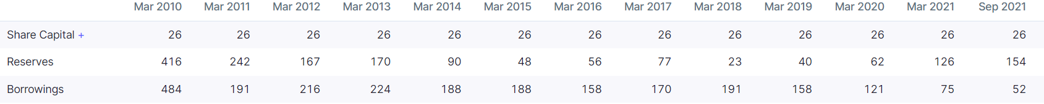



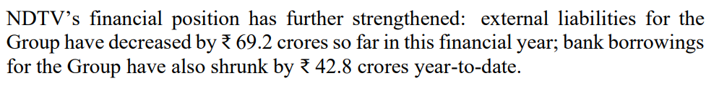

They have taken cost-cutting measures.

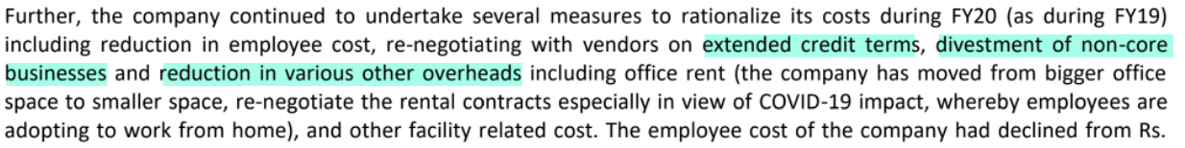



They have divested their 45.56% stake in the loss-making business, Fifth Gear Venture.



They also sold the non-core Gadgets360 business.

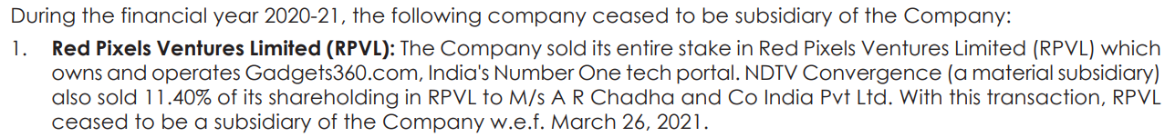

They have also decreased debtor days, by making provisions for and writing off bad debts, as well as improving collection efforts.

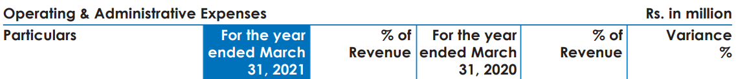

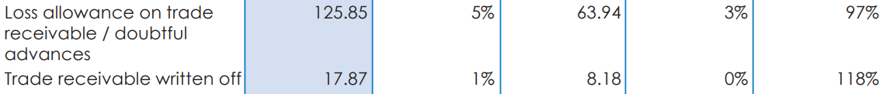

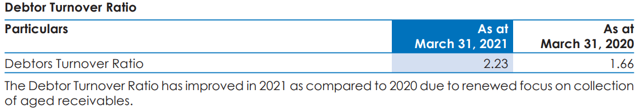

As a result, working capital has improved significantly in FY22.

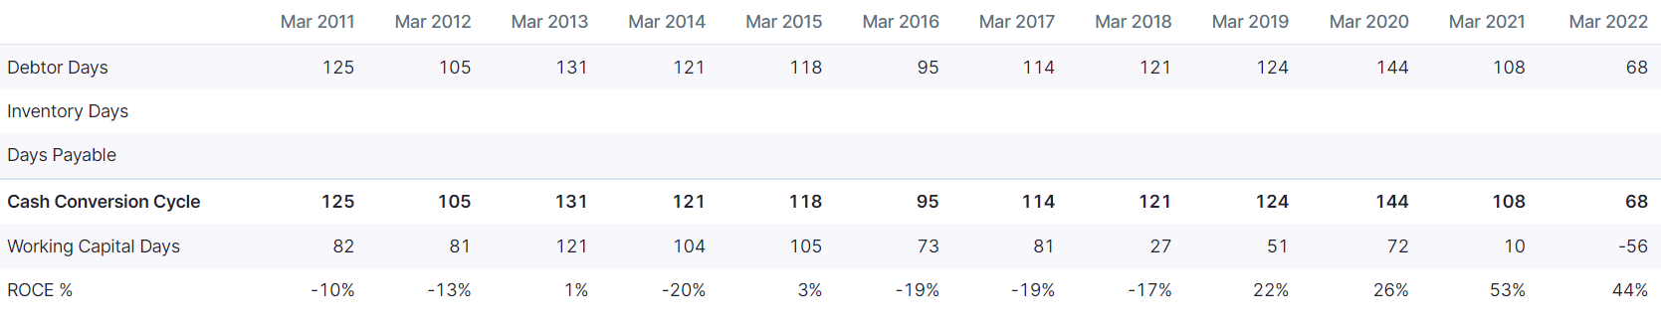



Recent financial performances, too, have been best-ever with highest-ever revenues and profits.



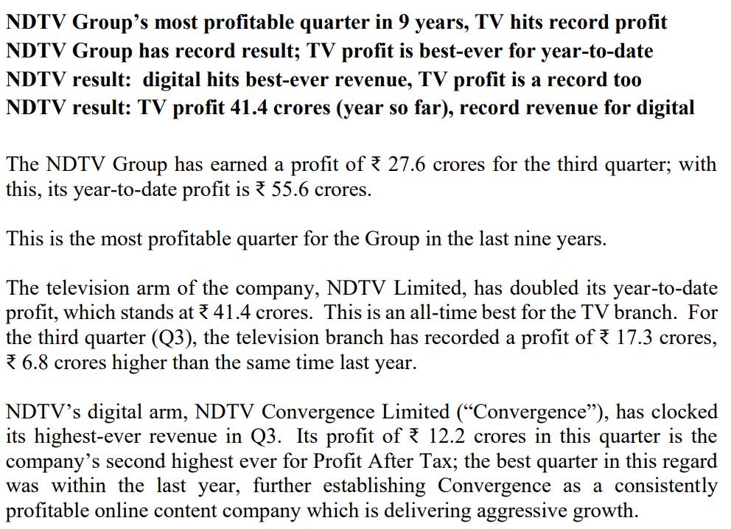

A penalty has been imposed on promoters: “The Securities and Exchange Board of India (“SEBI”) had issued a notice dated 5 September 2018 to Dr. Prannoy Roy, Mrs. Radhika Roy and RRPR Holding Private Limited (Promoter Group Company) in regard to alleged violations under Securities and Exchange Board of India Act, 1992 (“SEBI Act”) read with SEBI (Prohibition of Fraudulent and Unfair Trade Practices Relating to Securities Market) Regulations, 2003 and Equity Listing Agreement read with Securities Contracts (Regulation) Act, 1956 on account of alleged non-disclosure of the loan agreements entered in 2008 – 10 by – (i) the Promoter Group Company with ICICI Bank Limited, and (ii) the Promoter Group Company and Promoters with Vishvapradhan Commercial Private Limited. SEBI vide its order dated 24 December 2020 imposed a penalty of INR 2,500 lakhs (INR 25 crores) on the Promoters and Promoter Group Company under Section 15HA of the SEBI Act, to be paid jointly and severally within 45 days of the receipt of the order and a penalty of INR100 lakhs (INR 1 crore) each has been imposed on the Promoters under Section 23H of the Securities Contracts (Regulation) Act, 1956, to be paid within 45 days of the receipt of the order.”

The key risk is of litigation and court cases.

Disclaimer: Any analysis shared should not be construed as investment advice. Any analysis is not a buy/sell/hold recommendation. I am not a SEBI registered investment advisor. Please consult your financial advisor before acting on any analysis. The author shall not be liable for any losses incurred by readers while acting on any analysis. The author may have holdings (and hence a vested interest) in any companies mentioned and the analysis may be biased. The content and analysis shared are for educational purposes only.

The writer can be reached at malhar.manek@gmail.com