Banco Products

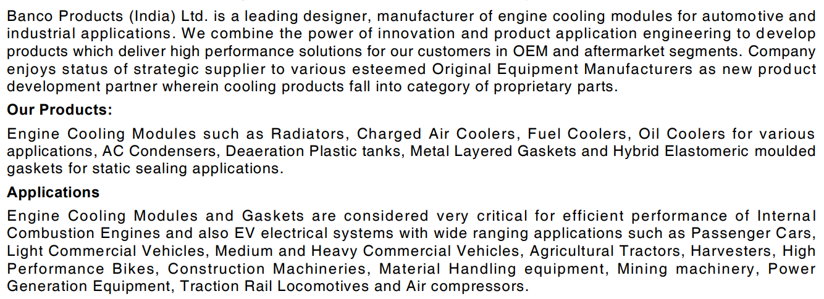



<https://www.careratings.com/upload/CompanyFiles/PR/31032022074052_Banco_Products_(India)_Limited.pdf>