Maithan Alloys Ltd.
Industry Analysis:
- Product Analysis:
  - Based on product, ferroalloy market is categorized into ferro chrome, ferro manganese, ferro silicon, ferro silicon-manganese and others. Among these ferro manganese shows a decent annual growth rate of about 6% over the forecast time spell. These are used in the production of steel as a desulfurizing agents. The product removes nitrogen bubbles and reduces the amount of iron oxide, which is undesirable during production of steel. It also acts as an alloying element contributor in various types of steels.
- Commodity
- Extremely scattered with a large number of market participants
- Extremely limited Pricing Power due to purchasing power of big steel plants
- Domestic Supply > Domestic Demand(Over-production): With an annual production capacity of 5.15 mt, the ferro-alloy industry is battling a slowdown for last five years and the production of:
  - Ferro-Chrome has stagnated at 1 mt
  - Ferro-Manganese at 0.52 mt
  - Ferro-Silicon at 0.09 mt
    - Dated info(2013)
- Porter’s Industry Dynamics:
  - Buyer Power: High
  - Supplier Power: Medium
  - Competitive Rivalry: High
  - Threat of substitutes: Low
  - Threat of Entry: Low
- Growth Estimates:
  - Domestic: National Steel Policy envisaging to take domestic steel production of about 300 million tonnes by the end of the year 2030 as against production of about 106.5 million tonne in FY19. This translates to an overall growth rate of 9% annually. Assuming a 1:1 ratio between Steel & Manganese ore demand
  - International: CAGR of more than 5.5% globally up to 2025
- Chinese market remained the primary driver behind manganese demand – this might have a negative impact on Maithan’s share price due to Corona virus outbreak
- Raw materials for bulk ferro alloys:
  - Manganese ore
  - Chrome Ore
  - Reductants
  - Power
  - Logistics
- Major cost contributors:
  - Raw Material prices
    - Maithan imports 90% of ore from outside India and 10% domestically
    - However, the Company sources raw material when it gets sales contracts, helping optimize inventory costs.
    - It has a captive mining lease in India through Anjaneya Minerals(a subsidiary)
  - Power & Fuel charges
    - Advantage may be due to owning captive power plants(long term advantage) and Power subsidies from state Govts.(short term advantage)
  - Logistics
- Possibility of a huge shortage of key raw materials as seven operating manganese mines and four working chromite mines will shut operations shortly – profit margin reduction due to rising raw material prices. The main concern would be the availability of Coal, Coke and high grade Manganese Ore and Chrome Ore. The Industry has to depend for high grade 17 Manganese Ores on imports.
- The ferro alloy industry in India has never been globally competitive, despite its rich ore deposits and low-cost manpower, essentially due to:
  - Stagnating steel demand and production in the country
  - High Power costs
  - Increasing ores and reductants cost
  - Non-availability of low ash, low phos. coking coal in the country for the production of desired coke with low ash, and low phos. contents, making import of such coke at a high cost imperative
  - High-cost and insufficient infrastructural facilities (both road and rail) for rapid transportation of ore from mines to plants
  - Cut-throat competition from producers and exporters of Ferro alloys in other countries like South Africa, Kazakhstan, China, Russia, Mexico, Australia etc. due to global trade agreements which has made drastic reduction in customs duty on imports necessary
  - Wide fluctuations in the International price of Ferro alloys depending on demand versus supply

- Ferro Alloy imports are mainly from China, Russia, Norway, South Africa and erstwhile USSR countries like Kazakhstan and Ukraine. India is out-beaten by the international prices of Ferro Alloys only because of the high Power tariff in India, which has been increasing every year by 15-20%.(2010-11))
- Offlate, the rising cost of power in South Africa and China has improved the competitiveness of Indian producers in the global market.
- Major Players:
  - International:
    - Tata Steel, Arcelor Mittal, OM Holdings, Gulf Ferroalloys, Brahm Group, Ferroalloy Corporation Limited, SAIL, Sakura Ferroalloys, Eurasian Natural Resources Corporation, S.C. Feral S.R.L., Jindal Group, China Minmetals Corporation, Pertama Ferroalloys, Nikopol Ferroalloy Plant, and Shanghai Shenjia Ferroalloys
  - Domestic:
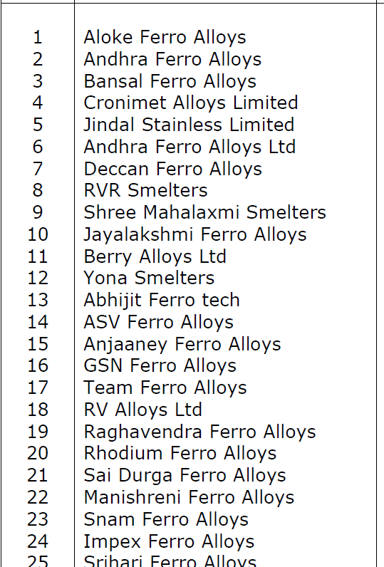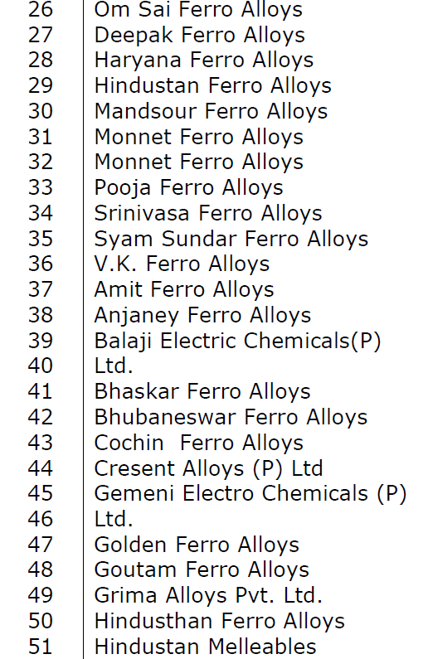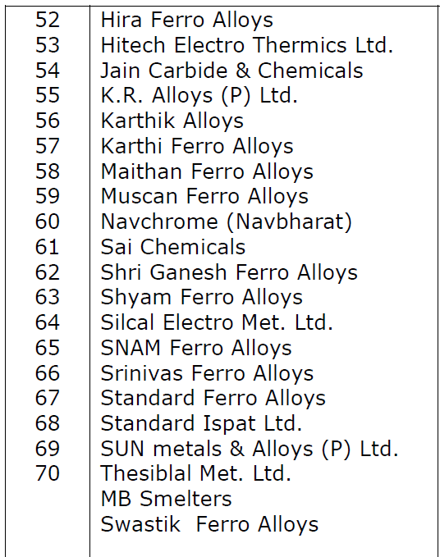
(Then the down turn in ferro alloys demand started in 1990s and further decelerated in 1997-98 due to over all recession in steel industry. This caused a crash in price of ferro alloys. In addition to this because of increased demand for ores from China, there was sudden rise in price of ores. Also there was increase in power cost due to withdrawal of some of the earlier concessional tariffs given in some areas. This resulted in closure of many ferro alloys plants in the country. Only those who had captive mining leases and/or captive thermal power generation plants or were located in such backward areas where concessional power tariff was extended, survived.

Company Analysis:
- Market Cap of Rs. 1415 Cr.
- High Promoter Holding - ~75%
- Institutional Holdings - ~3.02%
- Promoters have extensive experience having demonstrated capabilities to sail through several commodity down cycles with the focus on keeping costs low
- Lowest cost producer
- Had never in the last 15 years had a cash loss
- The company has zero debt in the books
- Rise in OPM is mainly due to external factors, such as Power subsidies & Lower Raw material costs, rather than the pricing power and/or culture of the company
- NFAT has been consistently increasing since FY2014 - Maithan Alloys Ltd has been able to time its capacity additions well with the customer demand so that the new capacity does not have to remain idle waiting for customer orders
- Inventory Turnover Ratio (ITR) on the rise since FY2013 - able to utilize the inventory more efficiently
- Able to convert its profits into cash flow from operations – Cumulative CFO of 1136 vs NPAT of 1101
- Business model of Maithan Alloys Ltd is relatively asset light, which is evident from the NFAT being consistently above 3.0 and reaching a level of 8.64 in FY2019 - Total capital expenditure of 361 to increase sales by 1336
- Maithan is India’s largest producer & exporter of Manganese alloys
- Market Share:
  - 6% domestic market share
  - 1.2% global market share
- Competitive Advantages:
  - Lowest Cost producer
  - Stronger Product Mix
  - Higher quality
  - Strong customer relations
- Industry will grow by a CAGR of more than 5.5% globally up to 2025
- Maithan Alloy’s selling prices are mostly fixed for long term contracts spanning more than approx. 3 months
- Does NOT have Pricing Power - Unable to pass on raw material cost increases to customers, as evidenced from the following graph:

Sources of Future Growth:
- Domestic Growth due to National Steel Policy – 6%
- Export growth – 5%
Ways to fulfill Growth:
- Greenfield expansion from Current capacity of 235600 tonnes in FY20 to 345000(=235000 + 120000 - Bankura) in FY24 – approx. 11% CAGR
- Greenfield + Brownfield expansion from Current capacity of 235600 tonnes in FY20 to 471200 in FY24 – 19% CAGR
The acquisition of the leasehold rights on land of Rs. 2594.32 lakhs is in conflict with the Asset-light business concept, as published by the company. May need to get a clarification on this from mgmt.. to determine future strategies.
High reliance of exports in Asian steel producers –may have impacted short-term due to Corona virus outbreak on both revenues and share price sentiments.

