Spectrum Electrical

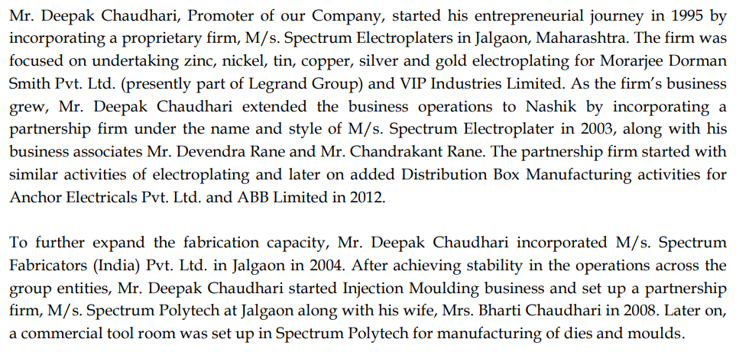

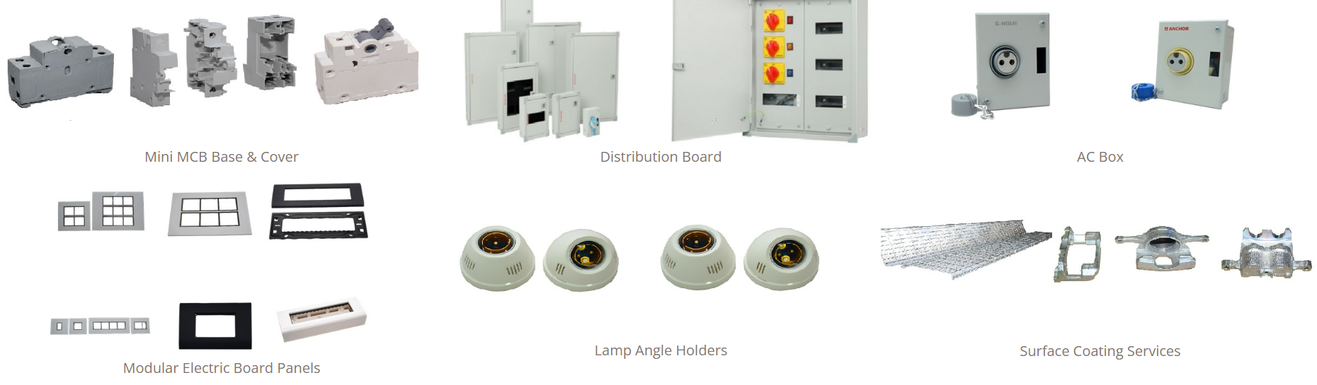

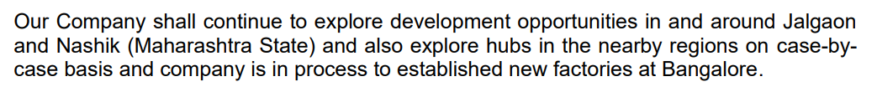

<http://spectrum-india.com/asset/Spectrum%20Prospectus_PrintFIle_SD_Declaration.pdf>