Wendt India



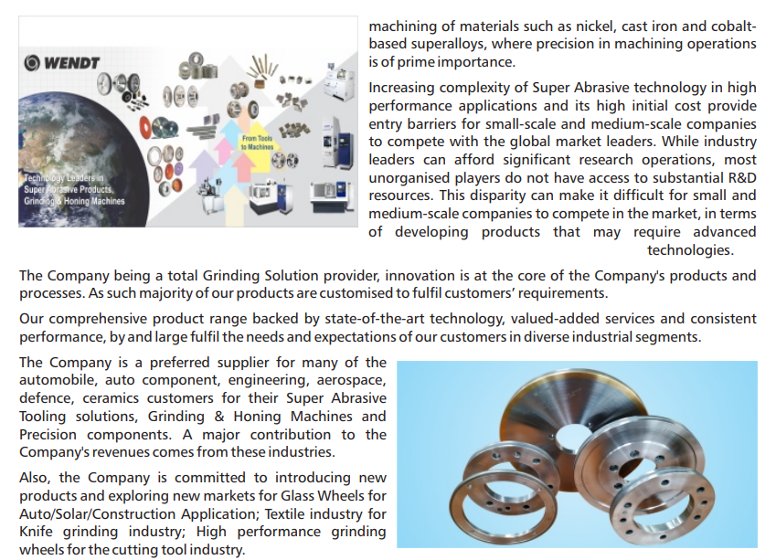

<https://www.bseindia.com/xml-data/corpfiling/AttachLive/c5816e4b-9225-4a4e-914c-a9a02ecc7ad2.pdf>