**FY15**

* Revenues grew by 10% but net profits declined by 9%, due to tough market conditions, rising costs and strict pollution norms. OPMs fell to 14% from 16% last year.
* Promoter shareholding declined by 4.16%
* **Dividend was skipped to fund expansion**
* 
* **Global Industry:** noticeable trend in the world market with regard to colour solution approach to counter commoditization with the advent of technological innovations. There has been a notable transition in the global arena during the last 2-3 decades in the manufacturing base of colorants, with a shift in production from Europe, USA and Japan to Asia viz. China, India, Taiwan, Thailand and Indonesia etc. With decline in production in most of the traditional centers, non-traditional centers like India and China are now preferred sources for supply of colorants to the global market. Gujarat and Maharashtra account for nearly 95% of the colorant production in the country.

Strengths:

* Ready availability of main feedstock except naphthalene and toluene
* Developed countries are looking at outsourcing dye production to developing countries, as production facilities shift base to Asian countries like India and China

**FY14**

Production up by 10% and revenues grew by 36% (screener info). OPMs improved to 16%;



Revenue distribution: Around 70 percent of the Company’s products are being exported world-wide including USA, UK, Germany, South America, Middle East, South East, South Africa, Indonesia, Thailand, Philippines, China, Brazil, Argentina, Chile etc. The Company has earned remarkable growth in its exports business over the years with excellent rapport with world-wide quality conscious buyers and attributed to customers satisfaction.

**Companies Strengths (as per AR):**

* Consistency in product quality is assured by our in-house Quality Assurance Department.
* Custom made products as required by the specific end users developed by our sophisticated Research & Development Department. (expenditure on R&D was nil in FY14!!!)
* Technical Support – Pre & Post Sales.
* Prompt deliveries.
* Different packaging as required by the customers.
* Support for new product / application development. Competitive Prices.

**Threats, Risks and Concerns**

• Price volatility of key raw, packaging materials and fuels.

• Increasing competition

**Sharp increase in contingent liabilities**

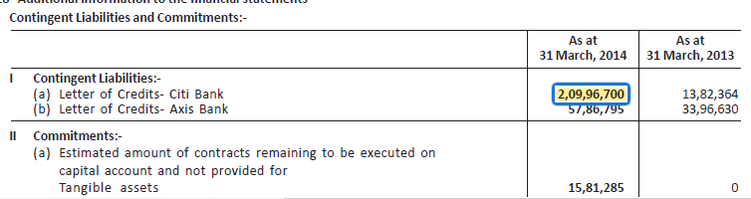

**FY13**

* Revenues were flat (production output declined by 16%) and *OPM Margins fell in FY13 further to 11.1% from 13.3% (Source Screener). Company considers performance satisfactory and never highlighted production drop!!! Reason for deterioration mentioned is MEE (Multiple Effect Evaporator) plant again (same as in FY12); Decline in OPMs were due to 2% lower gross profit margins; manufacturing costs remained at elevated 22% of sales (same as in FY12). Increase in manufacturing costs due to higher power (7%) and gas (16%) costs*







This year for the first time, Company has got its credit rating through CRISIL, and CRISIL has assigned CRISIL BBB/Stable on the long-term and short-term bank facilities.

**Opportunities**

* The global food colors market was worth USD 1,614.6 million in 2011 and is expected to reach 2,153.5 million in 2018, growing at a **CAGR of 4.3%** from 2011 to 2018. Europe is expected to acquire 32.6% of the global food colors market revenue in 2018 followed by Asia Pacific. Increasing consumption of this products especially in Asia Pacific and Latin America are expected to drive colorant demand over the next five years. Demand increased for more varieties and more-stable and vivid colors, as more and more processed foods fed our growing nation too.

**Threats**

* Competitive market
* Strict pollution control norms

**FY12**

* Revenues grew by 27% but *OPM Margins fell in FY12 to 13.3% from 16.7% (Source Screener). Net profits also declined by 7% YoY. The decline was due to expenses incurred related to setting up MEE* water effluent plant in both the units*.* This plant recycles maximum water waste which could be used again in process. Capital cost incurred was Rs 3.8 cr and working capital incurred was Rs 4.5 cr. Operating expenses in FY12 increased to Rs 72 cr (Rs 54 cr in FY11) due to higher manufacturing cost (22% of sales in FY12 vs 18% in FY11) – unclear what proportion was expensed through P&L



* Shri Shashikant P. Patel was paid compensation of Rs. 29,04,985/- after deducting TDS, the resolution which was passed by shareholders in previous year’s annual general meeting.
* FY 2011-12 has been a challenging one for each industry. Economic pressures have dominated with high interest rates, inflation and uncertainty in the global scenario.
* **Market size currently**: Dyestuff Industry has gone into a tremendous change during last ten years as manufacturing activities in European countries have been stopped due to environmental & pollution problems. Today the global market of dyestuffs, pigments and intermediates is around USD 25.85 Billion with dyestuffs and pigments market is approximately around USD 17.88 Billion and the intermediates is about USD 7.98 Billion. India’s share in the global market is about 8 to 9%.
* **Opportunity**
  + Global Food Colour will grow by 5-9% and faster for US by 8-9%
  + Global dyes will grow at 4%. Presently India, China, Korea, Taiwan and Indonesia are the main Producer for the Dyestuffs and Pigments. Manufacturers in Europe & USA have almost shifter the production base to these Asian Countries. Main reason for this is the low cost of production and ample manpower within Asian Country.
* **Risks**
  + Producers from Middle East (with feedstock cost advantage) and China aggressively pursuing Indian Markets due to very low tariff levels
  + High cost of Power, Energy, Finance and Capital Equipment.
* Unrealised losses on direct equity of Rs 35 lakhs in FY12 (Rs 20 lakhs loss in FY11) – Speculative nature of investing in companies like HDIL, Reliance Communication etc

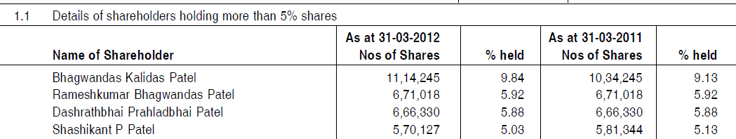

**FY11**

* The demand for the colours is derived directly from its customers and end users through the company’s various appointed distributors and country specific suppliers. The company is among the acknowledged world wide leaders in the manufacturing of Food Colours. The overall colour market is forecast to grow in line with technological and sociological changes that will lead to an overall increase in processed food industry.
* Though there is a growing realization that the color additives should be used to the minimum, the fact is that the food doesn’t even look presentable at times without it and appears inedible.
* 14% of RM was imported
* Company is in the process of implementing Enterprise Resource Planning solutions (ERP).
* Company has 150 permanent employees as on 31st March, 2011.

Risks: forex fluctuations

**Related Party transactions**

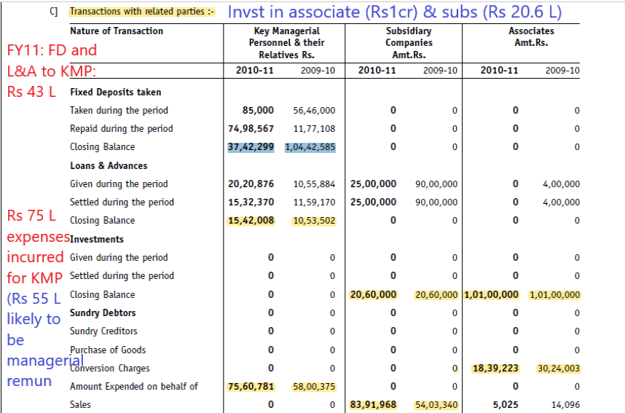

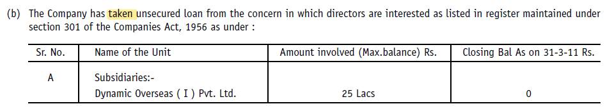

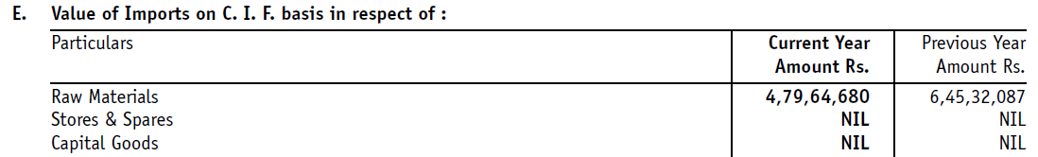

**Promoters**

1. **Shri Bhagwandas K. Patel** aged 55 years is the pioneer and founder of the Company. He is Inter C.A. and has wide and rich experience of 20 years in the existing business. Before starting his own company on 14th June, 1990, he had worked as administrative & finance head in M/s Britco Surgicals for six years. Under his leadership the Company has achieved great heights. He was appointed as Managing Director of the Company for a period of 5 years with effect from 16.07.2005 which was approved by the shareholders in the 15th Annual General Meeting held on 16.08.2005.
2. **Shri Rameshbhai B. Patel** aged 46 years is Bachelor of Science having rich experience of above 20 years in colour & chemical industry and is one of the promoter of the Company. He is in charge of total production/R&D of Unit I at Ankleshwar. He has been instrumental and a driving force for increasing efficiency of plants, developing new product/expanding product range, selecting technology at Dynemic Products Ltd*(FY11 AR)*
3. **Shri Dashrathbhai P. Patel** aged 58 years is Bachelor of Science having rich experience in colour & chemical industry and is one of the promoter of the Company. He is technological sound person and at present is In-charge of total production, R&D of Unit II, Ankleshwar. He is also marketing head of the domestic market *(FY11 AR)*

(Director of Rajvee Impex Private Limited - <https://www.zaubacorp.com/company/RAJVEE-IMPEX-PRIVATE-LIMITED/U51100GJ1995PTC026861>)

1. **Shashikant P Patel** (resigned on 28.5.2011) – was given Rs. 20,00,000/-, residential premises worth Rs. 7,05,985.25/- book value and its market value Rs. 9,75,000/- and car worth Rs. 3,23,952/- book value as a token looking to his long term association and dedication towards the Company.