Indraprastha Gas Ltd.  History and Business  Incorporated in 1998 to provide reliable natural gas supply as an alternative to auto fuel to Delhi residents. The transport sector uses natural gas as Compressed Natural Gas (CNG), the domestic and commercial sectors use it as Piped Natural Gas (PNG).  Shareholding - Bharat Petroleum & GAIL together own 45% equity as promoters. Zero equity dilution and share pledging in last 5 Yrs. FIIs hold 21.3% equity as of Mar’18.  Actual Financials  - Revenue – 5 Yrs. CAGR (as of Mar18) ~13%; YOY (Mar18) ~ 21%  - Earnings/Share – 5 Yrs. CAGR (as of Mar18) ~17%; YOY (Mar18) ~ 17%  - Net Profit margin (Mar’18) ~ 12%  - RoE (Mar’17) – 20%  - Zero debt  - Working capital is negative (current liabilities exceed current assets)  - Operating Cash Flow/PAT >1  - Receivables/Sales ~5-6%  - Inventory/Sales ~`1%  - Free Cash Flow >0  Company’s financials are good and stable.  What future looks like  - Over and above Delhi, IGL has started distributing natural gas in Gurgaon, Rewari and Karnal.  - Mgmt. has submitted bids for gas distribution permit in new cities.  - Plenty of govt. thrust on clean fuel usage. Recent ban on pet coke use.  All of these aspects provide clear visibility that IGL will continue to report healthy volume growth. |  | 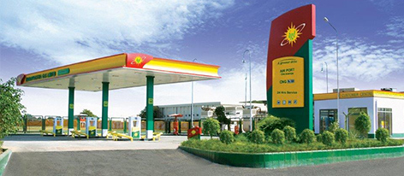  Moat (if it exists)  IGL is the sole distributor of gas in Delhi and adjoining areas, giving it a ‘monopolistic’ business model.  The company possesses ‘pricing power’ and has been able to raise prices to accommodate cost increase pressure (recent one on 29th May). Operating Profit margin stable ~ 22-25% in last 5 Yrs.  Natural gas continues to be cheaper than Petrol and Diesel and hence more economically viable for common man.  People running the company  S Ramesh, Chairman  E.S Ranganathan, Managing Director  ~570 permanent employees, as of 31st Mar, 2017 drawing salary of 91 Cr. INR. (Avg. 16 lakh/employee INR.)  Management salary is modest and top employees (by salary) have 25-30 yrs. of experience.  http://www.iglonline.net//english/5000_media/Investor_Relations/IGL-Annual-Report-2016-17.pdf

Risk/Red Flags (if exists)  - Govt./PNGRB interference in IGL’s pricing structure. There was one such incidence in past which IGL challenged in court.  - INR currency depreciation.  - Cut back in domestic city gas allocation.  - Electricity driven vehicles as an alternative to CNG.  Importance to my portfolio  IGL forms ~15% of my portfolio. Have been buying the equity in staggered manner in last 4 Yrs. |  | Valuation  Company has been consistently re-rated in the last 5 Yrs. Avg. PE ratio was ~12 in Mar13. The current PE is ~27.  The rise in PE corresponds to rising visibility and stability of earnings

