Modest changes in Chinese rebar demand spark acute price rises so can the reverse be true?
China announced that it had terminated steel production in all the country’s illegal induction furnaces by the end of June last year.
The majority of the operators in China are primarily small size private mills that use low quality scrap to produce substandard rebar. These rebars are mixed with grade III (HRB400) rebar and sold at a discount to construction contractors. For a long period, the government had neither record nor control of these private mills. Not only had they jeopardized the quality of building standards, but were able to force prices and eventually production down at state-owned mills during the construction and wider steel downturn between 2013 and 2016.
According to China Iron and Steel Association (CISA) and National Bureau of Statistics (NBS) data, CISA produced 64% of the country’s rebar in 2015 and the share declined to 62% in 2016. By H1 2017, CISA’s share slipped to 61%. As we expected, the apparent closure of induction furnaces since then has supported a recovery in state-owned mills’ market share. Indeed, CISA’s share soared up to a stunning level of 72% in H2 2017. This lead to a 5% increase in CISA’s share last year.
CISA data, at least for the first eleven months of last year, suggests that the profitability level among member mills, though substantially higher than the prior year, is not so high as we tracked on commodity products: In fact it is much less. This surprises us and some market participants who have gone so far. We understand the difference could amid in the way mills calculating profit. Mills might have discounted corporate tax, financial debt from previous years, capital depreciation of fixed assets, and other costs from their profit. Nevertheless, the leading mill Baosteel, whose profits are more consistent with the margin analysis we do. Whilst it is also possible that money made on certain steels, such as rebars and hot-rolled coil, was lost on the much smaller volume cold-rolling, coated and stainless steels, which CISA-member mills also produce, it seems unlikely that it would have made such an impact on the results.
Rebar prices recovered significantly last year, CISA mills like Baowu (Baosteel & WISCO), Shougang and Hegang (HBIS) hiked rebar prices on a monthly basis, except April and October. The average rebar price of northern, southern and eastern China increased 44% in January-December last year. In December 2017, Chinese domestic rebar prices beat our expectations in surging 13% month on month, to 4,615 yuan ($702) per tonne before prices started to fall. The last time rebar prices had reached that level was the end of 2011.
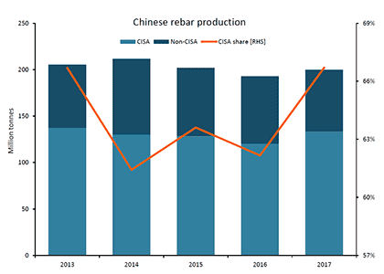
Rebar production increased 3.6% to just under 200Mt last year, but remains less than the 2015 level. Was it a huge demand recovery that boosted the price up? Arguably not although industry stocks did fall substantially, as did exports, which suggests at least that demand comfortably exceeded supply in China. Whether that was enough to support a 44% price rise is debatable but the retreat since December arguably has plenty to do with basic market fundamentals, including a large revival in stocks and seasonal collapse in demand.
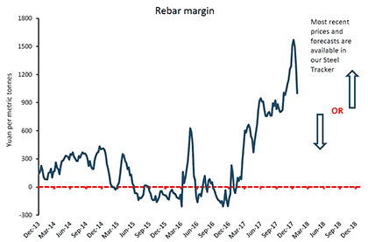
Looking ahead, the Chinese construction sector is likely to experience a hard time in 2018, as stricter measures of macro-control to housing prices in major Chinese cities is likely to kick in. Just as a relatively modest increase in demand can be associated with a large hike in prices, so the opposite risk is around this year.

CHINA REBAR: Domestic prices fall further on futures losses
China’s domestic rebar prices moved down further on Monday March 5 on futures losses.

China export rebar index, $ per tonne fob main port (from October 16 this changed from a weekly assessed price to a daily index)
 | Price | Change
05/03/18 | 575.42 | –
STLM | 551.06 | 4.42%
STLY | 480.00 | 19.88%
Monthly Averages
Feb 18 | 558.26 | 3.07%
Jan 18 | 557.92 | 3.14%
Dec 17 | 559.30 | 2.88%
Save this price

Domestic
Eastern China (Shanghai): 4,000-4,050 yuan ($630-638) per tonne, down 50-60 yuan per tonne
Northern China (Beijing): 4,050-4,080 yuan per tonne, down 50 yuan per tonne
A weak futures market led to bearish sentiment, and this, coupled with soft demand, pushed down spot prices.
High inventories added further pressure to the rebar market.
Export
Metal Bulletin fob China Rebar Index: $575.42 per tonne, down $7.08 per tonne.
Steel mills in China withdrew their offers and took a wait-and-see approach amid price drops in the domestic spot and futures markets.
Market participants expect offers of $595-605 per tonne fob, unchanged from last Friday.
Bids were heard at 560-565 per tonne fob, up $5-10 per tonne from last Friday.
Buyers could not get any low-priced supply from China or other countries, so they had to raise their bids, market sources said.
Transaction prices are expected around $565-575 per tonne fob.
Market chatter
“[China's] GDP growth rate [target of] 'around 6.5%' for 2018 is lower than [2017's] 6.9% - [a] negative signal in economic growth for the year, weighing on rebar futures,” a trader in Shanghai said.
Billet
As at 3pm, billet was being traded at 3,730 yuan per tonne including VAT in Tangshan. The price remained flat on Monday after dropping by 20 yuan per tonne late on Friday.
Shanghai Futures Exchange
The most-traded May rebar futures contract closed at 3,957 yuan per tonne on Monday, down 67 yuan per tonne from the previous working day.

