Summary – 11th Oct 2015
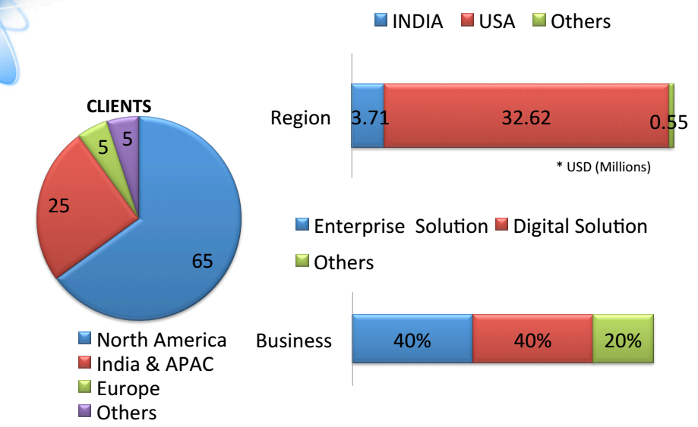
- Introduction
  - Promoters have good qualifications (Kellog/Wharton), serial entrepreneur
  - Scaling company mostly through M&A
  - So far walking the talk
  - Target top line of 2000 Cr in 3 years
    - FY17 expected top line 600cr
  - Riding on I-SMAC wave (IoT, Social, Mobility, Analytics, Cloud) wave
  - HQ @Hyderabad. Founded in 1993
  - Growth accelerated when new management took over in 2009
- Customers
  - Well-funded ecom players like Flipkart, Jabong, Makemytrip, Indigo
  - Mostly solution, no maintenance job
- Misc
  - 135 employee in Gurgaon, rest in US
  - On an average good review at Glassdoor
