This material does not constitute research for the purpose of SEBI regulations. Also this is neither a solicitation nor a recommendation to buy/sell any security, is not addressed to/customized for any specific person. Recipients should rely on their own investigations and take their own professional advice before investment. The authors will not treat recipients as customers/ clients by virtue of their receiving this report. This Research may have been prepared/ made based on the analysis of data available publicly and/or other sources believed to be reliable.
Outline
- Corporate Roadmap
- BFSI Roadmap
- Disclosures
- New Concepts
- Old Concepts/practices
- Examples
- Common Queries
- How annual reports can help you
- Trivia

Corporate Roadmap

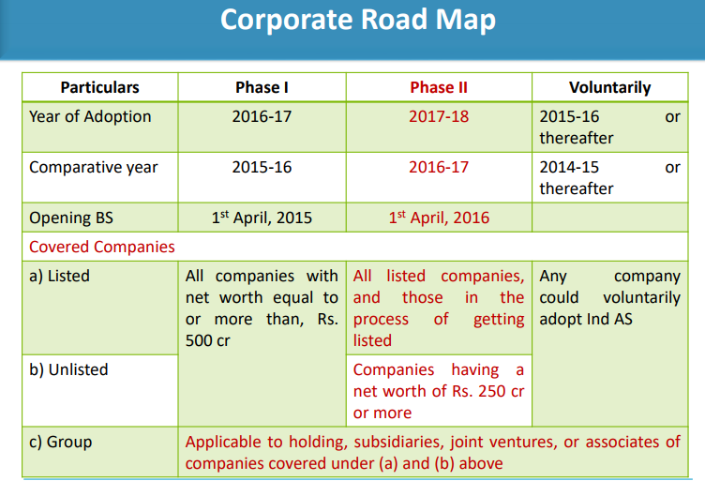

BFSI Roadmap

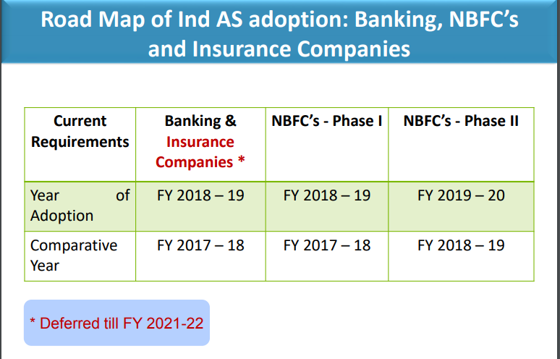

Disclosures needed
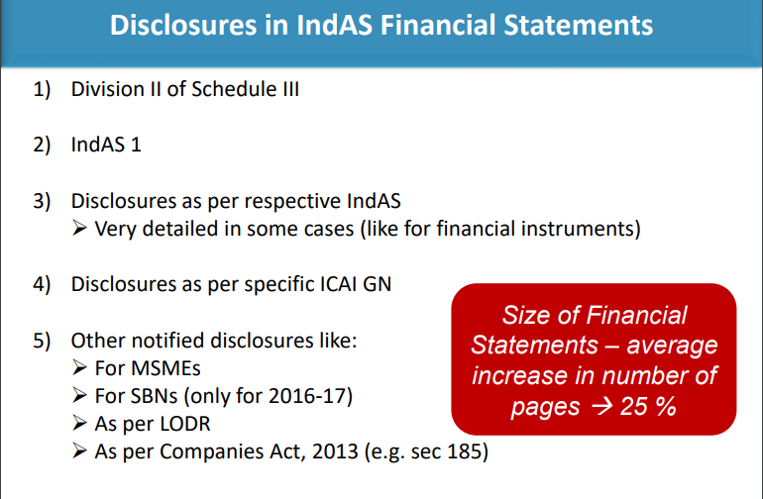

New Concepts/Practices
- statement of changes in equity(Beyond PL/BS/CF/Notes and schedules)-a reconciliation between the opening and closing balances, disclosing changes resulting from:
  - profit or loss
  - each item of other comprehensive income.
  - Transactions with owners in their capacity as owners.
  - Any item recognised directly in the equity like capital reserves on M&A
- Requires disclosure of information about management of capital and compliance with externally imposed capital requirements, if any

Old Concepts/Practices/to stop
- Presentation of any item of income or expense as extra ordinary item is prohibited.

Examples

Reconciliation-Overall Profit Impact small though item level
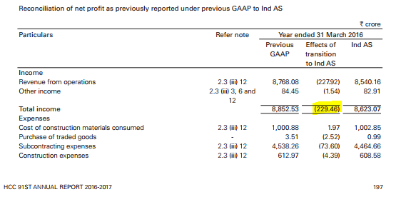

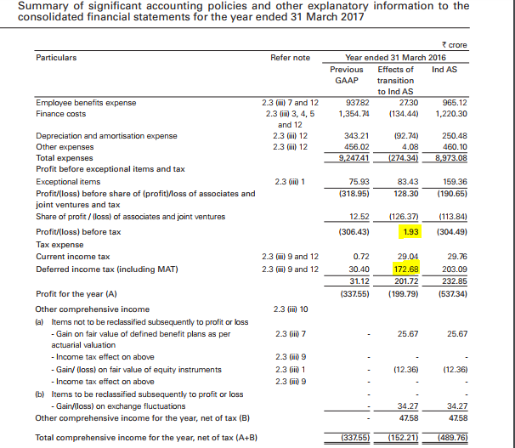

Asset heavy operations under WOS, hence standalone numbers inflated.
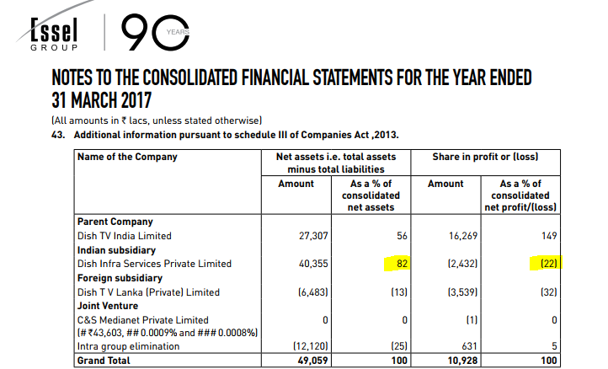
References
https://icaiahmedabad.com/Study-Presentation/IndAS-Special-focus-on-Phase-II-companies.pdf

Common Queries
- Consolidated or Standalone numbers?
- Subsidiary annual reports-read or not?
  - Hold Co accounts-noise due to intercompany transactions
  - However, able to get cash flow information missing elsewhere
- Changes since last 1 year in corporate tax/ financial reporting
  - ICDS/GAAR
  - IND-AS replacing Indian GAAP
  - Integrated reporting SEBI mandate

How annual reports can help you

Which PR agency involved in printing the annual report? Is it reputable?

Audit Quality
  - Auditor remuneration mix(Audit fee vs other services)
  - Excessive remuneration growth more than revenue
  - Qualifications/reservations in report
  - Whether reliance on ‘certified by management’ for key items
  - Single Auditor vs Joint Auditor
  - Audit Rotation year(If yes, chances of slips)
  - % of company assets and earnings audited by key auditor(instead of others)

Quality of earnings
  - Do operational items like raw material, power/fuel, freight vary with sales?
  - Extent of misc expenses/repairs and maintenance(if abnormal) and other charges

Employee/Management Remuneration/Directors
  - Is the KMP paid too less(eg CFO within Rs 6lakhs!)
  - Median/Mean increment to employees, KMP(key management personnel) and directors
  - Waiver of excess remuneration to KMP
  - What does the company expect its long term salary escalation as? Is this coherent with its strategy? Eg Indian hotels 3%-7% in defined benefit disclosure.
  - Details of employees paid more than 60lakhs/year(or else top 10 employees)
  - Sitting fees of directors, and do they hold any shares in the company. Look out for those sitting on few/too many boards and being paid high-potential conflicts.

Capital Structure/Shareholding
  - Extent of potential dilution to capital structure(ESOPs, warrants, bonds, FCCBs)
  - Mix/Cost of debt(effective interest rate
  - Lease commitments
  - Is there a mandated capital level(mostly for financial services cos)/overall gearing target
  - Significant Restrictions on subsidiaries
  - How much of cash/cash equivalents is “restricted cash”? If yes, reclassify. Eg wallets/PPI
  - Distribution of shareholding as per bucket(1 to 500 etc)(Directors Report)-This can help identify the marginal shareholder holding, and top 10 shareholder movements

Segment Disclosures across various business activities
  - Operating/Geographic segment disclosure of revenues, assets and profits? This helps refine cost of equity estimate.
  - Net Assets, profit or loss of legal entities( subsidiaries/associates/JVs)-this information often complements the often incomplete segment disclosure.
  - Subsidiary Annual Report

Expense provisioning/Conservatism
  - For disputed cases with government/taxes/statutory body, is provision taken/ disclose impact of pending litigations on its financial position in its Ind AS financial statements
  - Deferred Tax Asset not recognized/Investment writeoff taken?
  - material foreseeable losses, if any, on long-term contracts
- Does the company use a reputed ERP system? Does it have ISO?
- Integrated report disclosures-unfortunately this is a PR exercise largely

Legally permissible structuring
  - Expenses written off via securities premium through court schemes(loophole plugged)
  - Conversion of subsidiary to JV to avoid debt consolidation

IND-AS key pointers
  - Signals of cleanup? Goodwill worth 210.87 crores has been written off pertaining to a subsidiary at US as a measure of prudence under IND AS 8(Dabur 2016-17 Annual Report). To put this amount in perspective, it is around 1/6th of the FY17 profit.
  - Is the impact significant?
  - Need to rebuild earnings model till websites like screener update restated numbers. Especially vital for EBITDA, finance cost, depreciation, tax projections.

Did you know(Trivia)
- Taj SATS Air Catering Ltd contributed 11.37% to consolidated net profit of Indian Hotels, with just 1.49% of its net assets.
- HCC Infrastructure also owns a wine company(Charosa started manufacturing and selling premium wines in Indian markets with operations commencing from October 2013)
- Dish TV(The Company) has been making payment of license fee to the Ministry of Information and Broadcasting considering the present legal understanding. However, in view of the ongoing dispute (refer note ‘b’ below), the Company has made provision on a conservative basis considering the terms and conditions of the License given by the Regulatory Authority. Amount is around Rs 1397 crores cumulatively as at 31 Mar 2017
- Indian Hotels- As at the year end, the Group’s current liabilities have exceeded its current assets by ` 912.93 crores primarily on account of borrowings aggregating ` 574.96 crores which fall due within 12 months following the balance sheet date and certain provisions although classified as “Current” are unlikely to result in a cash outflow within that period. Management is confident of its ability to generate cash inflows from operations, liquidate certain non-current investments and raise cash from financing activities so that it would be able to meet its obligations on due dates as it has demonstrated in earlier years. On these considerations, these financial statements are prepared on a going concern basis.

This material does not constitute research for the purpose of SEBI regulations. Also this is neither a solicitation nor a recommendation to buy/sell any security, is not addressed to/customized for any specific person. Recipients should rely on their own investigations and take their own professional advice before investment. The authors will not treat recipients as customers/ clients by virtue of their receiving this report. This Research may have been prepared/ made based on the analysis of data available publicly and/or other sources believed to be reliable.

