Silver could be an interesting investment option now
Silver has greater return upside during market downturns and is a more volatile asset class compared to gold. Silver has dual uses - industrial and as a precious metal. However, silver investment is possible only via physical silver or e-silver via NSEL (National Spot Exchange Limited, founded by Financial Technologies). Silver ETFs are not investment options in India, but popular abroad.

An important global metric to assess the lucrativeness of silver is gold/silver ratio.

What is the Gold/Silver Ratio? At ~ 80, at historical highs, indicating silver is yet undervalued…
The gold/silver ratio is simply the amount of silver it takes to purchase one ounce of gold. Over the past 20 years, the ratio has averaged around 60:1. If the ratio is 60 to 1, ie. at the current price you could use 60 ounces of silver to buy one ounce of gold. The gold-silver ratio is considered to be one of the most reliable technical 'buy' indicators for silver, whenever the ratio climbs above 80. It crossed 84 levels in September 2018 and is now currently at ~80. When the ratio is high, silver becomes more favorable because relative to the ratio, silver is somewhat inexpensive. Not surprisingly, silver prices have started rising post December 2018, and rising sharply post June 2019, similar to the trend in gold. Currently, silver price is 19.08 USD/oz or excess of INR 44,000/kg. In the last downturn, silver prices rose to Rs 50,000/kg to over Rs 60,000/kg between 2011 and 2012.

Silver price trends historically – last downturn prices rose till mid 2012

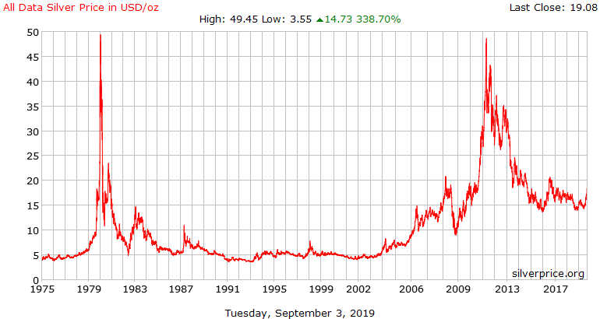

Silver price recent trends – rising from December 2018 & sharper from June 2019
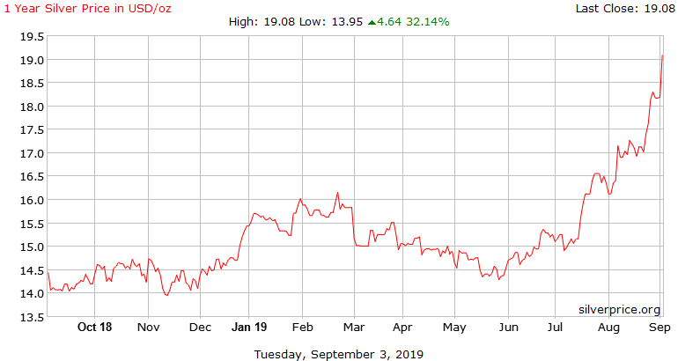
Source: https://silverprice.org/spot-silver.html

Gold/Silver ratio – a predictor of market crash?:
According to seekingalpha.com, The ratio typically spikes to extreme levels during the depths of an economic crisis or leading up to a significant correction in the equity markets. Hence, the signs were evident from September 2018 on hindsight. https://seekingalpha.com/article/4205481-gold-silver-ratio-spikes-highest-level-27-years

Trends in Gold to Silver Ratio: Spiked in Mar 2003 (76.3), Nov 2008 (80); now ~ 80
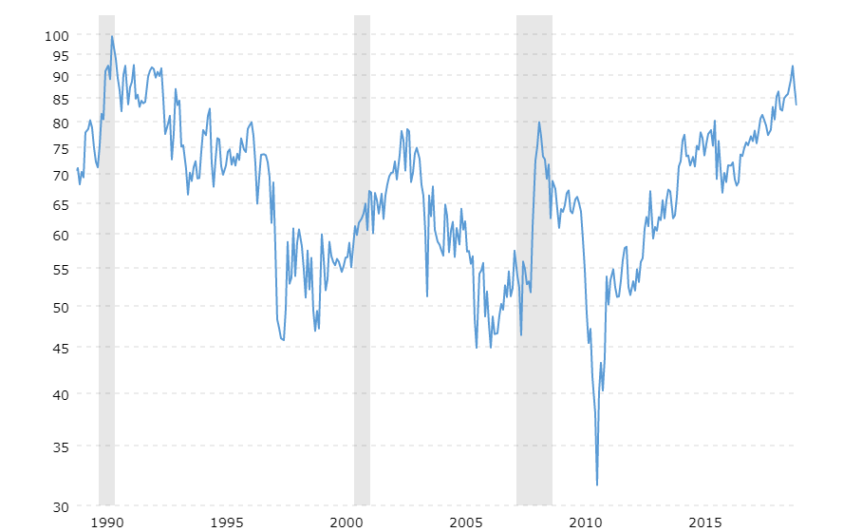
The marked grey portion on the graph signifies recession
Source: https://www.macrotrends.net/1441/gold-to-silver-ratio

Snippet:

Silver has been used as an investment by Warren Buffett’ Berkshire Hathaway in the past. However, the timing was incorrect, they invested in 1997, when silver prices were extremely reasonable, had dropped more than 90 percent from its record price of $50 an ounce in January 1980, but exited it after 8 years with a 5% CAGR. Had Berkshire Hathaway sold at $ 42.92 per oz on September 5, 2011, well below the $ 48 crisis peak, the returns would have been 16.5% CAGR valued at $ 4.2 billion on an investment of $560 million.
http://blog.press.princeton.edu/2019/04/16/william-l-silber-invest-like-buffett-buy-silver-when-its-cheap-but-dont-repeat-his-mistake/

