PATANJALI FOODS (erstwhile Ruchi Soya or RSIL)
EDIBLE OIL; FOODS; NUTRACEUTICALS

CHRONOLOGY OF EVENTS
Dec 2019: RSIL was acquired by the Patanjali Group (through NCLT route) in December 2019 for Rs. 4400 Cr (funded by equity/unsecured loan - Rs. 1104.75 Cr and secured debt - Rs. 3292.25 Cr). Ruchi Soya in FY21, had a turnover of Rs 16400 cr operating with margins of 6%

March 24, 2022: Follow-on public offer (FPO) on March 24 to garner Rs 4,300 crore. The company fixed a price band of Rs 615-650 for the public offer. The proceeds of the issue were majorly utilized for 100% repayment of the outstanding Terms Loans, Working Capital Loans, NCD’s and partial repayment of redeemable Preference shares resulting in Company achieving Debt Free status.

18th May 2022: Patanjali Foods entered into a BTA (business transfer agreement) with Patanjali Ayurved to acquire the Food Retail business (including mfring, packaging distribution) for a lump sale consideration of Rs 690 cr (no liabilities, market value of this transaction is Rs 12000 – Rs 14000 cr). This includes - FMFP (Fast Moving Food Products) and FMHG (Fast Moving Health Goods). Patanjali Foods will give a royalty of 1% of food sales to Patanjali Ayurved. There is a non-compete agreement between Patanjali Ayurved and Ruchi Soya. With this transaction, food division of Patanjali Foods has risen to 20% of total sales from 8%. The business is transferred wef July 1, 2022.
The transfer includes – 8 business sub-divisions and 536 SKUs.

Ruchi Soya will pay an annual royalty to Patanjali Ayurved, estimated at 1 per cent of the gross turnover of the products under the transfer

Business Model: Some of the products include Cow Ghee, Chyawanprash, Honey, Juices such as Amla, Aloe Vera Juice, Biscuits etc
FY22 revenue breakup – Edible Oil revenues constitutes a lion share of revenues

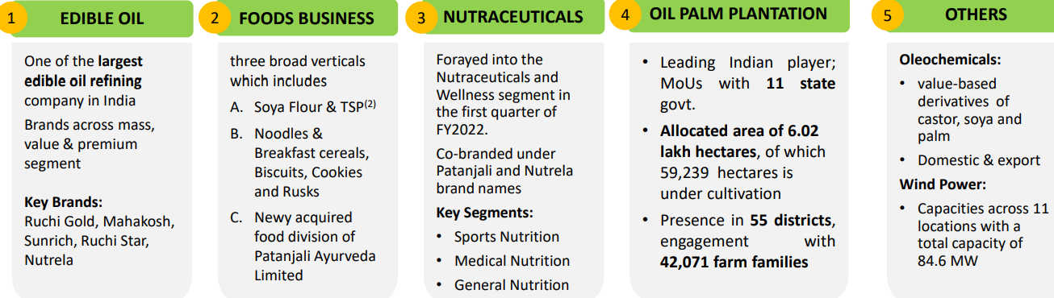

Thesis
- Large opportunity size in Packaged food products – currently only 15% of retail grocery (Rs 39.5 lakh cr market) is packaged. Multiple themes of unorganised to organised, commodity to brand, premiumisation and wellness
- Patanjali Foods is 2nd largest player in edible oil and largest manufacturer of Soya foods
- Increased focus on Food products: Demand for Patanjali products is high, both in India and abroad. Higher India penetration and exports. Propose to increase share of high margin food segment to 50% in 5 years, from 20% currently (post acquisition)
- The company has well recognized brands, 25 manufacturing facilities at strategic locations across India and access to 43 contract manufacturing facilities.
- Massive plan for palm plantation to reduce RM dependence: Patanjali to grow oil palm on 38,000 hectares in Arunachal Pradesh
- Debt free: FPO used for debt reduction
- Distribution focus: Company is targeting streamlining its distribution and increasing distribution reach by 50% in next 3 years. Some of its main distributors have had financial difficulties, which caused supply constraints, this will get ironed out
- Targeting revenue growth of 25% in coming years. FY23: Foods business should grow to Rs 4000 – 5000 cr (including the food segment acquired from Patanjali Ayurved)

Anti-Thesis
- Commodity share of revenue mix is high.. valuations will grow in tandem with increasing share of higher margin food business
- Supply overhang in Patanjali Foods – need to dilute 6% stake. The 6% stake dilution will be used to reduce debt (Rs 2000 to 2500 cr) in Patanjali Ayurved. Plan to come out with an IPO after that in Patanjali Ayurved, likely by Dec 2022 or 2023
- Exposed to fluctuations in raw materials prices, forex fluctuations and regulatory changes: Ruchi Soya’ raw material purchase costs comprise around 90% of its total operational costs, and thus, its business is exposed to fluctuations in raw material prices (majorly oil seeds and Crude Palm Oil). The raw material cost is highly dependent on the agro-climatic conditions, cost of imports, government interference in fixing-up the prices and so on. Due to the scarcity of palm plantations in India, RSIL Crude Palm Oil from Malaysia. The Government of India also affects changes in the import duty structure of CPO and refined palm oil from time to time, which directly affects the business of refining units in India.

Ruchi Soya - Background
It manufactures edible oils, soya food, premium table spread, vanaspati and bakery fats. It is also the highest exporter of soya meal, lecithin and other food ingredients from India. RSIL has plants in 23 locations in India. It has 90+ depots (with storage and other logistical facilities), which serve 4,000+ distributors across the country, reaching over 1 million retail outlets. RSIL also has exclusive palm oil procurement rights to over 2 lakh hectares of land in India with a potential to increase oil palm cultivation. It also owns 85.2 MW of windmill assets. The most popular brands of RSIL are Nutrela, Mahakosh, Sunrich and Ruchi Gold.

Patanjali Group
Combined turnover of Patanjali group, including Ruchi Soya, is over Rs 35,000 crore and it is ranked second in the FMCG and food space, after HUL (HUL turnover was Rs 46000 cr in FY21)
 | FY21 Revenues (Rs cr)
Patanjali Foods | 16400
Patanjali Ayurved | 9800
Patanjali Natural Biscuits | 650
Divya Pharmacy | 850
Patanjali Agro | 1600
Patanjali Parivahan | 548
Patanjali Gramudyog | 396

Q1FY23:
- Revenues up 37% YoY.
- Other income 5x jump.
- Edible Oil inflation hurts margins: Volume grown by 4% YoY; Prices declined by 18 to 20% YoY (Prices fell in last 45 days as war started to taper and Indonesia removed its export ban).
- Market share in edible oils is 8% and has been growing

 | Q1FY23
Revenues | Rs 7200 cr (up 37% YoY)
Gross Margins | 11.2% (down from 11.8% YoY)
Foods segment (8% of revenues)
- Revenue | 573cr (356 cr in Q1FY22)
- EBIT margin | 14.8% (8.8%)

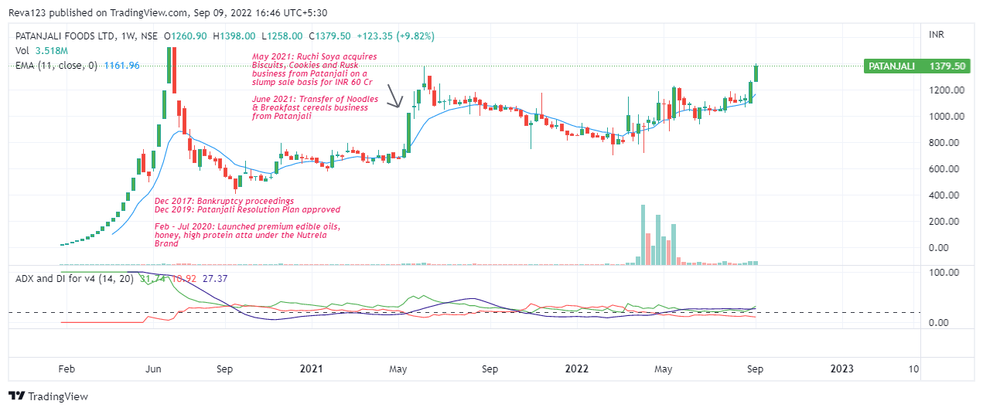

SOURCE: https://www.youtube.com/watch?v=VFsABs6vuL0
https://www.youtube.com/watch?v=h7xd2PqtglQ

