STOCK IDEA : INOX LEISURE

Background :
- With diverse business presence across segments in India and abroad, INOX Group is worth USD 3 Bn.as on 31st March, 2019.They are a professionally Managed conglomerate across multiple business segments. Inox group is present in multiple business like renewables wind, refrigerants, chemicals and entertainment. They claim to have decades of industry experience and have seen multiple market cycles.
- One of the largest multiplex chain operators in India, INOX Leisure Limited, is operating in 67 cities with over 600 screens and over 150,000 seating capacity. They are present in over 70 cities and 19 states. Maharashtra 130 screens has the highest share of screens along with west Bengal, rajasthan, Gujarat and Karnataka ( each have around 45 screens).
- The indian film industry delivered a growth of 12 % in 2018 with a market size of 17500 crores. The industry witness less number of films being released but the no of movies grossing more than 100 crore have increased substantially.(what make a movie gross 100 crore plus in india ). Out of this 42% share is of hindi films and 46 % is of the regional movies. Domestic theatrical revenue registered a growth of 6% and clocked around 10200 crores. India has a total of 9600 screens presently and amongst these 2500 are around multiplex screens and 6651 being single screens. Ratio of around 1:2.5
- Despite being the largest film producing country in the world india has less than 25% screens of what usa or china has. China has around 55000 screens and usa has around 40000 screens.
Industry trends :
- The advertisement revenues for the industry are healthy and the same grew by 37 % to 805 crore in 2018. The same is observed due to digital distribution and opening of multiplexes in tier2 and toer3 cities. ( source: pitch Madison advt report ) inox leisure has been increasing its revenues in a health way of avg 20% cagr from past few years and in fy 18 it was 139 crores.
- The mall space in india from top seven cities is expected to increase from 75 mn sq feet to 95 million sq feet in 2019. India has only around 8 screens per millon population as compared to 16 in china and 125 for usa. Most of the developed nations have in upwards of 40-50 screens.
- The industry is also expecting to steadily increase its f&b revenue and generally doubles it in every 3-4 years.
- Cinema industry is a story of long consolidation. The single screens have been giving way to multiplex format on account of better customer experience and shift from the unorganized to the organized. From a 80% market share in 2015 out of the total 11000 plus screens they have come down currently to 60% and share of multiplex screens has gone up from 15 % in 2015 to 40 % in fy 20. ( source : annual report pvr)

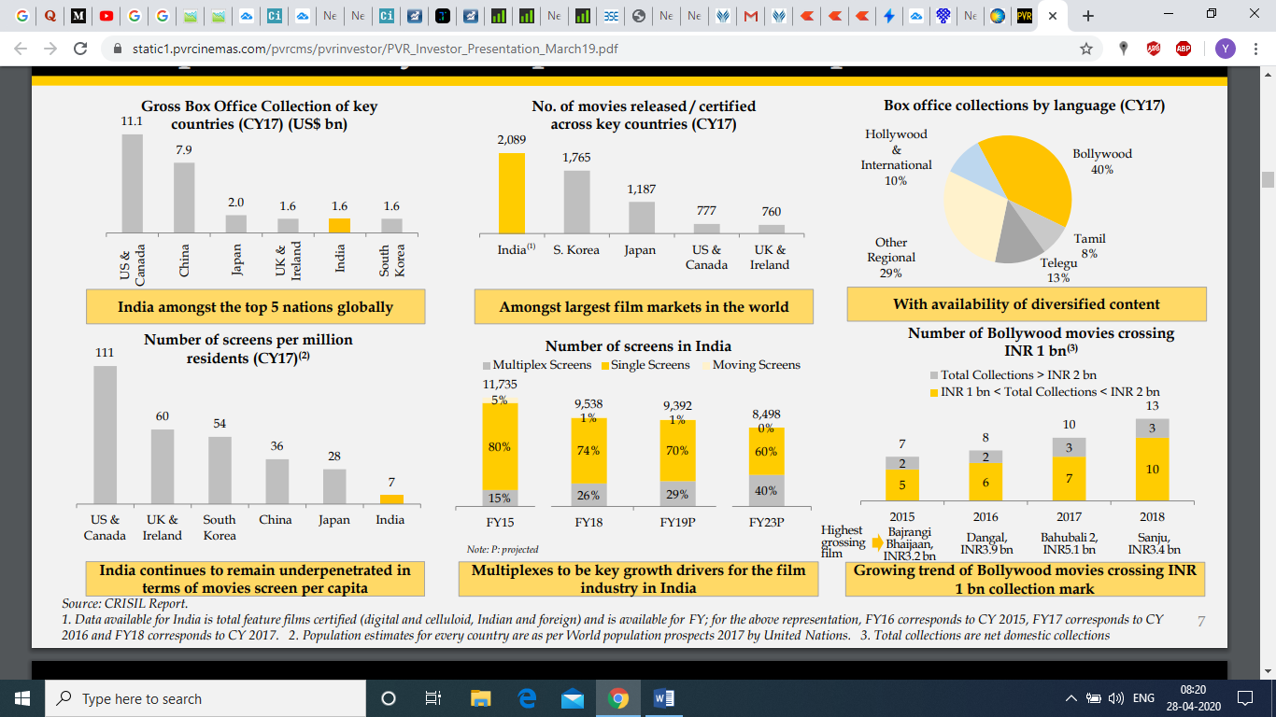

Business
- INOX leisure is a part of inox group. It has been active in the movie screening business and the other major name in the industry is PVR. PVR is run by the bijlee group and their business is double of what inox is doing currently.
- Inox have currently more than 600 screens in more than 19 states and 70 cities. From a screen count of 300 in fy 14 to currently around 600 plus in fy 19. They have been steadily adding screens in the rate of around 100+ screens every year.
- The promoters are same from the inox group. Though Mr. Siddarth jain is the promoter running the show and Mr. Alok Tandon is the current CEO. The promoters have a share holding of 50 %, mutual funds 20 % and FII have around 11 %. The general public has around 7% and hence this makes it a low float company but fairly discussed and discovered by the market.
- Sales and revenue :

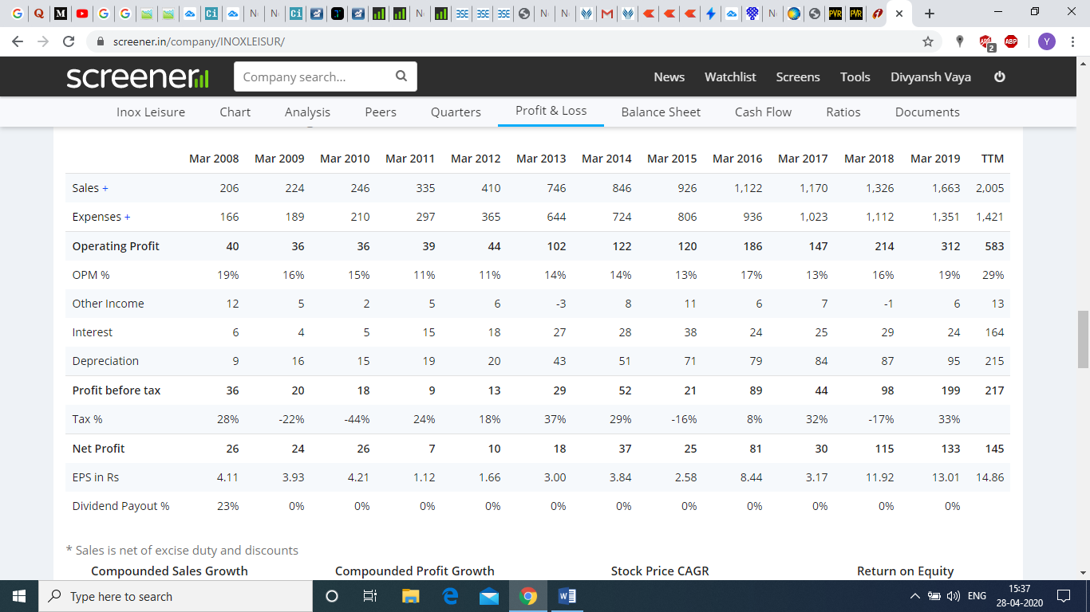
Above are the financials for last 10 years for inox , since 2012 the company has been able to double its reveue sales every 4 years. From 400 crores in 2012 to 1122 crores in 2016 and approx. around 2000 crores in 2020. Operating profit margin for the business has been constantly increasing from 11% to currently 29 %. The trend is pretty encouraging and it can be safely assumed that the multiplex screen experience has good traction amongst the masses. Though the average opm should be somewhere around 17-19 %. The industry attracts tax outgo of around 25 % plus and the same needs to be checked for more accuracy.
The profits of the company have been increasing at a faster pace then the sales growth. From a net profit of 10 crore in 2012 to 80 crore in 2016 to 145 crore + in 2020.

Balance sheet:

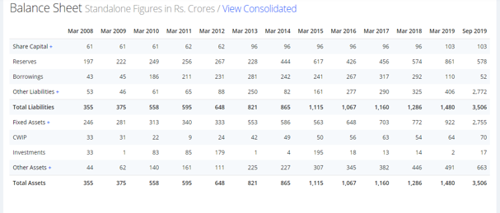
The promoters issued them around 65 lac share through warrants for a price of 250 rs in 2019 amounting to around 160 crores. The same was used to pay off long term debt. Also encouraging is to see with the increase in sales from 2012 the borrowings of the company have remained stable. Infact they currently have negligible debt on their books. Their has been infrequent equity dilution and the reason for the same needs to be ascertained.

Cash flow statement:
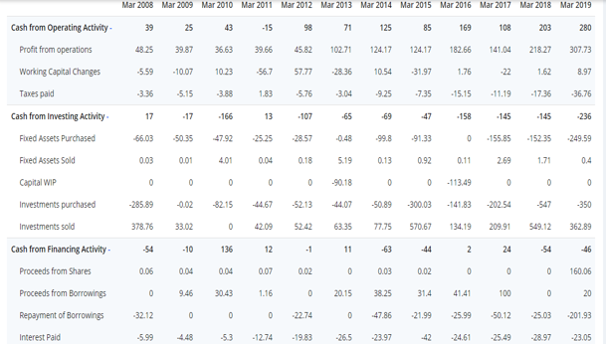
The operating profit of the company matches with the cash flow from operations. The company has not been generating free cash flows primarily as it is in a expansionary mode and has been ploughing back the money back for setting up of new screens. It is also using the cash flow from operations to pay off existing long term debt. The tax outgo though seems to be on the lower side as the company paid around 36 crores for fy 19. The company is assest heavy as the fixed costs consists of acquiring mall spaces in commercial areas. There is also heavy fixed cost of depreciation due to purchase of equipment and machinery. Though the same appears to be non linear and reduces % wise with increase in sales.
The ROCE of the company has been in mid teens to late teens and has improved considerably in past two years.

Other important financial metrics of the company:

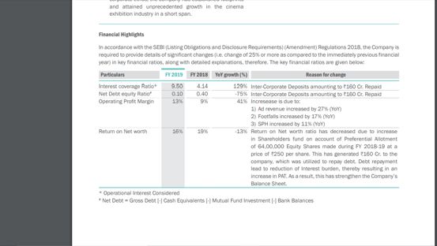
The company seems to have picked up momentum from fy 17 onwards where in it started registering steady growth in EBITDA, F&B and AD revenue. The F&B revenue currently stand at 436 crores (436/1663) (25%) as compared to 191 crores in 2015 (191/926) (18%). Also the as revenue in 2019 stood at 187 crores (187/1663) (13%) compared to 81 crores (81/926) (9%).
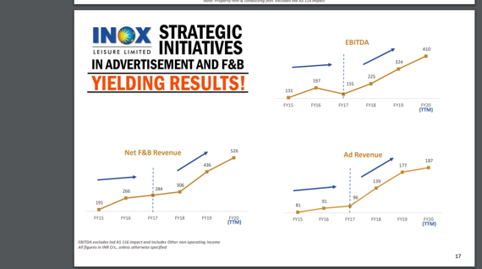

Management quality :
The management comes from the inox group whose founder was Mr Devendra jain who initially started the business of refrigerants. He was supported by his two sons mr vivek jain and mr pawan jain. Mr vivek jain is now helped by his son mr devansh and mr pawan jain is assisted by his son mr siddharth. The group and family interests were covered in detail by forbes in 2015 and the same can be read here https://www.forbesindia.com/article/boardroom/inox-the-wind-beneath-its-wings/40065/1 . Both the brothers and their sons have seats in executive committee of group companies but it is clear to certain extent that Mr siddarth jain is the brain behind inox leisure. But it is not encouraging to see that he shares his time in another full time business at inox wind and inox aero products. Their was a case of auditor resigning from inox wind wherein the auditor citied work overload for the same.

Capital allocation :
- The management at inox seems to be fair at capital allocation. They have not taken undue debt for expansion and the growth has largely been achieved slow and steadily. Their roce has improved and is now higher than 15% from past two years with nil debt.
- However that said if one looks at their other ventures there is a clear picture of poor capital allocation and poor business foresight. Both the other listed business on a glance look to be sub par business wherein the management has not been able to generate consistent wealth. GFL has shown erratic sales and profit growth with consistent rise in debt. The market has never fancied there other business due to poor fundamentals and being laden with debt. Same is true for inox wind wherein the company has poor sales growth and currently is running in losses from past two years. Also there is substantial rise in debt. Wind and renewable companies have been suffering due to various reasons in the country and I am not covering the same in detail here.
- It will be important to watch whether the company uses profit or reserves from inox leisure to other business ventures of their. If that happens then it will be a big red flag and might warrant reviewing investing in inox leisure.
- Key management renumeration :
Looks within permissible limits as % of net profits as mandated by company act.
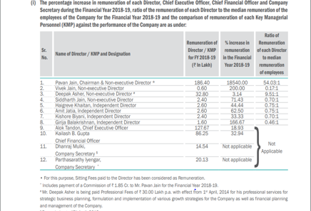

- Since the company is in a growth phase and is investing for expansion, they have not been paying dividends. The same needs to seen in a scenario wherein they are not investing back in the business and generating decent cash flows.
Related party transactions :
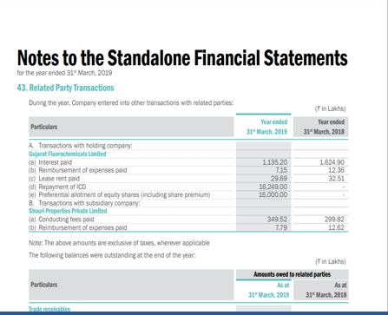
Nothing much to be concerned here as there are no huge/multiple or repeated related party tranactions. Need to find out more about the ICD (its benefits and uses)
PVR vs INOX :
Now coming to why I think inox is a better investment prospect as compared to PVR.
- Inox has shown the ability and the patience to grow in a slow and steady way. There are currently debt free as compared to 1.18 for PVR and outstanding debt of around 1262 crores. PVR has been the more aggressive of the two
- The solvency and liquidity ratios are far better for inox as compared to PVR. Assuming fixed costs with nil revenue for six months the balancesheet of pvr has more capability to withstand any strain and also progress after business resumes normal. (interest coverage ratio of 1.2:1 vs 12:1 )
- The promoters have more skin in the game for inox with promoter holding north of 51 % vs less than 20 % for PVR. FII holding for pvr is in excess of
40 % and mutual funds hold about 9 %.
- Poor corporate governance showed by the chairman and MD of PVR Mr Ajay bijli wherein he was fined by SEBI and also he agreed for out of court settlement for violation of securities rule. More about the same can be read here : https://economictimes.indiatimes.com/markets/stocks/news/pvr-ceo-ajay-bijli-settles-securities-market-related-violation-with-sebi/articleshow/62383668.cms
- Also personally I am not very comfortable with the extravagant lifestyle and expenditure of Mr bijli. I would like to side with conservative,shrewd and ethical promoter to run any business. More on Mr bijli can be read
here : https://www.forbesindia.com/article/best-things-money-can-buy/ajay-bijlis-pursuit-of-simple-luxury/36263/1
- The operating performance of inox is better and continuously improving as compared to PVR.

RISKS
- Covid 19 has presented a never before enormous problem for the movie exhibition industry. It affects the industry in following ways :
- Since the virus is highly contagious and has a incubation period wherein the patient might transmit with no visible symptoms. This has lead to govt ensuring that community transmission to be prevented as first priority. Hence all shopping and crowded areas like malls, shopping markets and cinema halls have been closed till further notice.
- Since movies are shown in a air conditioned environment there are chances of the virus surviving and transmission happening due to elongated life cycle of the virus.
- Since the movie goer crowd is mostly literate and urban, there will be decent scepticism in their minds even after the issue is resolved. Any one off incident of transmission can cause recency bias and force them to postpone their movie going plans. The same can extend till Diwali and also depends on the dynamic situation which is still evolving.
- The film industry might take its own time to resume normal due to travel bans and limited places to shoot internationally. The same might continue for atleast a year. This might affect big production houses and directors to delay making blockbuster movies for the time being.
- The company will be bearing fixed costs for the time being mainly (rent+employee+maintenance) which works out to around 15 lakhs per screen and for 600 screens works out to 90 crore per quarter. Though some of it might be mitigated due to laying off staff and invoking force majeure for rent leasing agreement. Still average footfalls and occupancy rates might drop drastically for the year. I am expecting a loss of 120 crore (for first two quarters ) along with 100 crores plus of depreciation for the full year. The second if ends up in no loss no profit might result in overall loss 200 crore pluss for the year. The same for pvr stands at (500 crore int cost+200 crore dep+200 crore fixed costs) in total 900 crore. This is huge in comparison to inox. These calculations are based on gross assumptions and might change as per evolving situation.

INVESTMENT RATIONALE AND VALUATION
- The movie screening industry in under penetrated in india as compared to china and other developed nation even though we have Bollywood and local regional players producing enormous amount of content.
- The industry has been consolidating since long and the current players have made acquistions on regulare basis. Few examples are DT cinemas, wave and satyam. Also the ratio of single screen halls are coming down every year and at the same time multiscreen multiplexes are opening aggressively.
- Rising urbanisation along with want of the consumer for better movie experience also makes one watch movies in inox or a pvr.
- For busy crowded cities in india like Mumbai, Chennai ,delhi or Bangalore. Movie coupled with eating out with the family or friends is a preferred activity over the weekend. Even after the virus scare and once the situation resumes normal I don’t see any reason for the consumption pattern not resuming normal. What all will be waiting for is few weeks or months of normalcy and then people will follow what the herd is doing.
- This looks like a one in life opportunity where in a long term stable consumption pattern is facing a headwind but the future looks bright with good potential.
- The covid situation along with GST might accentuate the fall of weak single screen owners where in they might find it difficult to survive cause of few quarters of lock down. They also might face issues in complying with new hygienic standards if any prescribed by the govt. The next phase of expansion and growth might be relatively easy for those who survive.
- Inox currently trades at a mcap of 2000 crore and pe of 14. Considering one year losses of 200 crore and the normal trajectory from 2021 onwards.. one can expect sales of 2500 crore by march 2022 and net profit of around 200 crore. Giving it a median pe of 25 (average of past few years) the mcap turns outto be 5000 crore (2 to 2.5 times return in 3 years). Any correction below 180 rs increase the potential risk reward ratio.

Disc: tracking position and would like to accumulate it at all declines for next few months. I might change my opinion based on results and easing of lockdown for movie screening business.
# This is not a investment advice and I am not a registered investment advisor. Please don’t act on the same and consult your financial advisor for the same.
** Any counter view or suggestions to improve the thesis layed out above is most welcome.
Regards
Divyansh jain

