CP’s McIntosh warns shrimp sellers against focusing all efforts on China
By Tom Seaman Aug. 30, 2018 17:41 BST
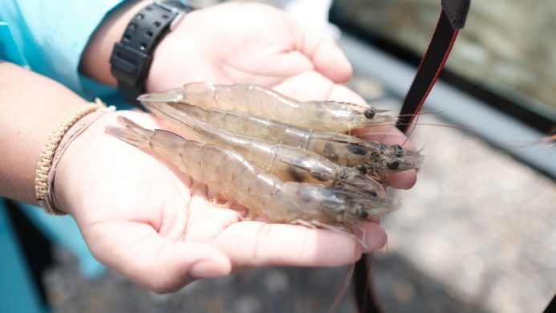
- A A

- Comment
Shrimp is selling for much higher prices in some markets where it is produced, meaning producers shouldn’t bet the house on selling to China, said Robins McIntosh, of Thailand’s Charoen Pokphand Foods.
In a presentation during the recent Aquaculture Roundtable Series, or TARS, conference, held in Chang Mai, Thailand, McIntosh presented a slide (see slide below) showing the much higher price levels for shrimp produced in the local market and also in China, Brazil, Mexico and the US.
With shrimp production going strong and diseases largely under control, farmers must focus on efficiency to reduce costs, but also sellers need to be more imaginative, said McIntosh.
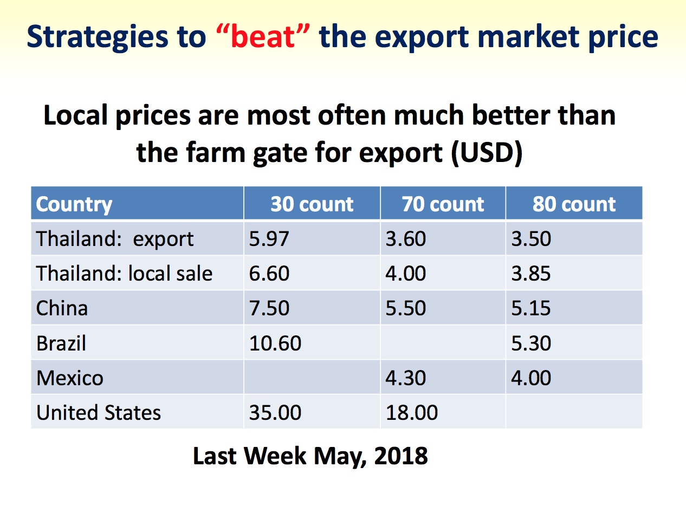
Credit: Robins McIntosh, senior vice president at Charoen Pokphand Foods, from the 2018 Aquaculture Roundtable Series, or TARS, conference, held in Chang Mai, Thailand.
“Even in Thailand, I make more money if I sell locally than export. Brazil, there are better prices,” he said.
Sellers need to “look at developing more local markets, not depend on the export markets”, said McIntosh.
China has seen the major growth in shrimp imports over the last ten years, with the US also up (see slides below), according to data presented by McIntosh.
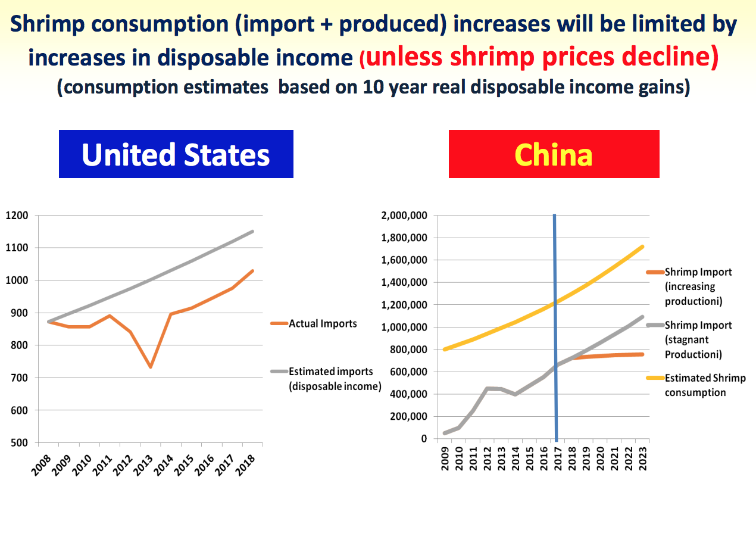
Credit: Robins McIntosh, senior vice president at Charoen Pokphand Foods, from the 2018 Aquaculture Roundtable Series, or TARS, conference, held in Chang Mai, Thailand.
“We are all going to the same markets. The only growth is in the US and China,” he said.
The European Union is flat with Japan, the other main traditional market, down (see slide below), he said.
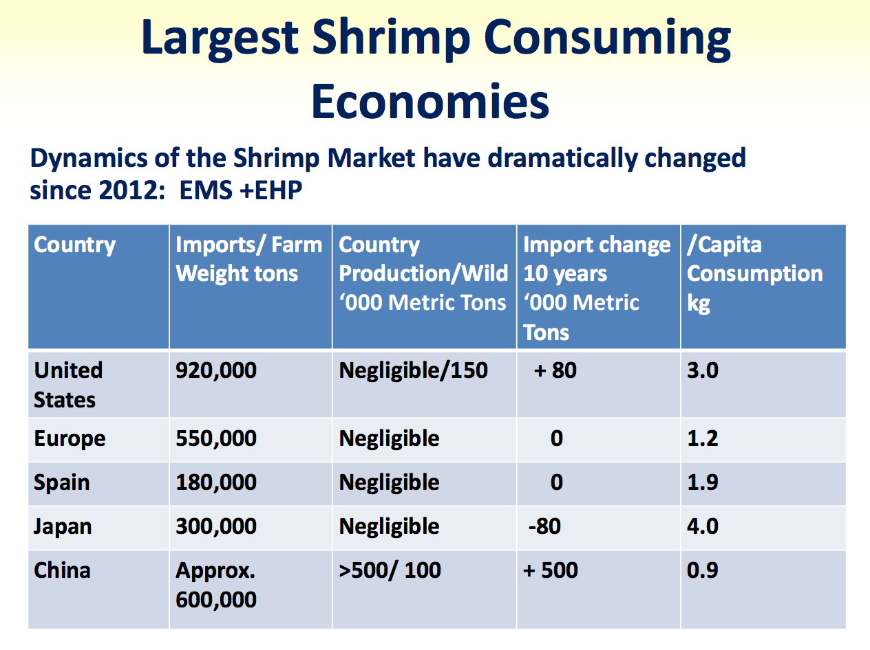
Credit: Robins McIntosh, senior vice president at Charoen Pokphand Foods, from the 2018 Aquaculture Roundtable Series, or TARS, conference, held in Chang Mai, Thailand.
China is now importing around 600,000 metric tons of shrimp a year in farm weight, McIntosh estimated, a staggering 500,000t increase in the past ten years. The US imports 550,000t, up 80,000t compared to ten years ago. The EU is flat at 520,000t, as is its main market, Spain, with 180,000t.

READ ALSO
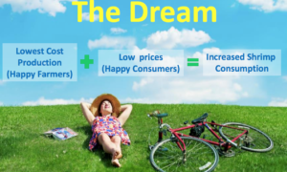

CP’s McIntosh outlines vision for future of shrimp farming, producing ‘more with less’

CP Foods’ chief operating officer for aquaculture, Sujint Thammasart, recently told Undercurrent Newsthe company is betting on China for its shrimp from Thailand, growing out to large sizes.
However, McIntosh warned against going all-in, even if China is obviously going to continue to be a strong market for shrimp. However, its status as a producer means sellers should exercise some caution.
“China is a different story [to the US], as it produces shrimp. It has a failed industry, but that’s not to say it can’t recover. To base your long-term strategy on selling more to China has to be a little bit tempered,” he said.
“The spike in imports to China is driven by a failed Chinese shrimp industry,” he said. Early mortality syndrome and other disease have decimated China’s shrimp production. “In 2009, China imported 5,000t, but exported 400,000t, they were self-sufficient. Then, with EMS [early mortality syndrome] and other diseases, they lost 600-700,000t of shrimp. But, will that last?”
Also, income gains in China for the last ten years are 5.5%,” but what happens when this reaches equilibrium?”, he said.
China could also turnaround its own farming industry.
“It is a failed industry, but what if they were able to turn their industry around? What if they were able to produce 300,000t more today?”

Need for automation
In addition to market development and investment in farming technology, McIntosh said the processing sector must invest and automate.
He displayed a slide showing an image of a shrimp wonton soup noodle plant owned by CP Foods, which runs with only 14 employees. Also, CP Foods is pushing branded shrimp products into local markets, as well as for export.
“It’s also about branding and value-adding, making more from the product, not just depend on selling commodity products into the same markets everyone is selling into,” McIntosh said.
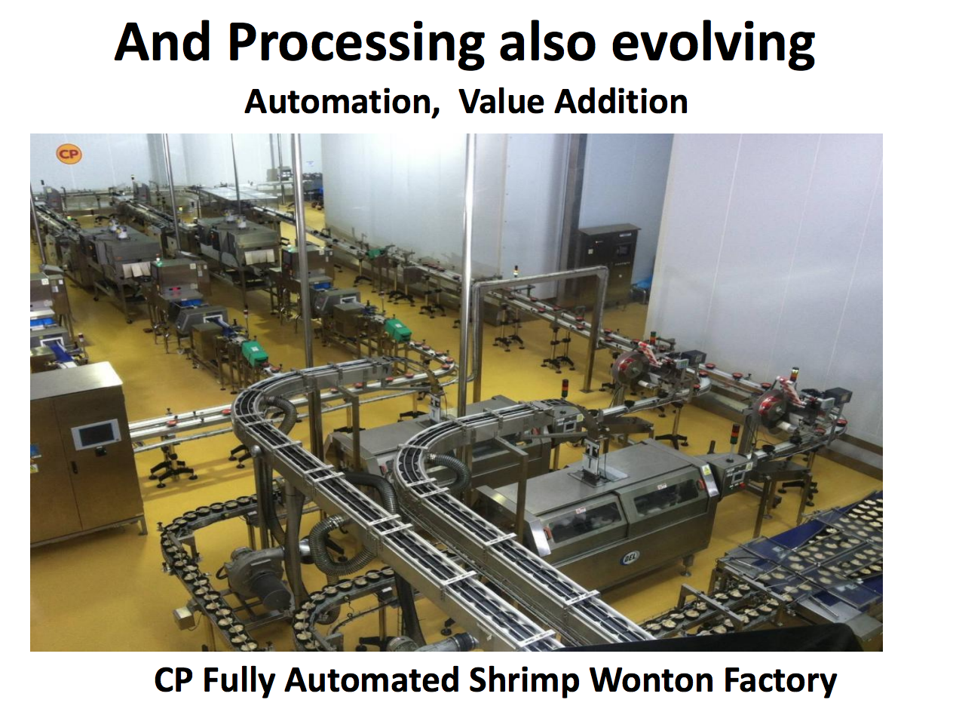
Credit: Robins McIntosh, senior vice president at Charoen Pokphand Foods, from the 2018 Aquaculture Roundtable Series, or TARS, conference, held in Chang Mai, Thailand.
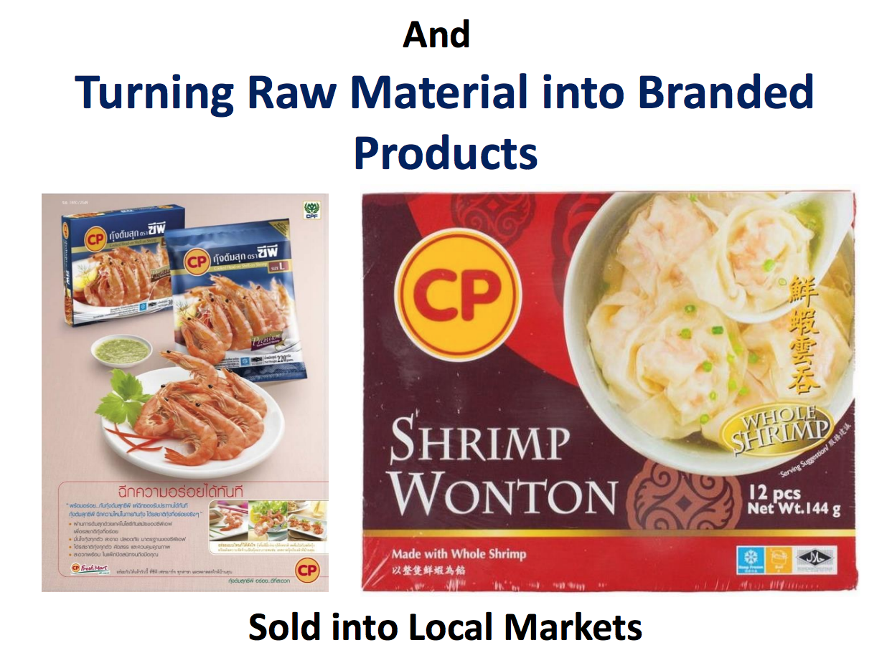
Credit: Robins McIntosh, senior vice president at Charoen Pokphand Foods, from the 2018 Aquaculture Roundtable Series, or TARS, conference, held in Chang Mai, Thailand.

