GOOD TO GREAT
Author selected few American companies based on certain selection criteria and studied them on how these organizations became Great companies from historical dull / mediocre performance. What made these companies beat their competitors for so long duration and sustain the competitive advantage?

Chapter 1 – Good is the Enemy of Great
Selection criteria of the companies (details given in Appendix IA)
- Only publicly traded companies were taken under study so that enough information is available in public domain.
- The company should demonstrate good-to-great pattern independent of its industry.
- Great Performance should be sustained for at least 15-20 years
These companies were then compared to its direct competitors who were in equal size (revenues / profits) and in same industry during the transition time.
Great Results
What’s Inside the Black Box
Good Results

$1 invested in these companies would have fetched $471 in 35 years compared to market return of $56 and the direct comparison company would have fetched $93, even beating companies like GE by 5 times and Coca Cola by 8 times.
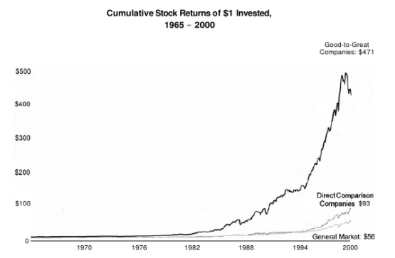

Below 11 companies got shortlisted for study who showed good to great characteristics
Sr No | Company | Industry | Comparison company  (in same industry, similar revenue / profits during transition)
1 | Abbott | Pharmaceuticals | Upjohn
2 | Circuit City | Electronics | Silo
3 | Fannie Mae | Credit | Great Western
4 | Gillette | Consumer Products | Warner-Lambert
5 | Kimberly-Clark | Paper | Scott-Paper
6 | Kroger | Retail | A&P
7 | Nucor | Steel | Bethlehem Steel
8 | Philip Morris | Cigarette | R.J. Reynolds
9 | Pitney Bowes | Postage meters | Addressograph
10 | Walgreens | Retail Pharmaceuticals | Eckerd
11 | Wells Fargo | Bank | Bank of America

Few Findings at start
- Larger than Life, celebrity leaders who came from outside are negatively correlated to taking a company from good to great (ten out of 11 good to great CEOs came from inside the company, three of them by family inheritance). The comparison companies turned to outsiders with six times greater frequency – yet they failed to produce sustained great results.
- Strategy per se did not separate good to great companies
- Good to great companies not only focused on what to do but also on what not to do and what to stop doing.
- Technology was just used as an accelerator for performance and was not the cause of transformation
- No correlation with mergers or acquisition.
- Good to great companies paid scant attention to motivate people.
- Good to great companies were from varied industries – steel, bank, pharmaceuticals, consumer products

Framework

Breakthrough

Level 5 Leadership
Technology Accelerator
Hedgehog Concept
First Who Then What
Confront the Brutal Facts

Disciplined People
Disciplined Thought
Disciplined Action
Flywheel
Chapter 2 – LEADERSHIP

Level 5 leader blends extreme personal humility with intense professional will.
Level 5 - leaders channel their ego needs away from themselves and into the larger goal of a great company. It’s not that Level 5 leaders have no ego or self – interest, they are incredibly ambitious but their ambition is first and foremost towards the institution, not themselves.
Humility + Professional Will = Level 5
Ample examples are stated in the book where the leader of the Good to great company has shown humility and professional will (versus I-centric communication of leader in comparable company). Some of the words used by others to describe the leader of good to great company were – quiet, humble, modest, reserved, shy, gracious, mild-mannered, self-effacing, understated. Level 5 leaders would give credit to others when things go well and take responsibility when things go poorly never blaming bad luck.
Level 5 leaders chose their successor for even greater success whereas Level 4 leaders set up their successors for failures.

Professional Will | Personal Humility
Creates superb result | Demonstrates compelling modesty, never boastful
Unwavering resolve to do whatever must be done to produce best long term results | Acts with quiet, calm determination; not inspiring charisma
Sets standard of building great company and greater successor | Channels ambition into the company; not the self
Takes responsibility for poor results | Gives credit to other people; external factors and good luck when things go well

Chapter 3 – FIRST WHO … THEN WHAT
Executives who ignited the transformations from good to great did not first figure out where to drive the bus and then get the people to take it there. They first got the right people on the bus (and the wrong people off the bus). Once the right people were on the bus, then the job was to put them in right seats and then figure out where to drive the bus, it would be someplace great. Reason being - First, if you begin with “who” rather than “what”, you can easily adapt to a changing world. Second, if you have right people on the bus, the problem of how to motivate people largely goes away. The right people will be self-motivated by inner-drive to produce best results and to be part of something great. Third, if you have wrong people, it doesn’t matter whether you discover right direction; you still won’t have a great company.
During the industry downturn, the level 5 leader hired talented people (contrarian approach – most level 5 leaders are, Warren Buffett is famous for it, he acquires companies during downturn / depression at a very bargain price).
Level 4 talented leader, would first decide what and raise the performance of the company through his personal brilliance. But it is not sustainable. When the leader 4 leaves the organization, performance starts to decrease.
Nucor rejected old adage – People are most important asset. In good to great transformation, people are not your most important asset. The right people are.
Rigorous, Not Ruthless - Rigorous means applying high standards in day today job. Good to great companies did not resort to firing but expected high standards from job to be done. People who couldn’t match the standards were let go off without any delay thereby making right people to stay on the bus and keeping their motivation high. Six of the 11 eleven good to great companies recorded zero layoff and four others had one or two layoff (recurrent firing was observed in comparable companies).

How to be Rigorous –
Discipline 1 – When in doubt, don’t hire – keep looking
Discipline 2 – When you know you need to make a people change, act.
If there is any need to monitor a person’s job, it means it is a hiring mistake and should be acted upon. The best people don’t need to be managed. In Good to great companies, people stayed very long or left very soon.
Discipline 3 – Put your best people on your biggest opportunities, not your biggest problems.
When selling off an asset / division – don’t let go off your best people.

Chapter 4 – CONFRONT THE BRUTAL FACTS
Each of the 11 good to great companies faced crises that would have made them extinct. They faced the crises head on and emerged much stronger after the crises. Comparable companies also faced the same crises but did not want to acknowledge the crisis thereby becoming extinct or acted very late on it after significant impact to the organization.
Facts are better than dreams – Charismatic leaders were liability as people were afraid to communicate the truth to the leaders. In Good to great companies, atmosphere was created so that truth can be communicated transparently across the hierarchy.
How to create atmosphere where truth is heard
- Lead with questions, not answers
- Engage in dialogue & debate, not coercion
- Check reasons for mistake (for corrective action) without blaming the person for mistake
- Build red flag mechanism (e.g. question and answer session in our town hall meetings, but business related questions are still not yet asked in town hall meetings).
Stockdale Paradox – Retain faith that you will prevail in the end, regardless of the difficulties and at the same time confront the most brutal facts of your current reality, whatever they might be.

Chapter 5 – HEDGEHOG CONCEPT
Companies which transformed from good to great had their main focus on joint area of below three circles. They got rid of everything which was not fitting in the joint area of below three circles. Doing one thing for which we are / can be best at in the world + what we love to do + earn profit from it is better than doing multiple doings and being average at those multiple things. X can be any variable – profit per customer / profit per unit and depends on that particular business defined by good to great company themselves. Anything that doesn’t fit the Hedgehog concept was stopped – launching unrelated businesses / acquisitions / unrelated JV. Every discussion + decision dwelled around Hedgehog concept.
(It takes time to figure out their Hedgehog concept, if there is no answer... keep looking).

Below image is not from the book but talks the same thing with one more dimension added
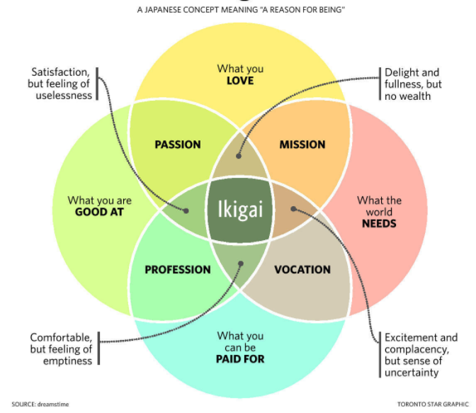

Chapter 6 – CULTURE OF DISCIPLINE
Culture of Discipline doesn’t mean authoritarian / strict culture. It means each individual totally understand his responsibility and takes responsibility for his actions. Each individual acts like an entrepreneur in a small way (freedom + responsibility) for the company’s success keeping the Hedgehog concept in mind. Good to great company hired disciplined people who didn’t need to be managed, and then they managed the system…not the people. It takes discipline to say no to big opportunities if it doesn’t fit Hedgehog concept. Budgeting - Activities which strengthened the Hedgehog concept were fully funded and activities which did not support Hedgehog concept were completely eliminated.

Chapter 7 – TECHNOLOGY ACCELERATORS
Technology implementation was not done for the sake of upgrading technology / fear of being left behind. During the internet boom, people assumed internet will change everything. But good to great companies thought differently on Technology change, they introspected, knew their Hedgehog concept and then implemented / upgraded their Technology with careful selection to strengthen their Hedgehog concept. Technology was the accelerator of the momentum …not the creator of momentum. 80% of CEOs from good to great didn’t even mentioned Technology as one of top factor for transition when interviewed. The ones who mentioned gave a rating of 4 among the top 5 factors for the transition. Technology was not the primary reason for greatness or decline. Crawl, walk and then run can be effective approach even during rapid and radical technological change.

Chapter 8 – THE FLYWHEEL
Flywheel is a heavy disk which is difficult to move at start. But once the momentum is set, it is difficult to stop the momentum. The transition of good to great is like setting momentum of a heavy flywheel. The transition of good to great if looked from outside looked like a miracle but from the inside of an organization it was like chicken breaking the egg and coming out of the egg shell applying huge efforts to break through the shell. Transition was a series of small changes. When the result did the talking, no one was required to be motivated / aligned.
https://www.youtube.com/watch?v=M19HJDeCuxg (watch it from 8.18 till 9.15 – story of Chinese Bamboo tree)
Good to great companies also had very high success rate in acquisition. The key to success was that the acquisition took place after flywheel momentum was set and with the understanding of hedgehog concept. Acquisitions were used as an accelerator of flywheel momentum…not a creator of it.

The Flywheel Effect

The Doom Loop (in comparison companies)
Disappointing Results
Reaction, without understanding
No Buildup; No Accumulated Momentum
New Direction, Program, Leader, Event, Fad or Acquisition

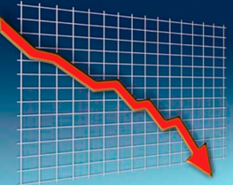

Chapter 9 – FROM GOOD TO GREAT TO BUILT TO LAST
Author superimposes the concepts of his first book – Built to Last, on these 11 good to great companies and find similar patterns of the Built to Last.
Not covering the summary of this chapter as we have not gone through Built to Last concepts.

