- R&D Work in the first year of partnership with a new client is typically small and scales up only with time
- In this field, most of the contracts seem to be time and material base - hence adding to the lumpiness in revenue - under time and material contracts, invoicing is done normally on a monthly basis

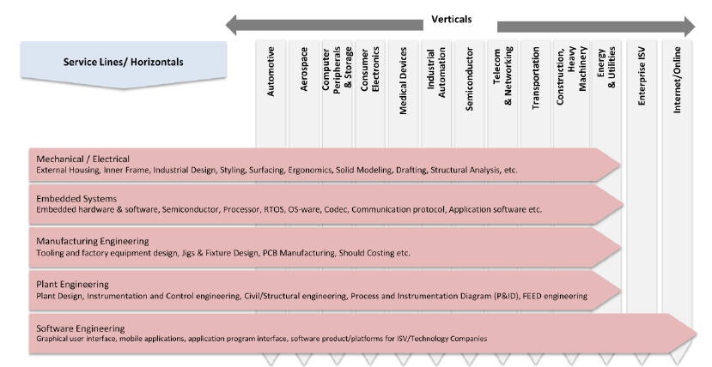

ER&D - > Product engineering and Process engineering

In 2015, the embedded, software and mechanical segments contributed USD 99 billion, USD 63 billion and USD 53 billion, respectively, of the addressable product engineering services market. According to Zinnov, the embedded and software segments are also the fastest projected growing segments of the addressable market

In-sourcing v/s out-sourcing
The demand for ER&D services are met by a combination of in-house ER&D teams and offshore in-house centres (also referred to as global in-house centres (“GICs”) or captives)

The demand for ER&D services are also met by offshore third-party ER&D service providers. The offshore third-party service providers are located mainly in countries like India and China and to a much lesser extent, Korea, South Africa as well as regions of South America and South East Asia.

Total spend on ER&D was 1.07 trillion USD In 2015
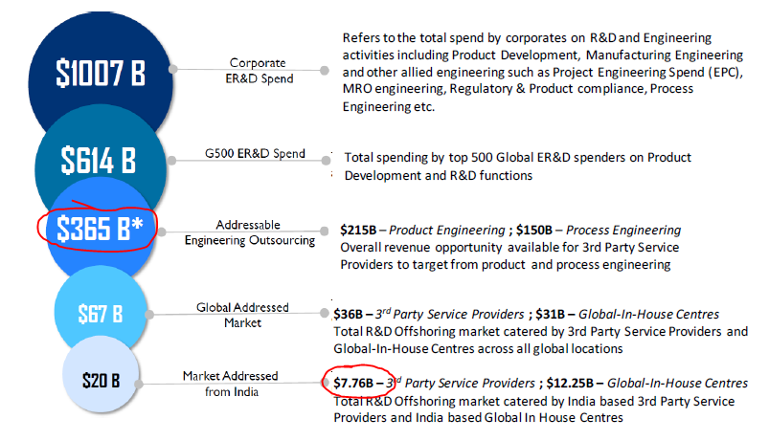

Breakup of R&D Spending by different industries..

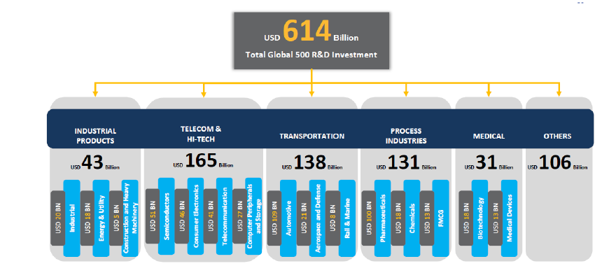

Globally, automotive, software and internet and the aerospace verticals are the most mature in terms of outsourcing the quantum of work.

According to Zinnov, there are very few scale players in the third-party ER&D service providers industry in India. Generally, only 10% of India-based third-party ER&D services providers in each vertical have revenues of more than USD 100 million. Over 40% of India-based third-party ER&D services providers in almost each vertical have revenues of less than USD 20
million. (Source: Zinnov GSPR Rating Report 2015)

So what will drive growth? Some labour related reforms..
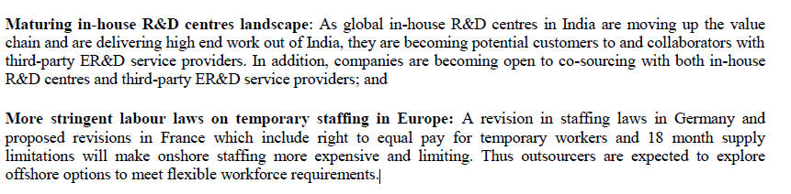

So how does the PES Segment stack up against traditional IT?

