2008-09

Sudhir Mehta, son-in law of Abhay Firodia is a director in the company and receives a sitting fee of 30,000 in 2008 and that doubles to 70,000 in 2009

Loan taken from Jaya Hind investments - 146cr

Advances given to the JV -
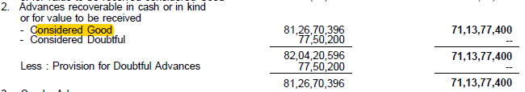

Interest received(presumably) on the loan -

This equates to an interest of 2.94%

2009-10

- Inter-corporate deposits - 71cr

- Misc receipts in revenue(?)

2010-11 Annual Report
- Inter-corporate deposits at 77.5cr

Misc expenses

2012
Proceeds from sale of investments - 1016cr
Capex - 206cr
Paying off loans - 187cr

2013
- Atul Chordia is on the board of directors - a Pune based real estate magnet who has connections with the Pawar family since college days
- What are these misc expenses?

2014

2015
2,00,000 sqft land given on lease but where is the rental income ?

Misc expenses

2016

They’ve brought another plane worth 46cr

